COM 2416-01 The Holocaust Dr Zimmerman, Instr. Fall 2018
WebQuest 4 Nazi Propaganda

Name: (Write your Name)

Purpose: to acquaint students with a variety of quality online resources regarding Nazi propaganda.

Directions: See instructions to former WebQuests for complete directions. Save this file as WQ4 the last name. Put your name at the top. Insert your answers after the questions in a black font so I can quickly see that you are answering the correct question. Succinct answers in your own words are best; I do not wish to read copied text from the Internet. You are documenting your learning in this paper. Email to me by midnight, Sept. 28; miriam@ndnu.edu.
- (10 points) Peruse the German Propaganda Archive, http://research.calvin.edu/german-propaganda-archive/ww2era.htm, housed by Calvin College and created and maintained by Prof. Randall Bytwerk. This is a huge website; take your time to explore it.
Questions: What interested you the most and why? What are two things you learned about Nazi propaganda that you did not know before?

Hitler’s justification to invading Russia was interesting to me, despite his violent nature of the ruling, he still felt the need to justify some of his actions.

The first thing I learned was about Hitler, he presented himself as a man who did everything he could, within his powers to keep the peace. This was contrary to most of his actions, such a revelation compelled me to read more about his sanctions.

The second thing was about Hitler’s youth quotation posters, most of them encouraged the youths to maintain a certain code of conduct, previously, I thought the young Nazi’s were forced to engage in war, it turns out that it was Hitler’s motivation through his party that encouraged them to fight for Nazi Germany.

- (10 points) Peruse the United States Holocaust Memorial Museum exhibit on propaganda, http://www.ushmm.org/propaganda/. What are two things you learned about propaganda that you did not know before?
Initially, I thought being defeated in World War I was the worst thing that happened to the Germans. Contrary to this, in 1919, the Nazis were forced to sign a peace treaty that required them to accept the full responsibility of initiating the war, this is worse considering that they lost the war.

I also learned that the Nazi government spread hatred to communities that were considered to be alien races such as Jews in the name of promoting national unity, this was taken literary by the innocent Nazis who had longed to achieve national cohesion and pride.
- (20 points) Compare and contrast the US Holocaust Memorial Museum’s definition of propaganda, http://www.ushmm.org/propaganda/resources/index.html, with Professor Bytwerk’s discussion of propaganda, which includes Jacques Ellul’s definition of propaganda. http://research.calvin.edu/german-propaganda-archive/faq.htm#anchor1443341
The Holocaust Memorial Museum definition of propaganda dwells on what is contained in a message that is termed as propaganda, in this definition, then propaganda is termed to be biased information which has the intention to change public opinion. On the other hand, Ellul defines propaganda as a set of methods employed by a particular group to bring about mass participation that is fueled by psychological manipulation in a specific organization.
Both definitions have the aspect of manipulation of a group of people in them.
After writing your comparison, reflect on all these meanings of propaganda. No right or wrong answer: What would your working definition of propaganda be?
Propaganda is a selection of formulated messages whether written or performed, that are aimed at changing the way a group of people perceive a particular issue.
- (10 points) https://www.youtube.com/watch?v=GHs2coAzLJ8&bpctr=1537672899
Triumph des Willens (1935) - Triumph of the Will is regarded by most media scholars as one of the greatest propaganda films of all time. Leni Riefenstahl, a former actress turned director, created the film and, arguably, was Hitler’s favourite filmmaker. Watch the first 15 minutes of the film (or more, as your time permits).
How do the first 15 minutes of Triumph of the Will depict Hitler as a savior figure? How many different examples can you find of Hitler as a savior in those 15 minutes? In your answer, include descriptions; do not simply list a number. What other propaganda messages did you see?
Hitler is depicted as a savior figure in the film through the way people in the film like him, the congregations are represented in a way that shows that he is the people’s most loved person, including the children.
Other examples include the monuments of Hitler on the roads, the film shows that people had already erected monuments of Hitler in the streets.
Other propaganda messages include the display of lightings that say “Heil Hitler”, this shows that the people loved him, a message which is contrary to what the situation actually was. In the 16th minute, the film shows children being involved in the military, it also depicts the situation to be enjoyable and a happy one. Such messages are messages of propaganda in this film.
- (10 points) Peruse some of the covers of Julius Streicher’s weekly antisemitic tabloid newspaper, Der Stürmer (The Striker). Select one cover and describe how the images depicted reinforce the message of the text, either explicitly or implicitly, or both.
http://research.calvin.edu/german-propaganda-archive/sturmer.htm
The selected cover is: Don’t Let Go! March 1935(Issue No. 10)
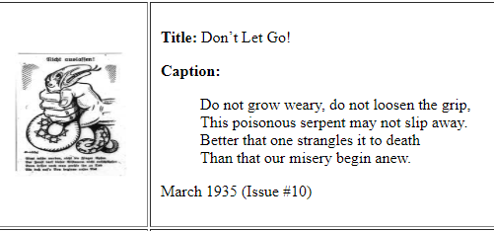
The poster entails a hand which is holding a snake tightly; the snake in this poster seems to be struggling to be set free, with its tongue out. In respect to the text that accompanies the poster, the picture explicitly represents the actions that are to be taken to ensure that the poisonous serpent does not slip away. This is seen through the strangling effect on the snake.
- (15 points) Read the speech, “German Women” by Nazi propaganda minister Joseph Goebbels, http://www.calvin.edu/academic/cas/gpa/goeb55.htm
  - To what extent do you see these values regarding women as espoused by Goebbels in this speech in today’s political discourse about women’s rights in the United States today?
Goebbels talks about the involvement of women in politics and military operations in Germany as unacceptable as far as the immortality of the country is concerned. This perception of women responsibilities in the society has been a major talking point even in today’s politics, different rights and amendments of the law have been made to include women in positions such as the government and military. The extent to which these values are adopted is enormous; this is in regards to the U.S politics.
  - To what extent do you agree/disagree with these values?
I disagree with Goebbels that women’s responsibility is limited to the family, feeding the children and parenting the country’s youth. In my own opinion, women should have access to all responsibilities that men are tasked with; this is because they have shown the capability to handle both the responsibility of parenting and accomplishing personal professional goals.
- (25 points) The Poisonous Mushroom (in German, Der Giftpilz) was an antisemitic children’s book published by Julius Streicher in 1938. Its purpose was to instruct children how to distinguish between Jews and non-Jews. The analogy is that there are poisonous mushrooms and there are edible mushrooms. It is important to be able to distinguish between the two so that you will live and not die should you eat one. Similarly, there are Jews and non-Jews. Jews are a deadly race and toxic to the Aryan race. Each chapter has an antisemitic fable, a picture to illustrate the negative trait of the Jew, and a nursery rhyme to drive home the propaganda.
Select any two of the images that interest you and read the accompanying story. In your own words, describe how the image reinforces the propaganda message.
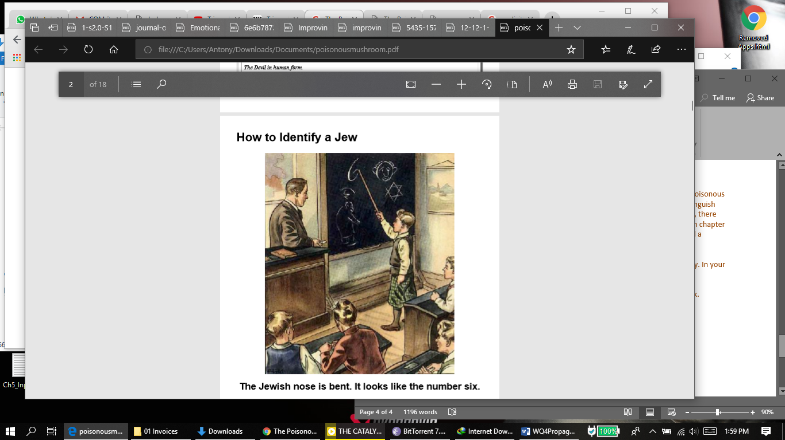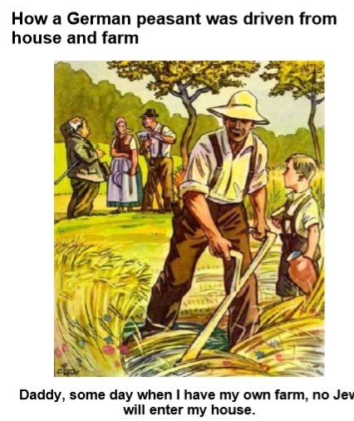

The image on how to identify a Jew shows a group of children being taught how a Jewish nose looks like and it incorporates a child point to the number six which according to Streicher is how the nose looks like. The number six in the picture is also bent in a way the author describes to the children as for how a Jewish nose is bend, this is different from how non-Jewish noses are bent. Through this, the author is able to drive home the propaganda of identifying Jews from their noses.
The second picture is an illustration of a German being kicked out of his farm by a Jew, in this part of the Story; Streicher brings out the aspect of hatred between Jews and Germans through saying that a Peasant German farmer was kicked out of his farm by the Jews. This follows the farmer's child saying that once they grow up they will never let any Jew near their own farm.

- Feedback: No points, but points will be deducted for failing to provide feedback.
  - What did you like/dislike about this assignment?

This assignment provides a great insight into the old day's propaganda. In addition to this, it is formulated in a way that each question builds further on the understanding of the issue being taught.
  - What would you add/delete?
I would delete question number 4.
  - How would you improve this assignment?
Include a question that allows the user to compare modern ways of spreading propaganda with those of during the time of Nazi Germany.
  - Which question provided the opportunity for the most learning?
The question about Streicher’s story on mushrooms as it offers useful insights on distinguishing Jews and non-Jews.

