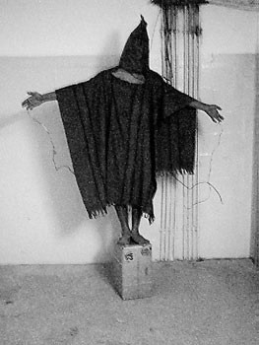
CASE ISSUE I: THE ROLE OF TORTURE
The captain’s dilemma: A French captain, who was opposed to torture because he was a devout Catholic, was faced with a dilemma. A known terrorist had been captured and reliable sources informed the captain that this man had planted a bomb that would go off at noon the next day, probably killing French ofﬁcers and wounding others. Time was running out. Should he order the torture needed to obtain the location of the bomb? He worried and worried over this decision and ﬁnally, ordered the use of the torture and the bomb was neutralized. The next day the captain committed suicide. (Derived from an account of the Algerian Wars of the 1950s)

Methods of enhanced interrogation, the term the United States government refers to while critics call such torture, during the War on Terror include: harsh heat and cold; withholding food; hooding (see image), for days at a time; isolation in dark, cold cells; public nudity; threatening by dogs; rectal
feeding; and water boarding (simulated drowning). The history of the issue:
September 11, 2001: al-Qaeda terrorists attack the United States.

September 14, 2001: A congressional resolution provides the President whatever authority he needs to combat the countries and groups responsible for 9/11.

September 16, 2001: VP Cheney says “We've got to spend time in the shadows in the intelligence world. A lot of what needs to be done here will have to be done quietly, without any discussion. It's going to be vital for us to use any means at our disposal.”

September 17, 2001: Bush gives the CIA the authority to kill, capture, and detain al Qaeda operatives. The CIA lays plans for secret overseas prisons and special interrogations.
January 11, 2002: The first 20 prisoners picked up in Afghanistan arrive in Guantanamo Bay, Cuba.

February 7, 2002: Bush issues an executive order denying Taliban and al Qaeda detainees the protections afforded under the Geneva Conventions, saying that the United States needs new thinking in the law of war. Article3 of the conventions prohibits cruel treatment and torture and the humiliating and degrading treatment of detainees.

May 2002: The CIA asks senior White House officials, including National Security Advisor Condoleezza Rice, to consider the possibility of using rough interrogation tactics, such as waterboarding, in interrogations.

December 2002: Secretary of Defense Donald Rumsfeld approves coercive interrogation techniques, including inducing stress by use of detainee's fears (e.g. dogs), for Guantanamo.

March 2003: U.S. captures and interrogates via waterboarding Khalid Sheik Mohammed 183 times over the course of the month.

March 20, 2003: US invades Iraq.

April 28, 2004: CBS News breaks story of widespread prisoner abuse in Abu Ghraib prison in Iraq.

November 2, 2005: Washington Post breaks story that CIA has been holding detainees in “black site prisons” or secret locations; CIA quickly destroys video recordings of interrogations at these prisons.

December 4, 2005: Washington Post breaks story of US participating in extraordinary rendition. A CIA informant states: "If you want a serious interrogation, you send a prisoner to Jordan. If you want them to be tortured, you send them to Syria. If you want someone to disappear—never to see them again—you send them to Egypt."

October 24, 2006: Cheney says “waterboarding's a no-brainer. I think the terrorist threat, for example, with respect to our ability to interrogate high-value detainees like Khalid Sheikh Mohammed, [waterboarding]'s been a very important tool that we've had to be able to secure the nation, he says. Khalid Sheikh Mohammed provided us with enormously valuable information about how many there are, about how they plan, what their training processes are and so forth; we've learned a lot. We need to be able to continue that.”

November, 2008: Senate Armed Services Committee receives a report on the treatment of detainees. It details the use of aggressive techniques, such as stress positions, on Guantanamo, Bagram, and Abu Ghraib detainees. The report notes that harsh interrogations began before the memos declaring them legal were written; Pentagon officials started considering harsh techniques in late 2001.

April 16, 2009: The ACLU posts four previously classified Bush administration memos. They reveal the extent of the waterboarding of Abu Zubayda and Khalid Sheikh Mohammed. The White House says that CIA officers involved will not be prosecuted.

April 30, 2011: Osama Bin Laden is killed in a raid on a compound in Pakistan; it would later be suggested that enhanced interrogation led to the identification of a courier, who was tracked to the compound and thus revealed the location.

December 2014: Senate Intelligence Committee releases report that suggests the torture and enhanced interrogation methods at best did not work and at worst produced misinformation.

Important Terms:

Extraordinary rendition: placement of detainees into the possession of other countries that may not be hampered by restrictive human rights laws.

Torture: any act which inﬂicts severe pain or suffering, whether physical or mental, and is intentionally inﬂicted on a person for such purposes as obtaining information or a confession from him

Waterboarding: common form of torture that is implemented in a manner that simulates drowning

Abu Ghraib: prison in Baghdad (Iraq) where it was discovered many prisoners were being tortured by a variety of soldiers

Khalid Sheikh Mohammed: third highest officer in al-Qaeda; most important official ever captured alive

Arguments For and Against:

FOR (John Woo, Office of Legal Counsel under Bush): If you’re a prisoner of war under the Geneva Convention, you can only be asked questions, and you cannot be treated any differently based on whether you answer them or not … I think this is an important thing about why the Geneva Conventions don’t really work for fighting a non-state terrorist organization. The primary commodity, the primary weapon in this war with such an elusive enemy is information. And the most reliable source of information comes from the people in Al Qaeda you captured. The need for information from individual detainees is not as important in a normal nation-state world, where you can observe the other side’s army and you know where their capital is; you know where their territory is. You have satellites and things, reconnaissance where you can determine what’s going on with the other side. You can’t do that in a war against Al Qaeda because they don’t have territory, population or cities. And so the way to stop future terrorist attacks pretty much comes from getting information from the terrorists.

AGAINST (Dallas News): Torture is tyranny in its purest form: the exercise of cruel, despotic authority over others. A nation whose founding principle is the fight against tyranny is nothing if not hypocritical if it doesn’t hold itself to a higher standard. Some argue that terrorists have no rights, but detainees under U.S. custody must never be deprived of the basic human right not to be sadistically abused. This nation must be better than that. Let’s not lose historical perspective: Torture was employed at a time when this nation felt a desperate need to get actionable intelligence. The patriotic motives of those involved should not be questioned.
Still, America must always be the standard-bearer for the world on the proper conduct of war and the treatment of prisoners. Our enemies, including current hostage-takers, might choose to ignore international human rights standards, but stooping to their level is never justified. If we truly are better than they are, our behavior must always reflect it.

Discuss whether torture is a justified action in the War on Terror. Before deciding, talk through the two questions below.

- Does the evidence collected at the expense of the one individual justify the potential of saving many lives?
- How does one know if evidence collected is trustworthy?

STEP 1: Answer the above questions to consider through discussion with your case study group members.

STEP 2: On your own, record two elaborated statements explaining why you feel that torture is just or unjust in the War on Terror. (Go beyond “it is not fair” or “it helps”)

STEP 3: Discuss your reasoning with your group peers. As a group, take a vote as a group to ascertain where everyone stands. Adopting the majority opinion, record the two best supporting reasons provided that illustrate the group’s position.

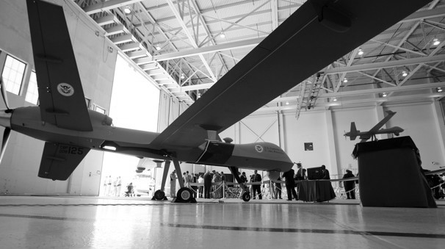
CASE ISSUE II: THE USE OF DRONES

What is a drone? A man-less aviation device flown by a military officer at a separate base. It has the capacity to collect intelligence as well as to be armed and fire if necessary.

How many people have been killed? The overall death toll of combatants during the Obama presidency is estimated to be at around 2,500. As of 2016, the estimated civilian death toll is estimated between 492 to 1100, a number disputed between the American government and independent journalists; this number is representative of the entire War on Terror.

How many strikes have occurred? As of January 2013, 362 attacks have occurred. Under the Obama administration, at least 563 have occurred in an escalation compared to the Bush administration.

Where have drones been used? Pakistan, Yemen, Somalia, Afghanistan, Iraq, Libya, and, reportedly, the Philippines (information remains sketchy on this case).

How are drone targets chosen? CIA officials state that the agency uses a careful screening process in making decisions on which individuals to kill via drone strikes. The process, carried out at the agency's counterterrorist center, involves up to 10 lawyers who write briefs justifying the targeting of specific individuals. According to the former officials, if the briefs' arguments are weak, the request to target the individual is denied. Since 2008, the CIA has relied less on its list of individuals and increasingly targeted "signatures," or suspect behavior. This change in tactics has resulted in fewer deaths of high-value targets and in more deaths of lower- level fighters, or "mere foot soldiers."

What kind of people are targeted? Primarily al-Qaeda and its affiliates. That includes al-Shaabab in Somali a, al-Qaeda in the Arabian Peninsula (which works in Yemen), and the Haqqani Network in Afghanistan and Pakistan.

Have Americans been killed by drone strikes? At least four. Anwar al-Awlaki, an American-born al-Qaeda operative in Yemen, was killed in a drone strike in 2011, as was his American-born 17-year-old son (in a subsequent strike) and Samir Khan, a North Carolina native who died in the same strike as the elder al-Alaki. Ahmed Hijazi, also an American citizen based in Yemen,
was killed in 2002. At least two American hostages have also been killed in strikes against terrorists. Critics claim that these strikes deprived Americans of a right to a trial by jury.

Is this legal? It derives the authority for the strikes from the Authorization for the Use of Military Force (AUMF) passed in the wake of 9/11, which grants the government broad powers against al-Qaeda. The Justice Department argues that drone strikes somehow don’t run afoul of Executive Order 12333, the ban on assassinations as a tool of policy that has existed since the Ford administration, as they are used for “self-defense.” Critics, like UN special rapporteur on extrajudicial killings, summary or arbitrary
executions Christof Heyns, say that this defense is a stretch, and the killings plainly go against the laws of war and international human rights treaties.

A HISTORY OF DRONE STRIKES IN PAKISTAN
YEAR | Number of Strikes | Maximum Killed | Minimum Killed
2004 | 1 | 8 | 5
2005 | 3 | 13 | 12
2006 | 2 | 102 | 90
2007 | 4 | 77 | 48
2008 | 36 | 344 | 219
2009 | 54 | 721 | 350
2010 | 122 | 1028 | 608
2011 | 72 | 599 | 366
2012 | 48 | 349 | 222

Important Terms:

Geneva Conventions- place a burden upon participants to limit civilian deaths and injuries through proper identification of targets and distinction between combatants and non-combatants

Decapitation strike-term used to describe a drone attack on a terrorist leader; used to describe the justification for the attack

occur found that only 17% of the population supports the policy.
History of Issue

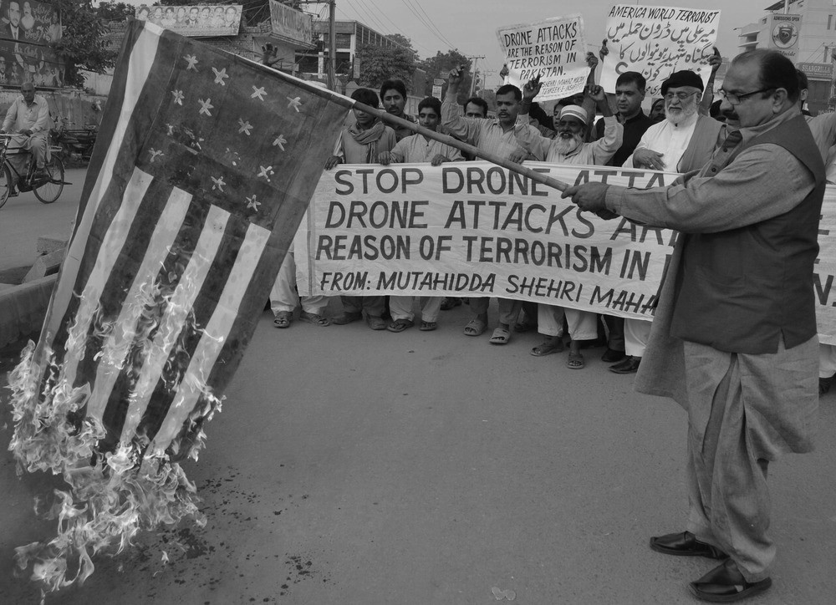
October 7, 2001: First successful Predator Drone attack in Afghanistan launched by the CIA.

2004: US launches first drone strike in Pakistan in the western mountainous region known as the Federally Administered Tribal Region.

Late 2008 to mid-2013: CIA leads tightly controlled air war over North and South Waziristan, Pakistani territory largely ungoverned, in an effort to prevent Taliban forces from re- crossing border into Afghanistan and to weaken Al Qaeda.

November 2011-January 2012: US temporarily halts drone attacks in western Pakistan following the accidental killing of 24 Pakistani soldiers.

2012: An international study in countries where drone strikes

March 2013: Obama nominates John Brennan, leading advocate of drone warfare, to CIA direction. Senator Rand Paul leads 12-hour filibuster of nomination alleging violation of constitutional principles in conducting drone strikes on Americans.

Arguments For and Against:

FOR (Bradley Strawser, US Naval School): …drones can be a morally preferable weapon of war if they are capable of being more discriminate than other weapons that are less precise and expose their operators to greater risk… killing is lamentable at any time or place, be it in war or any context. But if a military action is morally justified, we are also morally bound to ensure that it is carried out with as little harm to innocent people as possible….drones are more precise, result in fewer unintended deaths of civilian bystanders, and better protect their operators from risk than other weapons, such as manned aircraft, carrying out similar missions.

AGAINST (John Kaag, University of Massachusetts): …precision and efficiency are not inherently morally good. Imagine a very skilled dentist who painlessly removes the wrong tooth. Imagine a drone equipped with a precision guided munition that kills a completely innocent person, but spares the people who live in his or her neighborhood. The use of impressive technologies does not grant one impressive moral insight…. Second, assassination and targeted killings have always been in the repertoires of military planners, but never in the history of warfare have they been so cheap and easy. The relatively low number of troop casualties for a military that has turned to drones means that there is relatively little domestic blowback against these wars. The United States and its allies have created the material conditions whereby these wars can carry on indefinitely…. third, the impressive expediency and accuracy in drone targeting may also allow policymakers and strategists to become lax in their moral decision-making about who exactly should be targeted. Consider the stark contrast between the ambiguous language used to define legitimate targets and the specific technical means a military uses to neutralize these targets. The terms “terrorist,” “enemy combatant,” and “contingent threat” are extremely vague and do very little to articulate the legitimacy of military targets.

Discuss whether the use of drones and preemptive strikes is a justified action in the War on Terror. Before deciding, talk through the two questions below.

- Through using drones, what advantages do the American military possess in the War on Terror?
- If the United States is fighting an enemy that is not directly associated with a country, how else can the US pursue their enemy?

STEP 1: Answer the above questions to consider through discussion with your case study group members.

STEP 2: On your own, record two elaborated statements explaining why you feel that the use of drones is just or unjust in the War on Terror. (Go beyond “it is not fair” or “it helps”)

STEP 3: Discuss your reasoning with your group peers. As a group, take a vote as a group to ascertain where everyone stands. Adopting the majority opinion, record the two best supporting reasons provided that illustrate the group’s position.

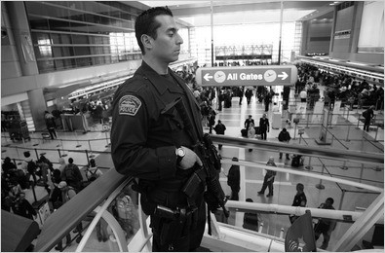
CASE ISSUE III: THE USE OF INCREASED SURVEILLANCE
The attackers on 9/11 utilized many different means of planning their attacks. In addition, on the day of the attack, they were able to easily go through security to access the planes that they would later use as weapons. In the official government report on 9/11, the government was criticized for a “failure of imagination,” in other words an inability to have seen the attack coming and possibly prevented it before it began. In response, the US government began taking a series of measures to better defend the nation from attacks through increasing surveillance and security means. One of the more famous measures was the USA PATRIOT ACT.

Key Features of the USA PATRIOT ACT, passed in 2001:

-Allows warrants to serve nationwide in electronic searches
-Makes it easier to obtain records from third parties (libraries, doctors, phone companies, etc.)
-No longer must demonstrate that subject of search is an “agent of a foreign power”
-Permits the seizure of voicemail messages under a warrant
-Prohibits lawsuits against companies that provide information to federal government for terrorism investigations
-A search does not require probable cause, but must only be articulated to be related to a terrorist investigation
-Requires sharing of intelligence amongst investigation/intelligence agencies Previous examples in history include:
➢➢ Alien and Sedition Acts (1798): extended period to become citizen; allowed president to deport suspicious foreigners; allowed president to deport any foreigner if their home nation was at war with US; made it a crime to publish “false, malicious, and scandalous writing” against the government
➢➢ Espionage Act (1917): sought to allow the American government to intervene on speech and activities that undermined public support for World War I; included the ability to sort through mail to remove anti-war literature
➢➢ First Red Scare and Palmer Raids (1917-1919): American fear of communists and anarchists in the wake of World War I led to illegal searches and seizures, unwarranted arrests, and detainments under the supervision of Attorney General A. Mitchell Palmer
➢➢ Executive Order 9066 (1942): ordered Japanese and Japanese-Americans along the West Coast (~120,000) into internment camps in response to attacks on Pearl Harbor
➢➢ House Un-American Activities Committee-HUAC (1945): House investigation committee formed with permission to investigate any threats to America, including its own citizens
➢➢ Second Red Scare (1945-1957): included HUAC and McCarthy’s investigations. Truman passed Executive Order 9235 and Federal Employees Loyalty Program. Like the 1st Red Scare, this intense period of fear focused on communism
History of Issue:

October 26, 2001: President Bush signs USA PATRIOT Act into law.

November 19, 2001: Aviation and Transportation Safety Act signed into law; creates Transportation Security Administration (previous airport security had been outsourced to private companies).

December 22, 2001: Richard Reid attempts to blow up a plane with explosives packed into his shoes; leads to requirement that all shoes be removed and inspected prior to air flights.

2002: TSA begins requiring screening of all checked bags.

November 25, 2003: Department of Homeland Security created.

2006: British agents breakup plan to explore airliners using liquid explosives; TSA bans all liquids over 3 ounces; TSA announces hiring of over 500 “behavior” experts to monitor for suspicious behavior at airports.

August 1, 2007: Congress passes Protect America Act, which eliminates warrant requirement for surveillance of international communication.

December 25, 2010: Passengers stop an al-Qaeda operative trying to ignite explosive powder packed in his underwear on a flight to Detroit.

2010: TSA deploys about 500 Advanced Imaging Technology units, or full-body scanners, to screen passengers for non-metallic and metallic threats. It begins using "enhanced" pat-down procedures at airports for secondary screening and for passengers who decline full-body scanning.TSA finishes implementing its Secure Flight program, in which airlines submit passengers' names for matching against a watch list of known or suspected terrorists.

January 5, 2010: Obama administration announces that residents of 14 countries (including Pakistan, Yemen, and Saudi Arabia) will receive more intense screening when flying to the United States.

May 26, 2011: President Obama signs into law the extension of the USA PATRIOT Act.

February 2017: President Trump begins efforts to implement a temporary travel ban from certain Muslim countries.

Arguments For and Against:
FOR (Senator Chuck Schumer): During those first few hours after the attacks, I kept remembering a sentence from a case I had studied in law school: "While the Constitution protects against invasions of individual rights, it is not a suicide pact." I took these words as a challenge to my concerns about civil liberties at such a momentous time in our history; that we must be careful to not take civil liberties so literally that we allow ourselves to be destroyed.

AGAINST (Senator Rand Paul): James Otis, a Founding Father, argued against general warrants and writs of assistance that were issued by British soldiers without judicial review and that did not name the subject or items to be searched. He condemned these general warrants as worst instrument[s] of arbitrary power, the most destructive of English liberty and the fundamental principles of law, that ever were found in an English law Otis objected to these writs of assistance because they the liberty of every man in the hands of every petty The Fourth Amendment was intended to guarantee that only judges not soldiers or policemen would issue warrants. battle against warrantless searches led to our Fourth Amendment guarantee against unreasonable government intrusion.
The USA PATRIOT Act, passed in the wake of the worst act of terrorism in U.S. history, is no doubt well-intentioned. However, rather than examine what went wrong, and fix the problems, Congress instead hastily passed a long-standing wish list of power grabs like warrantless searches and roving wiretaps. The government greatly expanded its own power, ignoring obvious answers in favor of the permanent expansion of a police state. It is not acceptable to willfully ignore the most basic provisions of our Constitution in this case the Fourth and First Amendments in the name of

Important Terms:
Racial profiling: the use of demographic features and statistics to justify a more focused search on a specific part of the population 4th Amendment: requires a warrant and probable cause as justification for a search

Discuss whether the use of heightened intelligence and surveillance is a justified action in the War on Terror. Before deciding, talk through the two questions below.

- In cases of emergency and threat to the United States, should citizens be willing to give up a greater sense of privacy in order to secure a greater sense of safety?
- Under what circumstances is profiling justifiable to identify and limit an enemy?

STEP 1: Answer the above questions to consider through discussion with your case study group members.
STEP 2: On your own, record two elaborated statements explaining why you feel that increased surveillance is just or unjust in the War on Terror. (Go beyond “it is not fair” or “it helps”)
STEP 3: Discuss your reasoning with your group peers. As a group, take a vote as a group to ascertain where everyone stands. Adopting the majority opinion, record the two best supporting reasons provided that illustrates the group’s position.

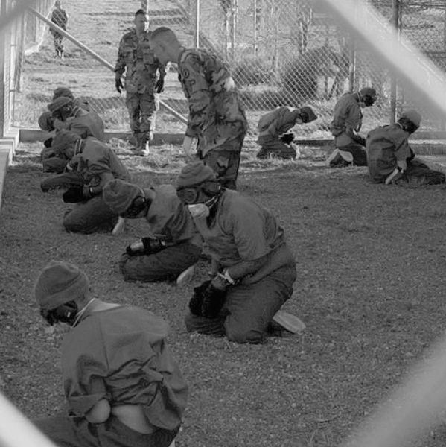
CASE ISSUE IV: THE USE OF INDEFINITE DETENTION
Once the War on Terror began, the US government established away from mainland United States the detention camp at the US Naval Base in Cuba, Guantanamo Bay (also known at Gitmo). Given the complexity of fighting soldiers not directly connected with a government force, the US felt a base away from the fighting was necessary to house the most dangerous captives and conduct interrogations without interruption. In theory, it would also house military trials for those under arrest. Initially, the US government hoped to retain secrecy about the site, the Bush administration adhering to a Freedom of Information Act request in late 2006 admitted to holding over 700 detainees from the War on Terror and provided their identities and nationalities.
History of the Issue

November, 2001: Deputy Assistant Attorney General John Yoo writes to President Bush with the opinion that as long as detainees are held off abroad that they can be detained indefinitely without congressional oversight and judicial review as part of a president’s powers as commander in chief.

July 11, 2002: Twenty detainees/prisoners in the War on Terror arrive at Guantanamo Bay Military Base (GITMO) in Cuba after Bush administration officials conclude base is outside US legal jurisdiction and therefore no trial is required to hold the prisoners.

July 2004: In Hamdi v. Rumsfeld, Supreme Court says detainees had the right to challenge their detention before an impartial tribunal.

July 7, 2004: Bush establishes military commission tribunals to judge whether detainees are enemy combatants or deserve release.

June 2006: United Nations calls for the US to close the Guantanamo Bay detainee camp.

June 29th, 2006: Supreme Court rules in Hamdam v. Rumsfeld that prisoners were entitled to basic rights under the Geneva Convention, which includes the right to a non-military trial.

January 20, 2009: Upon entering office, President Obama orders the suspension of military commission trials occurring at Guantanamo and orders facility to be closed.

May 20, 2009: The US Senate overrides Obama’s request to close the Guantanamo detention center; they refuse to fund any efforts to relocate prisoners.

January 22, 2010: A memo presented to President Obama declares 48 prisoners at Guantanamo were too dangerous to transfer to another prison or country as well as were not presentable for a trial.

January 2010: Harper’s Weekly presents findings that a secret facility, in conjunction with the detainment facility, is operating at Guantanamo for the purpose of interrogations.

January 7, 2011: President Obama agrees not to close Guantanamo for the foreseeable future.

May 2011: Over 600 prisoners released to their original home country.

June 2014: Four high-ranking prisoners at Guantanamo exchanged for US soldier captive Bowe Berghdahl.

January 2017: Leaving office, President Obama fails to follow-up on his promise to close Guantanamo Bay; however, the number of detainees had been greatly reduced.

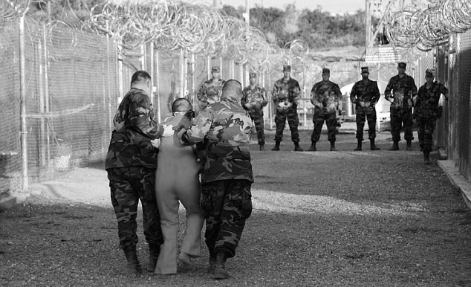
Arguments For and Against:

FOR (Bradford Berenson, White House legal counsel):
Guantanamo has become a symbol for a set of practices in the war on terror that people object to. But it's really not Guantanamo that people have a problem with. It's the practices involving detainees at Guantanamo that are the fodder for the critics. So closing Guantanamo really will have only symbolic value. The things that we are doing at Guantanamo Bay will still have to take place somewhere and Guantanamo is in many ways the ideal location to have prison camps of this kind. It is completely secure, so there are no risks to American civilian populations, no risks of escape, yet it is close to the United States so that policy-makers, lawyers, journalists, can have ready access, but it is not within the United States. In that sense, Guantanamo's somewhat unique.

AGAINST (lawyer for American Civil Liberties Union): I have now been to Guantánamo six times. Nothing I’ve seen has changed my view that the military commissions are unworkable. The system is set up to guarantee convictions and hand down death sentences, nothing more. Everyone, no matter how serious the allegations, deserves a fair trial. And the public deserves justice, which can only be achieved with fair trials. How sad that the most important terrorism trials ever held by our nation are being conducted in a system that is woefully incapable of providing fair trials for the defendants or justice for the victims of the 9/11 attacks.

Important Terms

Military commission-quasi-trial system established to investigate the need to keep prisoners at Guantanamo as enemy combatants

Habeas corpus-right for a prisoner to have a trial held for them and be presented with both charges and evidence against them

Article 3 of Geneva Conventions-requires that P.O.W.s of a war not of an international character (country v. country) must be given basic rights (including trial) and treated humanely

Discuss whether indefinite detention is a justified action in the War on Terror. Before deciding, talk through the two questions below.

- If a prisoner was to be granted a civil trial in the United States, what possible problems might occur?
- What rights would you give to a prisoner of war from another country that an American citizen has?

STEP 1: Answer the above questions to consider through discussion with your case study group members.

STEP 2: On your own, record two elaborated statements explaining why you feel that indefinite detention is just or unjust in the War on Terror. (Go beyond “it is not fair” or “it helps”)

STEP 3: Discuss your reasoning with your group peers. As a group, take a vote as a group to ascertain where everyone stands. Adopting the majority opinion, record the two best supporting reasons provided that illustrates the group’s position.

THE WAR ON TERROR: WHAT IS JUSTIFIED IN THE FIGHT AGAINST TERRORISM?

DIRECTIONS: As you engage in each provided case issue, reflect on the justification for the controversial tactic under investigation. Before providing reasoning for your own position, be sure to discuss the provided “Questions to Consider” with your peers (note: these are not questions that you should write down an answer to). Once finishing discussion, decide for yourself if the action is justified or not while providing two reasons explaining your position. Next, discuss as a group how everyone feels and adopt a group position, while also providing two of the best reasons supporting the group’s position.
CASE ISSUE I: THE USE OF TORTURE

>What do you say? Circle one: Justified Not Justified Reason 1:

Reason 2:

>What does your group say? Circle one: Justified Not Justified Reason 1:

Reason 2:

CASE ISSUE II: THE USE OF DRONE WARFARE

>What do you say? Circle one: Justified Not Justified Reason 1:

Reason 2:

>What does your group say? Circle one: Justified Not Justified Reason 1:

Reason 2:

CASE ISSUE III: THE USE OF INCREASED SURVEILLANCE

>What do you say? Circle one: Justified Not Justified Reason 1:

Reason 2:

>What does your group say? Circle one: Justified Not Justified Reason 1:

Reason 2:

CASE ISSUE IV: THE USE OF INDEFINITE DETENTION

>What do you say? Circle one: Justified Not Justified Reason 1:

Reason 2:

>What does your group say? Circle one: Justified Not Justified Reason 1:

Reason 2:

NAME:_____________________________________

EXAMINING THE WAR ON TERROR: EXIT TICKET
DIRECTIONS: Based on your analysis of the four issues, answer this 3-part question using complete sentences in the area below. Label each part of your response to coordinate with the question [ A), B), C)]

“We have to work the dark side. Spend time in the shadows…A lot of what needs to be done here will have to be done quietly, without any discussion…”
-September 2011, Vice President Dick Cheney

"As many critics have pointed, out, terrorism is not an enemy. It is a tactic. Because the United States itself has a long record of supporting terrorists and using terrorist tactics, the slogans of today's war on terrorism merely makes the United States look hypocritical to the rest of the world. A prudent American president would end the present policy of "sustained hysteria" over potential terrorist attacks. Treat terrorism as a serious but not a strategic problem, encourage Americans to regain their confidence and refuse to let al Qaeda keep us in a state of fright.
-William Odom, former National Security Agency director under President Reagan

- Explain how Odom and Cheney’s interpretations of the appropriate methods for the War on Terror differ.
- Using one of the four cases analyzed, explain how this method supports Cheney’s interpretation of appropriate methodology.
- Using one of the four cases analyzed, explain how this method could be used as an example that Odom would use to support his criticism.

Vice President Cheney’s interpretation on the War of Terror differs from the interpretation of Odom because unlike Cheney who wants the U.S government to work in silence and not get the public involved, Odom wants U.S citizens to fight back against al Qaeda and show that a terrorist threat will not scare them into hiding. Case Issue 1: The Role of Torture, supports Cheney’s idea of the government working quietly. This supports her idea as the case issue mentions how government officials would torture terrorists in an attempt to obtain information regarding potential targets, training camps, approximate number of soldiers, etc. If the government notified the public of their techniques, many would not approve and force the government to come up with another way of receiving information from the terrorists, a way which doesn’t involve physical and mental abuse.

