Waves Lab
Goal: Determine the type and behavior of ocean waves.
Website: https://phet.colorado.edu/sims/html/wave-on-a-string/latest/wave-on-a-string_en.html
You may have to adjust browser settings or cut and paste link to get the simulator started. Use your mouse to play around with the simulator by dragging the wrench up and down to see what happens. Then proceed to the lab:
A. When it starts you will see the page below except with a wrench. Click on the pulse format in upper left to make the lab have the pulse generator pole instead of the wrench.
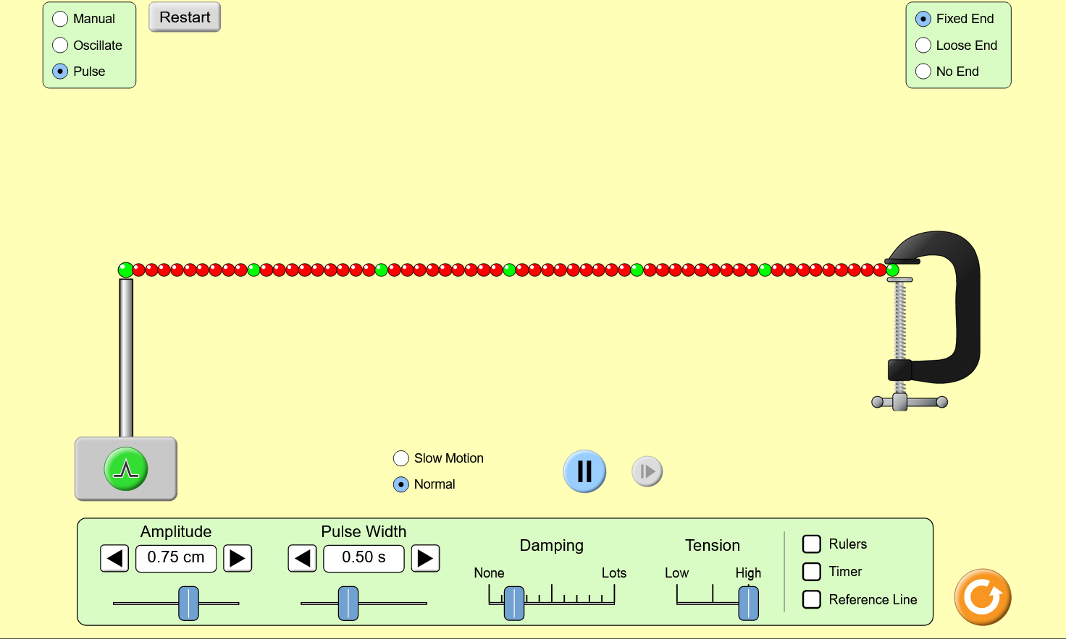
1. Click on the green circle with the upside down “V” and describe what the wave looks like and how it moves.
2. Increase the Amplitude to 1.25 cm then click on the pulse circle. How is wave shape different than in question 1?
3. Now increase the pulse width to 1 s (this is wavelength from your textbook) then click on the pulse circle. How is wave shape different than in questions 1 & 2?
4. Now click on oscillate in the upper left box to change to how it looks below. How is the wave different than in questions 1 to 3?
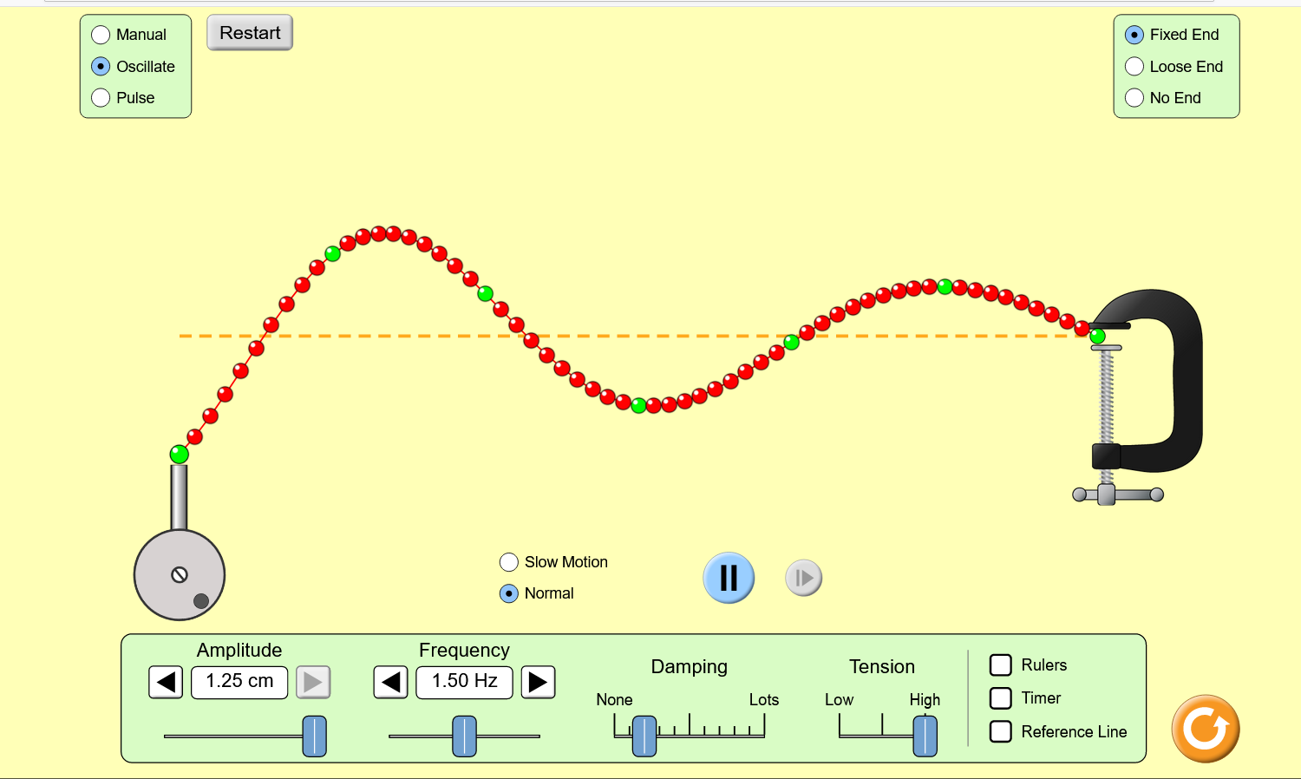
5. This is more like ocean waves. Now change the Fixed End in the upper right box to No End. How did the shape of the wave change from when it was on Fixed End?
You may need to increase the frequency and click on slow motion in order to see a difference. It is very subtle. You might also want to add the rulers and keep track of where the peaks of the waves are located. Take some time on these questions.
6. Cycle through all the different end types and describe how they are different. When an ocean wave strikes the beach, to you think it is acting more with the vice (fixed end that perfectly reflects the wave back), or the ring on the pole (loose end)?
7. Change the frequency to 1.5 hz (this means pulses per second) and the amplitude to 0.5 cm (how high the wave is). Reduce the damping to none. Start with no end and let it run for 10 seconds. Change from no end to fixed end. Describe what happens to the wave over 10 seconds.
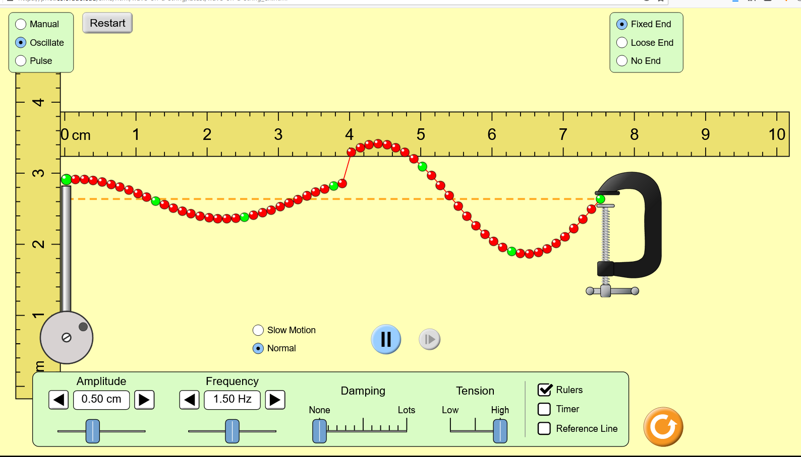
8. Change the oscillate mode to pulse and send a single pulse with no damping and fixed end. What happens to the pulse when it reaches the vise?
Watch the PBS video on waves.
https://www.youtube.com/watch?v=TfYCnOvNnFU
9. Return to oscillate mode. Note that in the fixed end mode the wave reflects from the vise towards the oscillator. What you see over the course of ten seconds is the addition of the top wave and the bottom wave. So, what must be happening to the addition (what part of the top wave is lining up with the bottom wave) when the line goes completely flat?
10. Set the amplitude and frequency to the highest values and have a fixed end mode. Describe when the upper and lower waves match up peak to peak (also take a screen shot and insert the photo in your answers).
11. With the same set up, describe what happens with the peak of the upper waves matches the troughs of the lower waves (also take a screen shot and insert the photo in your answers).

