Weather Consideration for the Development of Regional Airports in the Western United States
Name of student
Name of tutor
The institution of affiliation
Date

Determining Prevailing Winds at the New Airport Location
A wind rose is a fundament instrument located at airports. The instrument is used to measure wind conditions including direction and speed, over a period of time. To create a graph of a wind rose, average values of wind speed and direction are logged at an airport, at short intervals, and over a certain period of time. Information on a wind is presented in a circular format. The “spokes” on the wind rose show the number of times the wind blows from a particular direction (Bellasio, 2014). They also show the frequency of wind speed blowing in each direction presented on the concentric circles. An example of interpreting information on a wind rose is shown below.
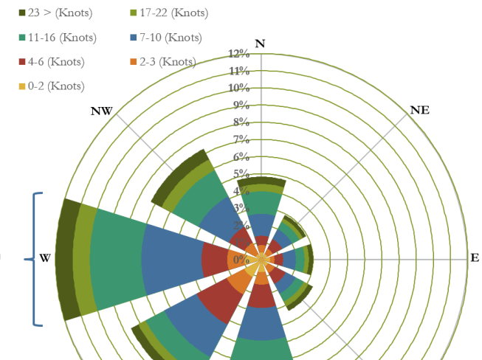
In the diagram above, the westerly spoke and the color bands on the wind rose present the following information:
- The wind direction is a westerly 12% of the time at the location in the diagram.
- Wind speed is 0-2 knots from the west 1% of the total time
- Wind speed is 2-3knots from the west 1% of the total time
- Wind speed is 4-6 knots from the west 1.5% of the total time
- Wind speed is 7-10 knots from the west 3.5% of the total time
- Wind speed is 11-66 knots from the west 3% of the total time
- Wind speed is 17-22 knots from the west 1% of the total time
- Wind speed is greater than 23 knots from the west 1% of the total time
A public resource for wind rose diagrams is provided: USDA’s Natural Resources Conservation Service Wind Rose Website.
Wind roses play a fundamental role in airport planning and development. First, an analysis of wind, especially wind direction is important for planning runway direction. It is recommended that runways should be oriented in a manner that aircrafts can land and take-off into the winds and also within the recommended crosswind limits (Roseman, 2019). Therefore, wind rose charts are essential in planning and designing of runways since they provide crucial information pertaining to winds at an airport.

Summary of Possible Weather and Associated Aviation Impacts for Geographic/Topographic Categories Common in the Western United States
Geographic/Topographic Category of a Possible of Airport Location | Weather Phenomena That Could Impact Aviation Operations | Station/Airport Example
Along the US West coast, with steep mountains to the east | Clouds. Cloudier part of the year at this airport is in November and ends around April. The sky is mostly cloudy during this time. | Santa Barbara Municipal Airport  Santa Barbara, California  Elevation: 10 ft.
In a valley in elevated terrain with high mountains on each side | Precipitation. The rainy season lasts for about seven months. Rain is sometimes accompanied by snow. | Friedman Memorial Airport  Hailey, Idaho  Elevation: 5300 ft.
In elevated terrain on the leeside of high mountains | Wind. The windier part of the year at this airport last for about six month. At this time, the winds are strong. | Northern Colorado Regional Airport  Loveland, Colorado  Elevation: 5000 ft.

Weather Impacts to Aviation Operations

Clouds: Clouds impact on the operation of aircraft. Some clouds like the cumulonimbus clouds are associated with rainfall. These clouds have updrafts and downdrafts which are associated with turbulence. Therefore, flying in such clouds may be uncomfortable and thus may impact on the safety of an aircraft. Moreover, some clouds may hinder visibility thus impact on the safety of an aircraft. The associated risks of clouds are that clouds affect the safety of operation of aircrafts (Schultz, 2018).
Rainfall: Rainfall affects the aerodynamics of aircrafts in flight. First, aircraft fuel tanks can suck in water when exposed to rainfall for a long period of time. This alters with the mixture of gasoline that fuels the aircrafts. This is risk because it makes gasoline lean and therefore ineffective to fly. Second, surfaces like flaps and ailerons can hold water while airborne and this means an additional weight on the aircraft, which can result in accidents. Third, flying through heavy rain reduces visibility and thus the pilot may be blinded thus the risk of an accident.
Wind: Wind effect, that is speed and direction, alters the way an aircraft maneuvers in flight. Head wind in flight increased drag. When drag increases, it reduces the performance of an aircraft in flight and this means an aircraft can use a lot of gasoline while in flight. When a lot of gasoline is used, it may force an aircraft to land in emergency or if not lead to an accident. Gusts of wind are dangerous in flying because they can cause accidents. Moreover, strong winds during takeoff or landing may cause accidents because they add extra weight on the aircraft.
Reflective Statements
Information learnt during the course has played a crucial role in formulating this report. Learning about weather has helped me to understand how different weather phenomena like rainfall, wind, cloud cover, among others impact on the performance of an aircraft. Therefore, engineers should put into consideration the different weather phenomena in designing airports. Safety is paramount for operation of aircrafts and therefore this should be made the first priority in designing airports.

References
Bellasio, R. (2014). Analysis of wind data for airport runway design. Journal of Airline and Airport Management, 4(2), 97-116.
Roseman, C. A., Argrow, B. M., & Pinto, J. O. (2019, January). Targeted weather forecasts for small unmanned aircraft systems. In 19th Conference on Aviation, Range, and Aerospace Meteorology (Vol. 1, pp. 1-6).
Schultz, M., Lorenz, S., Schmitz, R., & Delgado, L. (2018). Weather impact on airport performance. Aerospace, 5(4), 109.

