Physical weathering
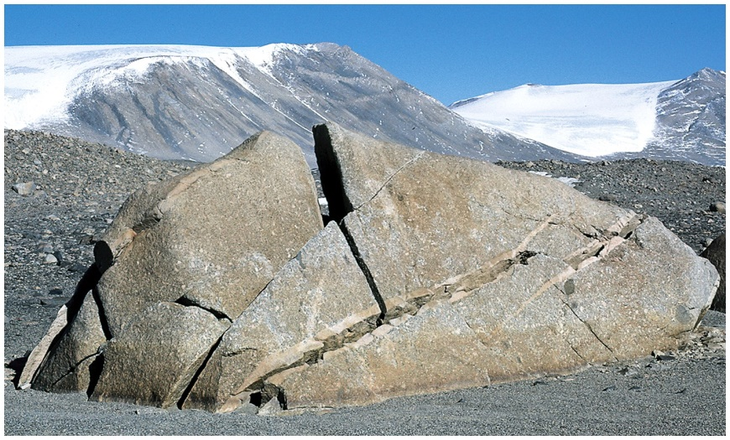 When rock’s conditions are affected by the area of the climate they react as a form of physical weathering. In this example, erosion has broken down the rock into smaller pieces. Also when the wind blows sand particles against rocks frequently, the rock wears away and it forms physical weathering. In deserts same physical effects and pressure causes rocks to split and have cracks.
Chemical Weathering
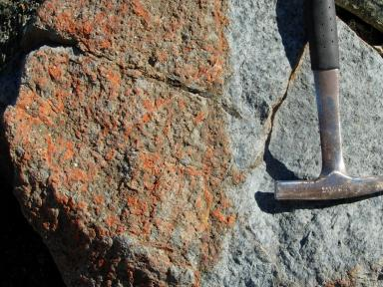 In this example, the reaction as a result of chemical weathering has turned the rock orange. The chemical reaction due to weather breaks down molecules on atoms. Moisture and heat are present in nature for this reaction to occur. With every element present, reactions like acidification, hydrolysis, and oxidation occur
Biological weathering
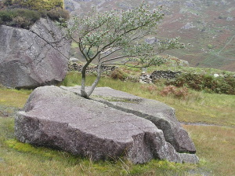Biological weathering occurs as a result of animals and plants. In this example, a tree has grown in the middle of the rock. In biological weathering, the breakdown of minerals through lichens or fungi affect the landscape. The lichens live on the rock so most often they are found by oceans where the air is humid and cool. Other bacteria can take the form of aerobic or anaerobic and thus capable of living in conditions such as in between rocks. Other aerobic bacteria can oxidize mineral, especially like pyrite resulting in degradation of the rock, staining, and change in color.

