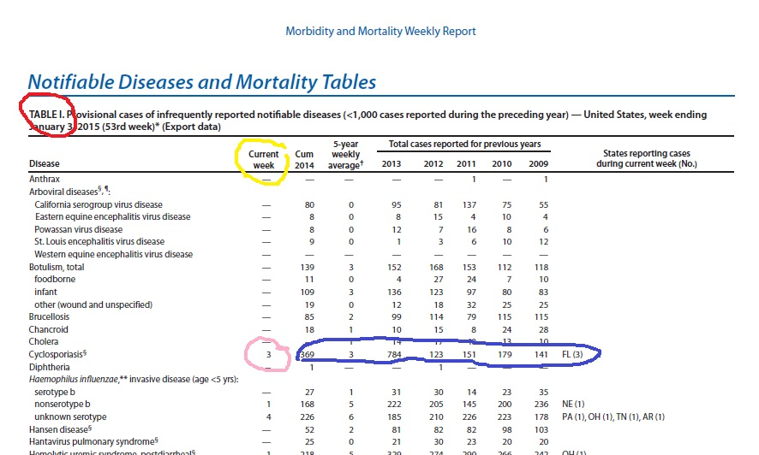

SEE PAGE 2 FOR MORE DETAILS…..
(NOTE: This chart is color coded….If you are color-blind and need assistance reading this chart, please contact your instructor to help walk you through it.)

RED circle: This shows you that you are on the correct chart: Table I
YELLOW circle: This is the “current week” column that you need to find
PINK circle: This is the first disease that shows any mortality number for the CURRENT WEEK
BLUE circle: This shows the trend in the disease going back to 2009 (as noted in the column headers)

STEP 2:
Part a: If I were doing this assignment, I would make sure I am on Table I (note the RED circle). Then, one of the diseases I would select is “Cyclosporiasis,” which has a number posted in the “current week” column (PINK circle). A potential second one might be “Haemophilus influenza nonserotype b” because it is the next one on the list that has a number in the “current week” column (YELLOW circle). See above. This is NOT circled. You do not have to use the first two diseases that have numbers in the “current week” column. BUT, you must use diseases that have numbers in that column.

Part b: I am asked to summarize the nature of these two diseases, their etiology, and symptoms. I would need to research both Cyclosporiasis and Haemophilus influenza nonserotype b. I would write out my response to this in paragraph form.

Part c: I am asked to explain the trend in cases of these two diseases. The trend is what has occurred with the disease over time. I need to look at the numbers under the 2009 to 2013 years (BLUE circle). For Cyclosporiasis, the chart shows that in 2009, there were 141 reported cases and in 2013, there were 784 cases. PART of my review will include that there has been a significant increase in cases of Cyclosporiasis from 2009 to 2013. But, notice that 2012 only had 123 cases. It appears that the number of cases remained relatively stagnant from 2009 to 2012 and rose significantly in 2013. Why? This would be a good thing to research to add to your paper. Why were there so many more cases of this in 2013 compared to the 123 reported cases in 2012? Then, you can look at the 2014 numbers, which are provisional. I know that only because the Table I title has an asterisk at the end and I went to the second page to review what that asterisk meant. It said that the 2014 are not finalized numbers yet.

In addition, notice that at the end of that line circled in BLUE, you see an FL(3). What that means is that all three cases reported during the current week came from Florida. So, that should tell you that the most current week, there were only cases of Cyclosporiasis in the state of Florida.

This is a short sampling of the type of analysis we are looking for in this assignment. I would do the exact same thing for my second disease.

