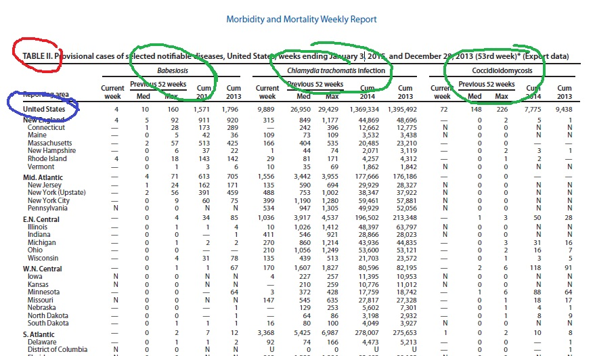

How to read this chart:

RED Circle: Make sure you are on Table II

GREEN Circles (3 of them): These are the diseases that are listed on this particular page. There are usually three on a page in this report. This one happens to be Babeslosis, Chlamydia and Coccidloldomycosts. Based on the instructions, this page is NOT what you want for your assignment.

BLUE Circle: The top line on EVERY page will be the United States numbers. Notice that the states are listed below that.

(NOTE: If you are color-blind and need assistance reading this chart, please contact your instructor to help walk you through it.)

Go To Next Page…

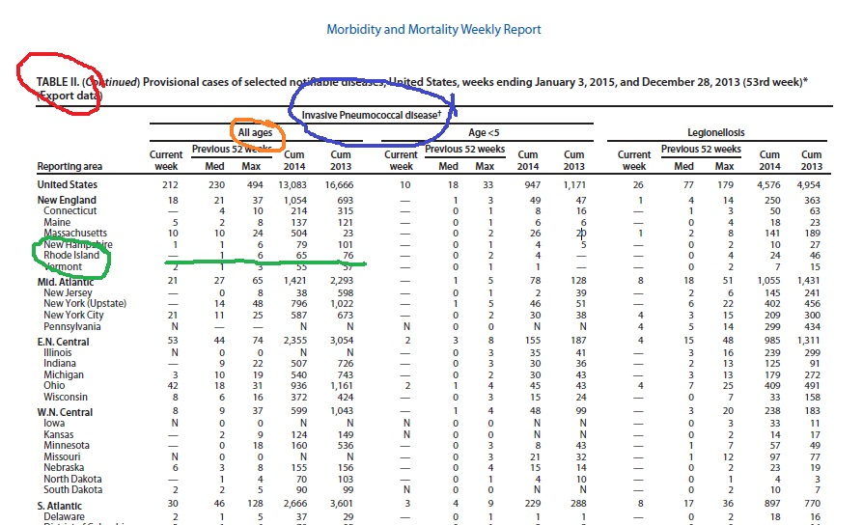

Let’s say I’m ready to start….I scroll down and find one of the diseases in the assignment. I found Invasive Pneumococcal disease on the 8th page of this particular report. This is circled in BLUE above. I double-check that I am still looking at Table II by looking at the upper left (RED Circle).

Remember, the instructions said NOT ages <5 so I need to look at All Ages (Circled in ORANGE).

I live in Rhode Island, so I need to find the information for my state as required by the assignment (GREEN Circle). The only information I will need for this disease is in GREEN underline.

Now, what am I to do?
Part a: find your state for the diseases….I found pneumococcal for all ages at this point

Part b: explain the trend within my state (all of the details are underlined in GREEN above): So, there were no reports of the disease for the current week as indicated by the dash. But, I do note that in 2013, there were 76 cases and in 2014, there were 65 cases. It appears that the trend of mortality from pneumococcal is dropping. The columns that are headed with “Previous 52 weeks” and under those say “Med” and “Max”…what that means is that from the immediate previous 52 weeks (that may not mean the last year. If this is July 15, then the previous 52 weeks would be from July 15 of the prior year to July 14 of the current year.). “Med” means median….the most often number of reported cases during those past 52 weeks; and “Max” means the maximum number of reported cases in that same 52 weeks. For my state of Rhode Island, it appears that the maximum number of cases was 6 with the median number being 1.

Part c: compare my states’ cases with the cases listed for the US. I go to the top line of the chart on this same page to find the US numbers. For this current week, there were 212 cases of this disease across the nation as compared to 0 in my state. I can do the same type of comparison for the cumulative totals in 2013 and 2014. I would need to type out my response in paragraph form and just note the differences or similarities. No explanation was asked, so I just need to compare the numbers.

Part d: Here is where the explanation is required. I am to explain what this means to epidemiologists and the general public. As a hint, I would likely state that for Rhode Island residents, there is good news and the public would want to know that we are doing far better than the rest of the country in terms of mortality cases from pneumonia. Why? That may require some investigation…perhaps vaccination rates are higher, perhaps early detection and prevention measures are better, that will need to be researched.

