Weekly Writing Assignment  Photography I  Professor Prince V. Thomas | 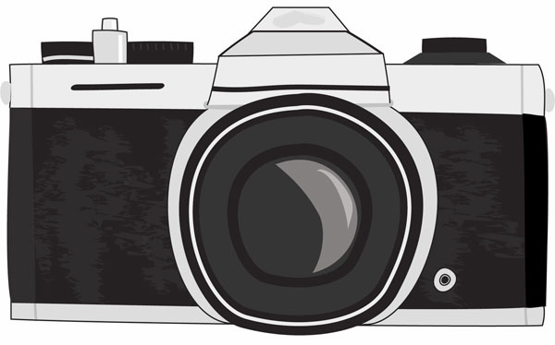

Look at the photographs of one of the artists on this list and answer the following questions in one page or less:

1) Does the photographer have a wikipedia page? If so, are they alive or dead?
2) Did the photographer have a subject or style that they consistently photographed?
3) Describe one photograph that you really liked – Include Title & Date of photograph.
4) Overall did you like or not like their work? Why?

Each week, you should write on a different photographer. If you repeat an artist, it will be a zero with no make-up opportunity for that week.

List of Photographers
Abbott, Bernice | Grossman, Sidney | Meyerowitz, Joel
Adams, Robert | Hine, Lewis | Metzger, Ray
Arbus, Diane | Gibson, Ralph | Michaels, Ray
Atget, Eugene | Gohlke, Frank | Misrach, Richard
Avedon, Richard | Gowin, Emmit | Model, Lisette
Baldassari, John | Guttman, John | Morris, Wright
Bourke-White, Margaret | Heinecken, Robert | Newman, Arnold
Brandt, Bill | Karsh, Yousuf | Nicosia, Nic
Bullock, Wynn | Kertesz, Andre | Nixon, Nicholas
Callis, Jo Anne | Krause, George | Owens, Bill
Cameron, Julia Margaret | Krims, Les | Outerbridge, Paul
Caponigro, Paul | Lange, Dorothea | Renger-Patzsch, Albert
Cartier-Bresson, Henri | Leibovitz, Annie | Penn, Irving
Cunningham, Imogene | Levitt, Helen | Phahl, John
DeCarava, Roy | Lynes, George Platt | Porter, Elliot
Eggleston, William | Lyon, Danny | Rodchenko, Alexander
Evans, Walker | North, Kenda | Sander, August
Frank, Robert | Meatyard, Ralph Eugene | Sherman, Cindy
Freund, Gisele | Maplethorpe, Robert | Sheeler, Charles
Siskind, Aaron | Slavin, Neal | Strand, Paul
Steichen, Edward | Thomas, Lew | Tice, George
Ullesmann, Jerry | Witkin, Joel-Peter | Man Ray
Steichen, Edward | Thomas, Lew | Tice, George
Adams, Shelby Lee | Turzcan, Katherine | Nemienas, Joyce
Heineken, Robert | Girvin, Linda | Hiser, David
Woods, John | Grant, Susan Kae

