Alternative Energy: The Way Forward
Introduction:
With fossil fuels dwindling and the need for energy increasing with today’s level of production, it presents a problem that was not even thought about fifty years ago. According to zmescience.com, we will run out of oil in 53 years, natural gas in 54 years, and coal in 110 years at the current rate of production (Lea). These are alarming numbers because it shows that if we do not find a capable alternative soon, we will run out of energy in many of our lifetimes. Simple things that people depend on today like driving cars and traveling on planes could be gone very soon if not acted upon now. In recent years, there have been several new technologies including electric cars, windmills, solar panels, and hydroelectric dams. These technologies are surely becoming more effective, but not at a rate at which we can completely shift from the use of fossil fuels to a completely renewable form of energy. It is crucial that more government spending is used for new research on alternative forms of energy so that we can continue our way of life with not only a more renewable source of energy, but one that is better for the environment too.
Reference:
Lea, Rob. “How Long before the World Runs out of Fossil Fuels?” ZME Science, 8 June 2018,
www.zmescience.com/other/feature-post/how-long-fossil-fuels-last-43432

Background/History:
It was not until the late 1800’s that the American primary source of energy that fueled the nation shifted to fossil fuels. This shift was for the benefit of the American economy to power machines in a more efficient and faster way than America had ever seen before. Prior to the introduction of fossil fuels, America primarily used the burning of wood as their main source of energy. Wood was used to heat homes, cook food, and light dark places. In the 1880’s, coal began to be used for heating and lighting factories and homes, which was a revolutionary step toward a new way of life for Americans. The first major American invention that used coal was the steam engine that was used mainly for transportation on the railroads and boats (Historical Timeline).
By 1901, roughly 72% of Americans were using coal as their main form of energy for everyday life. Fast forward to 2001, roughly 97% of Americans were using some kind of fossil fuel (U.S. Energy). After all these years of using fossil fuels, many are in panic about what we will do to sustain our lifestyles when fossil fuels run out. This was the start of the race to find an alternative form of energy. It wasn’t until the late 1970’s that experts started thinking about finding a new form of energy. Scientists recognized the fast rate of depletion of American oil and decided it was time to make a change. This gave birth to the widespread use of an invention that had been thought of almost a century prior known as the electric-generating windmill (Historical Timeline).
With the introduction of the modern wind turbine, technology has grown tremendously throughout the years. A wind turbine today can generate over 6 million Kilowatts per hour. This is enough to power around 1,500 homes (Wind Energy). This kind of energy was unheard of when the first windmill was created in the year of 1888. We now have thousands of wind turbines across the country that could potentially generate much more energy than the United States needs, given ideal conditions.
Another invention that kickstarted the use of alternative energy was the discovery of solar power. The first solar panel was made in the year 1954 by three men by the names of Daryl Chaplin, Calvin Fuller, and Gerald Pearson. These three men made history by creating an invention to capture the energy from the sun to directly power electrical equipment. The first solar panel only operated with a maximum of about 11% efficiency, meaning it could only convert about 11% of the light absorbed into usable energy. This still set the pace for the advanced equipment that we have today. Today’s solar panels now operate with around a 23% efficiency, leaving them with much greater capabilities of generating electricity (Solar Panel).
A third great leap toward the use of alternative energy was the first use of Hydroelectric Energy. Hydroelectric energy is an alternative form of energy that takes advantage of the rapid flow of water to convert its energy to electricity. Although it was not until later years that electricity was discovered, the first dam was actually built around 2800 B.C. Ancient ancestors used dams solely to block off the flow of water and contain it in one region. Little did they know, it was a genius invention that began to power thousands of homes centuries later. Hydroelectricity today is usually produced using the same type of dams used centuries ago. The dams stop the flow of water and build it up in a pool. Once the pool is full, the dam releases water through chambers where there are turbines that spin with the water. These turbines generate electricity and send it to a generator (Ingram).
The latest strive toward an alternative use of energy is through the invention of electric automobiles. The most famous company that has pioneered the electric car is known as Tesla, expected to produce around 400,000 electric vehicles this year alone. The first electric car made in America was technically made in 1890, but it has not been until recent years that electric cars have been up to a similar level to fossil fuel powered cars. In 2003, Tesla was founded, creating a new pioneer of the electric car industry and a great impact on the strive for alternative energy. The first car that Tesla made was called the Tesla Roadster. This vehicle achieved a completely unprecedented and unexpected 245 miles in one battery charge (Gregersen). This set the pace for the electric car industry. There is more information on Tesla’s electric vehicles and how they have impacted the world’s need for alternative energy below.
Gregersen, Erik, and Barbara A. Schreiber. “Tesla, Inc.” Encyclopædia Britannica, Encyclopædia Britannica, Inc., 4 Oct. 2018, www.britannica.com/topic/Tesla-Motors.
“Historical Timeline - Alternative Energy - ProCon.org.” Alternative Energy, alternativeenergy.procon.org/historical-timeline/.
Ingram, Elizabeth, and Jessamyn Norton. “Hydropower Tech.” Renewable Energy World, 13 Apr. 2020, www.renewableenergyworld.com/types-of-renewable-energy/hydropower-tech/#gref.
“U.S. Energy Information Administration - EIA - Independent Statistics and Analysis.” Renewable Energy Explained - U.S. Energy Information Administration (EIA), www.eia.gov/energyexplained/renewable-sources/.
“Solar Panel Efficiency.” Solar.com, www.solar.com/learn/solar-panel-efficiency/.
“Wind Energy Frequently Asked Questions (FAQ): EWEA.” EWEA RSS, www.ewea.org/wind-energy-basics/faq/.
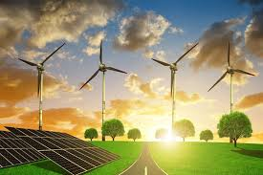

Current Research:
Currently, scientists are developing new projects to help engineer alternative energy sources around the world. One of these developments is occurring in sub-Saharan Africa. There, people are able to pay as they go for solar energy. With the Pay-As-You-Go model (PAYG), customers pay a $10 fee for a solar charger kit which includes solar panels and a unit that can power LED lights and charge phones. They then only pay for the energy that they require in advance or when they are able to, such as after a harvest. After about 18 months, the kits are able to be paid off and the electricity is now free to owners. The Angaza Design company in San Francisco designed a modem in the charger that is able to talk with the consumers' phones to authenticate transactions. Along with this, M-KOPA launched a payment network that helps to leverage networks to receive several payments at once. All 3 companies have shown major success in different countries around Africa, with Azuri having 21,000 consumers while M-KOPA heads over 30,000 customers. The PAYG model seems to replicate very adeptly from each country, being able to reach rural communities with the help of distribution partners, who also get a cut of each sale.
Reference:
Wogan, David. “Pay-As-You-Go Solar Energy Finds Success in Africa.” Scientific American, Scientific American, 22 Nov. 2013, www.scientificamerican.com/article/pay-as-you-go-solar-energy/#.

Another project being conducted is the Clean Line Express project. This project is meant to help carry 4,000 megawatts of wind power from Kansas to Indiana. However, the $2.3 billion project has had its fair share of struggles over the demand for regulations, as well as landowners within the crossing states. Eventually, Invenergy, a Chicago developer, bought Green Belt’s rights from the Clean Line and won the approval from Missouri’s government, granting them as a public utility. This would allow them to utilize eminent domain in order to secure the rights to fund and move on with the project. Currently, Green Belt is locked in a constant back and forth with the Missouri Farm Bureau, as landowners were able to lobby the legislature into introducing a bill to block Invenergy from utilizing their eminent domain power. If they are able to win this, Invenergy could be able to open new opportunities for the delivery of broadband internet to outer communities within Missouri and other states, which could help ease up on the lawmakers’ opposition.
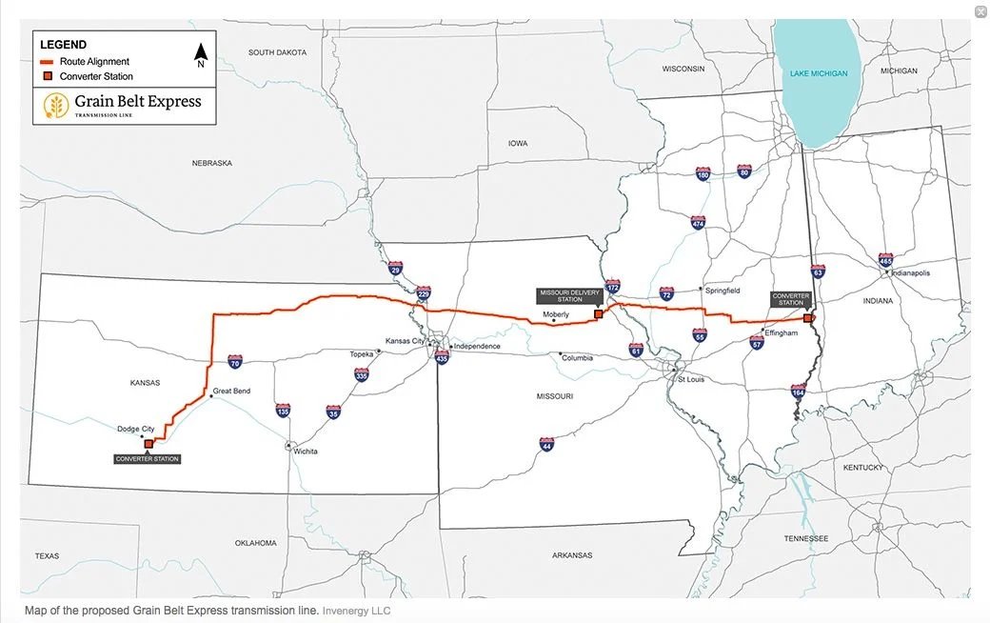
The $2.6 billion, 1,150-mile Gateway West project is designed as a transmission corridor to assist with the carrying power from the wind farms in Wyoming to the West Coast. The goal is to have it completed by the end of this year, however there are still pending permits and obligations needed in order to finish off the project. This joint proposal of PacifiCorp and Idaho Power’s Rocky Mountain power has laid out plans to grow the wind power portfolio within Wyoming in order to increase their strategy for sharing better, cleaner energy. The Energy Gateway Transmission Expansion plan is projected to increase the power capacity over 750 megawatts. The Gateway South Project is projected to add 1,500 megawatts that run along the southeastern border of Wyoming into Utah, which is scheduled to begin construction next year in 2021. 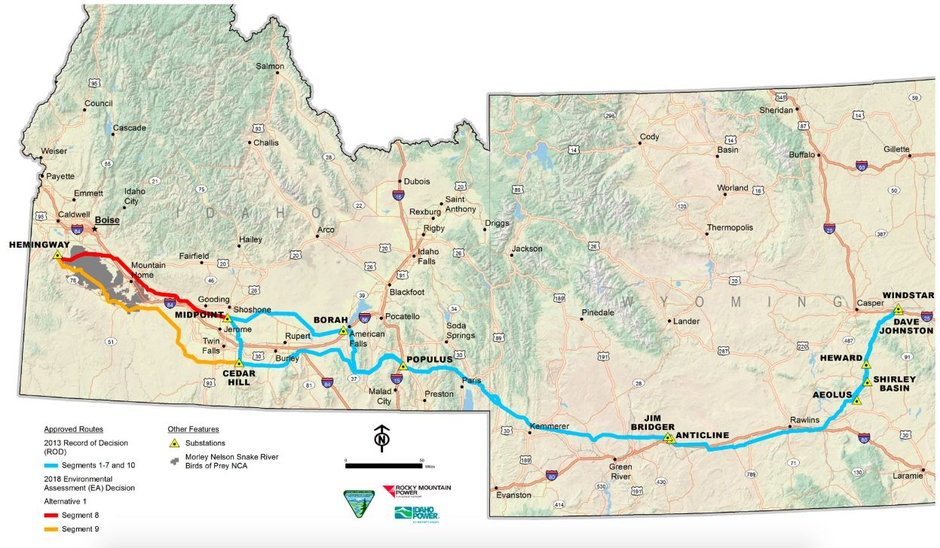
Reference:
John, Jeff St. “7 Transmission Projects That Could Unlock a Renewable Energy Bounty.” Greentech Media, Greentech Media, 9 Apr. 2020, www.greentechmedia.com/articles/read/9-transmission-projects-laying-the-paths-for-cross-country-clean-energy.

The energy section in Pakistan has faced turmoil in recent years following failing infrastructure, financial deficit, and insufficient capacity. Supply and demand for energy materials will continue to slow the economic progress of the country if no solution is found. The National Energy Security Plan (NESP) was created to develop strategies and expand power generation and the use of alternative energies. Currently Pakistan holds about 185.6 billion tons of coal and is ranked 11th as the world’s coal-rich country. The utilization of this coal can help generate 100,000 megawatts of electricity for the next couple of decades. Some of the alternative methods being used is biogasification, also known as biothermazation, is a process by which biomass is converted to biogas and can be utilized as fuel. Anaerobic digestion is a common way to do this process, as well as using higher temperature within the gasifier. Coal biosolubilization will have the capacity to transform molecular weight and waste to clean, economical energy. It is considered more environmentally sustainable and ecologically more safe.
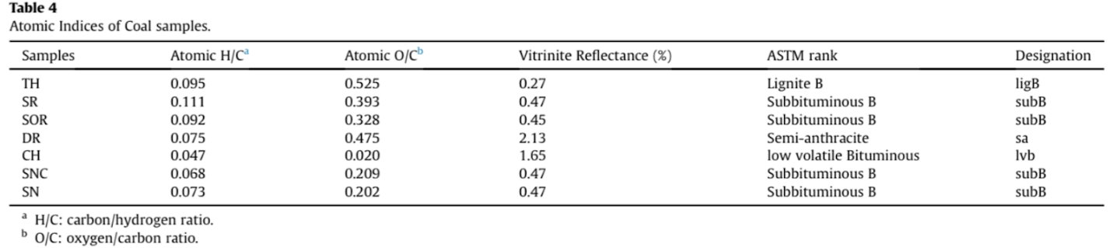

Reference:
Malik, Aneela Yours, et al. “Coal Biomethanation Potential of Various Ranks from Pakistan: Apossible Alternative Energy Source.” Journal of Cleaner Production, 2020, reader.elsevier.com/reader/sd/pii/S0959652620302249?token=245E648AFCFE84593D31C1B067FBC903ACF93F6BBB4509F036AB77780A482EA6BFA11D62D231FD9350FE9E7D885CA269.

One of the biggest pushes for alternative ways of transport is electric cars, more specifically, Tesla. As we have seen in our current situation, parts of the world were seen to have a decrease in air pollution and carbon emissions since many of the industrial companies had to be shut down due to the virus. The head CEO of Tesla, Elon Musk, has continued to make headlines to innovate and develop new methods to combat the ongoing environmental issues. One of the most recent developments to be showcased is Tesla’s new Semi Truck prototype. It costs almost $1.38 a mile in order to drive a normal diesel powered truck. $15,000 is put into maintenance fees, while $180,000 is used for the operating costs of fuel. Tesla is estimating that their Semi will cost $1.26 a mile to operate. The only issue with this is that the upfront cost of these are more expensive and that more than one battery is needed for these trucks. The initial price of these Semis is about $150,000 for the 300-mile range one and $180,000 for the 500-mile one. UPS operates over 80,000 trucks all over the world, with 100 of those being electronic, yet none of those have switched over. They placed 125 orders days after Elon announced the Semi at the Southern California Design Headquarters. Busch, PepsiCo, and even Walmart are other Fortune 500 corporations that placed orders for these trucks. Nikola One, a start-up down in Arizona has begun taking over 14,000 orders for their hydrogen fuel cell electric trucks. These trucks are scheduled to begin production in late 2021. Most of these trucks are being tested at Long Beach and Los Angeles’ Ports, with about 14,000 trucks passing through the complex everyday. The market for electronic trucks is expected to stay below 4% until 2025 according to the IHS Markit.

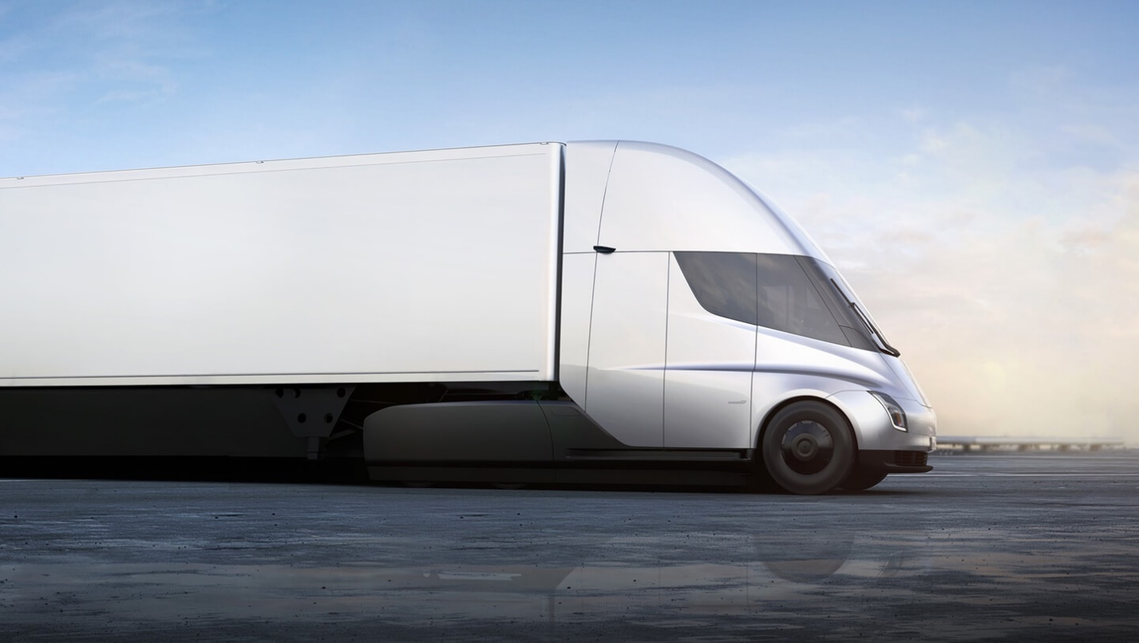
Reference:
Carpenter, Susan. “Big Rigs Begin to Trade Diesel for Electric Motors.” The New York Times, The New York Times, 19 Mar. 2020, www.nytimes.com/2020/03/19/business/electric-semi-trucks-big-rigs.html?searchResultPosition=5.

According to Bartels switching to a hydrogen economy

