PSYC602 
SOCIAL PSYCHOLOGY

A
TTRACTION
AND
C
LOSE
R
ELATIONSHIPS
;
G
ENDER
AND
S
EXUALITY
WEEK 10,
2020
-
LE
_{SOUTH LECTURER:} DR SHIVANTHI BALALLA NORTH LECTURER: DR RHODA SCHERMAN
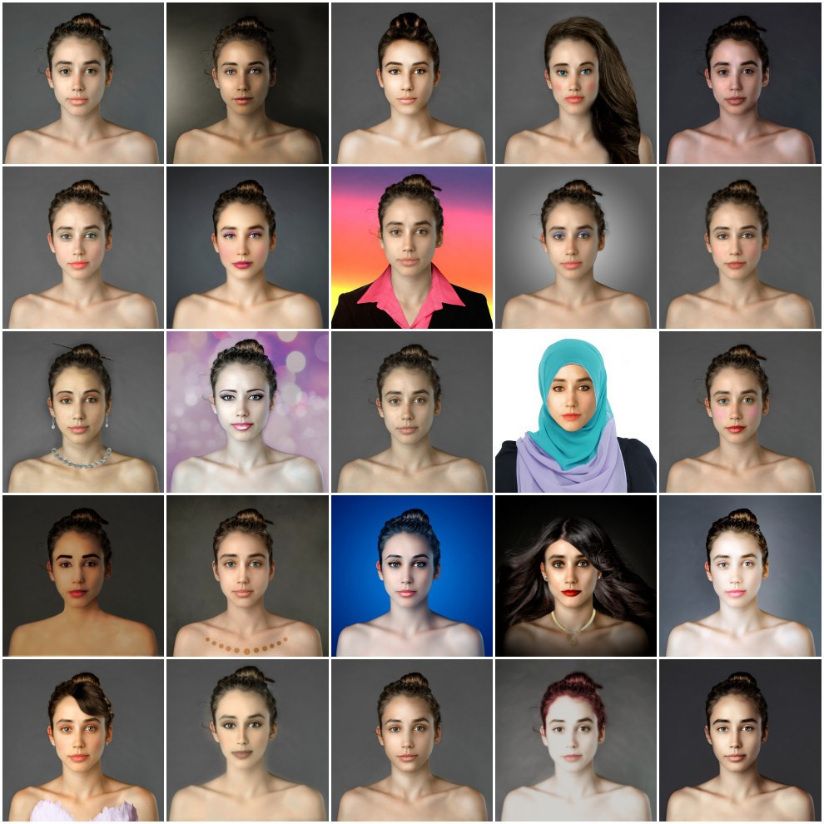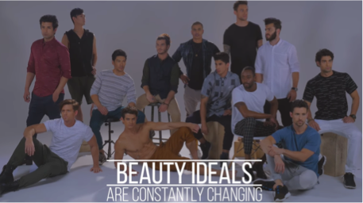
Attraction and Culture:
Women
&
Men
http
s
:
//www.yout
ube.com/watch?v=RT9FmDBrewA
https://www.you
tube.com/watch?v=tneKwarw1Yk

The benefits of being deemed ATTRACTIVE
§
Receive higher wages
§
More successful
in
careers
§
More physically healthy
§
Go on
more
dates
§
Have more self
-
confidence and self
-
esteem
§
Score higher
on
tests of intelligence and mental health
§
Are
judged as more
honest
§
Get
an
easier
time
from
judges
Attraction is beneficial in
our society
–
hence the
attention given to
makeup,
anti
-
aging
products, plastic surgery
Cosmetics
is big
industry
Attraction
also
dictates
what
we
believe
we
‘
should
’
look
like
.
This
causes
a
lot
of
issues
for
people
who
don’t
look
like
that
–
anorexia,
self
-
esteem,
body
dysmophism
,
etc
.
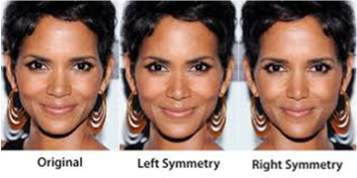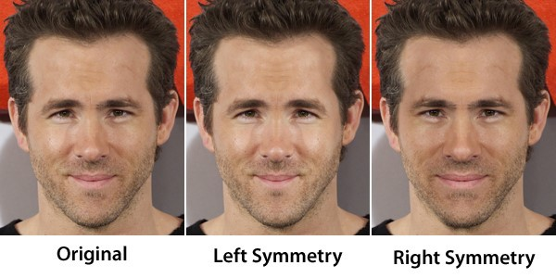
Evolution and Attraction
EVOLUTIONARY SOCIAL PSYCHOLOGY
§
Reproductive fitness: use physical cues such as health, youthfulness
and
facial symmetry
to guess the success of
peoples’
genes
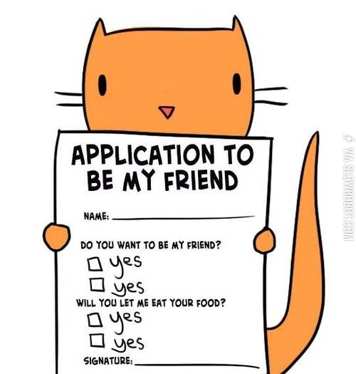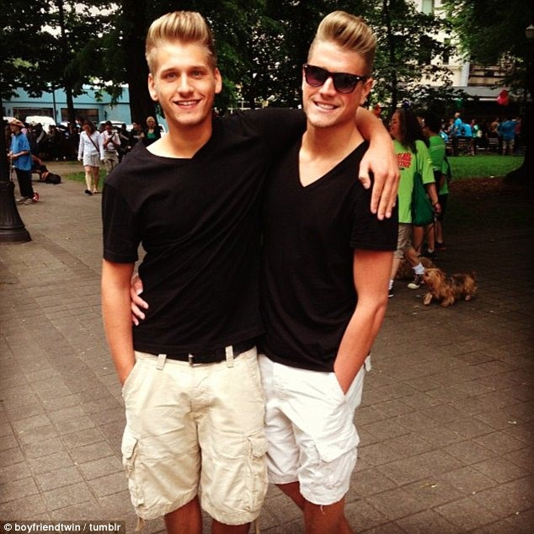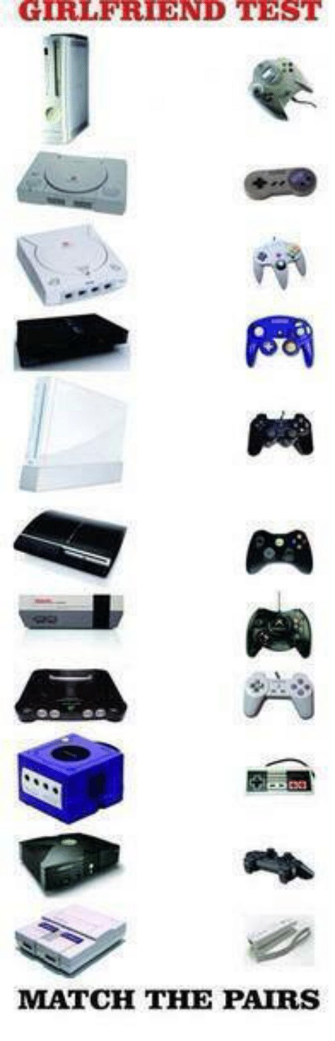
Attraction
–
why we like who we like
Main factors that influence how much we like people
1.
Physical proximity (more contact)
2.
Familiarity
3.
Similarity
PROXIMITY
§
Festinger
(
also of cognitive dissonance fame!)
studied student
accommodation and found that students were much more likely to
choose (as friends) those living in the same building and even on the
same floor.
§
Subtle architectural features that influence social contact, such as the
location of a staircase, can also affect the process of making
acquaintances
§
People who live close by are accessible so interacting with them
requires little effort and the rewards of doing so have little cost.
FAMILIARITY: Exposure Effect
§The more familiar something is the more we tend to like it § “Familiarity breeds liking”
§So if you want to be liked, make sure you are around a lot
(think repetition from Compliance tactics).
§Some have challenged this, finding that the more we learn
about someone, the more we discover about them that is different to ourselves and the less we potentially like them
(Norton et al, 2007; 2011)
SIMILARITY
§
Attitude similarity is an important basis for liking
§
While
we
like
people
in
proximity
to
us
,
we
are more
likely
to
prefer
someone
that
has
similar
beliefs
to
us
§
Newcomb
(1961
)

studied attitudes and values
of students
in
campus housing, and found:
§
Originally
attraction
was
linked
to
proximity
§
Over time,
students with
similarity
of attitudes were more
likely to be attracted to each other
Complementarity vs Similarity
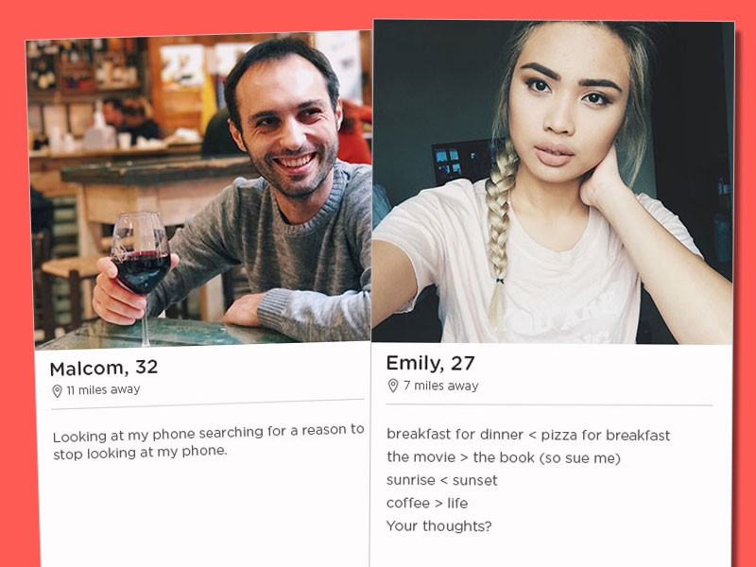
Assortative Matching
People do not select mates at random,
to
match
themselves according
to particular
features
§
Age
§
Gender
§
Physique
§
Philip
Kavenagh
et al
(2010)

found that people rely on cues like those above but also
calibrate a level of
aspiration
by using their personal dating ‘sociometer’.
§
A sociometer is a level of self
-
esteem based on feeling socially included or
excluded by other people. This study found that people choose a partner at a
similar level of aspiration to them
–
neither too accepting or rejecting.
Strongly culturally
-
mediated

Attachment and Isolation
- One way to learn about affiliation is to study the effect of being without it

- Isolation can be forced on individuals (prisoners), or can occur by choice (recluse), but some of the outcomes are the same:
  - Depression • Loneliness
  - Diminished growth • Sensory deprivation
  - Apathy • Hallucinations
  - Indicates that people have a need for affiliation with others, especially in times of stress and anxiety
  - Being in the company of others—who are experiencing a similar psychological state to ourselves—helps to reduce anxiety *
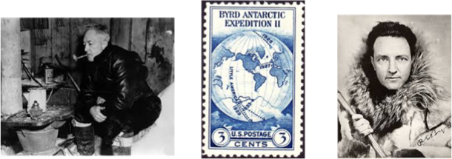
Attachment and
Isolation
AN EXAMPLE: Richard Byrd in
Antartica
§
Week 4
:
he wrote of feeling lonely
§
Week 9
:
became preoccupied with religious questions and meaning of life
§
Month 3
:
severely depressed, apathetic, hallucinated and bizarre ideas
Long
-
term deprivation
In animals
Harlow’s baby monkeys
preferred the cloth non
-
feeding
surrogate mother to the wire,
feeding surrogate
Monkeys without any social
contact would huddle in a
corner, and repetitively rock
back and
forth
https://www.youtube.c
om/watch?
v=OrNBEhzjg8
I
Video warning: may be upsetting
In infants
Bowlby’s institutional babies
were fed but rarely held, and
were confined to their cots for
most of their days
They were stunted socially,
mentally and had higher rates of
mortality than children receiving
more social contact
https://www.youtube.
com/watch?v=kwxjfuPlArY
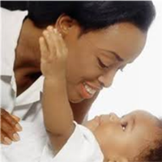
Attachment Theory
Has become an increasingly central topic in social psychology
–
relates both to children and parents, as well as adults with
those close to them
Attachment is a deep and enduring
emotional bond that connects one
person to another across time and
space
(
1969).
Ainsworth, 1973; Bowlby,
Attachment
Styles
-
Ainsworth
§
Mary
Ainsworth
(1969
, 1971, 1978)
studied attachment styles using an
observational study technique called
‘The Strange Situation’
§
Used this study to determine
children’s
individual attachment
behaviours and styles
§
Observed child with mother, with stranger, and alone
https://www.youtube.com/watch
?v=
QTsewNrHUHU
Attachment Styles
–
Ainsworth
§
Secure
:

trust others; not worried about being abandoned; belief
that one is worthy and liked; find it easy to be close to
others; comfortable being dependent on others and vice
versa
§
Avoidant
:

suppression of attachment needs; past attempts to be
intimate have been rebuffed; uncomfortable when close
to others; find it difficult to trust others or to depend on
them; feel nervous when anyone gets close

Attachment Styles – Ainsworth
- Anxious: Concern that others will not reciprocate one’s desire for intimacy; feel that a close partner does not really offer love; want to merge with someone and this can scare people away
- Disorganized A child who exhibits behavioural disorganization or
/Disoriented: disorientation in the form of wandering, confused expressions, freezing, undirected movements, or contradictory (i.e. “unorganized”) patterns of interaction with a caregiver. Most of these children have histories of maltreatment and may exhibit fear of the caregiver
Adult Attachment
Attachment is a process that operates throughout life
§
Feeney et
al.
(1990)

found that
securely
attached individuals
(
comfortable with closeness and having low anxiety about
relationships) were more often paired with similarly secure spouses.
They also exhibited more secure parenting styles.
§
People
with
avoidant
styles
were
less comfortable being close with
others, more closed off
§
Anxiously
attached people
experienced
more emotional highs and
lows in their relationships,
were
more vigilant to threats

Love
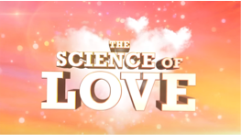
W
hat is love?
§
A combination of emotions,
cognitions, and behaviours that can
be involved in intimate relationships
§
Rubin
(1973)
§
Liking
:
want to interact with someone
§
Loving
:
Trust
§
Being in love
:
Liking + Loving +
Sexual
desire and excitement
https://www.youtu
be.com/watch?v=zFzjdysXLgE

Love
§
Triggered
by
same
factors
as
friendship
:

§
proximity
,
§
similarity
,
§
reciprocal
liking
,
§
personal
characteristics
§
PLUS:
consumed
with
thoughts
of
someone
§
Increases self
-
esteem and self
-
y
fficac
e
§
A combination of social and biological
processes
Evolutionary Social
Psychologists would argue that
the function of love is
procreation
.
What is wrong with this theory?
A
:
Highly
heteronormative;
c
annot
explain same
-
sex
relationships
cientist.com/article/dn13674
https://www.news
-
evolution
-
s
myth
-
natura
l
-
s
election
-
cannot
-
explain
-
homosexuality/
Three Factor Theory
(
Hatfield & Walster, 1981)
Romantic
love
is
product
of
three
variables
:
1.
A cultural determinant that acknowledges love as a state
2.
The prescence of an appropriate love object
3.
Emotional arousal that is felt when interactive with, and/or
thinking about love object

The Colours of Love (_{Lee, 1977, 1988)}
In this novel approach, each variety of love is likened to a primary or secondary colour: There are three primary colors or styles of loving
§Eros= (erotic love) immediate and powerful attraction; intensely emotional; quick to experience “love at first sight”
§Ludus= (game-playing love) views love as a game to be played with skill and often with several partners simultaneously
§Storge= (love without fever or folly) love is stable and based on a solid foundation of trust, respect, and friendship
Lee, J. A. (1973). Colours of love: An exploration of the ways of loving. Toronto: New Press.
The Colours of Love
(
_{Lee, 1977, 1988)}
These
primary love styles can be combined to form secondary colors or
styles of love.
§
(
Eros +
Lusus) =
Mania
–
the
m
anic
lover is desperate to fall in love and to be
loved;
an obsessive, jealous love
style
§
(
Ludus +
Storge) =
Pragma
-
the
pragmatic
lover goes
shopping for a suitable
mate, based on
a
shopping
list of features or attributes desired in the partner
§
(
Eros + Storge) =
Agape
-
an all
-
giving, selfless love style that implies an
obligation to love and care for others without any expectation of reciprocity or
reward
Sternbergs Triangular Theory of Love
Three
factors
are
categorise
different
types
of
love
§
Passion
§
Intimacy
§
Commitment
Passion
+
Commitment
+
Intimacy
=
Consumate
Love
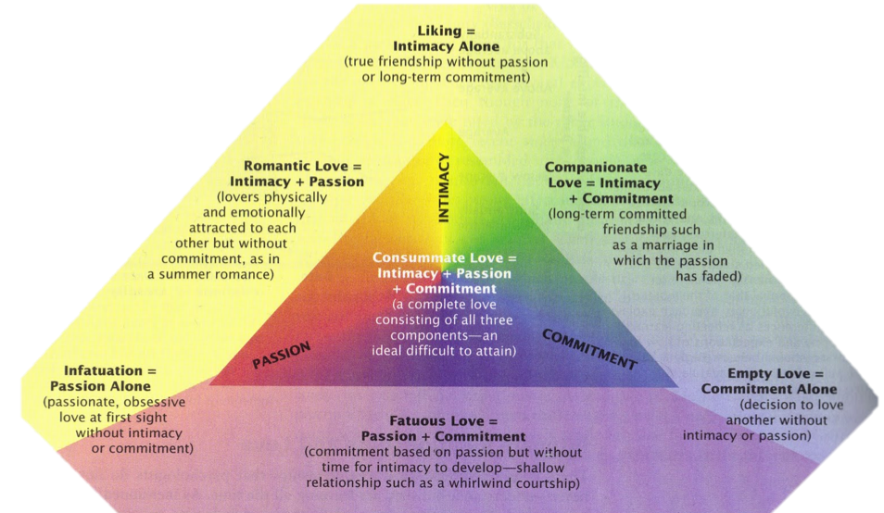
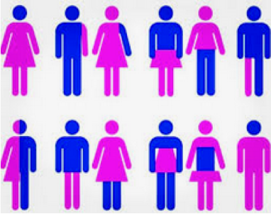
Gender &
Sexuality

Sex, Gender, Sexuality
—
and other importan
t t
erms
Sex
=

Bodies/bodily differences that make us boy/girl (genitalia, hor
mo
nes)
Sexual orientation
=

refers to the sex of those to whom one is se
xua
lly and
romantically attracted
Sexual identity
=

another word for S/O
-
s
how we feel as sexual bei
ng
Sexual expression
=

how we express ours sexuality (acts, people
etc
)
Gender
=

Sociocultural elaborations of sex (identities, practices, rol
es
associated
with sex characteristics)
Gender identity

=
r/g
enderfluid
sense of self as a woman, a man or transgende
Gender expression

=
er
nd
how a person acts to communicate their ge
Rainbow Youth
3
https://s
-
p
a
-
southeas
t
-
I'm+Local+Booklet+Sep+2019.pdf
2
.amazonaws.com/ry.storage/
Inside Out
https://ins
ideo
ut.ry.org.nz/vide
o
-
resources
/
Glossary of Gender
-
Related Terms
a
(
great
read!)
https://medinstgenderstudies.org/wp
-
content/uploads/Gender
-
Glossary
-
updated_final.
pdf
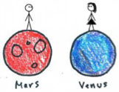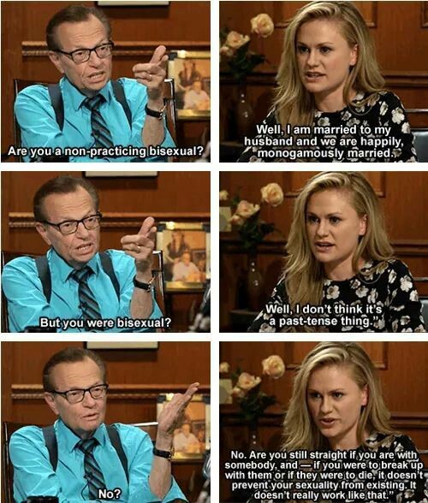
Biological perspectives of sexuality
•
Can only stem from genes
•
Can only stem from hormones
•
Sexuality is defined by sexual expression
•
Static throughout life
•
Always present at birth
•
That there is an internal and
uncontrollable sexual ‘drive’
(
especially men
)
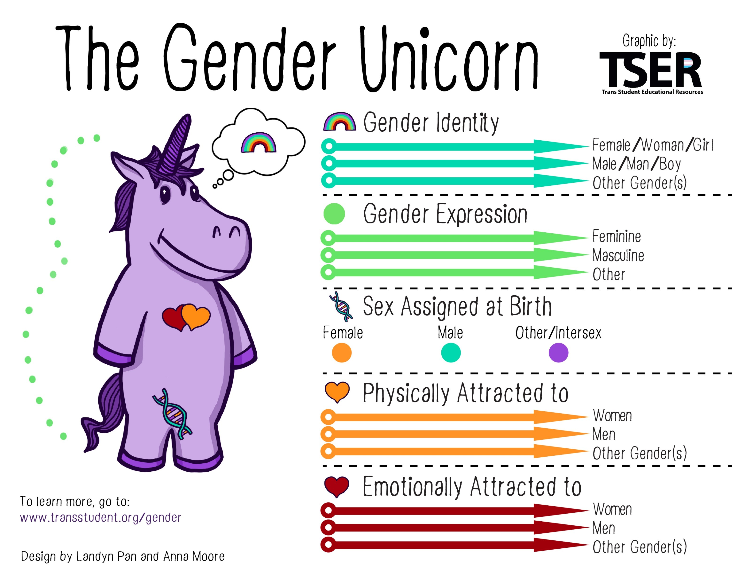
http://www.transstudent.org/gender/
Gender and Sexuality
are not as binary or
clearcut
for everyone
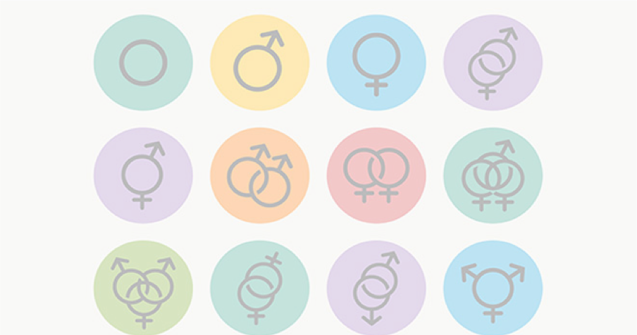
Sexual Identities
…
Any more?
Heterosexual (Straight)
Homosexual
Bisexual
Asexual
Queer
Polysexual
Pansexual
Omnisexual
Demisexual
Gay
Lesbian
Takatāpui
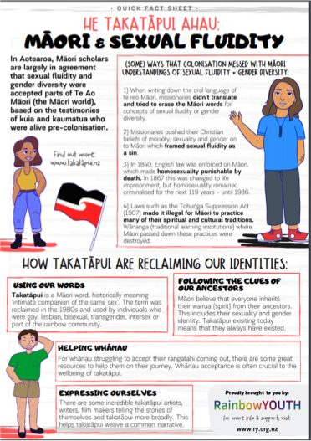
Takatāpui
•
Non
-
heterosexuality was accepted as normal
in Māori culture in pre
-
colonial times
•
Takatāpui
meant “intimate companion of the
same
-
sex”
•
It began being used again in the 1980s by
Māori people in the LGBTQI+ community as
an identity
•
It emphasises how being Māori is linked with
their gender and sexuality
•
”
Takatāpui
is about an intersection of identities. It
is not primarily about being queer and being
Māori in a secondary sense, it is about how those
two pieces of a person interact.”
https://www.makingqueerhistory.
com/articles/2017/10/8/takatpui
https://takatapui.nz/
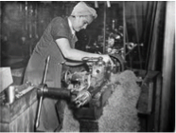
SEX vs. GENDER
•
SEX
=

what genitalia one is born with that
distinguishes us as girl/boy, male/female
•
GENDER
=

socialisation
or molding of people into
feminine or masculine individuals
•
We are not born ‘feminine’ or ‘masculine’, rather
become
feminised or masculinised based on a
multitude of intersecting factors.
•
How different are we?
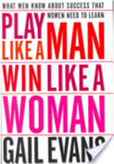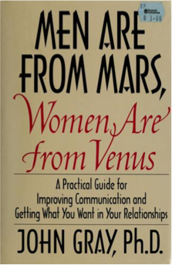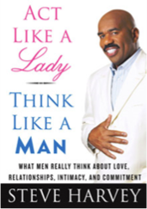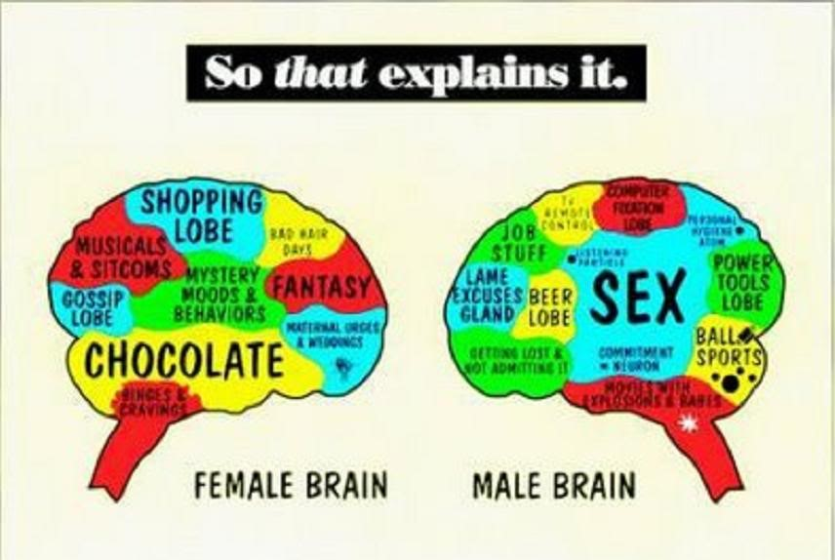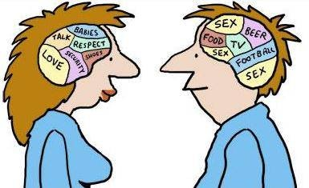
POP culture loves ‘sex differences’
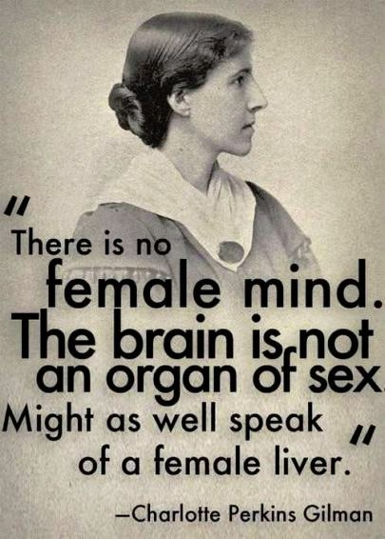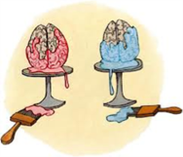
But research consistently shows...
•
There’s more variation
within
the same
gender than
between
the genders
•
Biologically: Men’s and women’s
chromosomes are almost identical to each
other...
•
So, what’s making us
so ‘different’, supposedly?
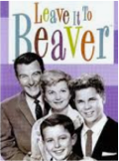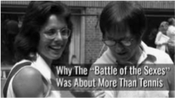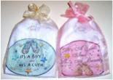
What influences development of
gender(
ed
identity?
)
•
History
•
Scientific discourse
•
Popular Culture
•
Religion
&
traditions
•
Internal/unconscious factors
•
Social interactions
•
Modelling
•
Media representations
•
Cultural discourse
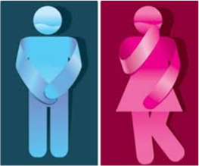
Traditional Gender Binaries
TRADITIONAL
MASCULINITY
Independent
Rational
Aggressive
Active
Reasonable
Hard
Culture
Provider
TRADITIONAL
FEMININITY
Dependent
Irrational
Gentle
Passive
Emotional
Soft
Nature
Nurturer

Current ‘Ideal’
femininity…?
Current ‘Ideal’
masculinity…?
WHAT IS OUR
…
What do you think?
Many
argue
that
current
ideals
are
best described as
Hyper
-
gender
Ideologies:
adherence to extremely traditional gender
-
role
ideologies
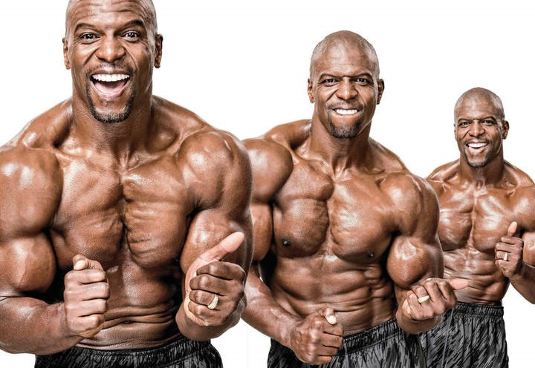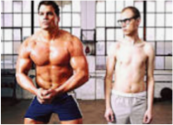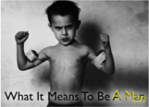
Consequences of gender norms for
men:
toxic hyper
-
masculinity
•
Caused by limited gender roles and restrictions on how men can behave
•
Related to race/ethnicity and sexuality
•
Consequences

:
mental unhealth, unhealthy relationships, criminality
=
?journalCode
5083
https://journals.sagepub.com/doi/abs/10.1177/1097184X1559
jmma
OTHER
EXAMPLES OF ALTERNATIVES?
https://www.youtube.com/w
atch?v=gmOvgwhbMW4
Consequences of gender norms for women:
sexism, misogyny
& hyper
-
femininity
•
Gender roles limit how women can behave in most contexts
•
Related to sexuality and race/ethnicity
•
Consequences
:

Glass ceiling, sexual violence, mental unhealth, sexual coercion
https://www.tandfonline.com/doi/abs
/
10.10
80/00224499409551755
h
ttps://pubmed.ncb
i.nlm.nih.gov/12674261
/
 | Mother  Virgin  Slut Bitch | OTHER EXAMPLES OF ALTERNATIVES?      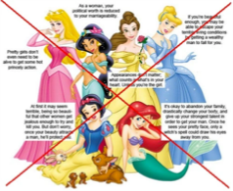  https://www.youtube.com/watch?v=ACM1kFMd9vM

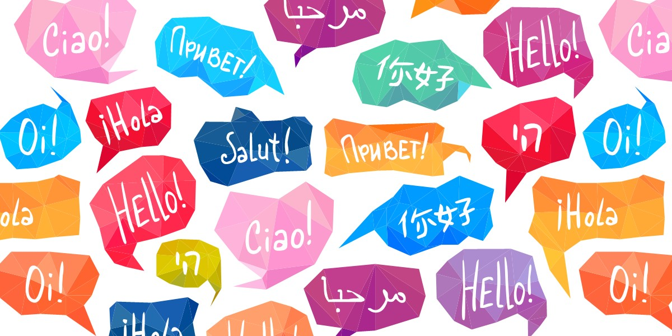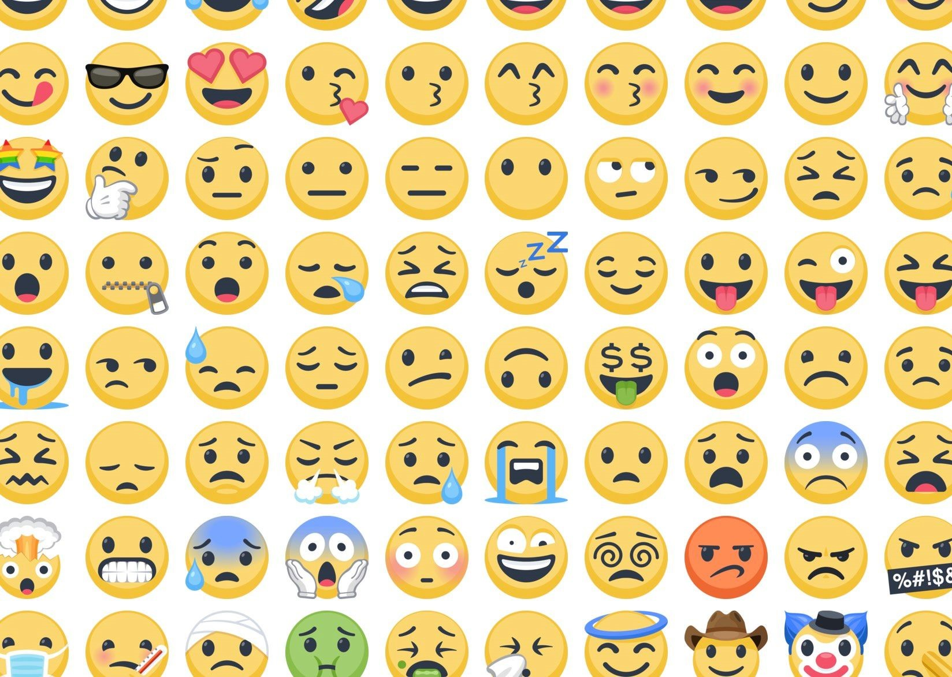
NEXT WEEK
Chapter 11:
Language
and Communication

