
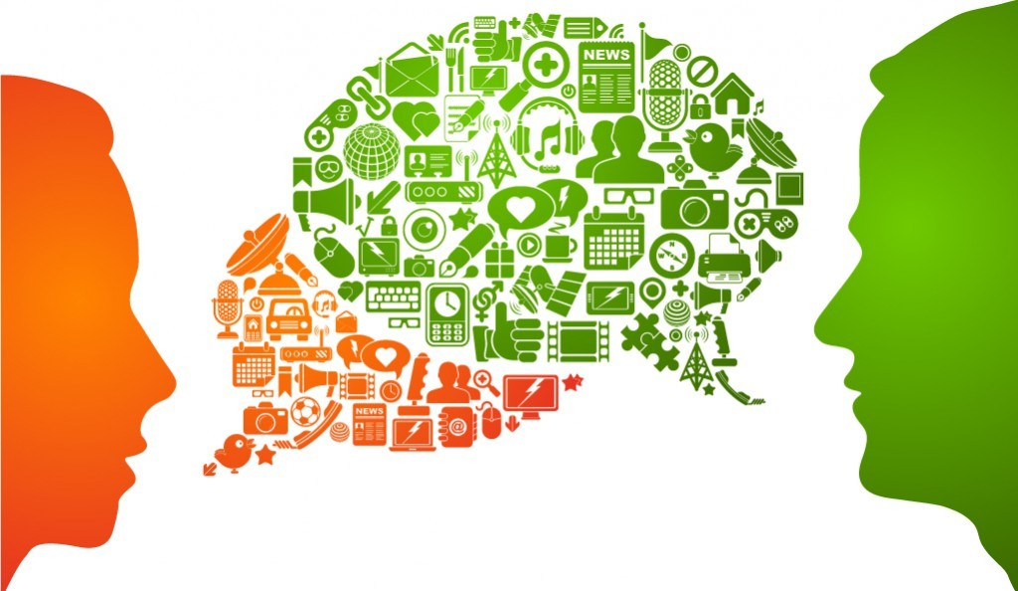
PSYC602 SOCIAL PSYCHOLOGY
LANGUAGE & COMMUNICATION  Week 11 (2020) | SHIVANTHI BALALLA RHODA SCHERMAN
SOUTH LECTURER: DR NORTH LECTURER: DR | SHIVANTHI BALALLA RHODA SCHERMAN
Communication is the essence of social interaction
We communicate what we sense, think and feel through words, facial expressions, signs, gestures and touch.


Communication is social in that:
- It involves our relationships with others
- It requires that people have a shared understanding of what particular sounds, words, signs and gestures mean
- It is how people influence, and are influenced by, others
What’s required for Communication?

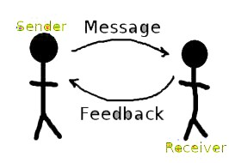
Four parts to communication:
- Sender
- Message
- Receiver
- Channel of communication
- Verbal vs Non-verbal
- Face-to-face, phone, online
There are a growing number of modalities for communication. Let’s talk about the benefits and
disadvantages of the following modes.

Email
Chat
Skype
Phone
Text
Face
-
to
-
Face
In your response consider communication effectiveness, familiarity with technology and demographics.
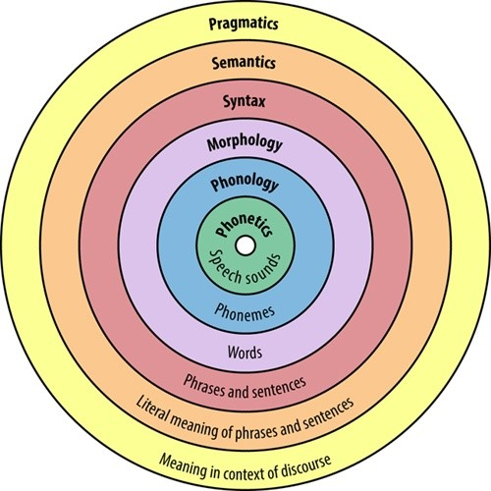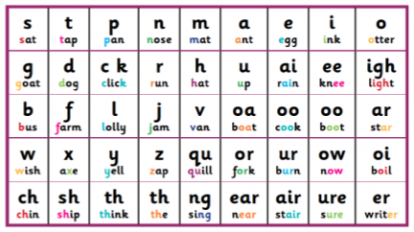
Building Blocks of Language
Language refers to a system of
sounds
(
PHONEMES
)

that convey
meaning
(
SEMANTICS
)

derived from a
word’s units
(
MORPHENES
)
,
based on shared
grammatical rules
(
SYNTAX
)
,
and shared
context
(
PRAGMATICS
)
.
https://
www.youtube.com/watch?v=s9shPouRWCs
Crash Course Psychology

Language has 5 main sorts of
meaning (Searle 1979)

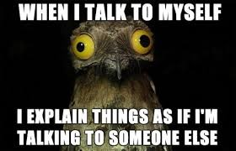
- To say how something is signified
- To get someone to do something
- To express feelings and attitudes
- To make a commitment
- To accomplish something directly
We have access to limitless meaningful utterances – and this is what makes language so powerful.


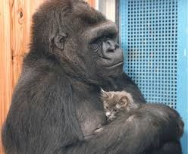
Language
Watch Koko the gorilla learn a new sign
- Many believe language is a distinctly human activity
- Some believe language is innate as children tend to understand grammar rules before being taught (others argue this is learned through prelinguistic observation between parent and child)
- Although some primates can be taught basic sign language they cannot come close to the complexity of meaning humans can communicate
https://www.youtube.com/watch?v=hgWPWEs63DA https://www.youtube.com/watch?v=U64k_fA2Rcc

Language, thought and cognition
Does language reflect our thought, or does our thought reflect our language?
- Thinking often involves a silent internal dialogue • Usually when we think we do so in terms of linguistic categories
(utterances, sentences etc)

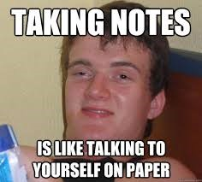
Could language determine what we think?
- Sapir and Whorf (1956) said yes. They called this linguistic relativity and argued different languages may think differently

Language, thought and cognition
It is more likely that language is adapted for the cultural and social context in which it is spoken • Language categories guide our observations in particular ways (Stapel and
Semin, 2007)
- E.G. snow important to Inuit

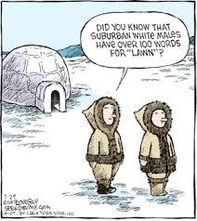
Although the technical meaning of language can be understood through understanding the building blocks, in order to be able to communicate we must also understand cultural rules.
- If I ask you: “Do you think I was born yesterday?” I am not actually asking you a question, but making a statement about myself – that I am not as naïve as you think I am
Language is not just what we say but how we say it, and requires shared context
(pragmatics). As we’ll see in Week 12, it is also influenced by whether a culture is High or Low Context (e.g. how literal language is expected to be.)
9
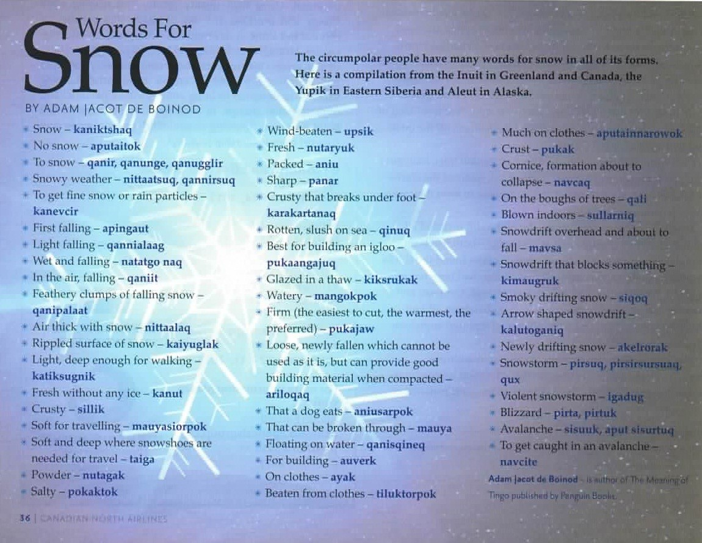

Paralanguage
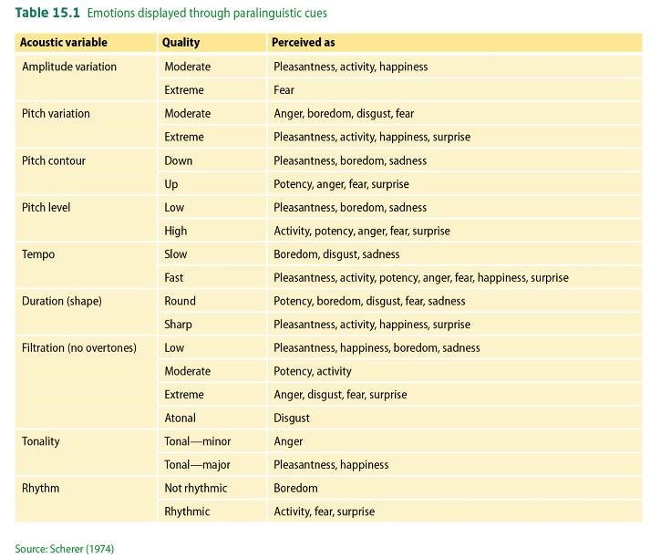
Paralanguage refers to non-linguistic features including:
- Volume
- Stress • Pitch
- Speed
- Tone
- Timing
- Pauses, • Throat Clearing
Paralanguage transforms the meaning of statements, with different features communicating different meanings.
- Grunts
- Sighs

Communication Networks
- Communication networks are a set of rules governing the possibility or ease of communication between different roles in a group.
- Determines who can talk to whom and how easy it is (e.g., can you walk in any time and speak to the CEO or the Dean?)
- Important factor is the number of steps/links to communicate with someone (how many steps to talk to the Dean?)


- Communication networks are on a continuum of more or less centralised
- Simple tasks – more centralised
- Complex tasks – less centralised
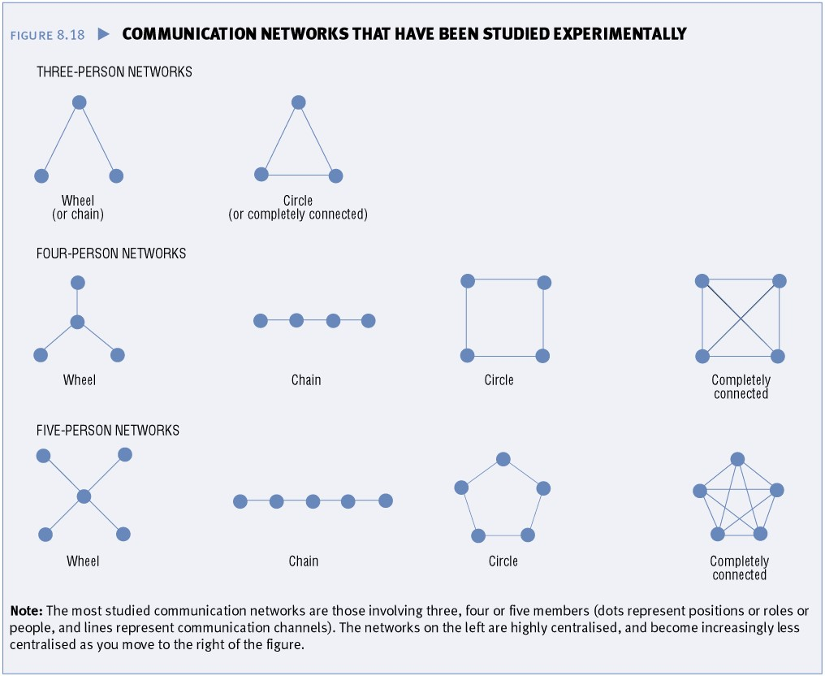

Language and Gender
- Stereotypes in sex/gender differences in speech
- Women assumed to be more talkative, polite, upbeat, less assertaive • Less distinct differences in gendered language than believed
- Gender differences mainly based in culture, gender roles, e.g.:
- Vocal Fry – gendered paralanguistic (and phonemic) feature

https://www.youtube.com/watch?v=UuAQsnAVoMw https://www.stuff.co.nz/life-style/well-good/teach-me/108960412/vocal-fry-epidemic-rising-among-kiwi-women--so-what https://www.economist.com/books-and-arts/2018/10/04/womens-voices-are-judged-more-harshly-than-mens
- More within-sex/gender variablity with paralinguistic features (e.g. higher pitch, different tone) than occurs between men and women
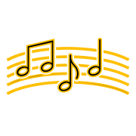
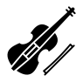 Is music a language?
- Traditionally music and language were treated as different psychological faculties
- Speech functions were thought to be localised in left hemisphere and music on the right-hemisphere of the brain
- But recent studies have shown music and speech functions have many common neutral networks
- “Music is an order of languages, though it is distinct from speech, as each expresses a different type of emotion” (Clark, 1982)
- From a social psychology view, music can be thought of as a common global language, that conveys powerful emotions and connects people from all corners of the world.

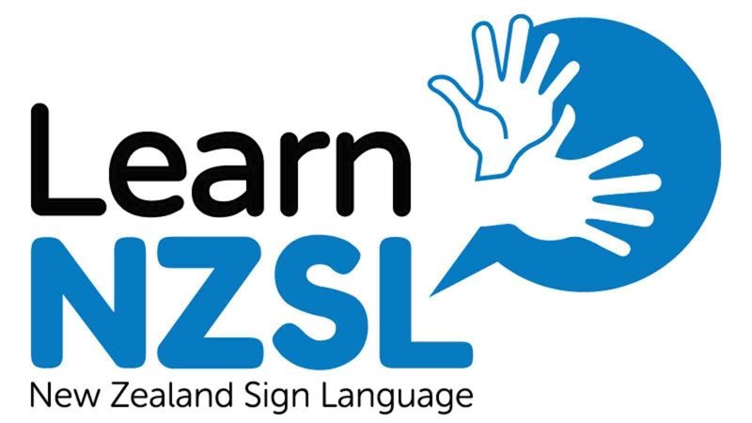
- What about non-verbal languages?
Clark, A. (1982). Is music a language? The Journal of Aesthetics and Art Criticism, 41(2),
195-204. doi:10.2307/430269

Language & Ethnicity
Ethnic groups can differ greatly in:

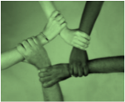
- Appearance, dress, cultural practices and religious beliefs
- Language is often one of the most distinct and clear markers of identity
- The Welsh and English are very distinctive in terms of accent and language (source of self-respect and pride)
- Northern UK accents remained largely unchanged due mostly to low rates of immigration
- Most of the research has been in New World immigrant countries (i.e., USA, Canada, Australia) where the biggest variety of large ethnic minorities live
- Australia has large populations of Vietnamese, Chinese, Italian, Greek speakers
- There are 160 different languages spoken in New Zealand
(https://royalsociety.org.nz/what-we-do/our-expert-advice/all-expert-advice-papers/languages-in-aotearoa-new-zealand/)




The humorous side Learning
https://
www.youtube.com/watch?v=MhCEdIqFCck
Could you match the voice
to the person?
https://youtu.be/EE3x1uS781s?t=53
accents
of Language, Culture

& Accents
Trevor Noah gives a comedic look at accents, and their function
(starts at 2:15)
World's Sexiest Accents | The Daily Show | 2 May 2019 https://www.youtube.com/watch?v=v1UeU7qPs4E
The world loves the Kiwi accent https://www.youtube.com/watch?v=E6ChRXioYzM
IS THERE SUCH AS A THING AS THE ‘GAY’ VOICE?
https://www.youtube.com/watch?v=Lkm0rmigGOw | https://www.youtube.com/watch?v=KpBYnL5fAXE
Adam Hills gives a comedic look at accents https://www.youtube.com/watch?v=SIzGVT1zCIc


“Whanaungatanga more resilient than Māori language in Māori culture” 27 June 2015, MaraeTV The NZ Context - te reo Māori
- During the first quarter century, children spoke Māori at home but, on pain of punishment, only English at school.
- During the second quarter century, many graduates of those schools spoke Māori with adults but not to their children, for whom English became their first language.
- During the third quarter century, monocultural schooling and mass urbanisation produced a generation who had little or no te reo Māori
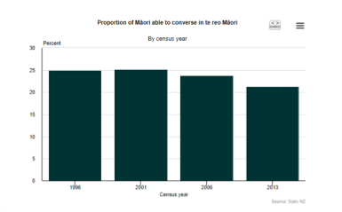
Kupu
is a Spark
-
sponsored app that uses
the camera in your phone to instantly
translate objects into
te
reo M
ā
ori
.
https://nzhistory.govt.nz/culture/m
aori
-
language
-
week/100
-
maori
-
words
100
M
ā
ori words every New Zealander should know
New Zealand’s third official language: SIGN LANGUAGE




New Zealand Sign Language (NZSL; te reo Turi) is unique to New Zealand and since 2006, it has been one of our official languages.
An introduction to NZSL
https
:
//nzsl.tki.org.nz
/
https://www.deaf.org.nz/learn
-
nzsl
/
ASL
It has its own grammar, rules and sentence structure
- It is a daughter language of British Sign Language (BSL), brought to New Zealand by Deaf immigrants from the United Kingdom;
- a sister language of Australian Sign Language (AUSLAN);
- and while it has borrowed some signs from other sign languages, including American Sign Language (ASL), it is not closely related to them
NZSL has its own grammar, rules and sentence structure—different from—but not wholly unlike English. However, NZSL is NOT …

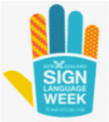

based on English or other spoken languages, therefore, there is not a one-to-one
•
•
•
relationship between English words and NZSL signs It is not just finger spelling
It is not a universal "Deaf" language NZSL Online
Dictionaryhttps://www.nzsl.nz/








- Transfer of meaningful information from one person to another, without using words.
Communication without words
Non
-
verbal communication is
characterised as the:
- This occurs with:
- Interpersonal distance
- Facial expression
- Touch
- Gaze
- Posture
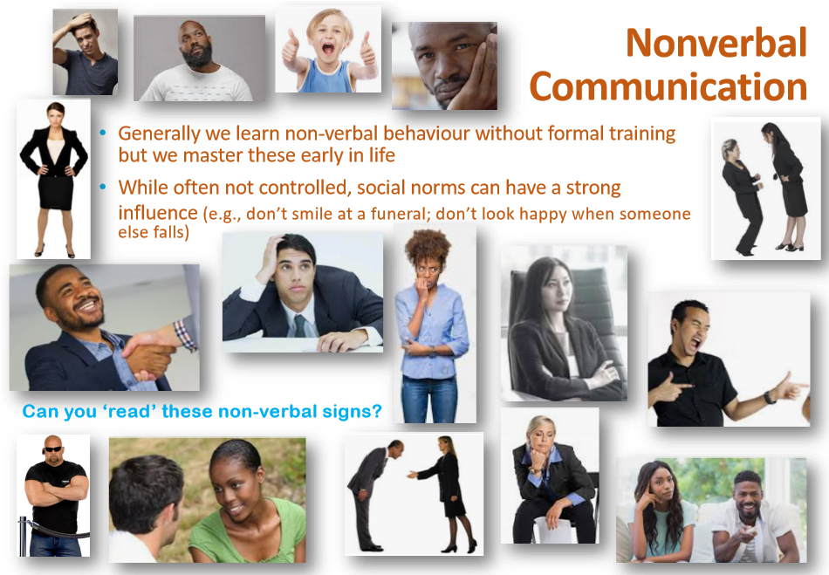

Gaze 
- Gazing is looking at someone’s eyes
- Gaze communicates feelings and status, regulates interaction, and exercises control
- The average ‘gaze’ lasts about three seconds
- We avoid some gaze:
- stranger walking past, or if we don’t want to be drawn into a conversation
- We gaze longer at those we like, and when wanting to be persuasive
- Higher status people generally gaze more than lower status
(visual dominance behaviour)
- Staring can indicate threat, dominance, disapprove
- Gaze is also an important nonverbal indicator of attraction

The importance of seeing one’s eyes
- Poker players bluff by masking their emotions through gestures, eye contact, facial expressions. In this way, the non-verbal messages are meant to confuse opponents.

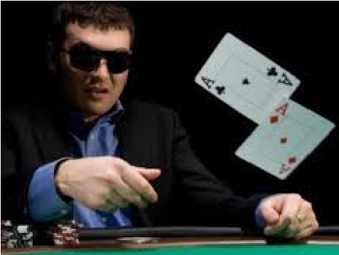
- This also shows how central facial expressions and emotions are to communication—and why we seek out gaze when someone is wearing sunglasses.

Using the face to express emotions
There are six (6) universal emotions (Darwin, 1872).
- Fear • Happiness
- Disgust • Surprise
- Anger • Sadness
- Along with body posture and paralanguage, facial expression tells us a lot about what people are thinking or feeling, their personality and actions.
- Research in this area has focused largely on how we communicate
emotion. • More complex and blended emotions



come from these basic feelings • Even children born blind have • Contempt, embarrassment, pride, the same facial expressions, shame, desire, awe… suggesting that emotional expressions are not taught or learned.
https://greatergood.berkeley.edu/quizzes/ei_quiz
Test yourself. Facial expression quiz
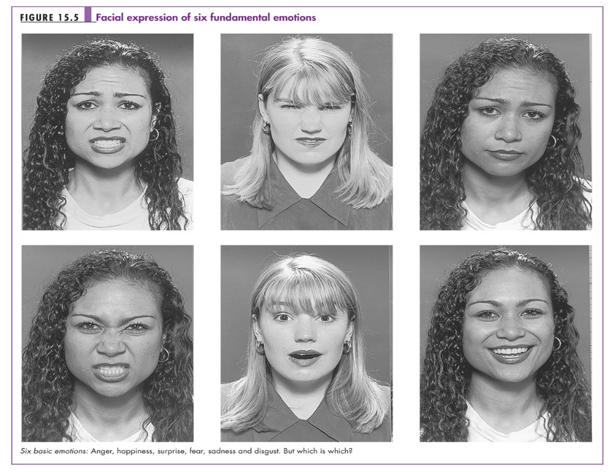

Micro-expressions
- In addition to the 6 universal emotional expressions, we also convey our emotions through micro-expressions
- Involuntary facial expressions, based on internal emotions
- Approximately 20 milliseconds
- There are over 10,000 micro expressions https://www.youtube.com/watch?v=tu1uzG_EBGM

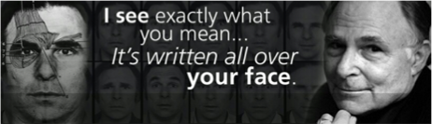
THE 7 MOST COMMON MICRO EXPRESSIONS:
Paul Ekman,
deception detection expert
http://www.paulekman.com/
- ANGER • SURPRISE
- FEAR • SADNESS
- HAPPINESS • DISGUST
- CONTEMPT

Display Rules
- Cultural and situational rules that govern the expression of emotions and dictate the appropriate emotion in the context
- We may even preemptively show an emotion in a conversation when we anticipate what the speaker is going to say
- Most display rules are learned, as we are taught to react with appropriate emotions based on culture, context and gender:
- Expression of emotion:
- encouraged for women (esp. Mediterranean cultures)
- discouraged for men (esp. in Northern European and Asian cultures)
- In Japan, one should control facial expressions of negative emotion; use laughter or smiling to conceal anger
- In West:
- taught its inappropriate to display happiness at beating an opponent in a contest
- tears appropriate at (e.g.) funeral but inappropriate in a business setting, even if hear bad news

Postures and Gestures
In addition to eyes (i.e. gaze), one’s head, hands, legs, torso and feet also communicate. This kind of communication is called: Kinesics: the linguistics of body communication.
- Most body language is culture-specific (e.g.: reference to self; indications of
‘yes’ or ‘no’; bowing; etc.)
- Body language can also indicate status and attraction (e.g.: dominant status=takes up more room; relaxed=leaning backward; attraction=leaning in)
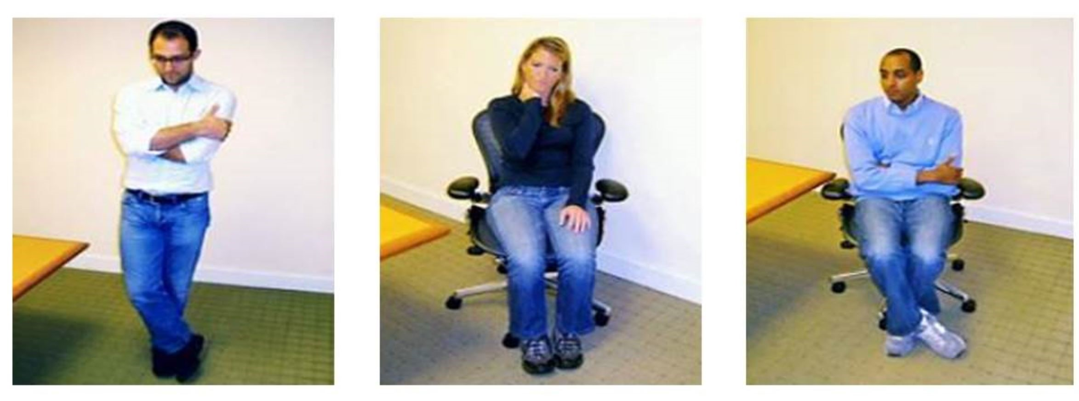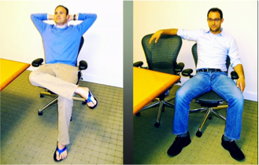
What message do the following postures tell you about the people in the pictures?
Postures - Meaningful positioning of one’s body
parts (e.g.: hands, head, arms, etc.)
Gestures - Meaningful body movements
(e.g.: pointing, nodding, flicking one’s hair, etc.)



Kinesics ^{The nod}
https://youtu.be/0RaBxH_MKQI


Illustrators - Body movements and postures that accompany spoken language
(e.g.: pointing as you give directions)


Emblems - Gestures that replace or stand in for spoken
language (e.g.: waving to say “hi”; using hand to say “come on”)

Touch

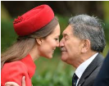



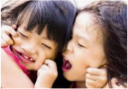


Social touch is one of the earliest forms of communication we learn. Seven discreet forms of touch have been identified:
- Positive affect: communicate appreciation, affection, sexual interest, concern
- Negative affect: pushing an annoying hand away
- Playful: communicate humour and playfulness
- Control: draw attention or induce compliance 5. Ritualistic: to satisfy ritualised requirements such as greetings & departures
- Task-related: to accomplish tasks such as taking a pulse
- Aggressive: slaps, kicks, shoves, punches

Tips in restaurant higher
if touched on hand
More likely to dance if
touched on forearm
when asked

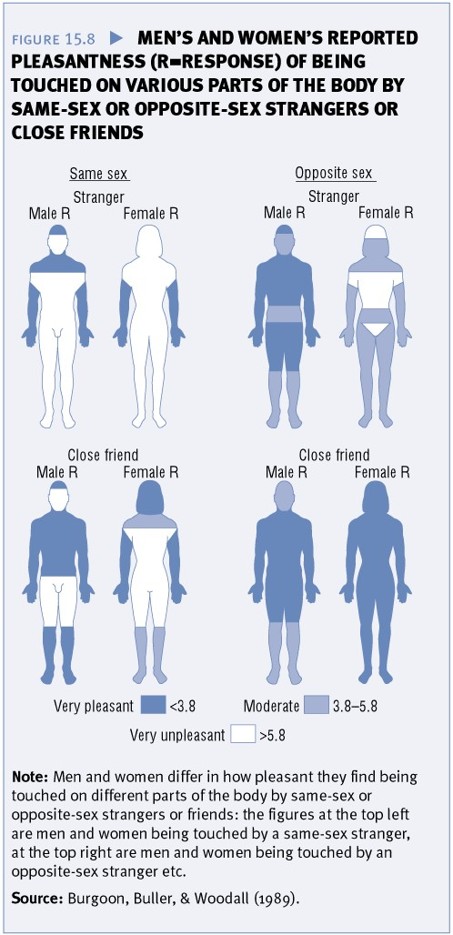

Gender differences in touch
- In general men touch women more often than women touch men.
- People are more likely to touch others of the opposite sex.
Dark blue: very pleasant
Light blue: moderately pleasant
White: very unpleasant
- Women did not like being touched by a stranger of the opposite sex, but men liked it a lot!
- Both find touch on arms moderately to very pleasant.
How close is too close?
We send messages not just through our body language but also by interpersonal distance (called Proxemics)
- Distance regulates privacy and intimacy.
- The greater the distance, the more private you can be
- Being closer means more intimacy messages can be conveyed
Personal space reflects the importance that people place on their perceived body buffer zone. Can indicate:
- Liking: study found when indicating liking, we position chairs closer than when avoiding the appearance of liking
- Status: study on navy found greater distance with higher rank than of those with the same rank
Intimacy-Equilibrium Theory
- Breaches of interpersonal space can be quite stressful
- When intimacy signals are increased in one modality, they are decreased in other modalities


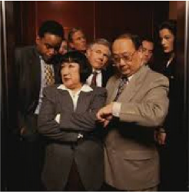
Interpersonal Space
- People are said to have four zones of space:
- Intimate zone
- Personal zone
- Social zone
- Public zone



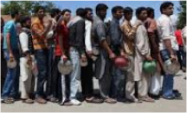
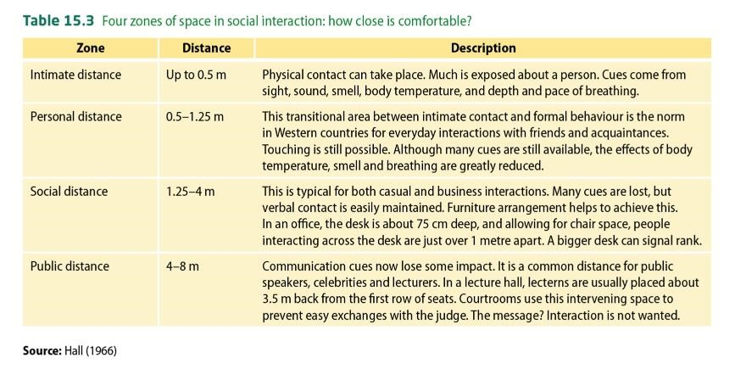
Zones of space are culturally influenced
Next week …
… is our last week!! And the topic will be:

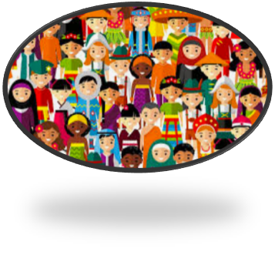Culture

