
Culture
W
EEK
12 (2020)
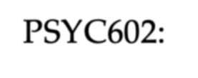
PSYC602: S P
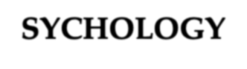
OCIAL
SYCHOLOGY
NORTH LECTURER =
D
R
R
HODA
S
CHERMAN
SOUTH LECTURER =
D
R
S
HIVANTHI
B
ALALLA
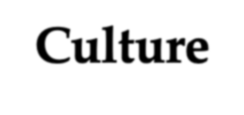
Culture
• Can be defined as the shared values, rules, beliefs, etc. that govern the behaviour of a group of people; can shape the identity and worldviews of people; and enable the members of that group to co-exist and survive
- Actual components/elements of culture are hard to define
- Is relatively stable from one generation to the next but evolves slowly over time (cultural shift). With increased urbanisation and globalisation, the cultural shifts and emergence of fluid cultural identities have increased more steadily, in recent decades.
- Definitions of culture will also vary whether you’re in the
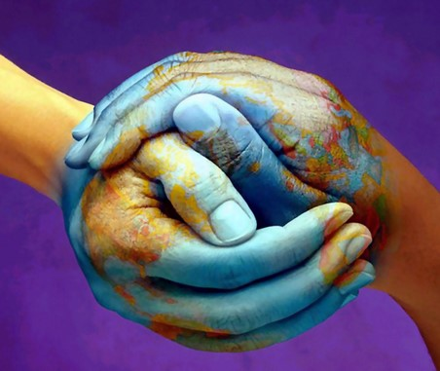
majority group, or ethnic minority group.
Enculturation
:

the process of absorbing and
internalising
the rules of one’s culture
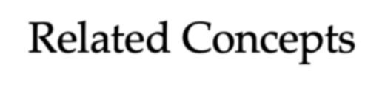
Related Concepts
- Race: group membership on the basis of biology and physical appearance
- Ethnicity: group classifications (by self or others) reflecting membership in, a sense of belonging to, evaluation of, and identification with, that group; whose group is perceived to be different from other groups on the basis of culture, ancestry, nationality, etc.
- Ethnic origins: the ethnic group one was born into; one’s parents’ ethnicity (can be different to the country of birth)

•
Nationality
:
refers to one’s country of citizenship
•
Jus
Sangue
=

law of blood
(
nationality based on who born to):
NZ
•
Jus Soli
=

law of soil
(
nationality based on where you’re born):
USA
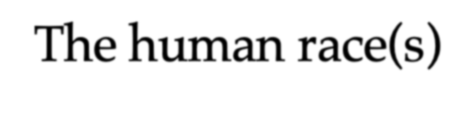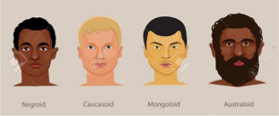Most anthropologists recognize 3 or 4 basic races of man in existence today. These races can be further subdivided into as many as 30 subgroups.
The human race(s)
THREE HUMAN RACES FOUR HUMAN RACES
- Mongolian (northern Mongolian, • Mongoloid (Asian, native Chinese and Indo-Chinese, Japanese American)
and Korean, Tibetan, Malayan, • Caucasoid (European, white)
Polynesian, Maori, Micronesian,
Eskimo, American Indian) • Negroid (east African, black)
- Australoid (native Australian,
- Caucasian (Aryans, Hamites,
Semites) south Asian, Pacific Island)
- Negroid (African, Hottentots,
Melanesians/Papua, “Negrito”, Referent terms like Black, White, Asian, and

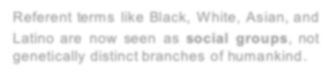

Australian Aborigine, Dravidians, Latinogeneticallyare nowdistinctseenbranchesas socialof humankindgroups, not.
Sinhalese)
“Scientists have reached general agreements in recognizing that mankind is one: that all men belong to the same species, Homo sapiens…that all men are probably derived from the same common stock; and
that such differences as exist between different
groups…are due to evolutionary factors…


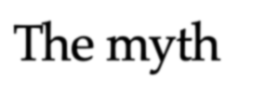
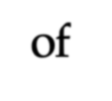
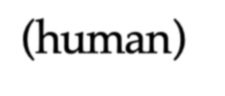
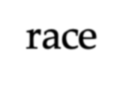
The myth The biological fact of race and the myth of ”race” should be distinguished. For all practical purposes of ”race” is not so much a biological phenomenon as a social myth. The myth ”race ”has created an enormous human) amount of human and social damage. race The biological differences between ethnic groups
(
should be disregarded from the standpoint of social
acceptance and social action. The unity of mankind from both the biological and social viewpoints is the main thing. To recognize this and to act accordingly is the first requirement of modern man” (UNESCO, 1969).
https://unesdoc.unesco.org/ark:/48223/pf0000128291
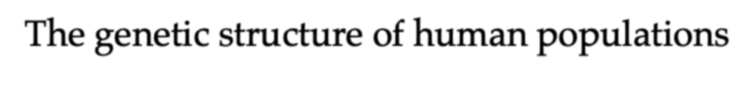
The genetic structure of human populations
 | “If separate racial…groups actually existed, we would expect to find “trademark” alleles…that are characteristic of a single group but not present in any others. However, [Rosenberg et al, 2002] found that only 7.4% of over 4000 alleles were specific to one geographical region. Even when region-specific alleles did appear, they only occurred in about  1% of the people from that region— hardly enough to be any kind of | “We identified six main genetic clusters, five of which correspond to major geographic regions, and subclusters that often correspond to individual populations.” (Rosenberg et al, 2002)  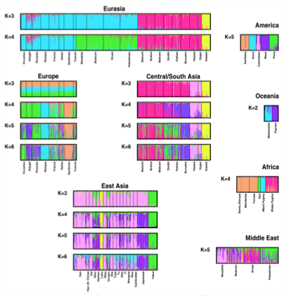
 | trademark. Thus, there is no evidence that the groups we commonly call “races” have distinct, unifying genetic identities.”  Chou, V. (2017)  http://sitn.hms.harvard.edu/flash/2017/science-geneticsreshaping-race-debate-21st-century/ | Rosenberg et al., 2002:  http://ww  w  -  leland.stanford.edu/~huatang/gene244/read  ings/Science%202002%20Rosenberg.pdf
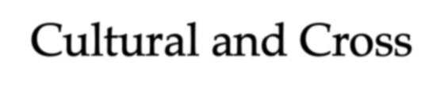

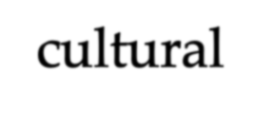
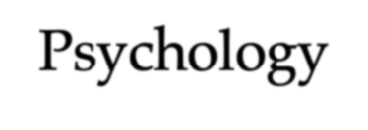
Cultural and Cross-cultural
Psychology
Cultural Psychologists:
study the ways in Cross-cultural Psychologists: compare the similarities and which people are differences in behaviour affected by the
culture they live in across different societies or
(individual ^{cultures}
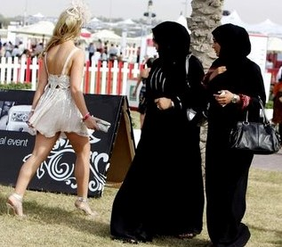
psychological
processes are shaped
by cultural context)
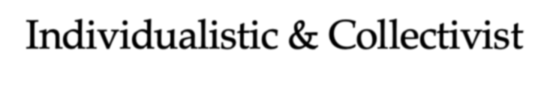


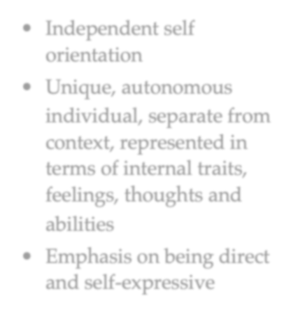

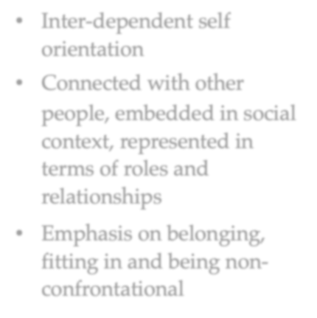
Individualistic & Collectivist Worldviews
Individualistic cultures Collectivistic cultures
(Western) (Eastern)

- Independent self orientation
- Unique, autonomous
individual, separate from context, represented in terms of internal traits, feelings, thoughts and abilities

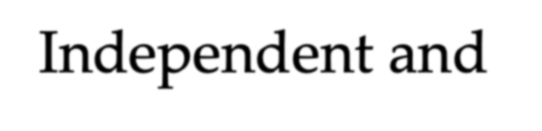
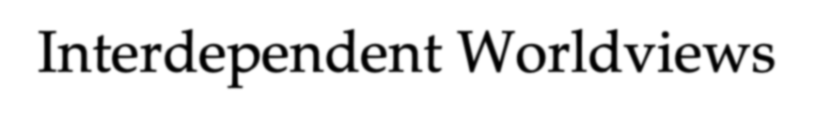

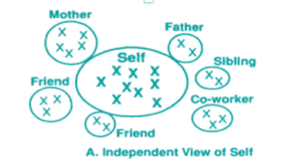

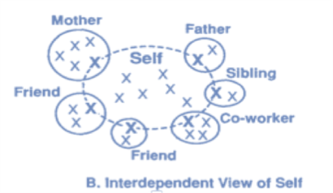
- Emphasis on being direct and self-expressive
Independent and
Interdependent Worldviews
- Inter-dependent self
orientation
- Connected with other people, embedded in social context, represented in terms of roles and relationships
- Emphasis on belonging, fitting in and being nonconfrontational

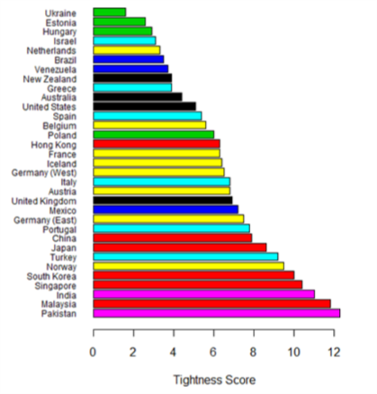deviance
The Dimensions of Culture
The extent to which people
are required to adhere to
cultural norms
•
Loose
:
highly permissive with
weak social norms
•
Tight
:

little tolerance for
Tight versus Loose
Cultures:
https://core.ac.uk/download/pdf/216381144.pdf
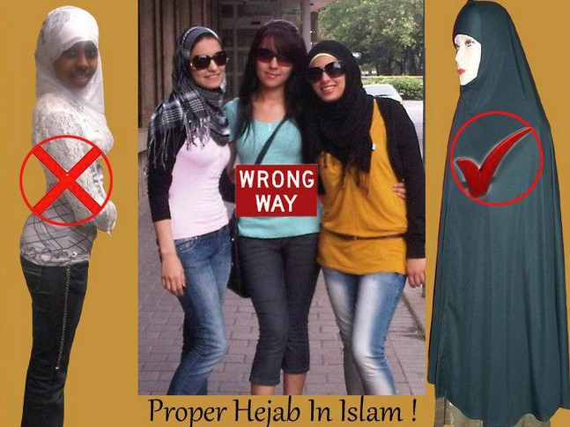
Gelfand et al.(2011). Differences between tight and loose cultures: A 33
-
nation study
[
Electronic version]. Retrieved from Cornell University, ILR School site:
h
ttps://digitalco
mmons.ilr.cornell.edu/articles/1287
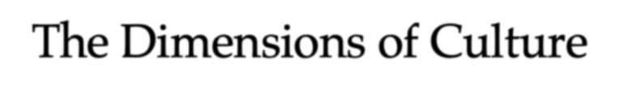
The Dimensions of Culture
Cultural Display Rules
- cultural norms learned early in life that govern the regulation of expressive behaviors depending on social contexts

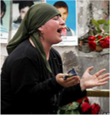
- specify the appropriateness of displaying certain emotions in particular social settings
Irish woman keening
  - differences in display rules are typically greater for negative emotions than for positive ones
  - across emotions, stronger display rules are found in Eastern rather than Western cultures
Interpersonal Space
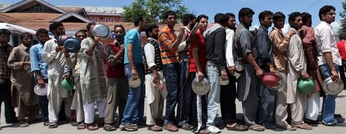
•
Intimate Space
•
Social and Consultative
Space
•
Public Space

The Dimensions of Culture
Context High Context cultures:
Low Context cultures: pay close attention to nonverbal interpret actions and words literally, messages and contextual cues to
so no need to rely on context or ^{decode the meaning behind} nonverbal cues words or actions
- Western cultures like the UK, USA, • Eastern cultures like Japan, and Australia. ??New Zealand?? China, France, Spain, Brazil, and
others • More diverse with many differences,
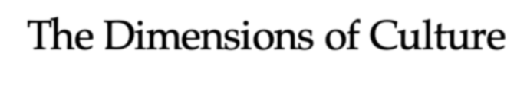


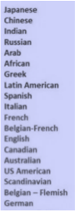


so communication must be basic • Are more homogeneous so enough to allow for as many people ^{similarity is an important} to understand it as possible ^{characteristic}
- More interpersonal connections of • Value long-term relationships
- Can be difficult to enter if you
shorter duration


• Relatively easy to enter if you are ^{are an outsider (because you} an outsider (because the ^{don't carry the context} environment contains much of the information internally, and you information you need to participate ^{can't instantly create close} relationships).
VIDEO: What Is The Difference Between a High-Context and Low-Context Culture?
https://www.youtube.com/watch?v=qKViQSnW-UA
The Dimensions of Culture
Chronemics
Polychronic People
Monochronic People
- do many things at once
- do one thing at a time • are highly distractible and • concentrate on the job subject to interruptions
- take time commitments • consider an objective to be
(deadlines, schedules) achieved, if possible
seriously • are high-context and already





- are low-context and need have information information • are committed to people and • committed to the job human relationships
- adhere strongly to plans • change plans often and easily
Other Cross-cultural Relations
Pluralism: general
acceptance of the



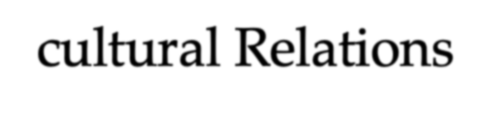
existence of many Fusion: combining cultures and ethnic two cultures to form a
groups and their right to new culture
retain their cultural heritage while co-existing
- emphasise promptness • base promptness on relationships

Multiculturalism
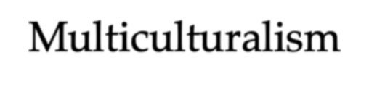

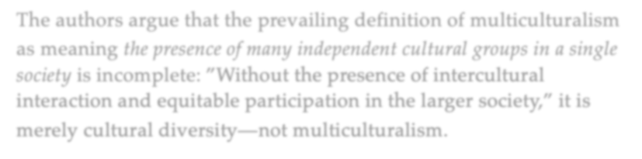
According to Berry and Sam (2013), multiculturalism as a concept has “two main and equally important emphases – the maintenance of heritage cultures and identities (the cultural diversity component) and the full and equitable participation of all ethnocultural groups in the life of the larger society (the social equity and inclusion component). Together, and in balance with each other, it should be possible to achieve a multicultural vision.”
The authors argue that the prevailing definition of multiculturalism as meaning the presence of many independent cultural groups in a single society is incomplete: ”Without the presence of intercultural interaction and equitable participation in the larger society,” it is merely cultural diversity—not multiculturalism.
Berry, J. W., & Sam, D. L. (2013). Accommodating cultural diversity and achieving equity. European
Psychologist, 18(3):151–157. doi: 10.1027/1016-9040/a000167
Acculturation
Changes that individuals undergo when they come into contact with another culture
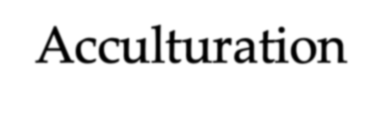
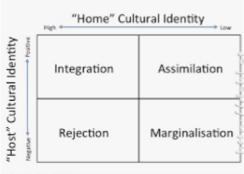
According to Berry, outcomes include: Integration:
- strongly identifies with both the Assimilation: traditional and mainstream cultures
simultaneously; • greater identification with the
mainstream culture, relative to the • individuals maintain cultural identity while becoming active ^{traditional culture;}
participants in host culture • individuals give up their cultural
identity and become absorbed in
Separation/Rejection: host culture
- greater identification with the
traditional culture, relative to the Marginalisation:
mainstream culture; • when one’s identification with
• individuals maintain cultural both cultures is weak; identity and reject involvement in
host culture • individuals do not participate in either host or home culture
Berry, J. W. (1994). Acculturative stress. In W. J. Lonner & R. S. Malpass (Eds.), Psychology and Culture (pp. 211-215). Boston: Allyn & Bacon.
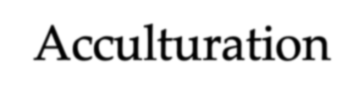
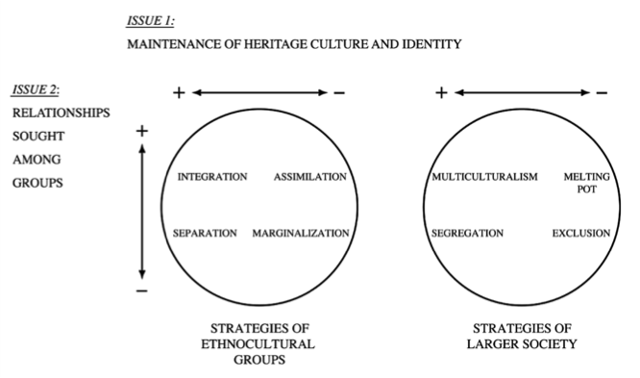
Acculturation
Berry, J. W., & Sam, D. L. (2013). Accommodating cultural diversity and achieving equity.
European
Psychologist
,
18
(3):151
–
.
157
doi
: 10.1027/1016
-
9040/a000167
Intercultural orientations in ethnocultural groups and in the larger society
Issue 1
Issue 2
VIDEO: Prof John Berry discusses cross
-
cultural psychology
ube.com/watch?v=XAm0iqkZCKI
https://www.yout
Acculturation was initially explored only from the point of view of the nondominant cultural
groups (e.g. immigrants, visitors). But Berry realised that the dominant group (host culture)
also plays a role
that can influence the way nondominant groups relate.
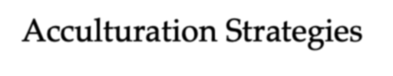
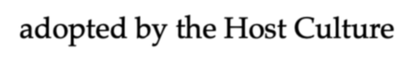
Acculturation Strategies adopted by the Host Culture
In addition to the individual acculturation outcomes for people upon arriving into a new culture (previous slide), Berry (2001) developed a framework of possible acculturation strategies emphasised by the host culture.
Multiculturalism: Segregation:
- The society values and fosters • The society forces separation diversity
Exclusion:
Melting Pot: • The society imposes
- The society seeks assimilation marginalisation
As shown on the next slide, this model considers the relative
preferences for (a) maintaining heritage culture and identity on the part of its immigrant populations, and (b) having contact with and participating in the larger society along with other cultural groups.
Berry, J. W. (2001). A psychology of immigration. Journal of Social Issues, 57, 615-631.
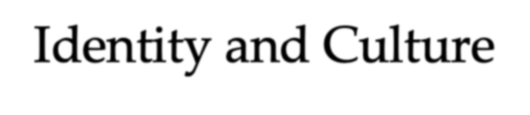
Identity and Culture
- Ethnic Identity: Members of an ethnic group identify
us and them in relation to aspects of shared culture,
language or religion (also referred to as cultural identity or ethnicity)
- Bicultural Identity: Holding two or more ethnic identities. One can even have multiple worldviews:
  - Collectivist identity = related to social identities
  - Individualist identity = related to personal identities
• Identity Denial: When people are not recognised as members of the groups that they identify with
?? Can you think of any contexts where this might happen ??

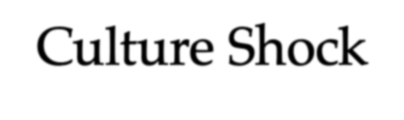
Culture Shock
A feeling of disorientation and anxiety that occurs as people from one culture encounter and adapt to the practices, rules and expectations of another culture. There are four recognised phases:


- THEHONEYMOONPHASE: The euphoric phase that can last several weeks or more. Everything is new and exciting, and travelers are infatuated with the language, people, etc.
- THEDISENCHANTMENTPHASE: This is the most difficult stage,
when the traveler starts to miss friends and family back home, and is increasingly confused or challenged by the cultural differences.
- THEBEGINNINGRESOLUTIONPHASE: Routines are established, and the traveler becomes more familiar with the local way of life; challenges become easier to manage.
- THEEFFECTIVEFUNCTIONINGSTAGE: Sometimes called the
bicultural stage, the traveler now feels comfortable in the new country and better integrated.

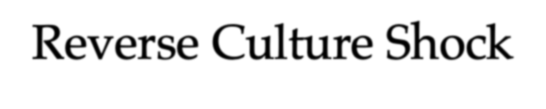
Reverse Culture Shock


It often comes as a surprise that upon returning home after a period of studying abroad, international students often experience reverse culture shock
• Also called Repatriation Distress, this relates to
– New values or ideals that conflict with former ones embedded in the home country
–
Changes in the student that conflict with
previous perceptions held by family/friends
–
Termination of friendships made while
abroad
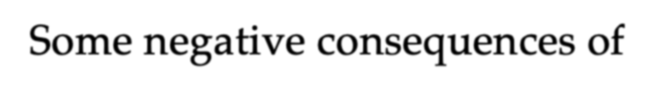
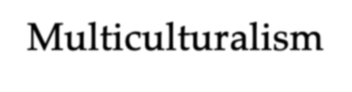
Some negative consequences of Multiculturalism
Racism: Xenophobia:

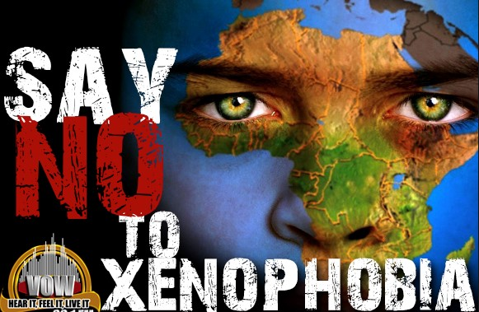
Pervasive and systematic The fear or hatred of assumption of inferiority and foreigners, or anything the unfair and differential foreign or unfamiliar treatment of others based on this assumption of inferiority
Discrimination:
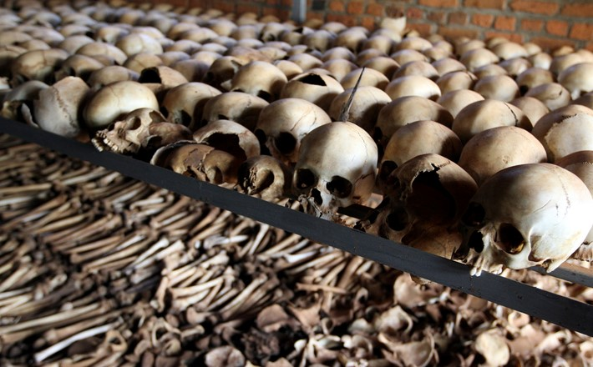
Behavioural
manifestation of
prejudiced attitudes
–
Genocide
:

The ultimate form of racial
discrimination
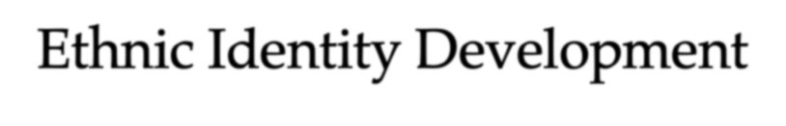
Ethnic Identity Development
How one acquires the “group patterns” associated with one’s ethnic group

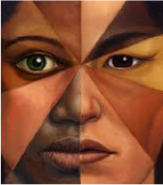
“That part of an individual’s self-concept which derives from his knowledge of his membership of a social group (or groups) together with the value and emotional significance attached to that membership”

(
Phinney, 1990, p. 500)
https://www.facs.nsw.gov.au/__data/assets/pdf_file/0004/536755/MEI
M
-
qu
estionnaire
-
Authors
-
summary.pdf
Phinney
(1990)
Multi Ethnic Identity Measure
A short survey
measuring your
identification with a
chosen ethnic group

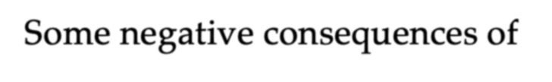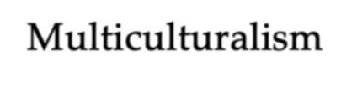Prejudice
Some negative consequences of
Multiculturalism
Ethnocentrism
Tendency for a person
’
s own
culture to influence the way they
view the rest of the world
An unreasonable and negative

stereotype about members of
another group; negative pre
-
judgment based on group
membership
‘Yesterday I was African, today I am lost’,
New Zealand student Takunda Muzondiwa delivers her poem about racism.
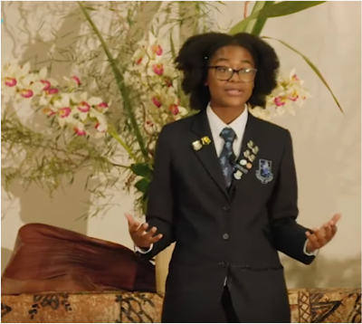
https://www.youtube.com
/watch?v=
23
lMjIeRU6Y
Race Unity Speech Awards 2019
-
Takunda
Muzondiwa
from
Mount Albert Grammar
School

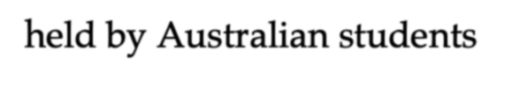
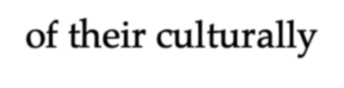

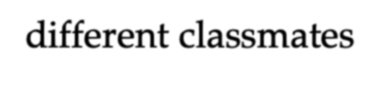
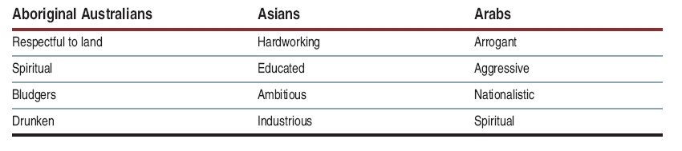

Common stereotypes
held by Australian students
of their culturally
-
different classmates

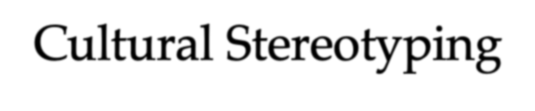
Cultural Stereotyping
Generalised views that we hold about particular While cultural stereotypes groups of people, that all involve a mixture of positive members of a cultural and negative attributes, they
group share common traits lead to three distortions in or behaviours thinking:
- Accentuation of group differences
(us versus them)
- Creation of selective thinking
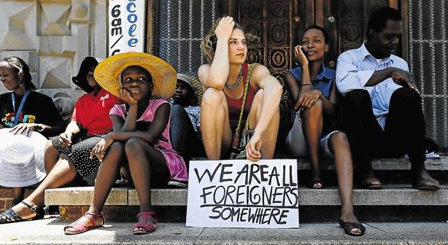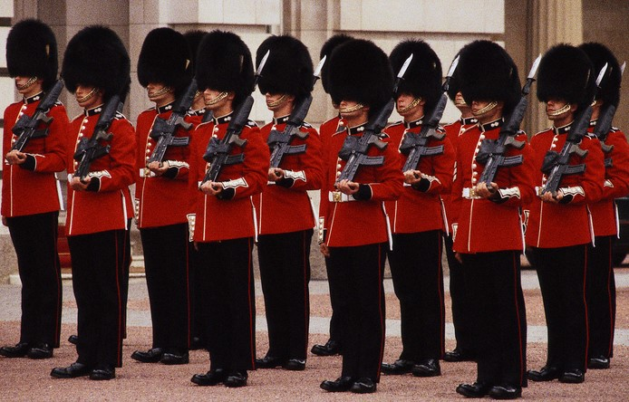
3.
Assumption of homogeneity in
other groups
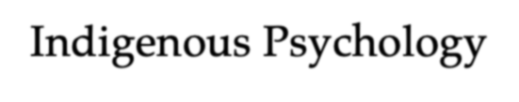
Indigenous Psychology
- “The scientific study of human behavior or mind that is native, that is not transported from other regions, and that is designed for its people.” (Kim & Berry, 1993).

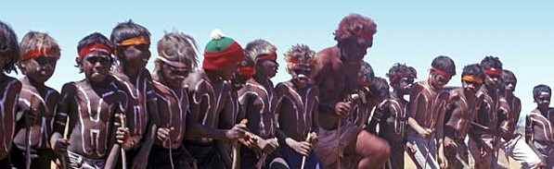
- Around the world, indigenous cultures are asserting and demanding the acknowledgement of their own psychologies.
- INDIGENOUS PSYCHOLOGIES:
  - are characterised by a critical challenge to the dominance of American psychological knowledge, and by indigenous peoples' demands for a voice in decisions that impact on their futures
  - recognise that people have complex and highly developed
understandings of themselves
- understand there is more than one approach to understanding the social world
- report that indigenous peoples are resilient and adaptive
Kim, U., & Berry, J. W. (1993). Indigenous psychologies: Experience and research in cultural context. Newbury Park, CA: Sage. http://indigenouspsych.org/Resources/Indigenous%20and%20Cultural%20Psychology%20-%20Understanding%20People%20in%20Context.pdf
Meta-stereotypes of Pākehā, Māori, Pacific Nations, and Asian New Zealanders 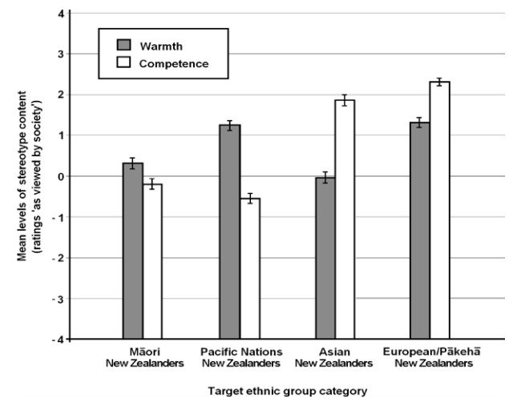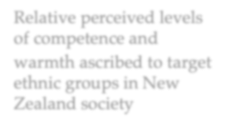using a national random postal sample (N = 246)
Note: A rating of
-
4

represented
‘not at all
descriptive’
, a rating of 0
represented
‘somewhat
descriptive
’ and a rating
of 4 represented
‘extremely descriptive’
of
the target ethnic group.
Relative perceived levels
of competence and
warmth ascribed to target
ethnic groups in New
Zealand society
Error bars represent the
standard error of the
mean.
Sibley, C., et al. (2011).
New Zealand Journal of Psychology
,
40
(2)
, p.
25
-
35
https://www.psychology.org.nz/j
ournal
-
archive/NZJP
-
Sibley.pdf

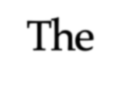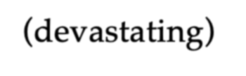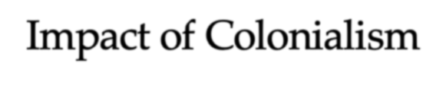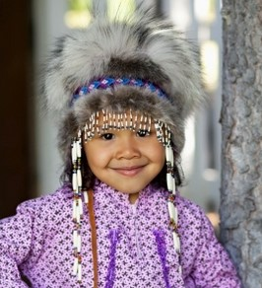
The
(
devastating)
Impact of Colonialism
Colonialisation has had a major and persistent impact on indigenous cultures around the world:
• In NZ, we see inequalities between Māori and Pakeha
- Lower levels of education, employment and income
- Lower health status for children and adults
- Higher rates of mental health difficulties and substance abuse
- Higher exposure to offending and criminality
• In Alaska, comparing native (minority) with white (majority)
- Similar disparities in health and education
- Higher rates of substance abuse
- Higher rates of childhood mortality
Ethnicity, national identity and ‘New Zealanders’ (2010)
https://www.otago.ac.nz/wellington/otago600094.pdf
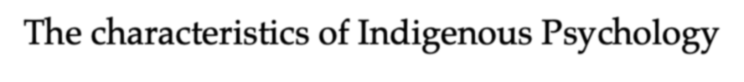
The characteristics of Indigenous Psychology
- It emphasises examining • It is part of a scientific tradition that psychological phenomena in advocates multiple perspectives, but not
ecological, historical and cultural multiple psychologies or absolute context. relativism.
- It needs to be developed for all • Although descriptive analysis is the cultural, native and ethnic groups. starting point of research, its final goal is
- It advocates use of multiple methods, to discover psychological universals and the integration of "insiders”, that can be theoretically and empirically
"outsiders" and multiple perspectives ^{verified.}
to obtain comprehensive and • It is a part of the cultural sciences integrated understanding. tradition in which human agency,
- It acknowledges that people have a meaning and context are incorporated complex and sophisticated into the research design.
understanding of themselves and it is • It advocates a linkage of humanities necessary to translate their practical (which focus on human experience and
and episodic understanding into creativity) with social sciences (which analytical knowledge. focus empirical analysis and
verification).
Kim, U., Yang, K. S., & Hwang, K. K. (2006). Contributions to indigenous and cultural psychology. In U. Kim, K. S. Yang, & K. K. Hwang (Eds.), Indigenous und cultural psychology: Understanding people in context (pp. 3–25). New York: Springer.
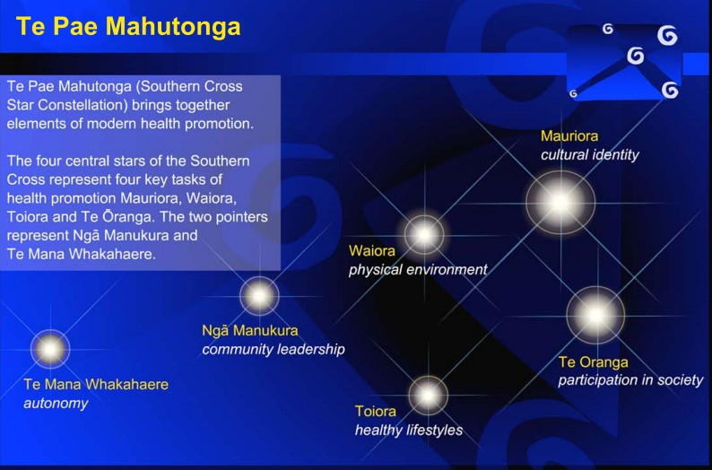


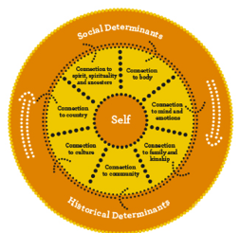
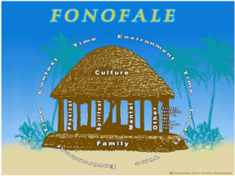
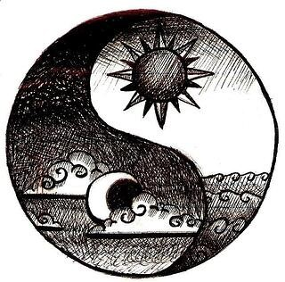
M
ā
ori models:
•
Te
Pae
Mahutonga
•
Te
Whare Tapa
Wh
ā
•
Te
Wheke
•
Kaupapa M
ā
ori research
Australia
-
Indigeneous
social and
emotional wellbeing
Other models:
•
African
–
Ubuntu
•
Filipino
–
Pakikipagkawa
•
Mexican
–
Popol
Vuh
•
Chinese
–
Yin
-
Yang
Pasifika
-
Fonofale
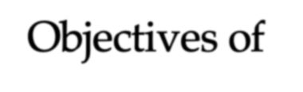
Objectives of
Indigenous Psychologies
… to develop psychologies that are not imposed or imported; which are influenced by the cultural contexts in which people live; are developed from within the culture using a variety of methods; and that result in locally relevant psychological knowledge.
(Nikora, Levy, Masters & Waitoki, 2004)
https://researchcommons.waikato.ac.nz/bitstream/
handle/10289/918/?sequence=1
https://www.psychologytoday.com/nz/blog/mora
l
-
landscapes/201910/in
digenous
-
psychologies
-
around
-
the
-
world
Developing cultural competence in psychology …
- …is the gold-standard of best practice
- requires culturally-focused and explicit learning and training about
  - how others view themselves and their world
Your feedback is gratefully requested
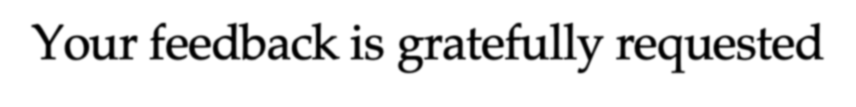
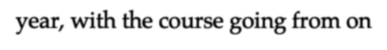

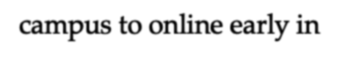
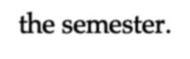
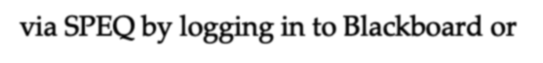
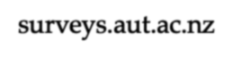

We as lecturers and paper leaders really appreciate the feedback students provide using SPEQ. It helps us understand what you think is working well and where we can improve. Your responses help us to provide the best learning and teaching environment to you and future students. This is especially so this year, with the course going from on-campus to online early in the semester.
I ask you to please take a few minutes now to provide feedback via SPEQ by logging in to Blackboard or surveys.aut.ac.nz. Please use the open-ended question to comment on the COVID-

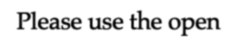

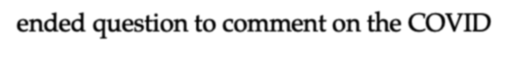
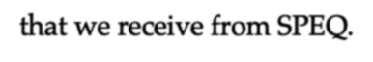
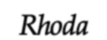
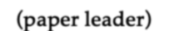
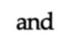
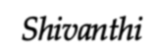
19 related changes to the paper. Once you login, your SPEQs should be available at the top of the page. All of your feedback is made confidential and you cannot be identified in the reports that we receive from SPEQ.
Rhoda (paper leader) and Shivanthi
  - what is meaningful and relevant to others
- brings many advantages to the field of psychology, and those we work with
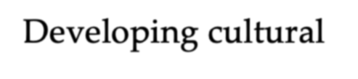
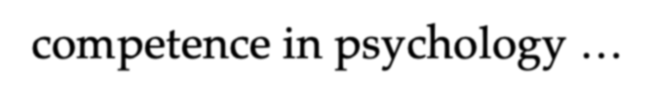

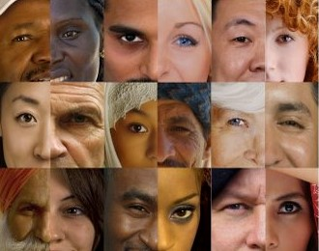

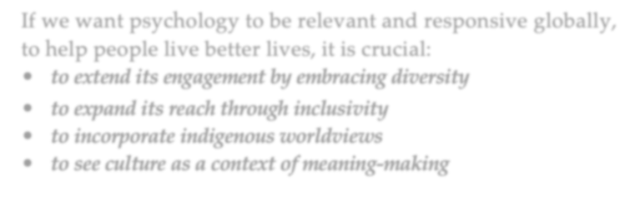
If we want psychology to be relevant and responsive globally, to help people live better lives, it is crucial: • to extend its engagement by embracing diversity
- to expand its reach through inclusivity
- to incorporate indigenous worldviews
- to see culture as a context of meaning-making
This brings us to the end of
Social Psychology
Shivanthi and Rhoda hope that through this course, you have gained a better understanding of not only other people and groups, but also of yourselves as a social beings.
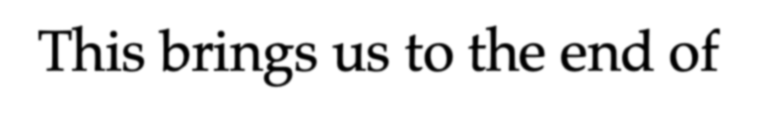
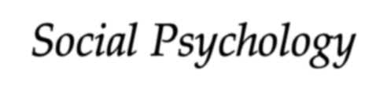
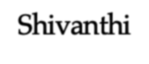
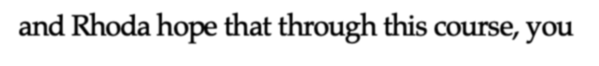
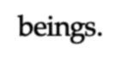
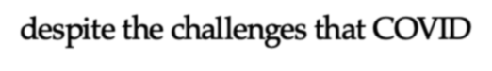

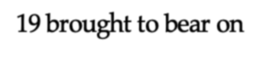
We also hope that you have managed to enjoy the course, despite the challenges that COVID-19 brought to bear on the class. Providing us with some feedback (see next page) will help tremendously as we go forward into what might
be a new normal in higher education.

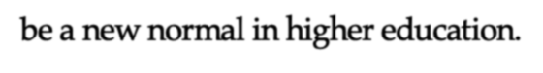
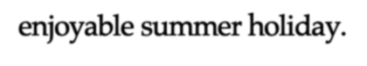

We wish you all the best as you complete your final assessments, and hope you have a replenishing and enjoyable summer holiday.

