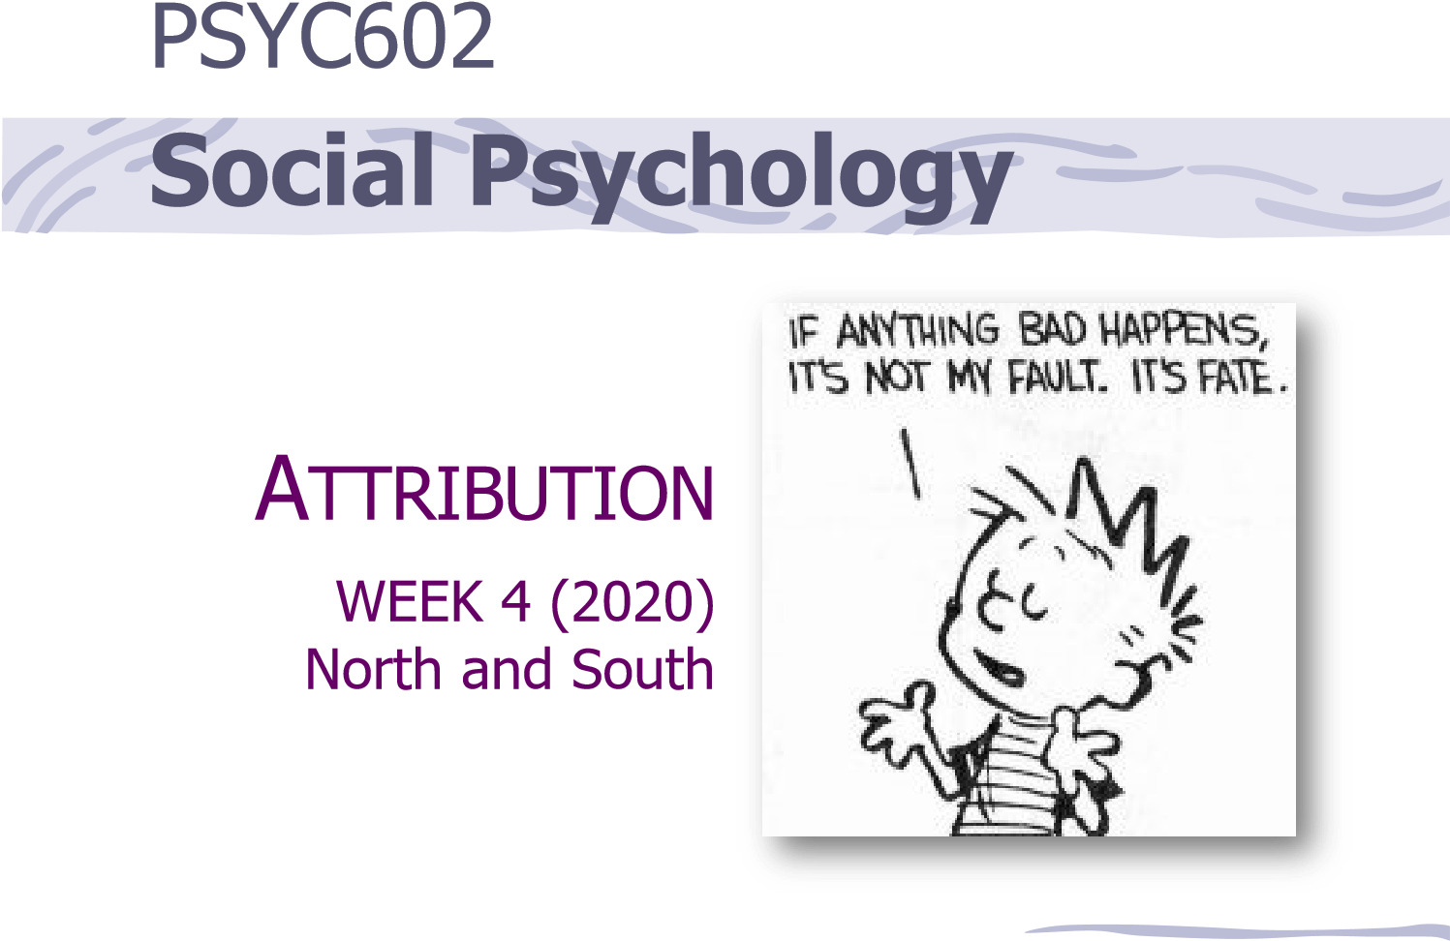

How do we attribute causality and why is it important?
Thinking about your experiences...

Think of a very positive life experience you have had. This can be personal, social, academic, or work related.
- Think about the experience
- What was the outcome?
- The reason this happened was because…
Think of the a very negative life experience you have ever had. This can be personal, social, academic, or work related.
- Think about the experience
- What was the outcome?
- The reason this happened was because…

Why did I fail the test?

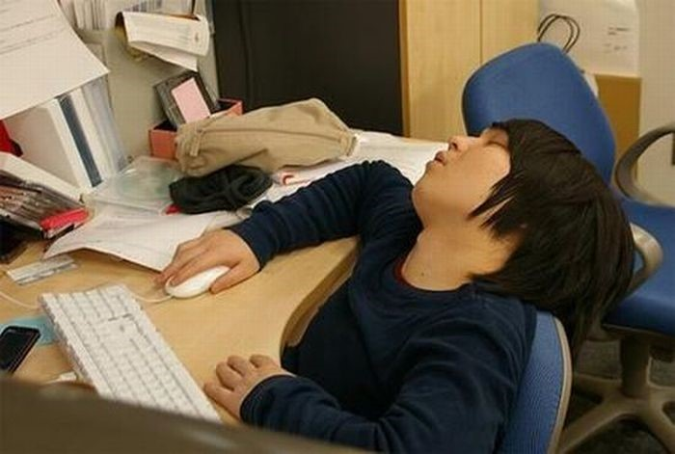
  - I tried and failed because I’m not smart enough
  - The test was too hard
  - The room was too distracting
  - I didn’t study hard enough but next time I will and then I will pass
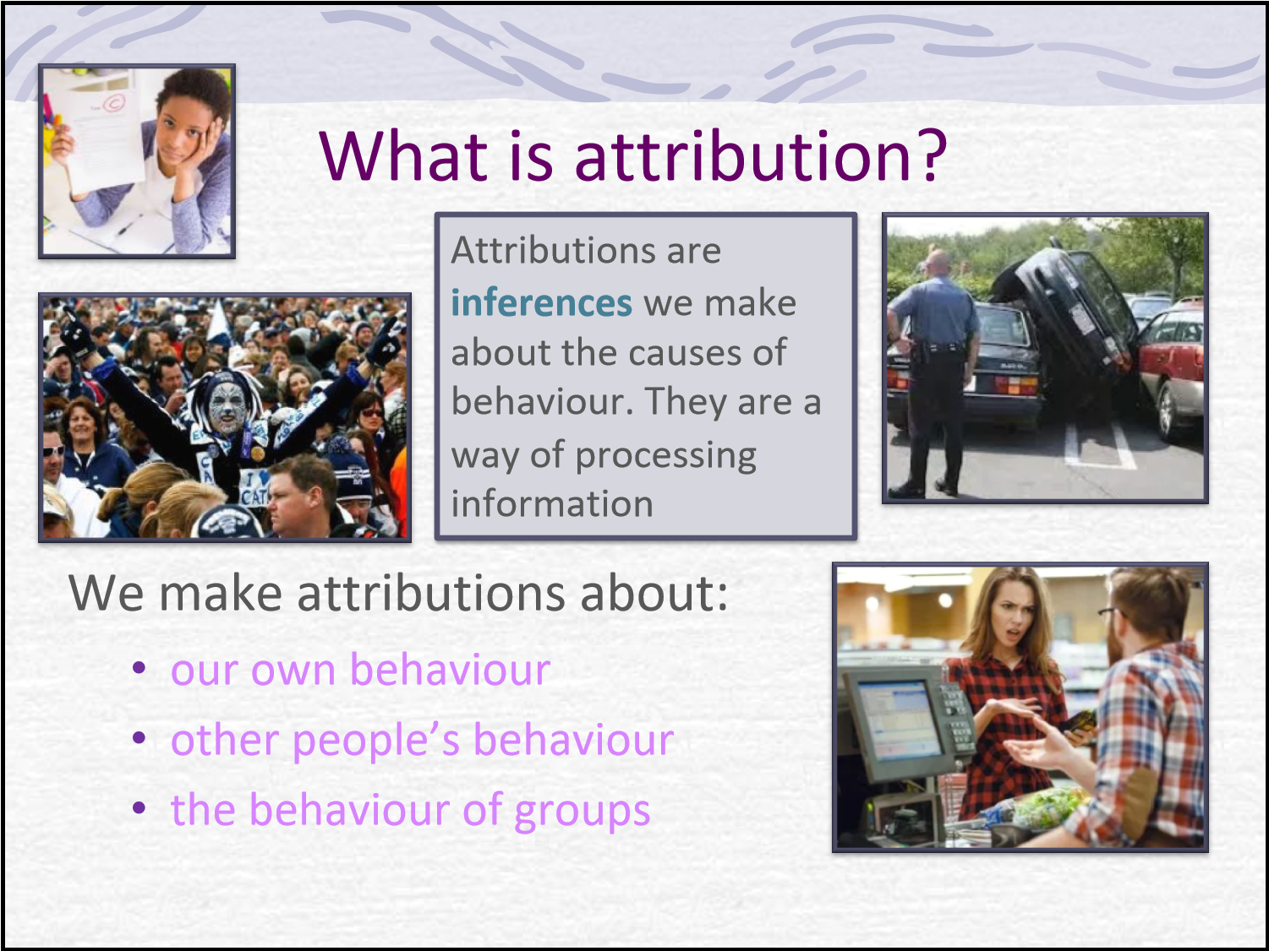

Attributional Dimensions
There are several attributional dimensions of task achievement
Locus of causality: was the performance caused by the actor (internal) or the situation (external)?
Involves Ability (ability to perform the task) and Motivation
(intentions and degree of effort)
Stability: was the cause stable or changeable over time?
Degree of permanence or consistency over time Controllability: to what extent is future task performance under the actor’s control?
Factors like skill and competence are classified as controllable
Luck and mood are classified as uncontrollable
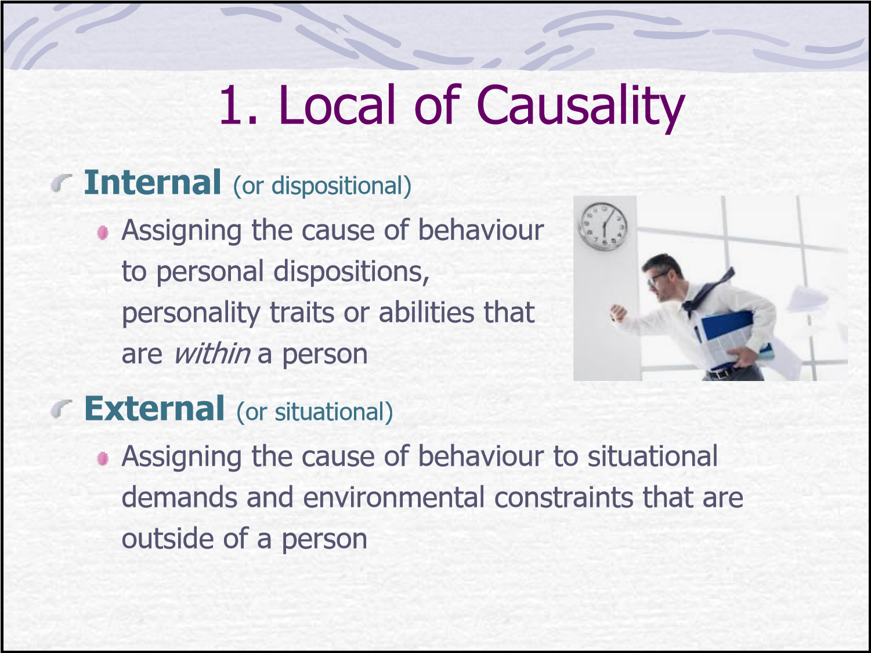

Stability or Permanence
Consistency over time  Is the cause stable or changeable over time? Is it typical? | Rate the following as more stable or unstable 1. I always fail  - It was just a bad day  - I am not smart enough  - The subject is too hard  - I can’t do all of the work that is required ever!
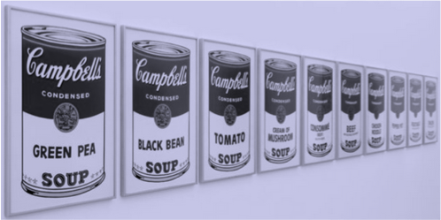
- I will have to study more next time
- I am unlucky
- I studied the wrong material
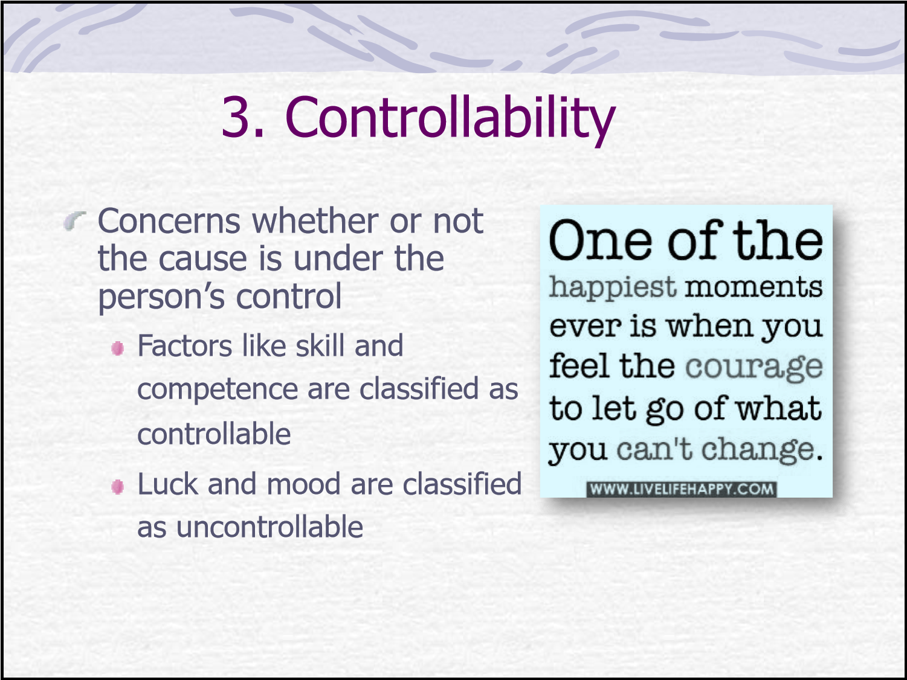
Possible causes of success or failure, classified according to locus, stability and controllability
  INTERNAL
  STABLE UNSTABLE
  EXTERNAL
  STABLE UNSTABLE
Typical effort |  | Unusual effort
Consistent help Unusual
CONTROLLABLEor hindrance help/hindrance
from others from others

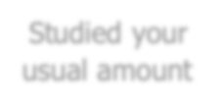



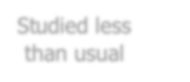



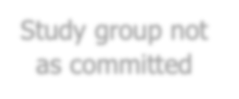


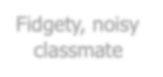

Studied your Studied less Study group not Fidgety, noisy usual amount than usual as committed classmate
Ability |  | Mood
UNCONTROLLABLETask difficulty Luck
Luck

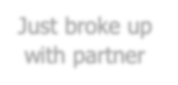


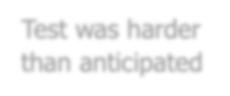



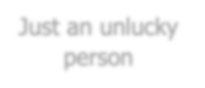

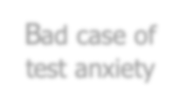

Bad case of Just broke up Test was harder Just an unlucky test anxiety with partner than anticipated person
(Weiner, 1979)
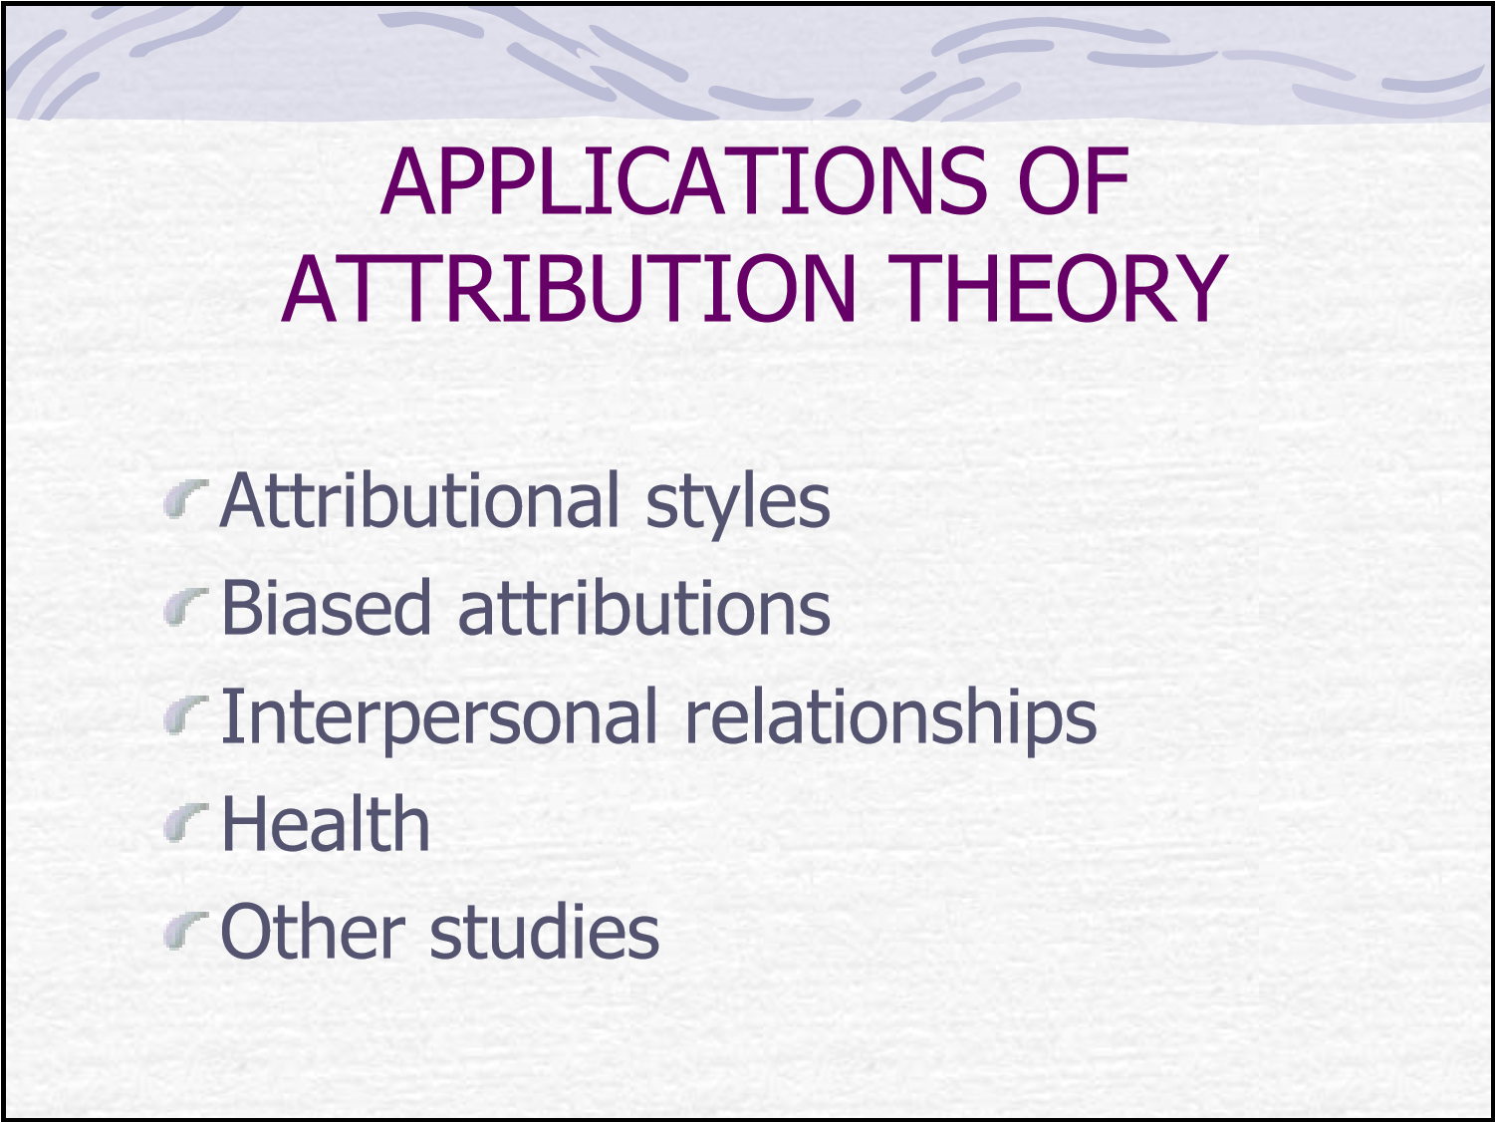

Attributional Styles
An individual predisposition to make a certain type of causal attribution for behaviour (personality trait)
Internals –
believe they have an enormous amount of personal control over their destiny
Externals –
are more fatalistic and believe they have little control over what happens to them
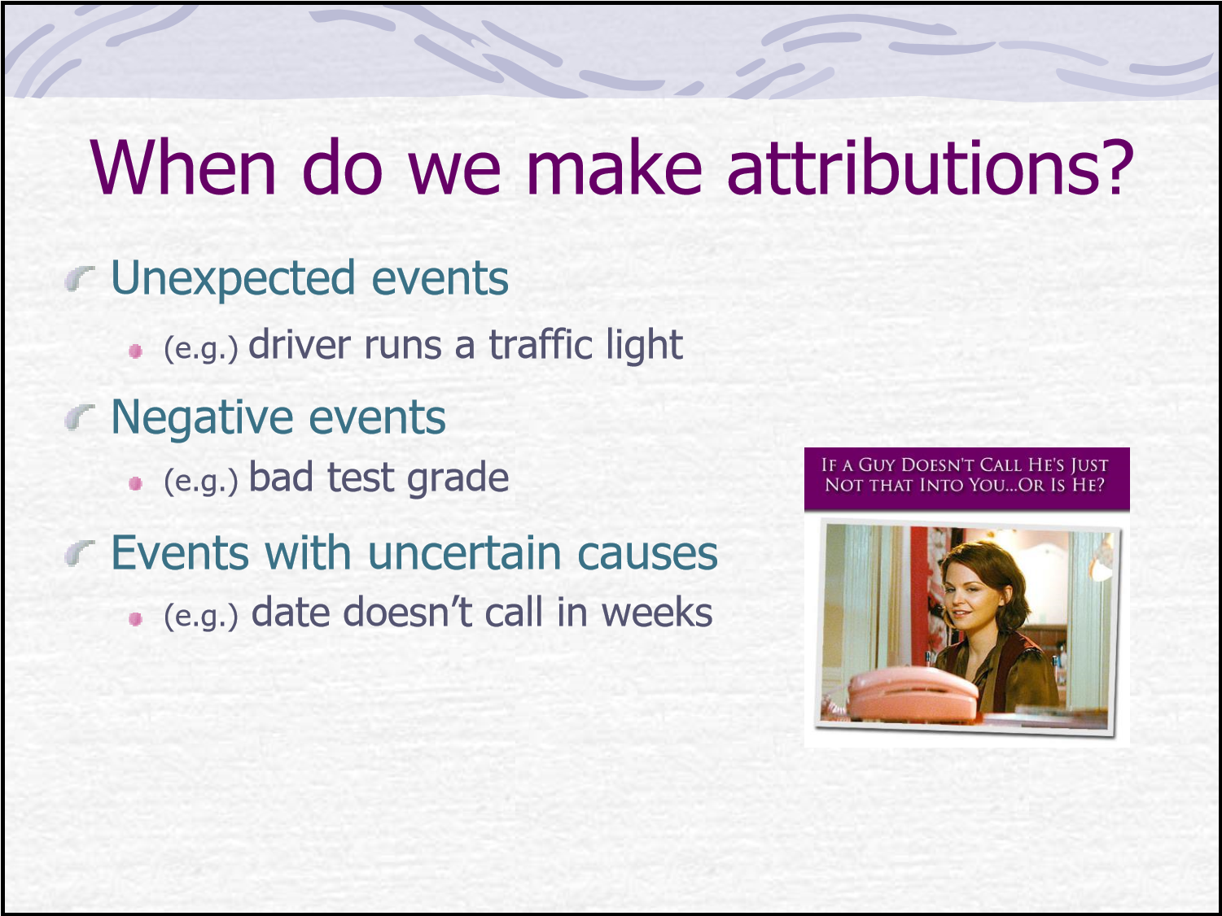
BIASES in Attribution


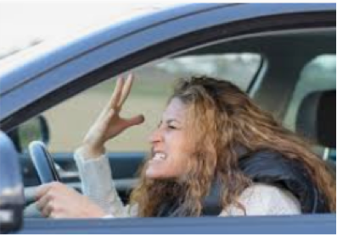
Fundamental Attribution Error
Tendency to overestimate the extent to which other people’s behaviour is due to internal, dispositional factors and to underestimate the role of situational factors.
The ‘observer’ (person seeing another’s behaviour) to favour internal attributions to explain that person’s behaviour
Also referred to as Correspondence Bias
a bias in which people have an inflated tendency to see behaviour as a reflection of stable underlying personality attributes
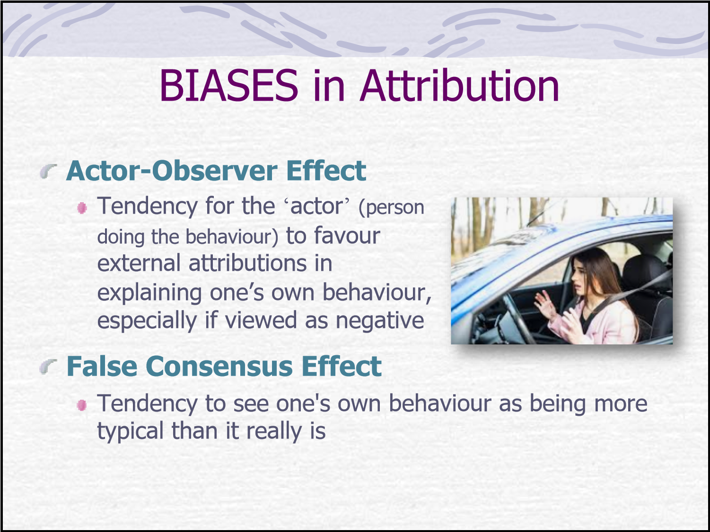

SELF-SERVING BIASES
A range of biases that protect or enhance self-evaluation



Self-Enhancing Bias
Attributing one’s successto personal factors

Self-Protecting Bias
Attributing one’s failuresto situational ones

Self-Handicapping
Publicly making advance external attributions for one’s anticipated failure or poor performance in a forthcoming event
Interpersonal Relationships
GOTHROUGH 3 PHASES:
Formation – attributions reduce ambiguity and facilitate communication and understanding

Maintenance – need to make attributions decreases as stable personalities and relationships have been constructed
Dissolution – attributions increase in order to regain an understanding of the relationship

What is your Relationship Attribution Style?
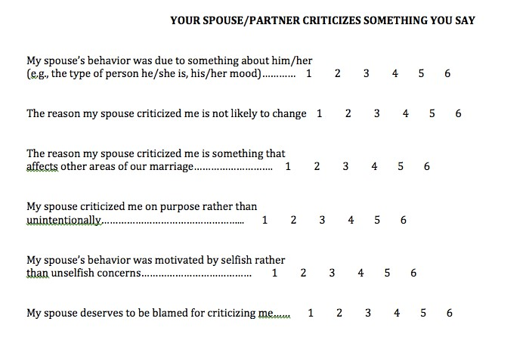
Attributions in Marital Satisfaction
Happily married (non-distressed) spouses:
Credit their partners positive behaviours by citing internal, stable, global and controllable factors

Explain away negative behaviours with external, unstable, specific and uncontrollable causes Distressed couples engage in the opposite attributions
Attributional styles and health
Reaction to an uncontrollable event

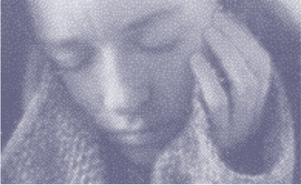
Depressive attributional style
(AKA pessimistic style)
= Internal + Stable + Global
Typically stable across time
Negative implications for health and mental health
Vulnerable to depression and low self-esteem
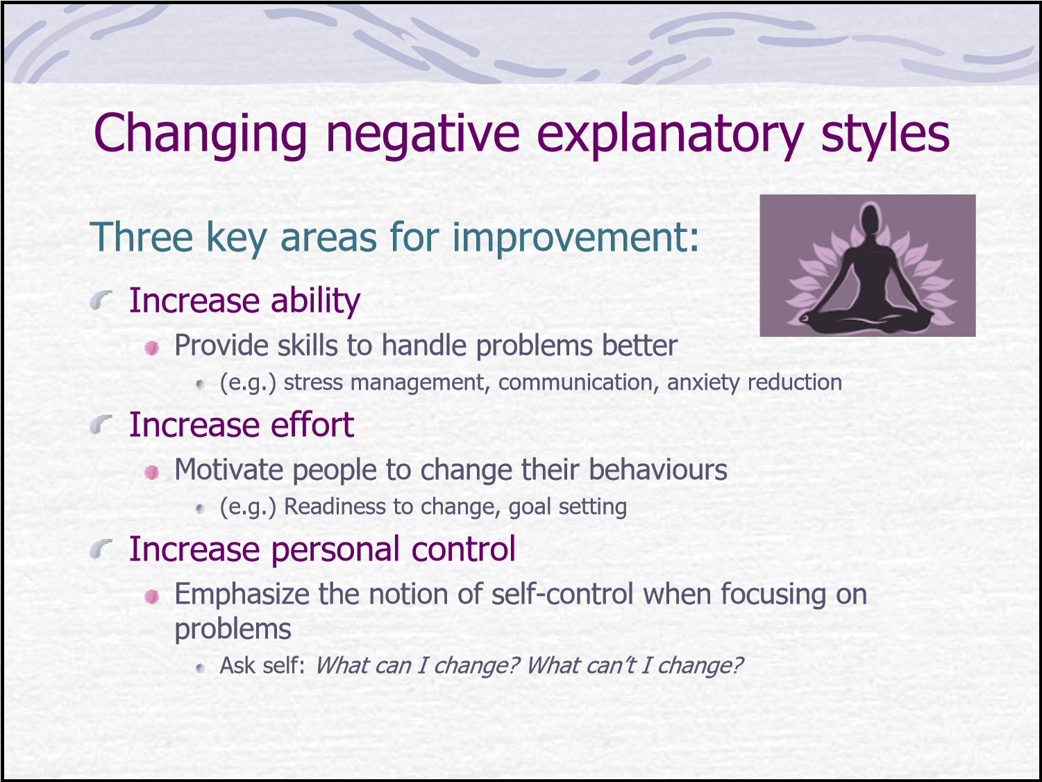

More applications of Attributional Thinking
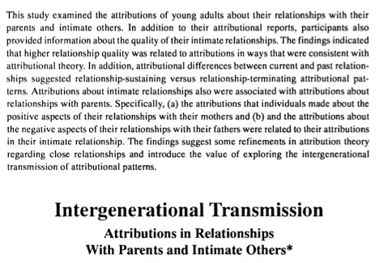

Extra Readings
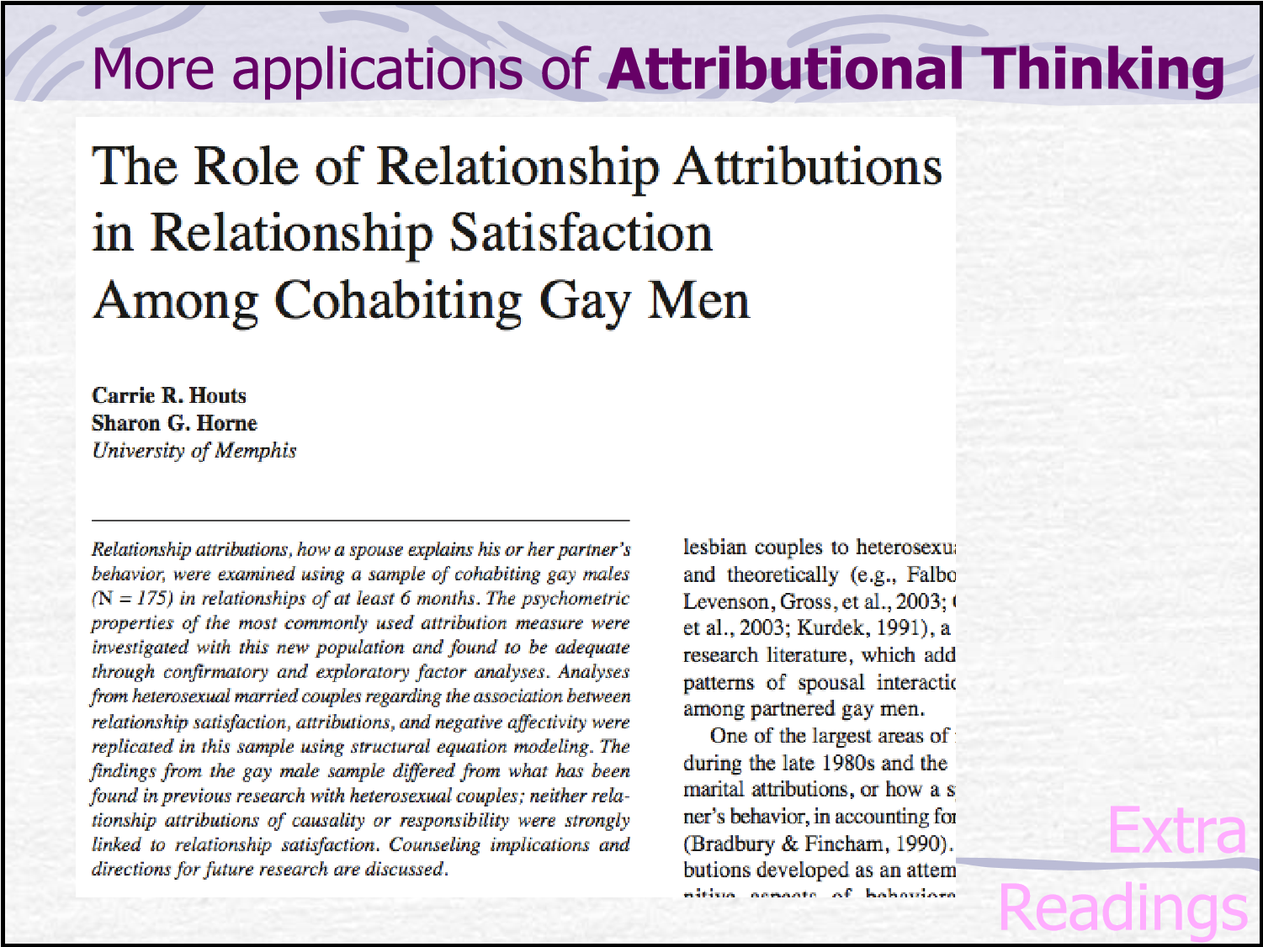

More applications of Attributional Thinking

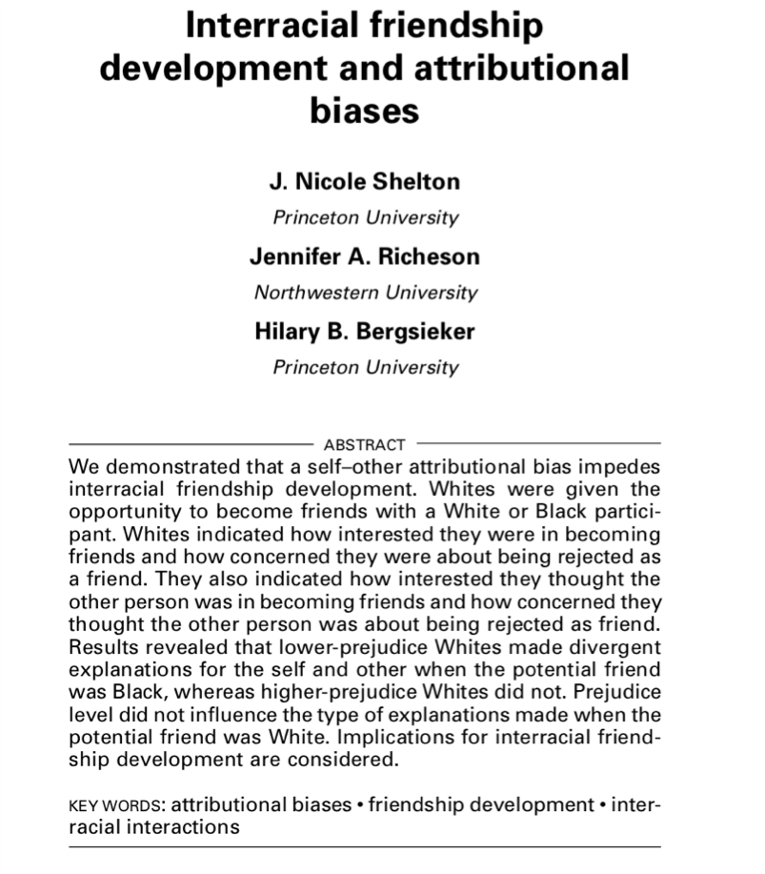
Extra Readings

