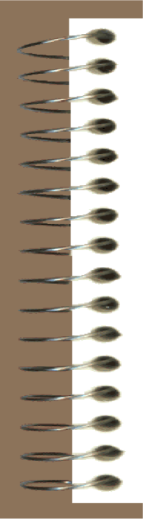
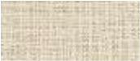

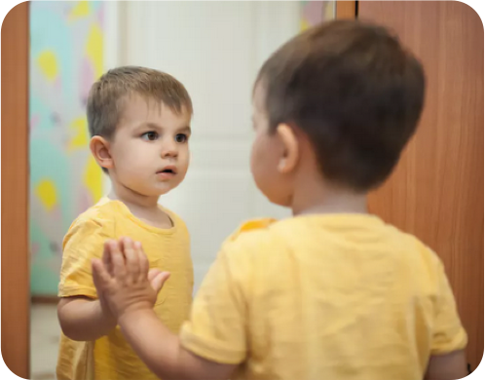
PSYC602 SOCIAL PSYCHOLOGY
IMAGE: http://theconversation.com/how
-
do
-
children
-
develop
-
a
-
sense
-
of
-
self
-
56118
W
EEK
3
_
2020
N
ORTH
AND
S
OUTH
SELF AND IDENTITY
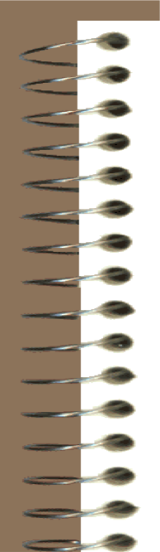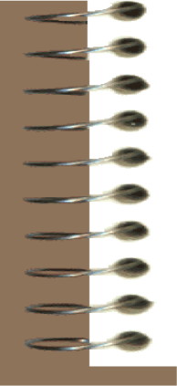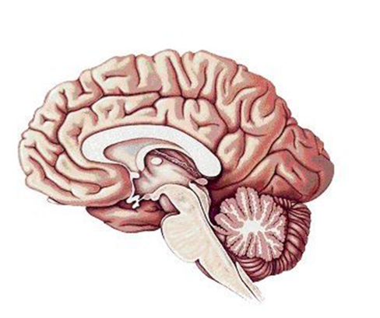
What is ‘the self”?
•
Identity and self
-
concept influence everything that we
think or do. It allows you to:
–
P
redict
what others think and do
–
Predict
what you will think and do
–
Interact with others by knowing guidelines or rules for
interacting with others
No single area of the brain
that holds
“the self”
•
However, we cannot point to an
exact part of the brain and say
–
this is the self. Instead self is an
abstract or theoretical construct
PSYCHODYNAMIC VIEW OF SELF
- Freud viewed the self as very personal and private—the very essence of individuality
– Others have argued that the self is a shared or collective self, part of a ‘we’ or ‘us’ (Jung)
- Self-representations can be conscious or unconscious; explicit or implicit; embody both positive and negative emotions.
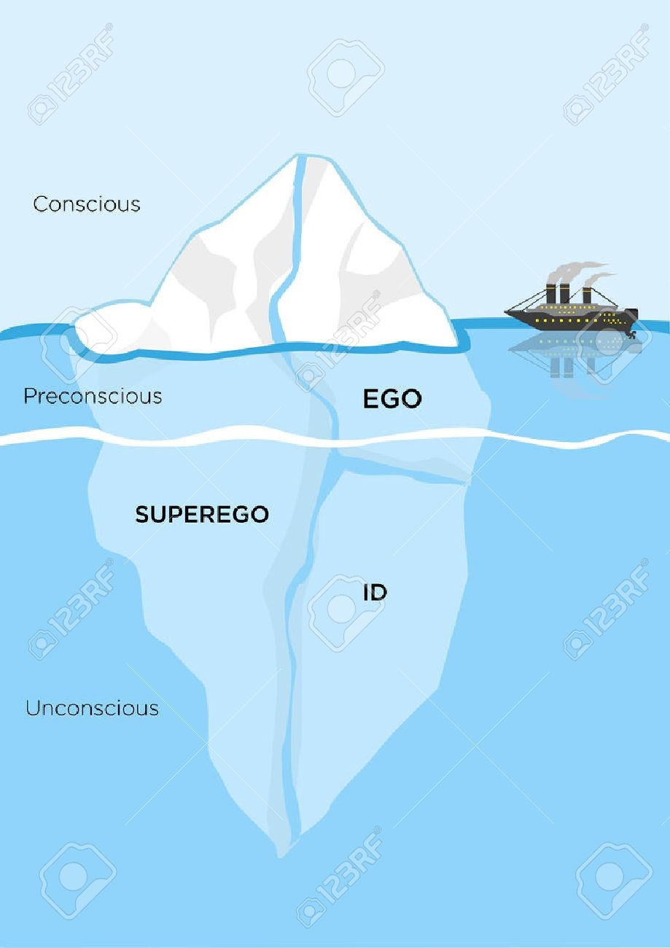
PSYCHODYNAMIC VIEW OF SELF
•
Id
:

asocial and selfish,
instinctive
(
the pleasure
principle)
•
Ego
:

seeks pleasure,
decision making
(
the reality
principle)
•
Superego
:

control the Id’s
impulses and the Ego’s
realistic goals

SYMBOLIC INTERACTIONIST VIEW OF SELF
- Belief that the self emerges from, and is shaped by, human interaction
- Interaction involves taking the role of the other person in order to understand what that person is communicating
- While in that ‘other’ role, we get a chance to see ourselves as others do
- Thus, self-conception comes from seeing ourselves as others see us (the looking-glass self)
Criticisms of

SYMBOLIC INTERACTIONISM
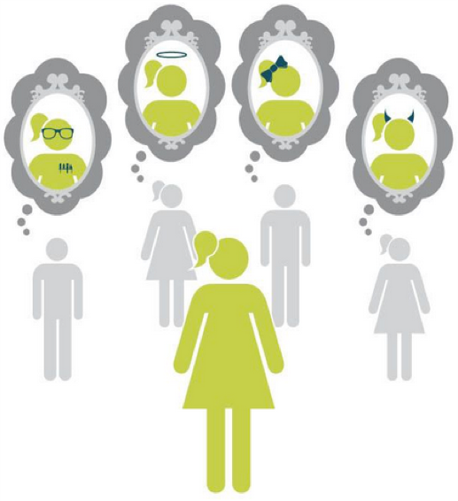
- There should be a strong correlation between how we rate ourselves and how others rate us, but research has found otherwise.
- People see themselves not as others see them, but as they think others see them
- In reality, people are generally unaware of what other people really think of them

COGNITIVE VIEW OF SELF
• Most people have a complex self-concept, with a large number of self-schemas, which influence information processing in the same way as do schemas about other people

• Self-schemas
- cognitive structures that represent knowledge about concepts, attributes and relationships, that we hold about ourselves
- are self perpetuating, and can be imposed by others

SELF-DISCREPANCY THEORY OF SELF
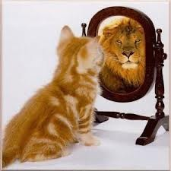
… proposes that we have three types of self-schemas
- Actual self: how we currently are
- Ideal self: how we would like to be
- ‘Ought’ self: how we think we should be
• We often compare our actual self with our ideal and ‘ought’ selves
- Ideal self = fit and healthy
- Actual self = unfit and not very healthy
- Discrepancy creates agitation; motivates change (e.g., going to gym)
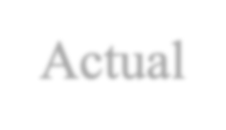
Actual
Ideal
Self-Discrepancy Theory: https://www.youtube.com/watch?v=jhk1D2QxRss
SELF
-
DISCREPANCY
THEORY OF SELF
Actual self
Discrepancy
Ideal self
Discrepancy associated with
depression or low
-
self
-
esteem
Discrepancy
Ought self
Discrepancy may be associated
with guilt, self
-
contempt,
uneasiness, avoidance and
procrastination
•
Ideal and ought selves are self
-
guides for our behaviour
•
Discrepancy between actual and ideal/ought can be changed through
self
-
regulation
•
involves using strategies to match our behaviour to an ideal or an ought
standard
•
This can reduce negative outcomes associated with actual
–
ideal or
actual
-
ought mismatch
EXERCISE:
1.
2.

The Selves Questionnaire
Participants are asked to list up to 10 traits or attributes associated with actual, ideal, and ought self-concepts (you will list 7).
INSTRUCTIONS: In the following questionnaire, you will be asked to list the attributes of the type of person you think you actually, ideally, and ought to be:
Actual self: Your beliefs concerning the attributes you think you actually possess.
Ideal self: Your beliefs concerning the attributes you would like ideally to possess; your ultimate goals for yourself.
3. Ought self: Your beliefs concerning the attributes you believe you should or ought to possess; your normative rules or prescriptions for yourself.
Higgins, E. T., et al. (1986). Self-discrepancies and emotional vulnerability: how magnitude, accessibility, & type of discrepancy influence affect. Journal of Personality and Social Psychology, 51(1): 5-15
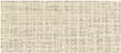
Inventive
Exciting
Thoughtful
Practical
Proactive
Productive
Quick
Balanced
Achiever
Knowledgeable
Leader
Logical
Initiator
Original
Outgoing
Particular
Patient
Active
Positive
Consistent
Compassionate
Incredible
Independent
With integrity
Mediator
Emotional
Cheerful
Forgiving
Sensuous
Generous
Sporty
Devoted
Rebellious
Cooperative
Busy
Interesting
Meditative
Understanding
Quirky
Honest
Assertive
Attentive
Direct
Broad
-
minded
Committed
Conscientious
Hard worker
Persistent
Mature
Methodical
Motivated
Objective
Tenacious
Sociable
Friendly
Realistic
Reliable
Resourceful
Respectful
Responsible
Creative
Confident
Traditional
Trustworthy
Unconventional
Optimistic
Accomplished
Analytical
Articulate
Artistic
Self
-
disciplined
Controversial
Individual
Tolerant
Naïve
Unselfish
Sophisticated
Stable
Strong
Successful
Tactful
Talented
Team player
Fun
Intelligent
Changeable
Passionate
Intense
Intuitive
Upbeat
Vibrant
Funny
Constructive
Dependable
Direct
Competitive
Political
Social consciousness
Modest
Courageous
Enthusiastic
Enterprising
Facilitator
Focused
Genuine
Open
-
mindedness
Wise
Sensitive
Sense of humor
Sensible
Sincere
Skilled
Solid
Communicative
Helpful
Fast
Responsible
Self
-
reliant
Organised
Knowledgeable
Logical
Personable
Pleasant
Flexible
Adaptable
Persuasive
Perceptive
Insightful
Trustworthy
Easy going
Good listener
Imaginative
Warm
Ambitious
Diplomatic
Curious
Leader
Loyal
Calculating Self-Discrepancy:
•
•
•
Compare the attributes listed for the actual self-concept with those listed for the ideal self-concept.
Determine which attributes match (appear on the lists for both actual self-concept and ideal self-concept), and which attributes mismatch (i.e., an attribute on one self-concept list is the opposite of an attribute on another self-concept list).
(Repeat the process for your actual self-concept list and your ought self-concept list)
• Calculate the self-discrepancy score by subtracting the total number of actual ideal matches from the total number of actual-ideal mismatches. The same calculation is used for the actual-ought self-discrepancy score.
SELVES AND IDENTITIES
A further classification of self:
•
Individual self
–
defined by personal traits that
differentiate self from all others
(
personal identity
)
•
Relational self
–
defined by dyadic relationships that
assimilate self to significant other persons
•
Collective self
–
defined by group membership that
differentiates ‘us’ from ‘them’
(
social identity
)

SOCIAL IDENTITY THEORY
Tajfel (1982); Turner (1987)
Theory that people favour in-groups over out-groups in order to enhance their self-esteem. Develops through these ways of thinking:
- Social categorisation (putting people in groups based on similar characteristics such as age, ethnicity, behaviours)
- Intergroup relations (how you think, feel and perceive your own and other groups)
- Prejudice (feeling) and stereotyping (belief) about another group
- Social comparison (e.g., wondering if the other group is better or worse than your)
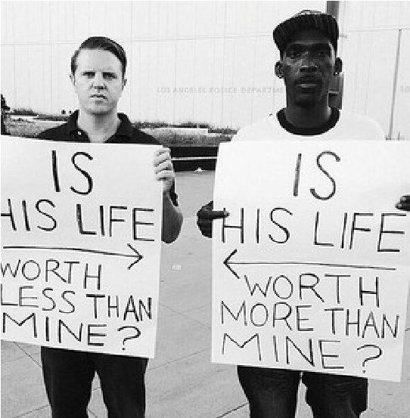
SOCIAL IDENTITY THEORY
Henry Tajfel (1969) and
John Turner (1974, 1979)
•
Two main types of identity
–
Personal Identity
–
Social Identity
•
‘In
-
group’ and ‘out
-
group’ dynamics
•
In
-
group
favouritism
(
even when arbitrary)

Examples of In-groups – Out-groups
- Northern Ireland: • Rugby: League & Union Catholics & Protestants • Gender: Males & Females
- Rwanda: Hutus & Tutsis • Social Class: Middle &
- Yugoslavia: Bosnians & Working Classes
Serbs • Religion: Shia Muslims &
•  • | Germany: Jews & Nazis  Politics: Labor & National | • | Sunni Muslims  Ethnicity: Pākehā & Māori

SOCIAL AND PERSONAL IDENTITIES

- Social identity
  - Defines self in terms of group membership
  - Associated with group and inter-group behaviours:
  - Ethnocentrism, ingroup bias, group solidarity, intergroup discrimination, conformity, normative behaviour, stereotyping and prejudice
- Personal identity
  - Defines self in terms of unique personal relationships and traits
  - Associated with positive and negative close interpersonal behaviours, and with unique personal behaviours
- Ethnic (and cultural) Identity introduced and considered in later lecture

OTHER THEORIES OF SELF
SELF-PERCEPTION THEORY
Daryl Bem (1938-)

- We develop attitudes/opinions by observing own behaviour and drawing conclusions from it.
– “we are what we do.”
SOCIAL COMPARISON THEORY

Festinger (1954)
- We learn about ourselves by comparing ourselves to others.
Extra reading https://www.psychologytoday.com/blog/redirect/20 Bem, D. J. (1972). Self-perception theory. Advances in
1201/we-are-what-we-do experimental social psychology, 6, 1-62.

SELF-AWARENESS
- Self-awareness is a state in which one is aware of oneself as an object – objective self-awareness
- When you are objectively self-aware, you make comparisons between how you actually are and how you would like to be (an ideal or goal), which can lead to awareness of shortcomings
- Self-awareness can cause discomfort (e.g. feeling selfconscious); it can also make one feel good, especially if the standards of comparison place us in a good light.
- Too little self-awareness is a key element in ‘deindividuation’, and stops people from monitoring themselves, making it easier to behave in impulsive or anti-normative ways

SELF-MOTIVES
People are highly motivated to gain self-knowledge, preferring enhancement information over verification or assessment:
•Self-enhancement
- The motivation to promote a favourable image of self
•Self-verification
- The motivation to seek out information that verifies and confirms what one already knows about oneself
•Self-assessment
- The motivation to seek out new information about self in order to find out what sort of person one really is
•Self-handicapping:
- Publicly making advance external attributions for one’s anticipated failure or poor performance on a forthcoming event

STRATEGIES TO ENHANCE SELF-CONCEPT
- Take credit for successes but deny blame for failures
- Forget failure feedback more readily than success or praise
- Accept praise uncritically, but receive criticism sceptically
- Try to dismiss interpersonal criticism as being motivated by prejudice
- Perform a biased search of self-knowledge to support a favourable self-image
- Persuade oneself that one’s flaws are widely-shared human attributes, but that one’s valued qualities are rare and distinctive
STRATEGIC SELF
-
PRESENTATION
Jones and Pittman (1982)
Self
-
presentation
strategy
Convinces
people
we are…
Typical
behaviours
Self
-
presentation
risks
Ingratiation
Likable
Compliments,
favours
Insincere, deceitful
Self
-
promotion
Competent
Boasting,
showing off
Conceited,
fraudulent
Intimidation
Powerful,
ruthless, feared
Threats
Reviled,
ineffectual
Exemplification
Virtuous, morally
superior
Self
-
denial,
martyr
Hypocritical
Supplication
Helpless
Self
-
depreciation
Manipulative,
demanding

