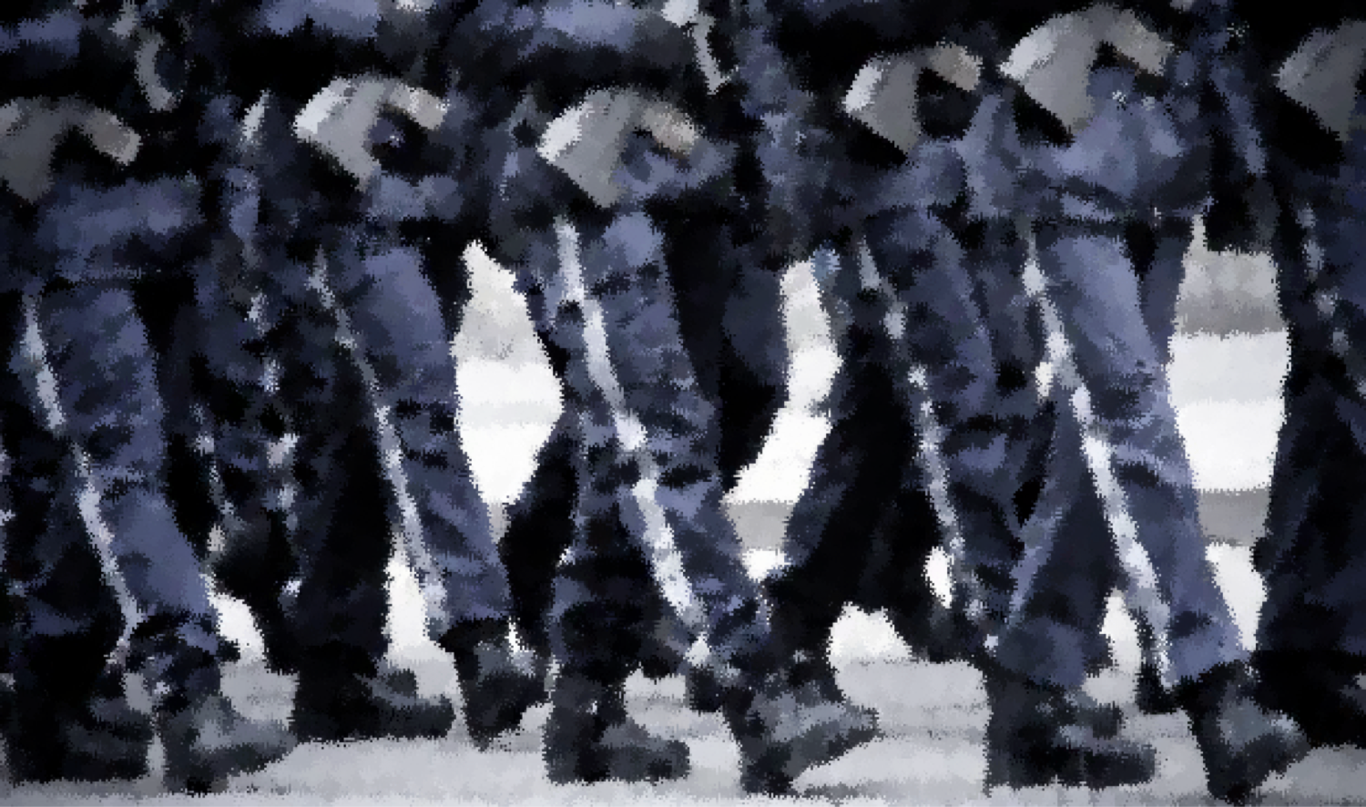
P
OWER
, S
OCIAL
I
NFLUENCE
,
AND
L
EADERSHIP
PSYC602
-
Social Psychology
W
EEK
6
(2020 _ T
HE
L
OCKDOWN
E
DITION
)
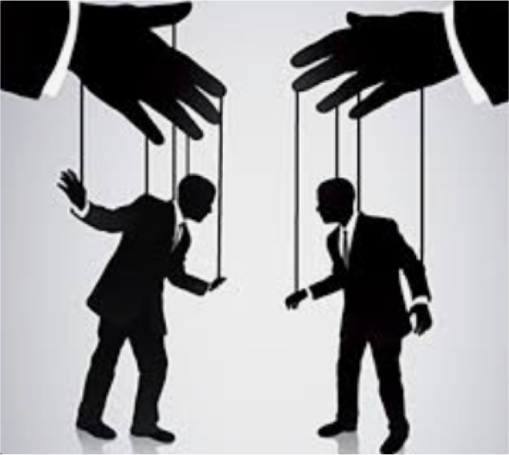
Today’s Topics
•
P
OWER
•
S
OCIAL
I
NFLUENCE
•
C
ONFORMITY
•
C
OMPLIANCE
•
O
BEDIANCE
•
L
EADERSHIP

DEFINING POWER
in the context of
S
OCIAL
P
SYCHOLOGY
•
Capability
of
doing
or
accomplishing
something
•
Great
or
marked
ability
to
do
or
act
•
strength;
might;
force
•
Political
or
national
strength
•
Political
ascendancy
or
control
in
the
government
of
a
country,
state, etc.
•
Possession
of
control
or
command
over
others
•
authority; dominance
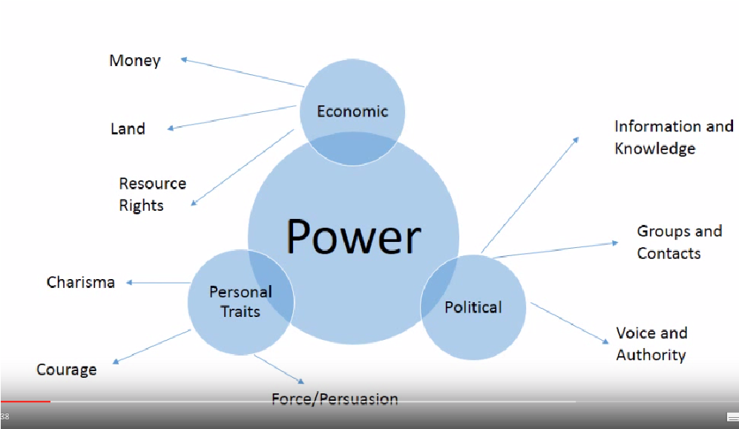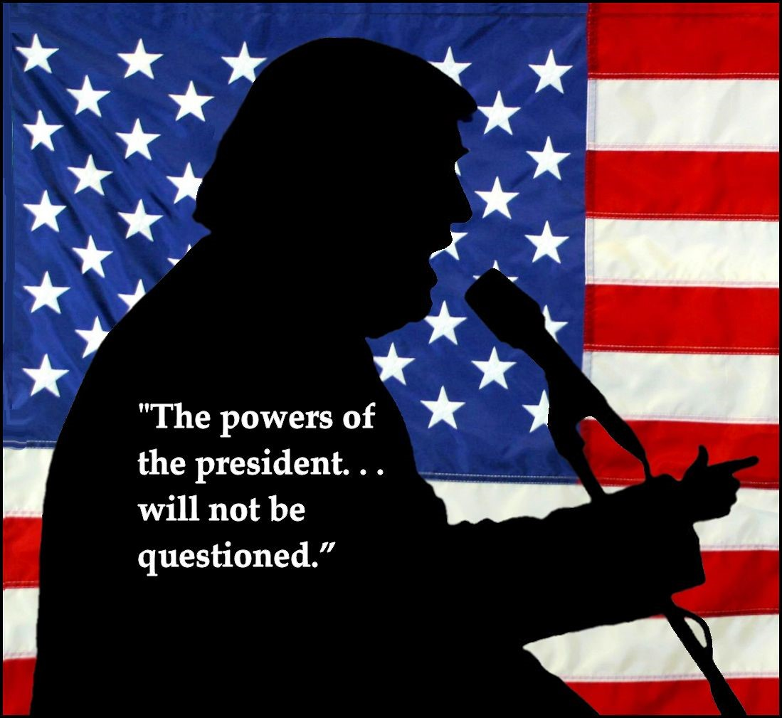
W
HAT
DOES
IT
MEAN
TO
HAVE
POWER
IN
OUR
SOCIETY
?
Critical Social Psychology
=
a more complex look at power
https://www.youtube.co
m/watch?v=m7oO08AwLpc
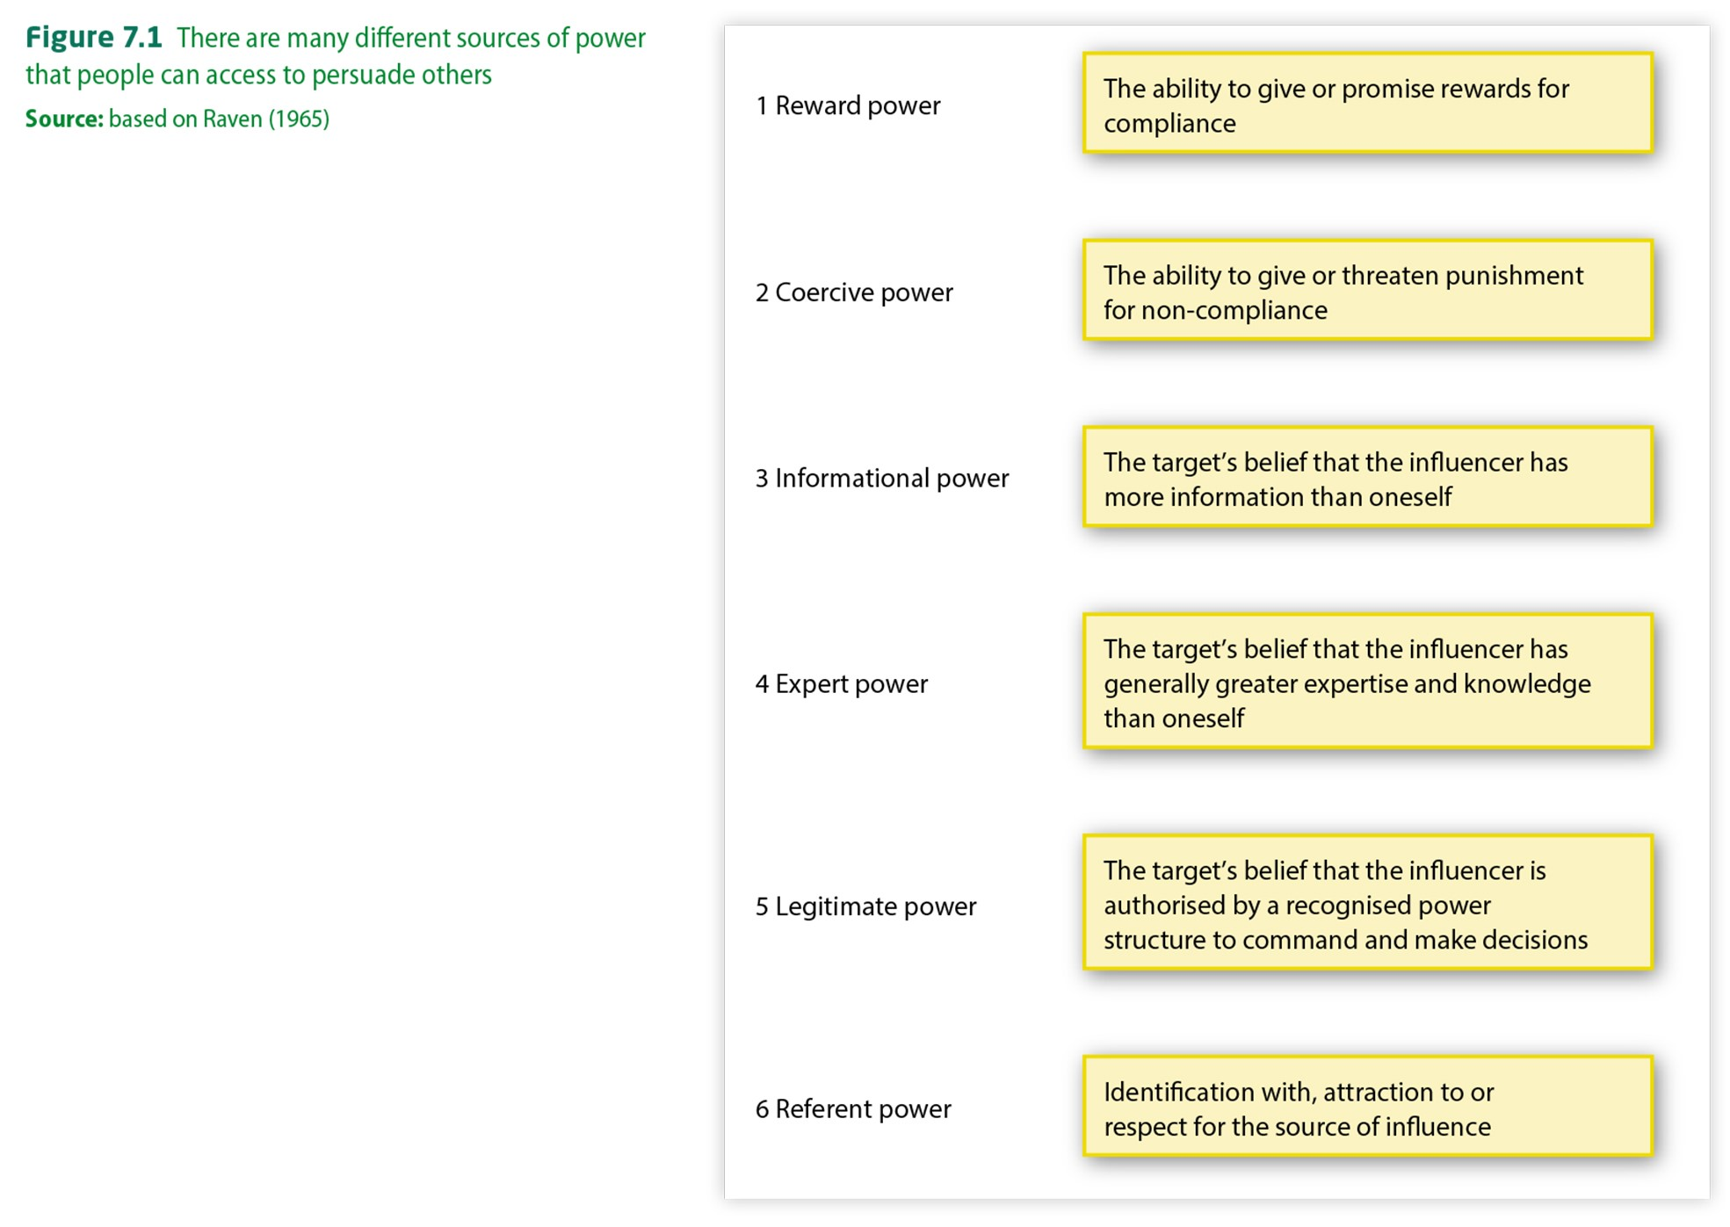
Power can be control over
behaviour through
domination
that produces
compliance and submission
•
If one has power, one doesn’t
need influence
•
If one can effectively influence,
one doesn’t need to exert power
Power can also be an aspect
of leadership
•
Some leaders influence using
power through coercion
•
Some influence by persuasion
YouTube clip that introduces the work of  Michel Foucault  in relationship to power, politics and International Relations  https://www.youtube.com/watch?v=XeADQW4Gu6A | GOVERNING POWER  Sovereign vs. Disciplinary  Sovereign Power is exercising authority over subjects. Michel Foucault  It is recognisable through particular and identifiable ^{(1926–1984)} individuals. And yet, most of one's life is beyond the ^{French historian} control of one’s sovereign. and postmodernistphilosopher  Disciplinary Power regulates the Power comes about ordering of people (in schools, ^{through accepted}    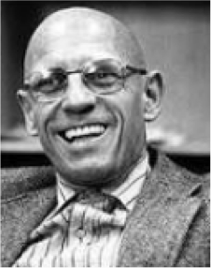              ‘Power is diffuse rather military, work, etc). forms of knowledge, scientific than concentrated, ^{understanding and} embodied and enacted ‘Power is everywhere’ ^{‘truth’.} rather than possessed, and ‘comes from  discursive rather than everywhere’. It is dispersed  coercive, and constitutes and pervasive, so in this agents rather than sense is neither an agency being deployed by them’ nor a structure.
SOCIAL INFLUENCE

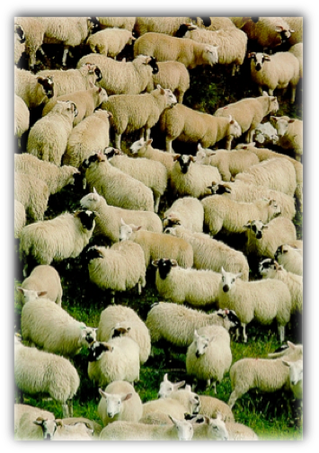
- Social influence = efforts by one or more individuals to change the attitudes, beliefs, perceptions, or behaviors of one or more others
- Social Norms = rules regarding how people are expected to behave in specific situations
- We study social influence
by examining how social Conformity norms are constructed, Compliance
how they are regulated Obedience
and how they change

Main types of Social Influence
- Conformity: When individuals change their attitudes or behavior in order to adhere to social norms
- Compliance: Involves changing an attitude or behaviour in response to a direct request from another person
- Obedience: When following the orders of someone perceived as having some authority
Q: How much do we conform?
A: More than we think

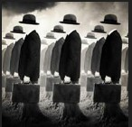
- Conformity is a type of social influence in which individuals change their attitudes or behavior in order to adhere to social norms
- We feel much more comfortable when we are similar to our socially-significant others (friends, peers, family) than when we are different from them
- But do we recognize just how much we are influenced in this way?
Research findings indicate that we do not.
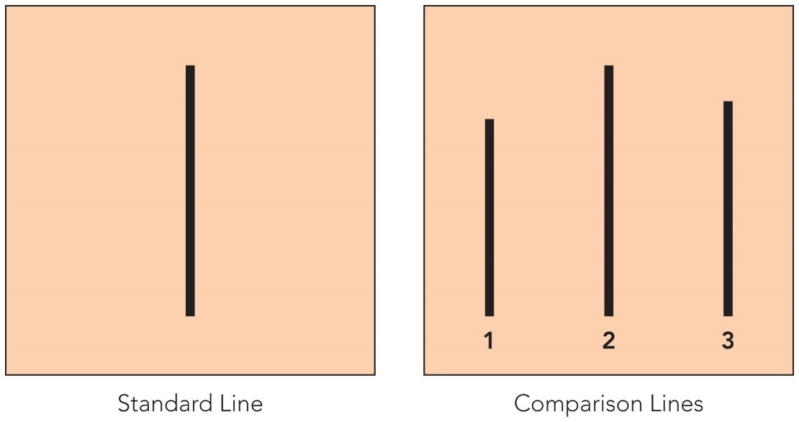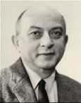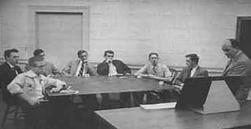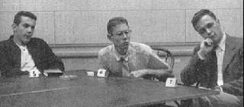
Conformity
:

Asch
’
s Conformity
Experiment
•
Participants were asked to indicate
which of three lines were as long as
a central, standard line
•
During the critical trials, participants
had to give their answers after a
unanimous group (all confederates)
gave the wrong answer
•
76
%
conformed to the group
’
s false
judgment at least once
•
Overall, they agreed with the errors
37
%
of the time
http://www.youtube.com/watch?v=TYIh4MkcfJA
Factors Affecting Conformity:
Variables that determine the extent to which we Go Along
- COHESIVENESS: degree of • GROUP SIZE: As group size


attraction felt by an individual increases, conformity increases toward an influencing group (to a point!)
- As cohesiveness increases, • Optimal size for conformity is conformity increases 3-4 members
On the other hand, conformity reduces when:
- We have an ally (someone else who disagrees with the group)
- We’re able to make responses privately
The Social Foundations of Conformity: Why we often choose to Go Along
NORMATIVE SOCIAL INFLUENCE:
social influence based on the desire to be liked or accepted
- Agreeing with others and behaving as they do causes them to like us


- We conform for approval INFORMATIONAL SOCIAL INFLUENCE:
social influence based on the desire to be correct (or not wrong)
- Especially strong source of conformity when the task is important, and difficulty and uncertainty are high
- We rely on others to guide norms, which we then conform to

Why, sometimes, we choose not to go along:
The effects of power, basic motives, and the desire for uniqueness
•
The need to maintain individuality,
culture and resistance to conformity
•
The desire for personal control
•
Norms that encourage individualism
Individuation
:
the need to be
distinguishable from others in
some respects

Compliance
:

To ask
—
sometimes
—
is to receive
•
A type of social
influence involving
direct requests from
one person to another
•
Also defined as a
superficial, public and
transitory change in
behaviour and expressed
attitudes in response to
requests, coercion or
group pressure
Caildini’s Basic Principles of Compliance
(1994, 2006)

• FRIENDSHIP OR LIKING • RECIPROCITY
- if a friend or someone • if the request comes we like makes a request from someone who has
- COMMITMENT OR done a favor for us in
the past

CONSISTENCY
- if we have made a prior • SOCIAL VALIDATION commitment • if we believe that similar
- SCARCITY others are behaving in the same way
- if it involves outcomes or objects that are relatively • AUTHORITY
scarce • if the request comes from an authority figure
Multiple requests tactics of compliance

Foot-in-the-door tactic:
- The focal request is
preceded by smaller request that’s bound to be accepted.
- When the person agrees to the first request, a larger (the real request) is made.
- Having agreed initially, it is easier to agree to the subsequent request.
Door-in-the-face tactic:
- The focal request is preceded by larger request that is bound to be refused.
- After being turned down for the larger favour, people are more likely to agree to the smaller one
Lowball tactic:
- People who agrees to a request can feel obligated, even after finding hidden costs.



- Having committed to ‘A’, people are more likely to accept ‘B’ when they’re told ‘A’ isn’t available or will cost more

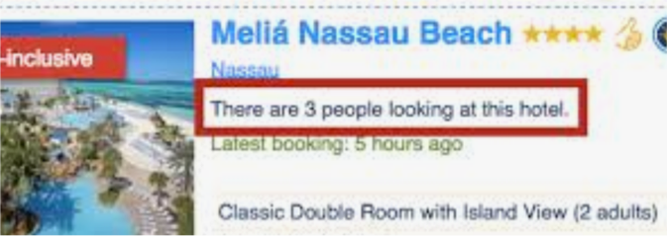
More COMPLIANCE tactics
Playing Hard to Get:
•
Suggesting that a person or object is
scarce and hard to obtain
Deadline tactic:
•
Target persons are told that they have only limited
time to take advantage of some offer or to obtain
some item, increasing feelings of urgency
“
That
’
s
-
Not
-
All
”
:
•
Requesters offer additional
benefits to target persons
More COMPLIANCE tactics
Ingratiation
- Requesters first induce target persons to like them, and then attempt to
Reciprocity Principal change their behavior in some desired manner
- Involves the law of ‘doing unto others as they do
unto you’ Mindlessness
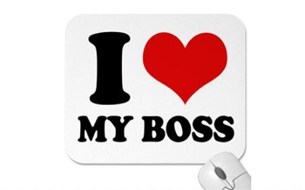


- If we do someone a • Agreeing without thought; good for favour, person will feel small requests, even if a spurious obligated to reciprocate reason is provided; (e.g.) Can I use the photocopier first?
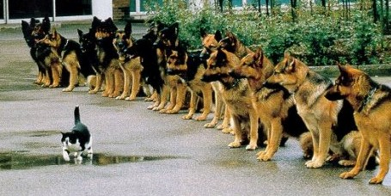
OBEDIENCE
TO AUTHORITY
•
Obedience
is a form of social influence in which one
person follows the orders of one or more others to
perform some action(s)
Obedience to Authority:
Would you harm an innocent stranger if ordered to do so?
- Forty men
- 20-50 years old
- Asked to be “teacher” in study of memory, while the “learner” was a confederate
- Asked to give shocks each
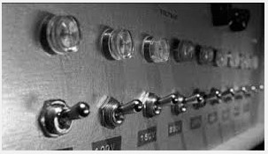
time the “learner” got an How far do you think answer wrong they were willing to go?
- 15v (slight shock) to 450v (danger: XXX)
- The “learner” cried out (mock) each time shocks were given
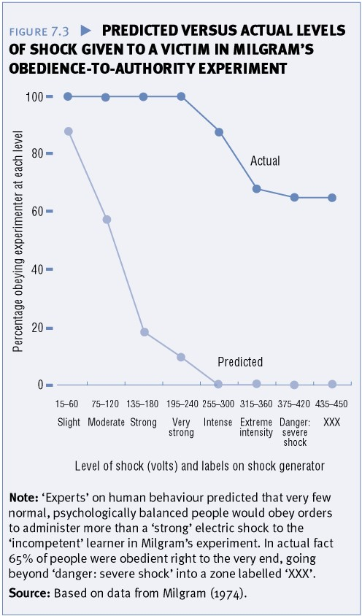
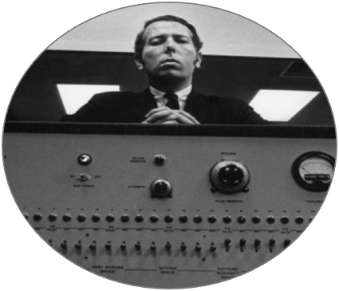
Obedience is affected by:
The proximity
and
legitimacy of
the authority
•
When experimenter absent =
20.5
%
•
When experimenter gave no instructions & participants free to choose
=

2.5
%
•
When experiment conducted in run
-
down inner
-
city office by a ‘private
commercial research firm’ =
48
%
•
Uniform and other trappings imply legitimacy (power)
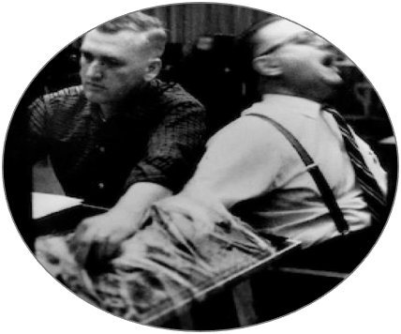
The
proximity
of the
victim
Obedience is affected by:
•
When victim neither seen nor heard =
100
%
•
When victim visible =
40
%
•
When had to hold victims hand onto electrode =
30
%
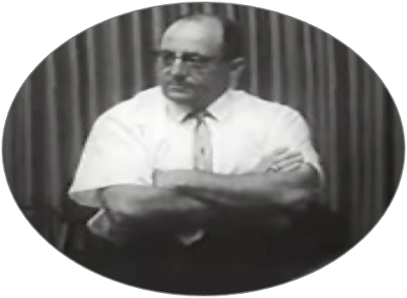
The degree of
social support
(
group pressure) for
obedience or
disobedience
Obedience is affected by:
•
Presence of two obedient peers =
92.5
%
•
Presence of two resistant peers who refused to continue above 150v =
10
%
Would Milgram find less obedience if he conducted his experiments today?
“I doubt it. To go beyond speculation on this question, I carried out the following statistical analysis. I gathered all of Milgram's standard obedience experiments and the replications conducted by other researchers. The experiments spanned a 25-year period from 1961 to 1985. I did a correlational analysis relating each study's year of publication and the amount of obedience it found. I found a zero-correlation…no relationship whatsoever. In other words, on the average, the later studies found no more or less obedience than the ones conducted earlier.”
Dr. Thomas Blass

Social Influence in Film
•
Das Experiment
(
The Experiment
)
•
Die
Walle
(
The Wave
)
•
12
Angry Men
•
Compliance
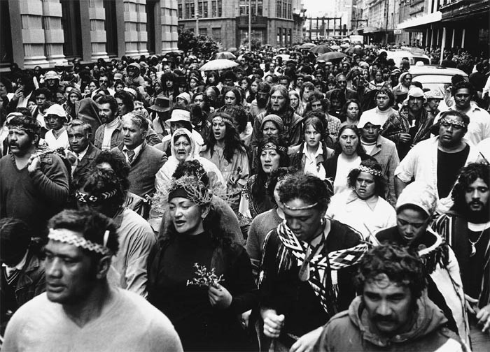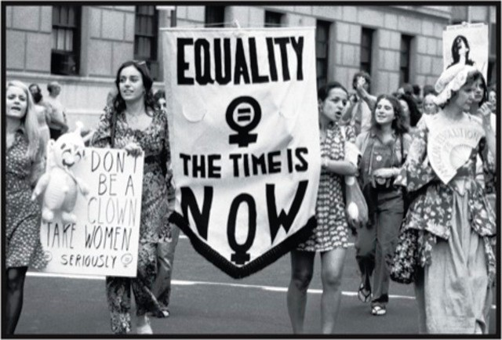
Minority Influence
A social influence processes
whereby
numerical
(
e.g., just one
or a few)
or
power
minorities
e.g.,
(
less legitimate power)
change the
attitudes of the majority
.
Minorities make social
change possible.
http://stu
dy.com/academy/lesson/group
-
psycholog
y
-
min
ority
-
vs
-
majority
-
influence.html
Minority Influence:
Does the majority always rule?
Minorities can:
- Influence majorities when they are consistent, flexible, and congruent with social trends
- Provoke majorities to engage in systematic processing of the issues
- Often must form strong arguments to defend their positions (e.g. 12 Angry Men)
- May over-estimate the support for and agreement with their views
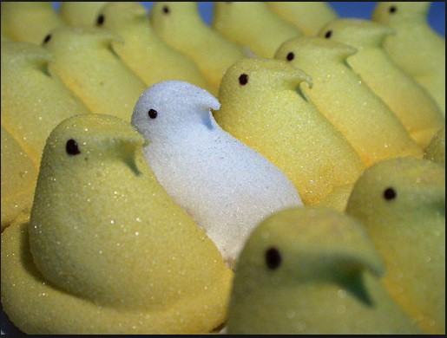
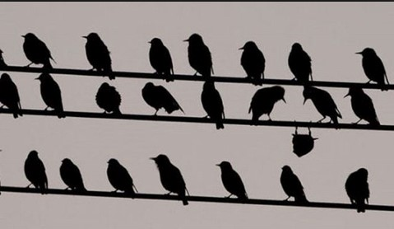
- Can increase their perseverance, resulting in large-scale social change

For Minority Influence to work
- Must provide a consistent message across time and context
- Speaks to an alternative norm and identity rather than the majority
- Can produce uncertainty and doubt in the majority view and offer an alternative certainty
- Draws attention to the minority as an entity or group
- Indicate personal investment or material sacrifice in position
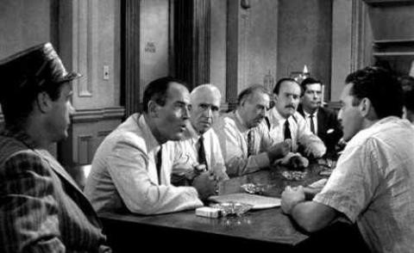
- Demonstrates autonomy by acting on principle rather than ulterior or other motives • Film example: 12 Angry Men
https://www.youtube.com/watch?v=OvebOqneLIU
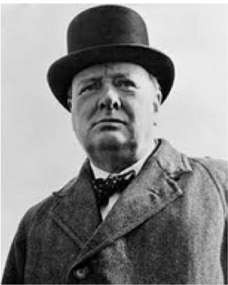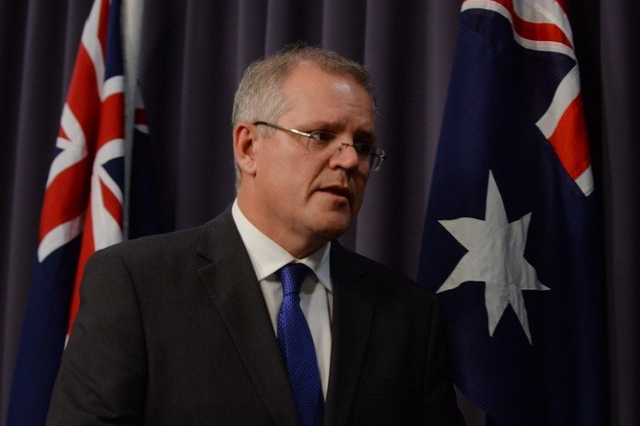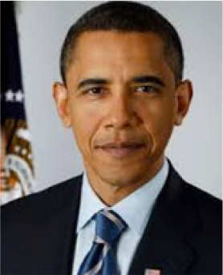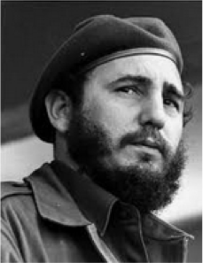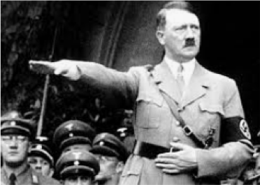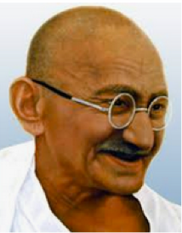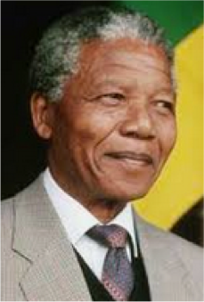
What do these people
have in common?
What is LEADERSHIP?
- Leadership is defined as getting group members to achieve the group’s goals
- A process of social influence through which an individual enlists and mobilises the aid of others in the attainment of a collective goal (Chemers, 2001)
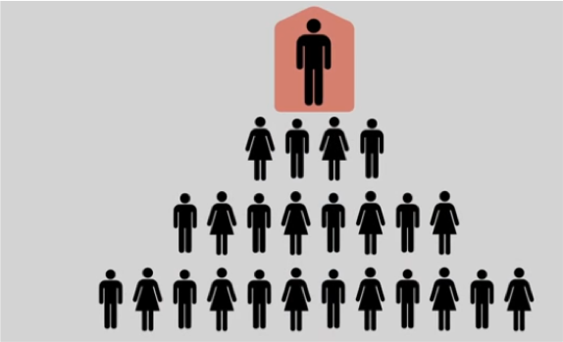

- Leadership is not (per se) compliance, power, influence or conformity to norms; rather leaders shape and define collective or group goals rather than interpersonal process

Characteristics of Leaders
Leaders are found to be above average on:
- Self confidence, sociability and need for dominance
- Intelligence (fast decisions) and talkativeness
- Size (Napoleon being an exception), health and physical attractiveness ? Innate or acquired individual characteristics ?

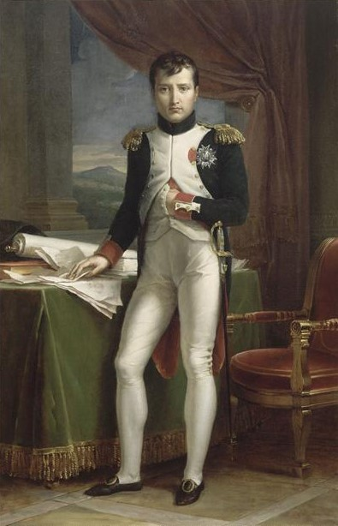

Based on the Big Five Theory of personality, Judget et al., (2012) found the best predictors of leadership to be extraversion, openness to experience, and conscientiousness
Bad leaders, on the other hand, related to the ‘dark triad’ of personality variables • Narcissism, Machiavellianism, Psychopathy


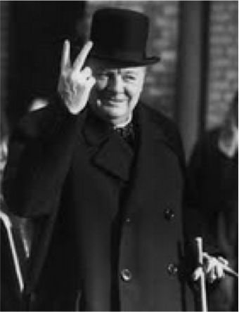
Situational Perspectives on Leadership
- Any one can be a great leader if the situation is right.
- Different situations may call for different types of leaders.
Effective leadership is the right combination of personal characteristics and situational requirements
Includes ability to adapt to the situational demands
(e.g., Nelson Mandela released from 26 years in prison to a very different political environment;
Churchill voted into government during the war
but voted out after the war).

Leadership Styles: Lippitt & White (1943)
These researchers observed the responses of young boys in after-school clubs, and found three types of leadership:
- Autocratic leadership (organised, gave orders, aloof, focused on task in hand)
- Democratic leadership (called for suggestions, discussed plans, behaved like other members)
- Laissez-faire leadership (left the group to its own devices, very low level of intervention)
One person was the leader for 7 weeks, then replaced by another, but this person also adopted the same leadership style (2 more times)
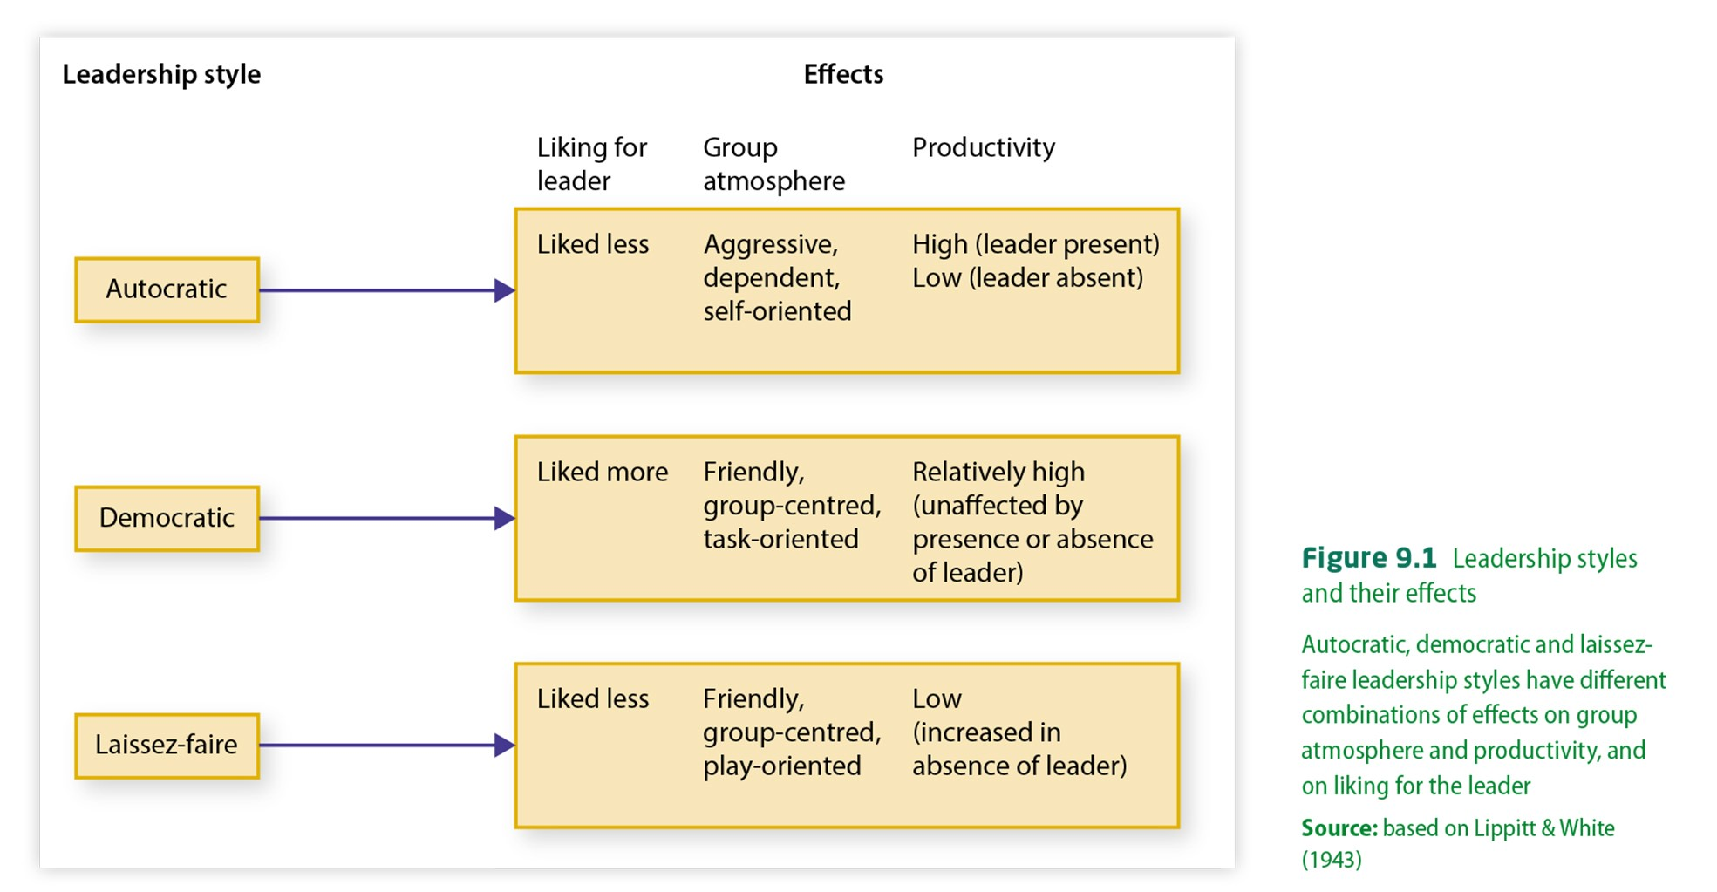
https://www.youtube.c
om/watch?v=J7FYGn2NS8M

Socio
-
emotional
leaders
•
are alert to the feelings of
the group
Leadership Styles:
Bales
(1950)
Task
-
oriented leaders
•
concentrate on reaching goals,
giving directions, etc.
No one person usually occupies both roles
Leadership Styles: Fiedler (1967)
Fiedler’s contingency theory
- Referred to as the “it depends” model of leadership; there is no one best way to lead: it’s “contingent” on the situation
- Viewed below as a characteristics of the individual who would be high on one or the other (not both)
- Like Bales (1950) distinguished between:

Task-oriented leaders = Socioemotional-oriented
Concerned with the group task more leaders = Concerned with group’s so than relationships among feelings and relationships, more so members; Authoritarian, values group than the group task; Relaxed, success; Derives self-esteem from task friendly, non-directive; Derives selfaccomplishment; Most effective when esteem from harmonious group situational control is high (group relations; Most effective when doing well) or low (group needs situational control is between the directive two factors (above)

Transactional Leadership

- A style of leadership that illicits compliance from followers through rewards and punishments
- Most effective in crises, emergency situations, and on projects that need to be completed in a specific way.
- The transactional approach is not about changing the future*. It’s about keeping things the same.
- Followers may also reward leaders through social approval, praise, status.

Transformational Leadership
- Focuses on the way that leaders transform group goals and actions mainly through their charisma.
- They inspire followers to adopt a vision that involves more than individual self-interest.
- Individualised consideration: Attention to needs of follower’s needs, abilities and aspirations to help raise and improve these.
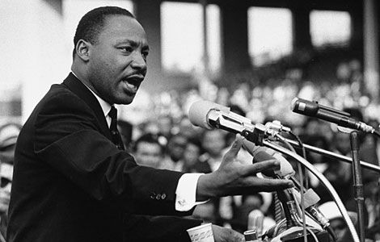
- Intellectual stimulation: Challenging followers’ basic thinking, assumptions and practices to help them develop new practices and thinking
- Charismatic/inspiring leadership: provides the energy, reasoning, and sense of urgency that transforms followers.
IDENTIFY YOUR OWN
LEADERSHIP STYLES
•
https://www.zoho.com
/survey/leadership
-
questionnaire.htm
l
•
https://www.surveymonk
ey.com/r/CHGNFH5
•
https://www.questionpro.co
m/blog/leadership
-
surve
y
-
questions
/

