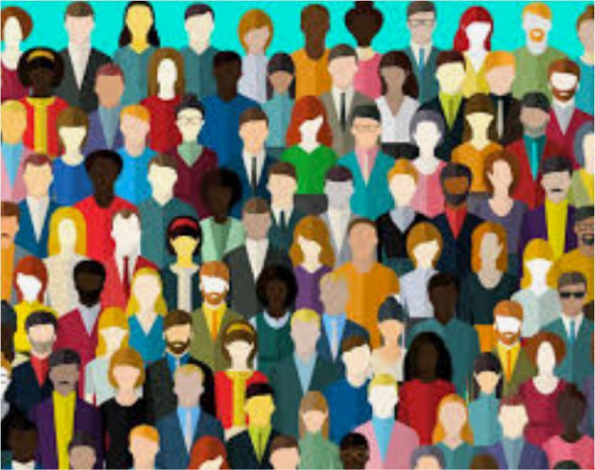
PSYC602
S
OCIAL
P
SYCHOLOGY
WEEK 8
(2020
-
LE)
P
REJUDICE
AND
D
ISCRIMINATION
D
R
R
HODA
S
CHERMAN
N
(
ORTH
)
D
R
S
HIVANTHI
B
ALALLA
(
S
OUTH
)

Prejudice: A universal condition?
What aspects of your identity cause you
to
feel
discriminated against?
-
Gender
-
Race
-
Occupation (computer nerd vs wrestler vs
janitor vs Fortune 500 CEO)
-
Sexual orientation
-
Religion
-
Physical appearance
–
clothing style, body size,
piercings, hair
colour
-
Illness
–
HIV, Depression,
ADHD
None of us emerge unscathed…!
Who among
you has
absolutely no
prejudices?
Three inter
-
related concepts make up
this week’s lecture:
S
TEREOTYPES
•
Thoughts or beliefs that
associate group of people
with certain traits
C
OGNITIVE
COMPONENT
P
REJUDICE
•
Negative attitudes or feelings
towards people based solely
on their membership in a
particular group
A
FFECTIVE
COMPONENT
D
ISCRIMINATION
•
Behaviour and unequal
treatment toward an
individual based on the
groups or categories to which
they belong
B
EHAVIOURAL
COMPONENT
WHAT IS STEREOTYPING?
COGNITIVE COMPONENTS
- Beliefs about social groups in terms of some traits or characteristics that are applied to almost all members of that group
- Stereotypes are cognitive shortcuts (heuristics) that influence the processing of social information
- Stereotypes are also schemas and therefore:
- often have some basis in reality, but may not be objectively supported
- facilitate processing of complex information
- are resistant to change
- can lead to confirmatory hypothesis testing
- are not necessarily negative
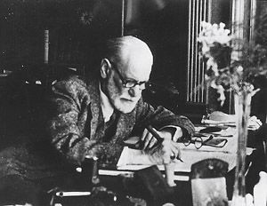
What is a
stereotype of psychologists?
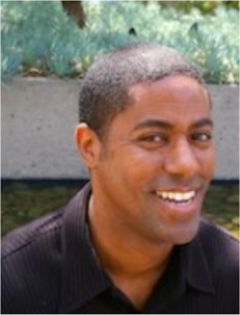
These are all images are of actual
or types of
psychologists
Do they fit your stereotype?
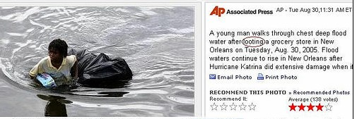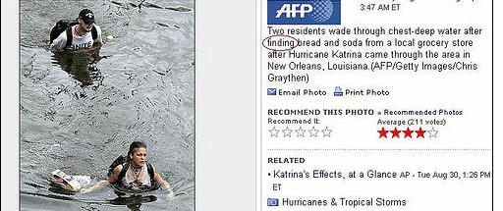
Stereotypes can influence
us
to
have
d
ifferent
interpretations
of the same
event
Stereotypes inform how we
see our social world.
They can be embedded in the
language we use and the way
we talk to and about people
from different outgroups.
https://www.facebook.com/bravenewfilms/videos/vb.7035457015/10152837180812016/?t
ype=2&theater

WHAT IS PREJUDICE?
AFFECTIVE
COMPONENTS
•
Prejudice is derived from the Latin
prae
and
judicium
meaning
pre
-
judgement
•
Unfavourable views
of people belonging to a particular group
IN THE EXTREME:
D
EHUMANISATION
–
stripping people of their
dignity and humanity
•
Negative or hostile
evaluation
of
persons
based on their membership
in a group other than one's own.
Some types of prejud
ice
•
Racism
•
Sexism
•
Ageism
•
Singalism
•
Classism
)
Socioeconomic status
(
•
Heterosexism
)
(
Heteronormativity
•
Sexual orientation
•
Occupation
sex work, strippers,
(
road workers, cleaners)
•
Physical disabilities
•
Mental health
•
Religious views & beliefs
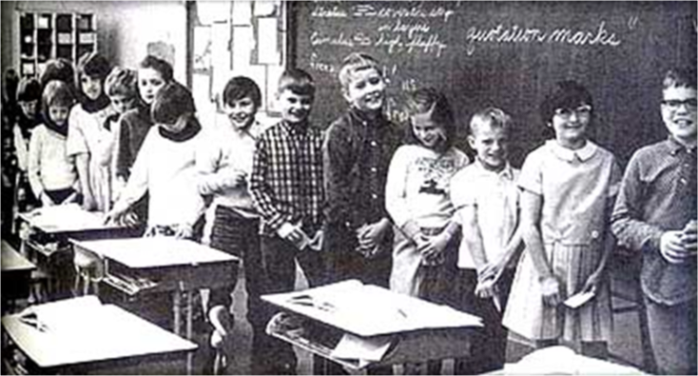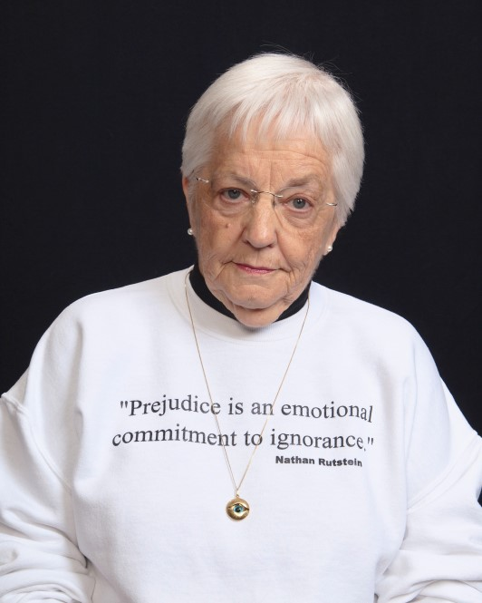
Why does prejudice arise?
•
In group/out group
dynamics
(
remember Social Identity Theory
)
Jane
Elliott’s Blue Eyed/Brown Eyed study
https://www.youtube.com/watch?v
=
NLAqAtW1h
-
o

CAUSES OF PREJUDICE

Biological explanation
- Survival of the fittest, propagation of our genes
- Motivated to look out for others with the same genes (in-group)

- Children, kin, tribesman more likely to share our genes than strangers and members of competing groups, therefore we look out for their interests
- Creates the “US” versus “THEM” phenomenon

Realistic Conflict Theory*
- Limited resources lead to conflict between groups, and results in increased prejudice and discrimination
- Especially true in an economic recession, when jobs are scarce all around
- “The immigrants are taking our jobs and buying up our land’’
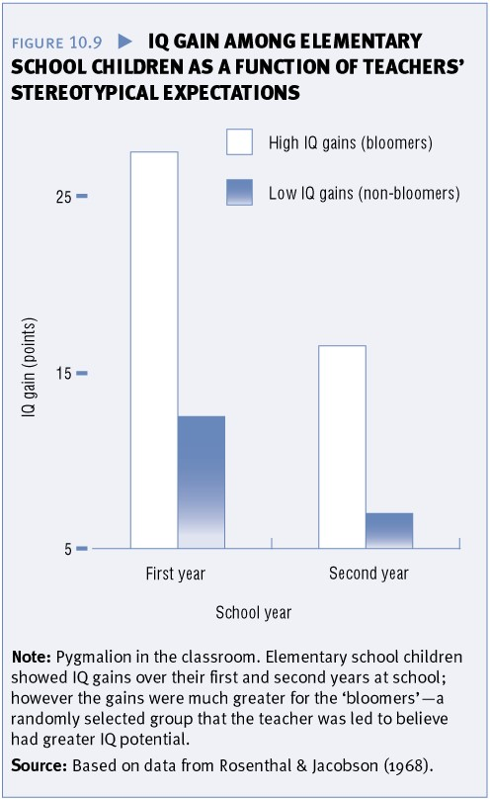
*We looked at this theory in Week 7
•
S
ELF
-
FULFILLING
P
ROPHECY
:

Expectations
and assumptions
about a person that influence
one’s interaction with that
person and eventually change
that person’s behaviour in line
with one’s expectations
Negative Consequences of Prejudice

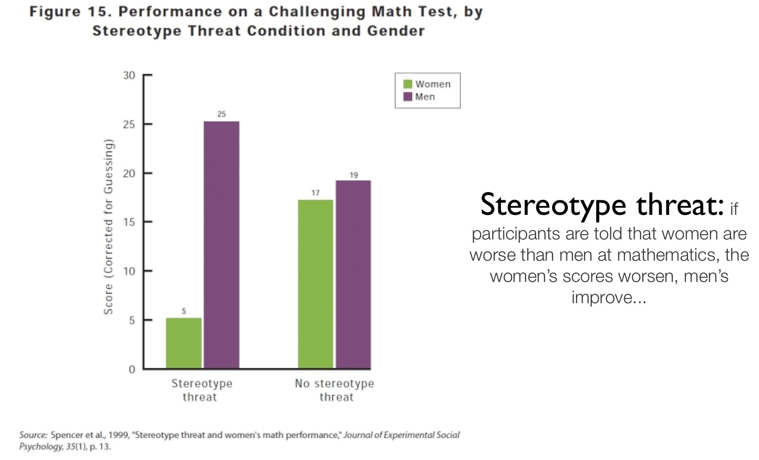
•
S
TEREOTYPE
T
HREAT
:

the
fear that one might confirm the stereotypes that others hold.
When people fear that they will be negatively
stereotyped,
their
performance suffers.
Negative Consequences of Prejudice
•
M
INORITY
S
TRESS
:

chronically high levels
of
stress
faced by members of
stigmatized minority groups.
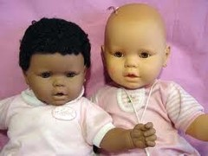
•
Reduced
self
-
worth, self
-
esteem,
well
-
being
https://www.youtube.com/watch?v=
WG7U1QsUd1g
Negative Consequences of Prejudice
•
Stigma:
Possessing some attribute that conveys a
social identity that is devalued in a particular
social context
•
Failure and disadvantage
•
Violence, genocide, infanticide
COMBATING PREJUDICE
•Contact hypothesis (Allport, 1954)
- Increased contact can decrease prejudice by increasing familiarity and reducing anxiety.
- Social Learning View (of Prejudice): prejudice is acquired through direct and vicarious experiences in much the same manner as other attitudes.
- Mixed research about the effectiveness
- Does not need to be direct contact, vicarious contact through media can also work.
- Better if inter-group collaboration toward mutual goals. ✪

COMBATING PREJUDICE

Social Influence
- Social influence plays an important role in both the maintenance and reduction of prejudice.


- We want to hold beliefs that we see as normative of our group; providing individuals with evidence suggesting that members of their group hold less prejudiced views than they previously believed can reduce prejudice.

Critical Disruption
Curbing prejudice at the individual, group and social level
- Challenge subtle prejudicial discourse
- Through language and dialogue
- Speak up and resist racist/sexist talk
- Offer and foster alternative and egalitarian discourses
- Change social and group norms… … so it becomes socially unacceptable to do or display modern prejudice


WHAT IS DISCRIMINATION?
BEHAVIOURAL COMPONENTS
•
Harmful actions or behaviour directed at certain
groups, due to stereotypes and prejudice
IN THE EXTREME:
G
ENOCIDE
–
the extermination of an
entire social group
To recap:
•
Stereotypes
are
the
beliefs
•
Prejudices
are the negative feelings
•
Discrimination
is
when
one
acts
on
those
feelings
and/or
beliefs
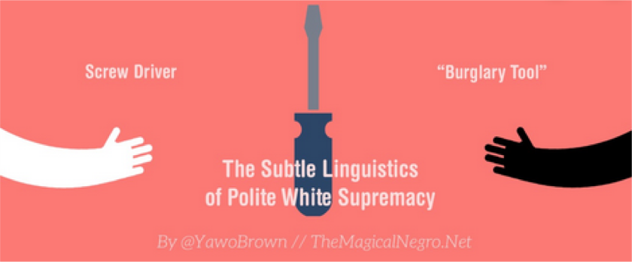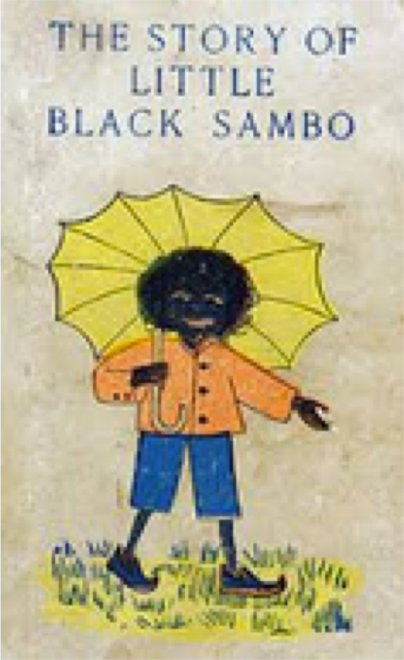
NEW
/
MODERN
PREJUDICE
(
& DISCRIMINATION
)
OLD
-
FASHIONED PREJUDICE
(
& DISCRIMINATION
)
versus
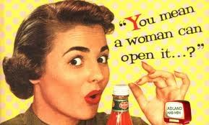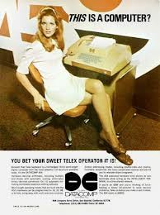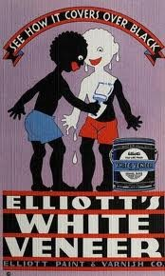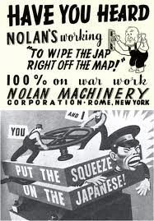
‘Old fashioned’ forms of prejudice
•
Overt and hostile
•
Direct and explicit to equality (based on race; gender)
•
Men seen as superior to women
•
White seen as superior to ‘others’
Over the past 30 years, blatant New / Modern discrimination has been reduced, Prejudice but not eliminated. Instead, it has become …
- More covert and subtle
- Harder to detect/deter
- Is often institutionalised / standardised in practices
- Prevalent in mass media
- Is influenced by culture, history, politics
- Modern racism revolves around ‘cultural’ differences
- Modern sexism revolves around the ‘nature’ of men/women
Stronger efforts to decrease/deter are needed

Overt
(
Old fashioned)
Prejudice
:

•
Prejudice that is widely frowned upon in
this society
Subtle
(
Modern)
Prejudice
:

•
Sometimes slips under the radar
•
Outwardly
acting unprejudiced, while
inwardly maintaining prejudiced
attitudes
Which is more common?
Which one is more dangerous?
Can you pick up on your own or others'
subtle prejudices?
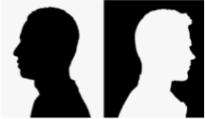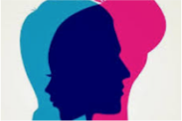
EXAMPLES OF NEW
R
ACISM
&
S
EXISM
Manifestations of Stereotyping, Prejudice and Discrimination based on
RACE
and
GENDER

NEW RACISM
Goes by many names:
- Modern racism
- Subtle racism
- Symbolic racism
- Aversive racism
- Regressive racism
- Ambivalent racism
- Implicit racism
It is more subtle, complex and ‘socially acceptable’
- Target types of things people do and/or who they are and their actions (rather than how they look or racial difference)
- Less about ‘biological’ superiority; more about ‘cultural’ superiority
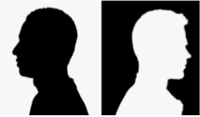

- Can involve concealing prejudice from others in public settings, but expressing bigoted attitudes when it is safe to do so; for instance, in the company of friends known to share these views
- more subtle beliefs than blatant feelings of superiority.
- consists primarily of thinking minorities are seeking and receiving more benefits than they deserve
- a denial that discrimination affects their outcomes

New / Modern Racism
- Rejects white supremacy
- People say they are not racist
- Egalitarianism promoted
- Ambivalent…say both good and bad things about a group
- Not outright racist
- Subtle undertones
- Hard to measure in
experimental/mainstream ways
- Critical psychology and the corresponding discursive methods are designed to deal with ambiguity and contextual variability (Edwards & Potter, 1992; Tuffin, 2005).

Common Forms of Modern Racial
Discrimination
- Reluctance to help
- Failing to help other groups to improve their position in society
- Tokenism
- Practice of publicly making concessions to a minority group in order to deflect accusations of prejudice or discrimination
- Reverse discrimination
- The practice of publicly being prejudiced in favour of a minority group in order to avoid accusations of prejudice or discrimination
- Microaggressions
- Brief and commonplace verbal, behavioural or environmental indignities
- “Everyday insults, indignities and demeaning messages sent to people of colour by well-intentioned white people who are unaware of the hidden messages being sent to them” (DeAngelis, 2009) https://www.apa.org/monitor/2009/02/microaggression
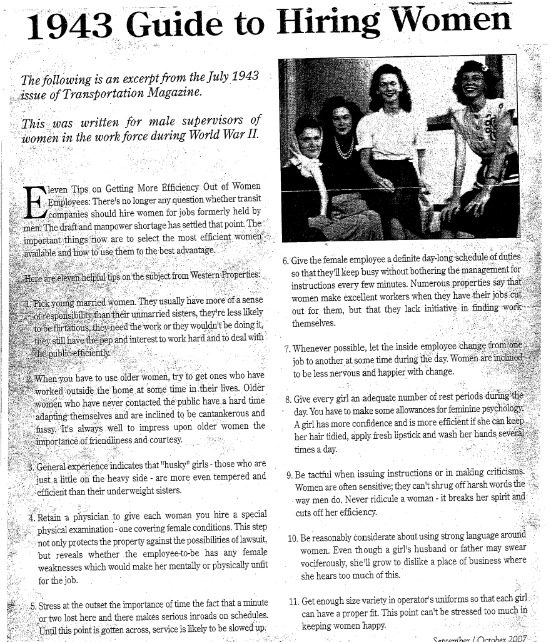
Old fashioned
sexism

Hostile sexism
•
Old
-
fashioned beliefs about
women and their capabilities
and nature
•
“a woman can’t do a man’s job”
•
“all women are irrational”
Benevolent sexism
•
Chivalrous ideals about how
women are special and need to be
protected
•
Women put on a pedestal
•
Idealised/cherished
•
But still not seen as equal to men
A
MBIVALENT
S
EXISM
2001)
Glick & Fiske,
(
NEW SEXISM
Types of sexism (toward women)
SOME OLD AND NEW
- Generic Masculine
- Face-ism
- Requirement for girls/women to be far more groomed than boys/men
- Continued pay gap (13%)
- Promotions going to men (who won’t be leaving to have babies)
- Women leaders judged for their ‘attire’ or ‘looks’ vs. policies
- Treating of ‘family/domestic’ violence as less serious
(Toward men??)
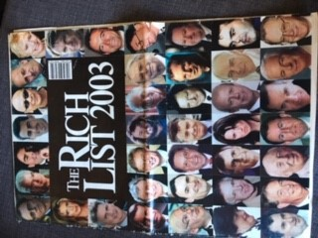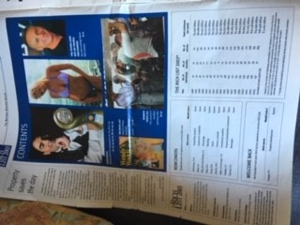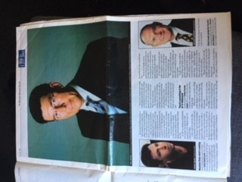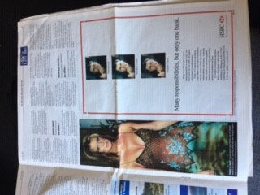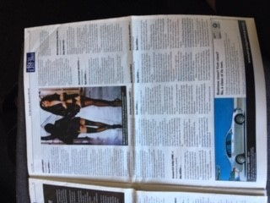
Face
-
ism
•
Tendency
for visual media and advertisements to represent
men by their faces
(
representing their intellectual worth)
but
women
by their whole bodies
representing their physical worth).
(
National Business Review,
18
2003
July
Out of the many New Zealanders listed/shown on the
cover, inside there were
four stories (and pictures) of the ‘wealthiest’ women. Three of
them
were
shown
in lingerie or
swimwear.
None of
the
men were photographed in lingerie or
swimwear
—
or in ways that depicted how they made their money.
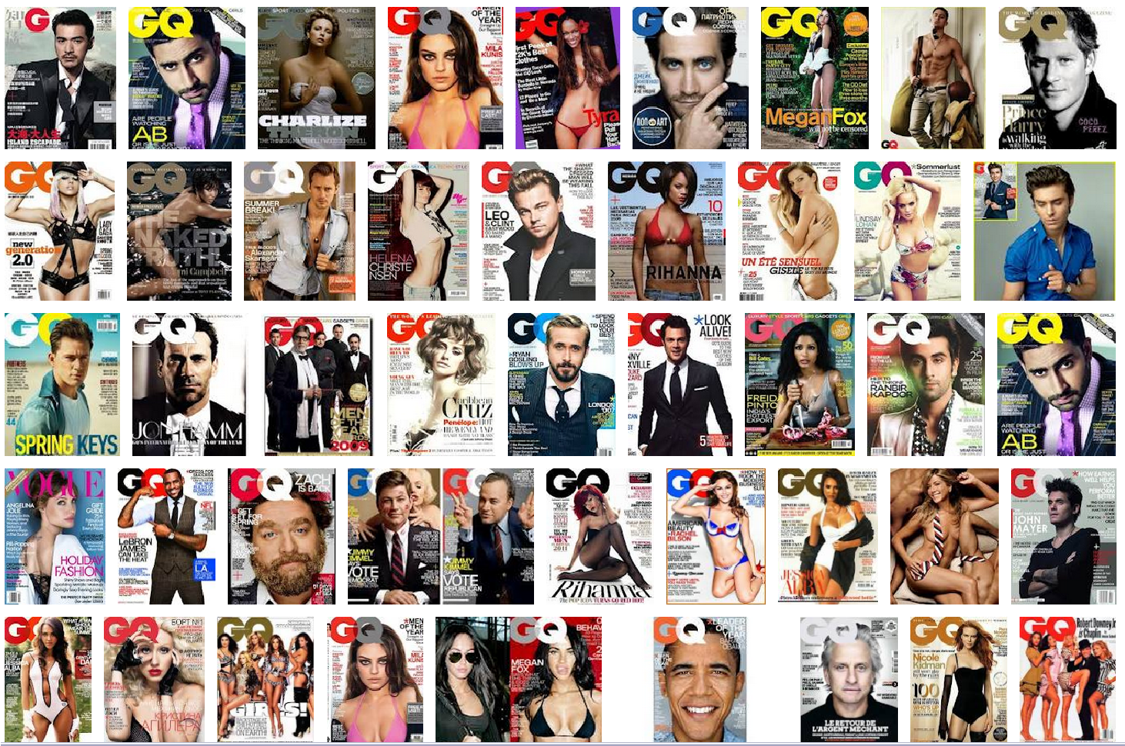
Media perpetuation?
22
male covers
How many are
under
-
or scantily
-
dressed, or being
sexually depicted
?
25
female covers
How many are
under
-
or scantily
-
dressed, or being
sexually depicted?

