A_{GGRESSION} HARMING &
(CHAPTER 12)
HELPING
PROSOCIAL
BEHAVIOUR
(CHAPTER 13)
WEEK 9 (2020)
DR SHIVANTHI BALALLA _ SOUTH
DR RHODA SCHERMAN _ NORTH
PSYC602:
SOCIAL PSYCHOLOGY
Topics covered this week
AGGRESSION PROSOCIAL BEHAVIOUR
- How aggression is defined and measured  - Biological and Social theories of aggression  - Personal and situational variations that contribute to aggressive behaviour  - Institutional aggression  - Reducing forms of aggression like Domestic  violence |  | - Defining prosocial behaviour  - Evolutionary and Biological theories of helping  - Learning to be helpful  - Bystander Apathy  - Factors that contribute to prosocial behaviour  - Special forms of helping behaviour

Definitions of Aggression

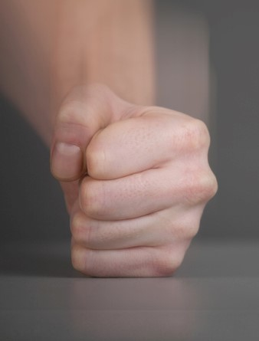
- Actual harm (even if it wasn’t intended)
- Physical injury (excluding psychological harm or verbal abuse)

¡ Harm in a rule-governed context ¡ Injury alleged to be in one’s best interest (e.g. smacking a child)
(e.g. boxing)
- Harm to a person (excluding animals and property)
- Intention to do harm (excluding carelessness or neglect)
- Harm to people in war They all distil down to:
- Self-injury The intent
- Belief by a victim that harm has

occurred to harm
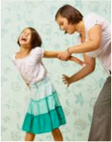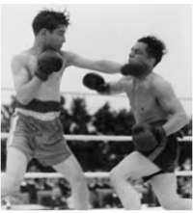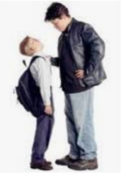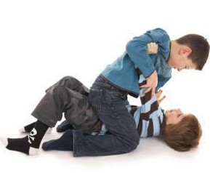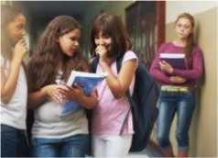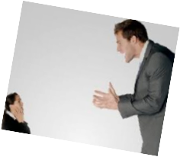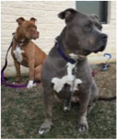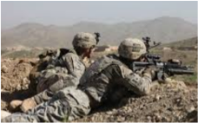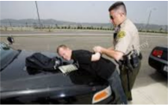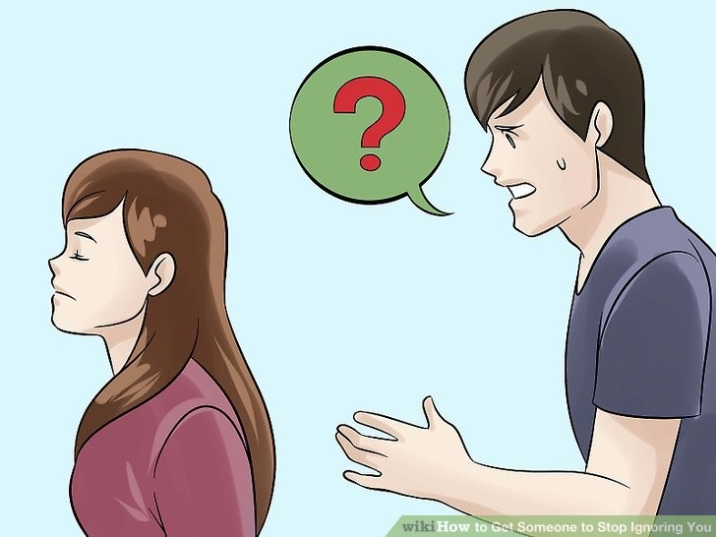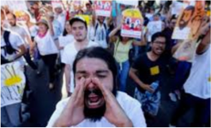
Is this aggression?
Protesting?
Animal
Combat?
Scheduled fight?
abuse?
Gossip?
Verbal
threats?
Physical altercation?
Bullying?
Law
Enforcement?
Passive
aggression?
Smacking?
Even though somewhat subjective,
to answer, one needs to ask if the
actions were intended to harm

Rates of Aggression
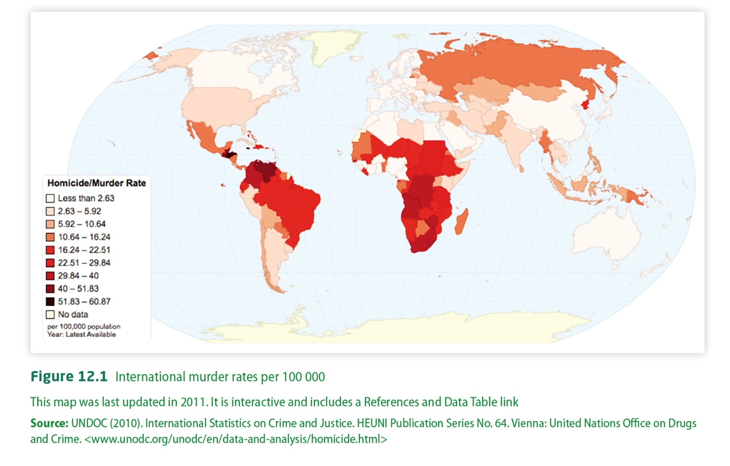
Any thoughts on the locations of the highest rates?

Factors that increase Aggression
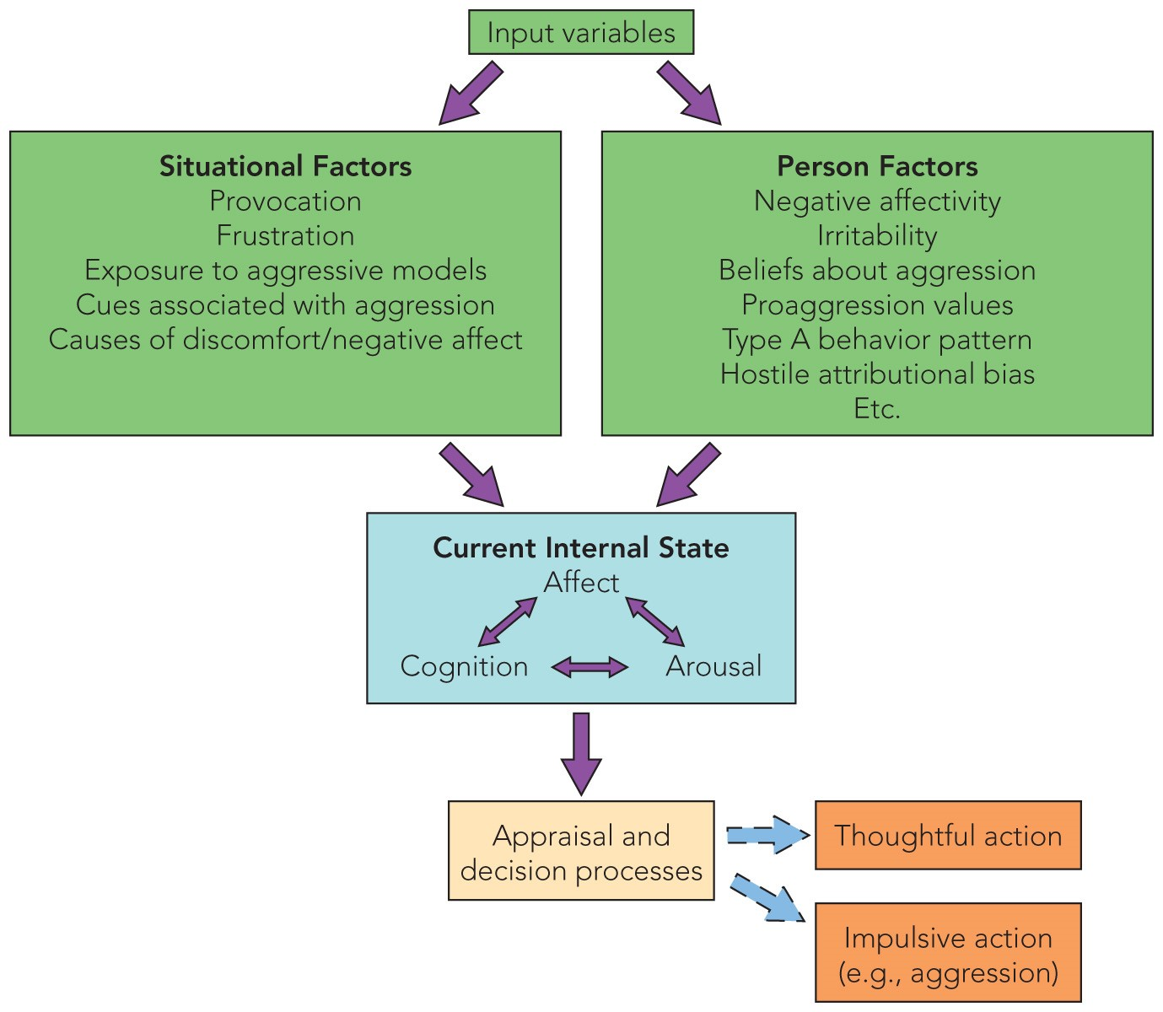
Situational
Personal

–
Hormones
–
Socialisation
–
Personality
–
Catharsis
¡
Some research into causes of
aggression has concentrated
on factors thought to be
‘part’ of the person:
Personal Factors in Aggression
Personal Factors in Aggression
- Hormones  - Men statistically more aggressive when compared to women  - Testosterone explains only 2% of aggression, and the correlation may not mean causality | ¡Socialisation  ¡ Theory holds that gender differences are more related to societal norms than to biology
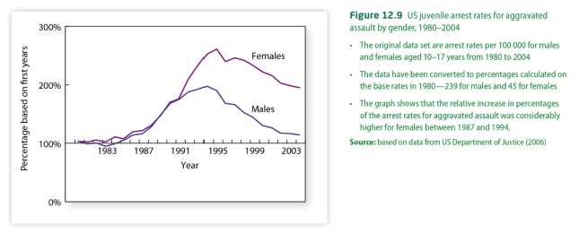
Personal Factors in Aggression

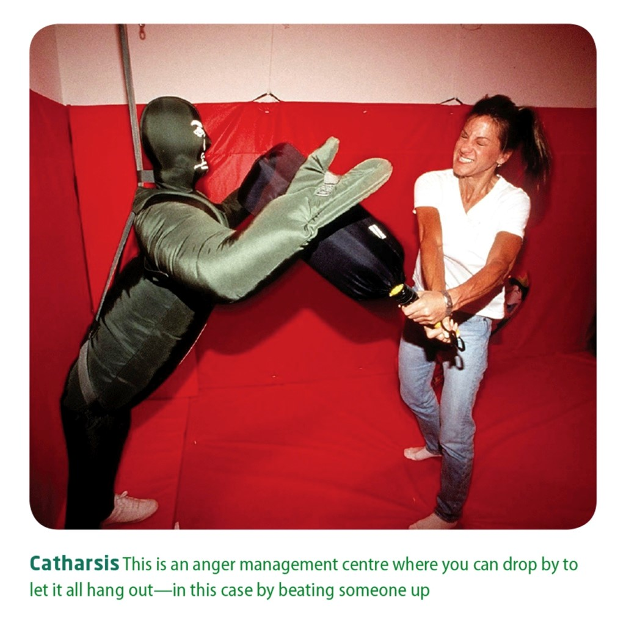


¡Catharsis
¡
Rage
Rooms
used for
catharsis
- Belief that venting helps release aggression
- Yelling, punching a pillow or inflatable doll
- Empirical evidence is weak
https://www.psychologytoday.com/us/blog/modernminds/201703/rage-rooms-not-good-idea

¡Personality
- Type A or Type B
- Competition, urgency, hostility
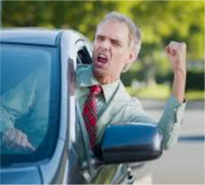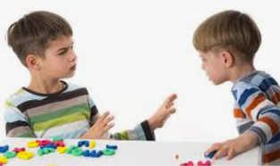
Situational
Factors in Aggression
¡
Some
studies have focused on situational factors
to explain
aggression
–
Social disadvantage
–
Physical environment
–
Direct provocation
Remember “relative deprivation”?
Think HEAT
Defending oneself?
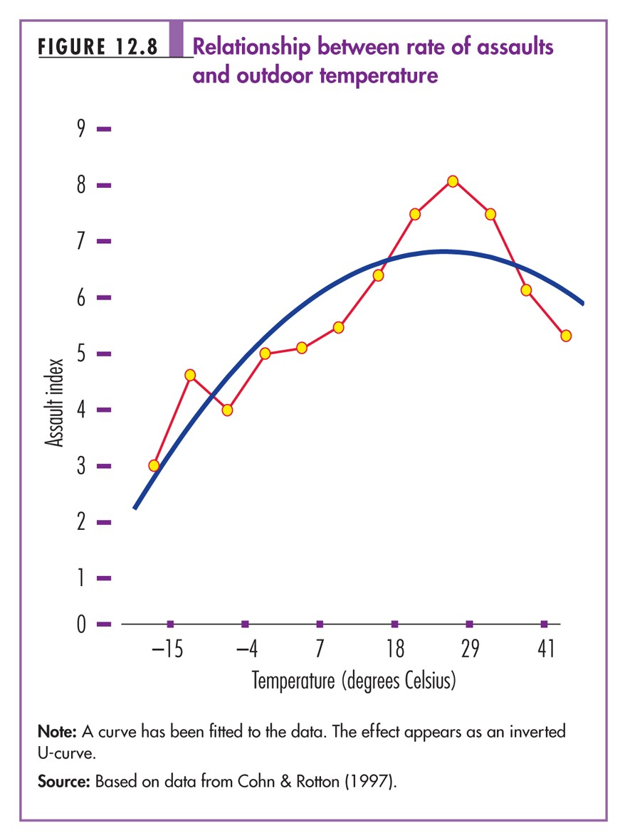
Why do rates of aggression begin to drop in the highest temperatures?
Alcohol and Aggression




¡Alcohol
Can be Situational or Personal
Usually results in the Three Ds …
Alcohol and Aggression
Deindividuation
Disinhibition ¡ A loss of self-awareness
- Lack of restraint for or sense of identity; social conventions; reduction in saying/doing comparisons of oneself
without thought of against meaningful consequences social standards; when people cannot be
Dehumanisation individuated from the

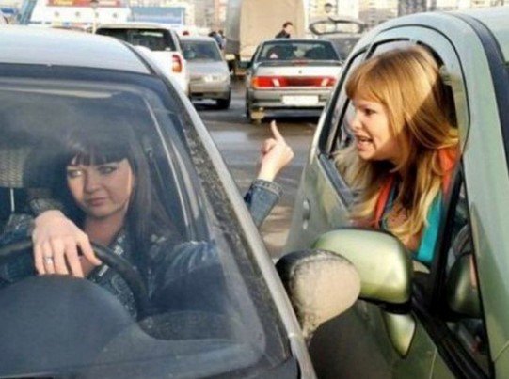

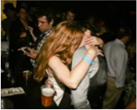

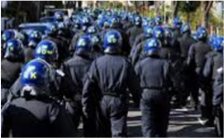
- Reducing a crowd, they can lose human being to sense of accountability a single (usually negative) characteristic
Biological Theories of Aggression

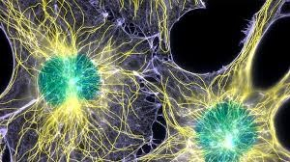
Biological explanations
- Aggression is instinctual
- Environmental stimuli can also be a trigger for aggression, suggesting interplay
between nature and nurture influences

Evolutionary Social Psychology

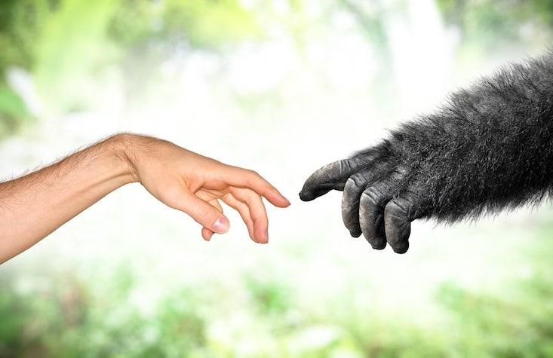
- All social behaviour (including aggression) has a biological basis
- Aggression helps us survive and protect kin
- Aids in competition for resources
Bio-Social Theories of Aggression
 |  | 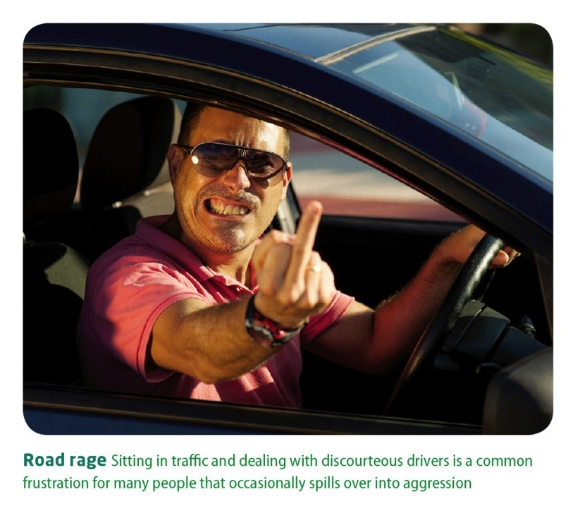
  Frustration-Aggression Hypothesis:
  Suggests that frustration is a very powerful determinant of aggression
  What might be a
  weakness of this theory?
Excitation Transfer Theory:
Suggests that arousal produced in one situation can persist and intensify emotional reactions occurring in later situations.
This is more likely to happen when people are:
- not aware that they are experiencing residual arousal
- aware of their arousal but attribute it to the present situation




Bio-Social Theories of Aggression

Excitation-Transfer Model
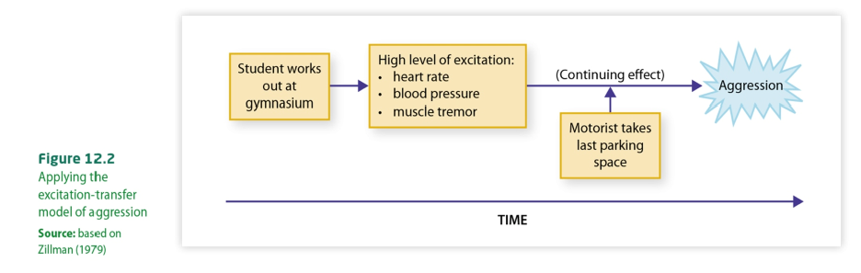
Consider the situation where
sports fans are hyped up on a
win
—
or a loss
—
and post
-
game
excitation turns
aggressive.
V
iolence erupts in Buenos Aires after Arge
ntina’s World Cup loss
Social Theories of Aggression

Social Learning Theory
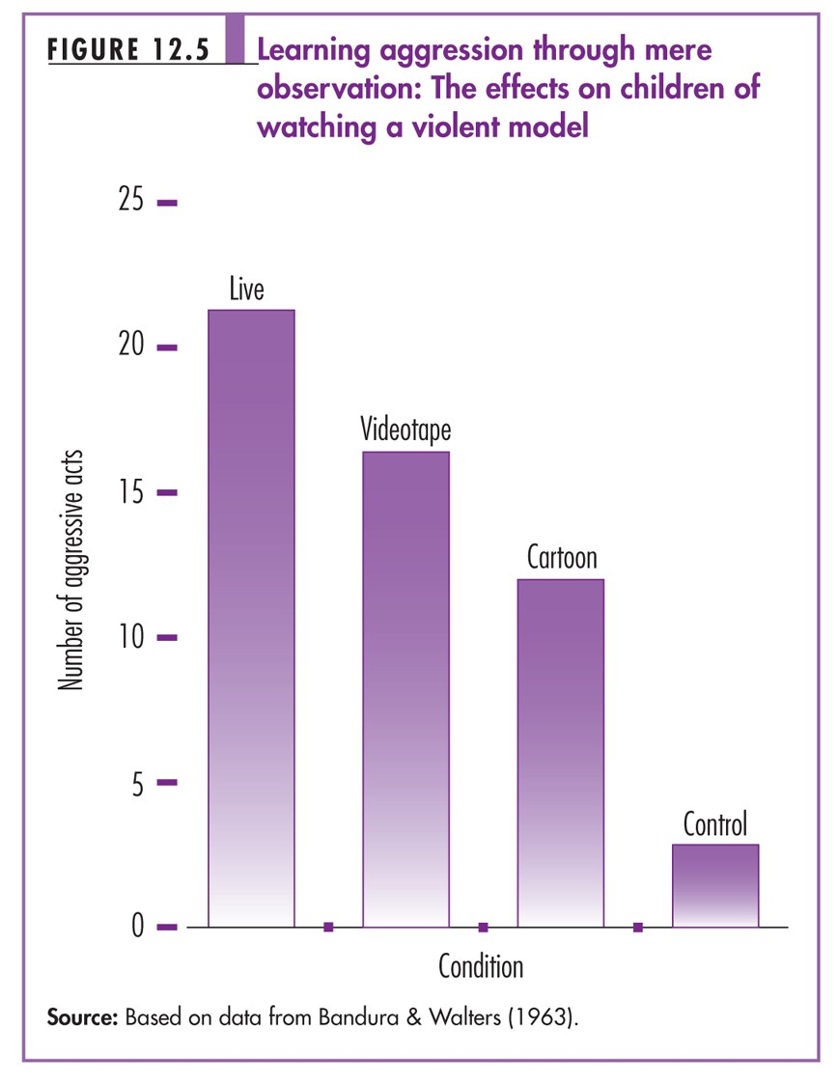

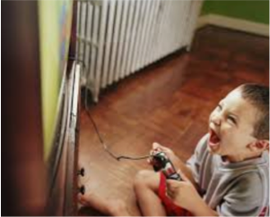
¡ Stresses reinforcement principles and the influence that models have on the young child
https:/
/
www.youtube.co
m
/
watch?v
=
Z0iWpSNu3NU
Media and Aggression

- The role of the mass media, particularly television, is controversial
- Violence is very frequent
- It is fashionable to argue that
in the popular offerings of the continued portrayal of ^{the mass media} violence at the very least
- Some researchers claim desensitises young people to that the effects are the consequences of violence temporary, and most
significant (i.e. influential) ¡ A stronger argument is that it in those who are already provides a model for future
predisposed towards behaviour, a debate that aggression continues still today

Domestic violence
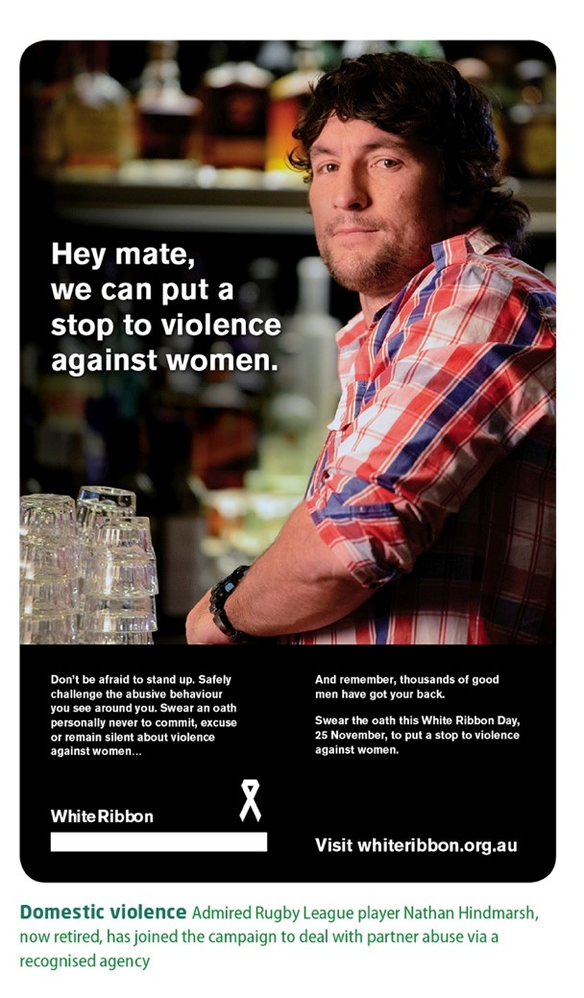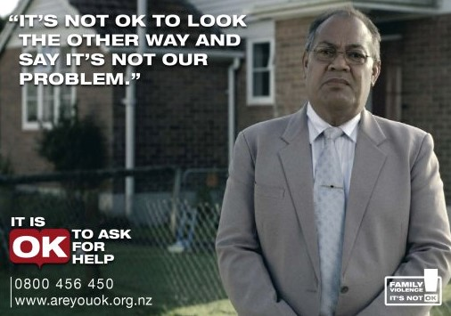
¡
Chronic
under
-
reporting
makes
collecting
accurate
stats difficult
¡
Domestic violence
(
assault, rape, and incest
within the home)
accounts for as much
as 80% of all violent
offences in the country
Belief in a Just World
- People want to Blaming believe that the
world is just, and the that people get Victim what they deserve.
- They look for ways to explain the bad things that happen
She was to people, asking for it! sometimes
rationalising that




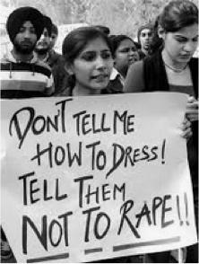
Just look at the victim somehow how she’s deserved it dressed!
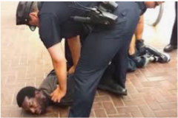
Institutional aggression
¡
Aggression that is
given formal or
informal recognition
and social
legitimacy by being
incorporated into
rules and norms
¡
Different cultures
view aggression
differently
¡
We value institutional
aggression in certain
^{contexts, including:}
¡
Sports
¡
War
¡
Law and Order

Institutional aggression
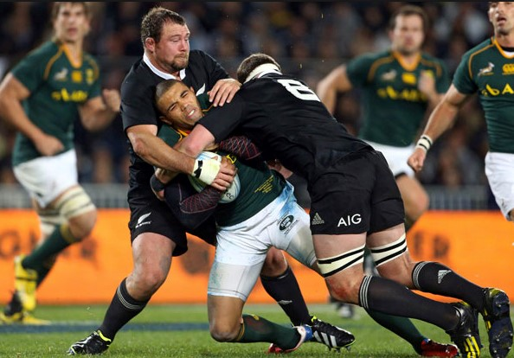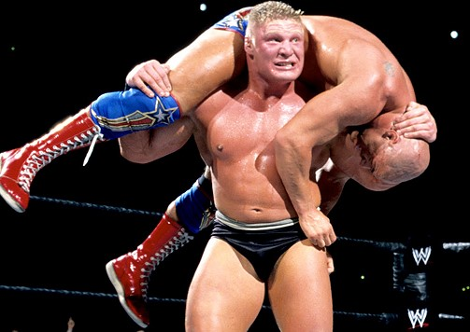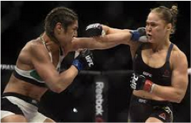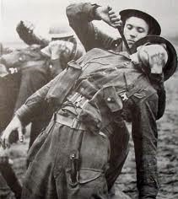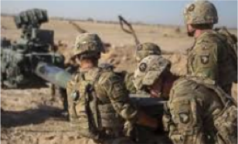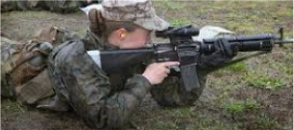
Sports
War
Aggression can be useful for society in certain contexts (e.g. maintain social order); when highly regulated, aggression provides enjoyment.

PROSOCIAL BEHAVIOUR

Helping behaviour

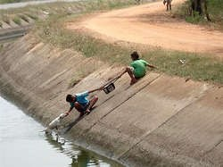

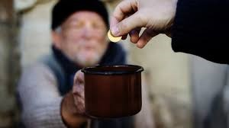
¡Refers to all acts positively valued by society, and includes helping and altruistic behaviours
Altruism
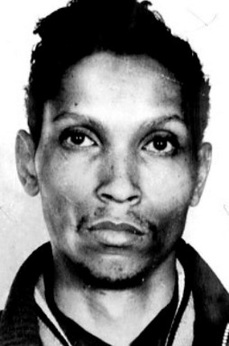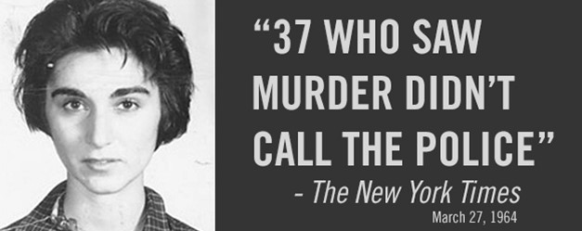
The Kitty Genovese murder
¡
This single event in credited with
stimulating and heavily influencing the
entire field of
prosocial
behaviour
in
human beings
¡
It also sparked research into
bystander
involvement
https:/
/
www.youtube.co
m
/
watch?v
=
BdpdUbW8vbw
People help others because …
It’s adaptive and helps the species
Evolutionary Social Psychology:
- Views complex social behaviour (like helping) to be adaptive, helping the individual, kin and the species as a whole to survive

Helping is not just a human behaviour
Animals also engage in cross-species helping behaviours …
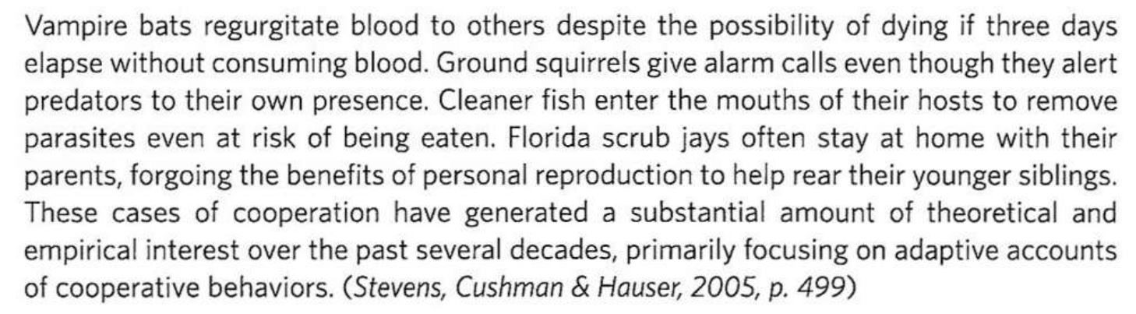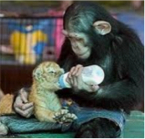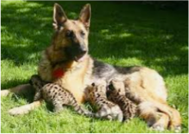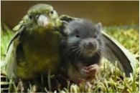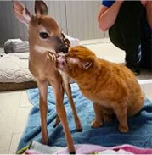
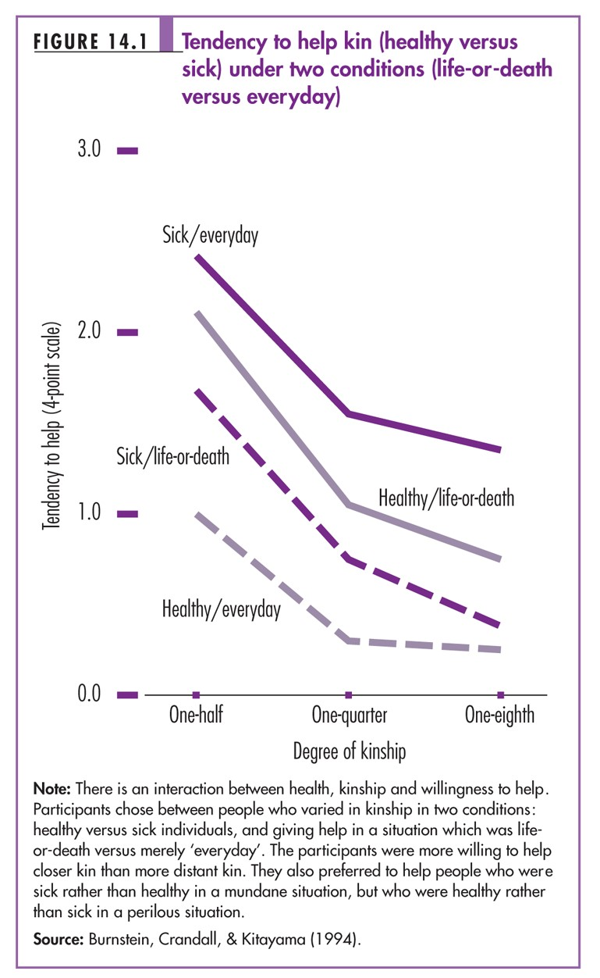
Evolutionary Perspectives
Kin Selection Theory
¡
Suggests that a key
goal for all organisms is
getting their genes into
the next generation
¡
One way in which
individuals can reach
this goal is by helping
others who share their
genes
Empathy and Helping
Empathy
- Ability to feel another person’s experiences
- Emotional reactions that are focused on other persons, and include feelings of compassion, sympathy, and concern
- Helping others reduces our own unpleasant feelings
Empathy consists of three distinct components
- Emotional empathy – sharing the emotions of others
- Empathic accuracy – accurately perceiving others thoughts and feelings
- Empathic concern – feelings of concern for another’s well-being.
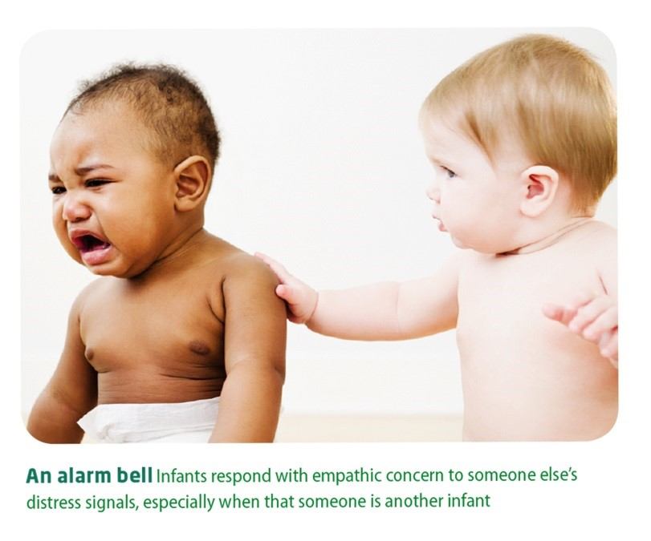Even very young children demonstrate a capacity for empathy
People help others because …
We’ve learned to

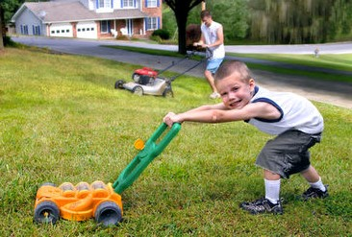
Modeling:
- Tendency to reproduce the actions, attitudes and emotional responses of a real or symbolic model
- Observational Learning is another term for this concept
Learning to be helpful
Social Learning
Theory
¡The view championed by
Bandura that human social behaviour is not innate but learned from appropriate models.
Vicarious Learning
¡Acquiring a behaviour after observing another 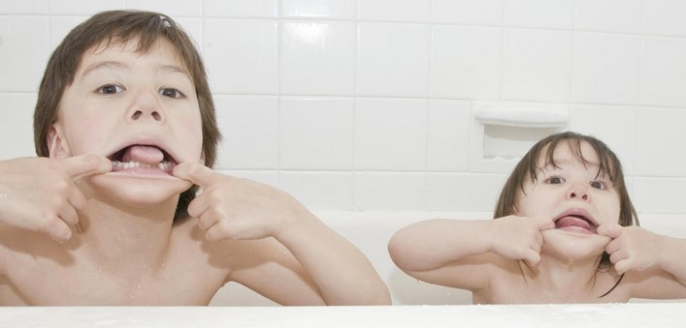person was rewarded for it.
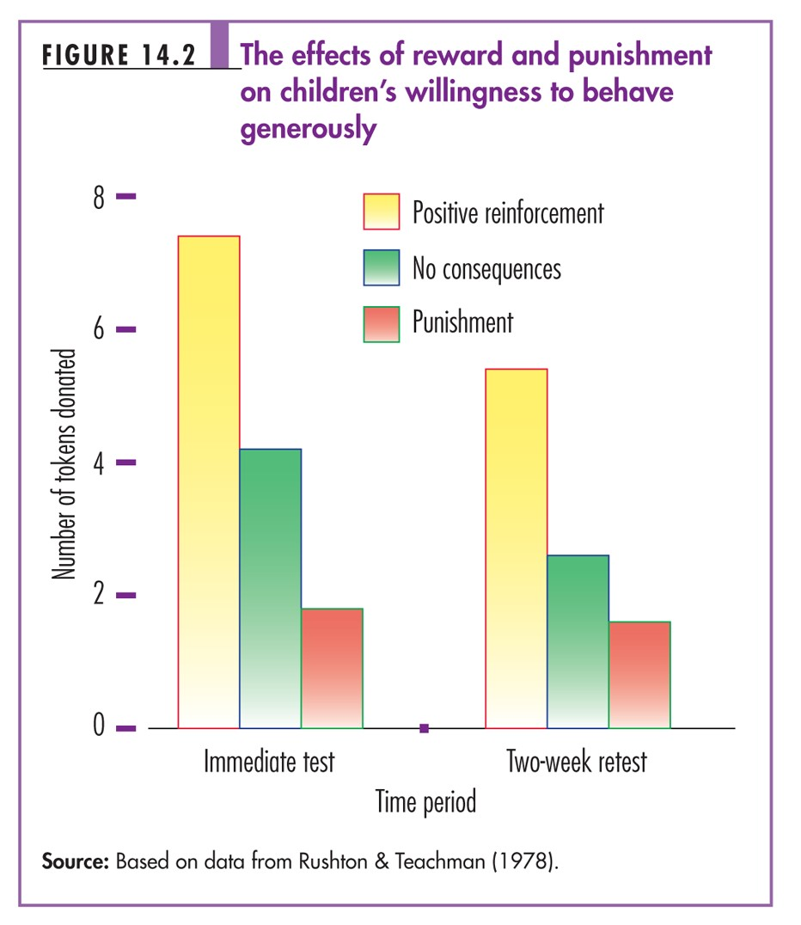

Latané and Darley’s Cognitive Model

When faced with an emergency, a bystander’s tendency to help or not help depends in part on decisions made at five crucial steps.
- Noticing an event
- Interpreting the event as an emergency
- Assuming responsibility
- Knowing how to help
- Deciding to implement the help
Elements of an emergency situation:
- Can involve danger for person or property
- An unusual event, rarely encountered by ordinary person
- Can differ widely in nature from a bank on fire to pedestrian begin mugged

- Not foreseen so that prior planning of how to cope is improbable.
- Requires instant action, so leisurely consideration of options is not feasible.

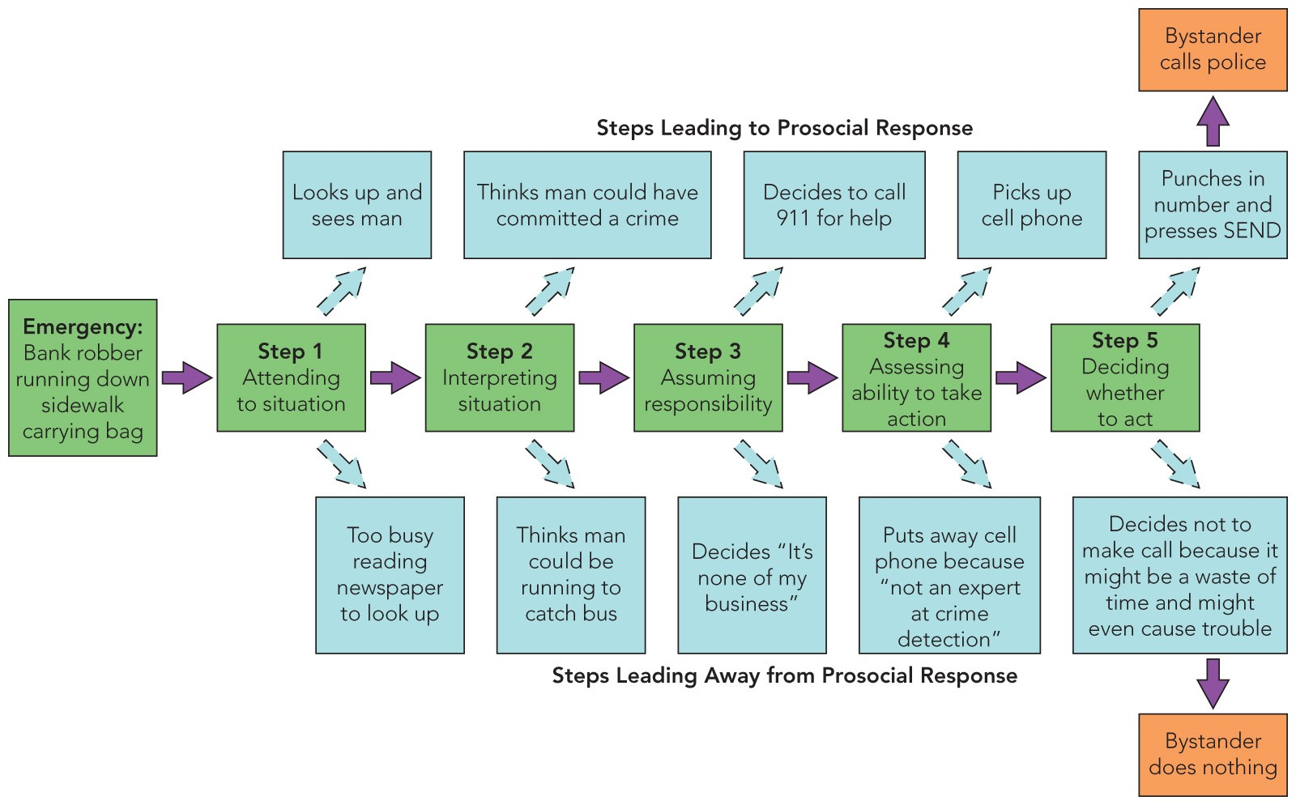
Latan
é
and Darley’s Cognitive Model
Processes contributing to bystander apathy


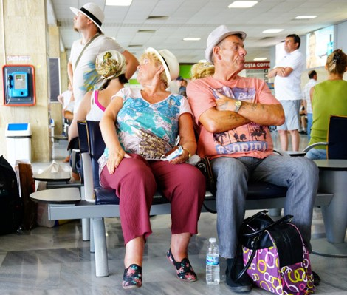

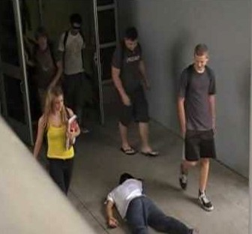
Diffusion of responsibility
https://www.youtu
be.com/watch?v=ybpg_B9S_q0
¡ The tendency of an individual to assume that others will take responsibility; as a result no one does. This is an hypothesised cause of the bystander effect.

Fear of social blunders
¡ The dread of acting inappropriately or of making a foolish mistake witnessed by others. The desire to avoid ridicule inhibits effective responses to an emergency
by members of a group.

Personal factors in helping
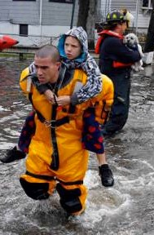
¡
Attachment styles
¡
Leadership
¡
Competency
E
¡
Geographic location
E
¡
Mood
E
Children who share or offer help, continue to do so as adults
Acts as a cue to take responsibility
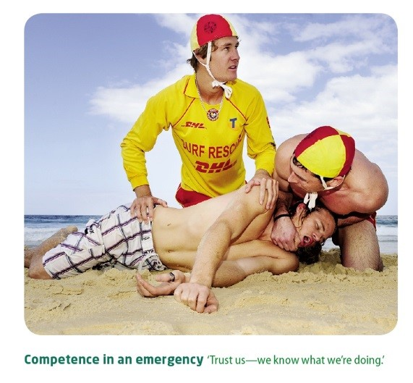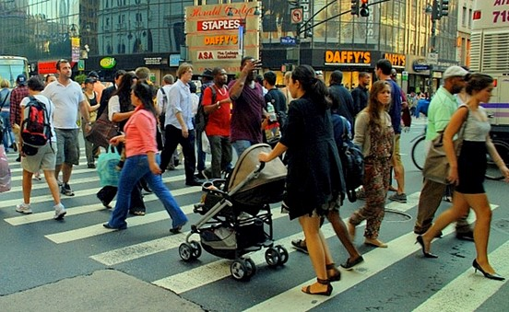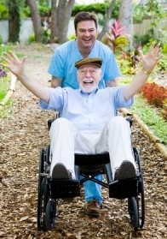
Personal factors in helping
¡
We’re more likely to help if
we feel able to deal with the
situation
Competence
¡
A
s population size increases,
helping behaviour decreases
Urban living
¡
When we’re in a good mood,
we’re more helpful
Mood

Volunteerism

The ultimate helpers

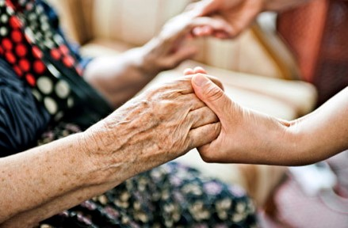
¡An increasing number of people volunteer their time to help others ¡Civic participation
¡Health and wellbeing
¡Hospice
¡Social change

Four motives for helping others

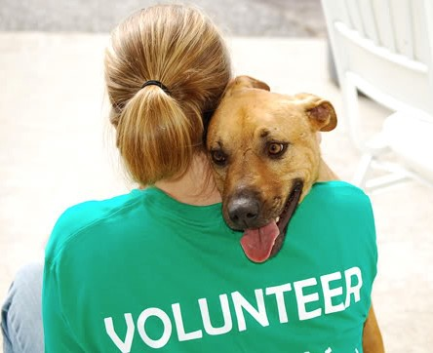
¡Egoism – act contributes to the welfare of the individual
¡Altruism – act contributes to the welfare of other people
¡Collectivism – act contributes to the welfare of a social group
¡Principalism – act follows from a moral principle, such as “greatest good for the greatest number”

How it increases helping
¡ While some people who ¡Gratitude engage in prosocial


behavior prefer to remain ^{Thanks expressed by the} anonymous, most want recipients of help—has been
found to increase subsequent to be thanked for their
help publicly and ^{helping} graciously
An
Attitude of
Gratitude
Some additional of factors that increase helping
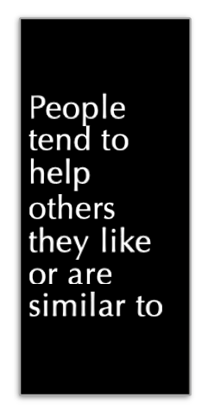  Exposure to  prosocial  models  increases  prosocial  behavior
  Inclusion and feelings of
  belonging with the group increase
  helping
  People tend to help those who are not responsible for their problems
The presence of a helpful bystander

Random acts of kindness
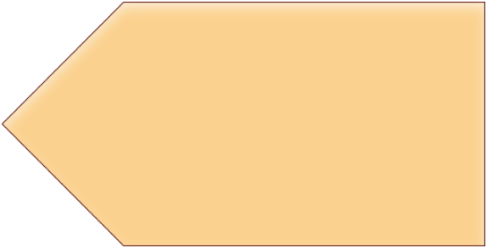
My religion is
simple.
My religion is
kindness.
The Dalai Lama
"Random acts of kindness are those sweet or lovely things we do for no reason except that, momentarily, the best of our humanity has sprung into full bloom.
When you spontaneously give a stranger the bouquet of red carnations you had meant to take home to your own dinner table, when you give your lunch to the guitar playing homeless person who makes music at the corner between your two subway stops, when you anonymously put coins in someone else's parking meter because you see the red "EXPIRED" medallion signalling to the meter maid… you are doing not what life requires of you, but what the best of your human soul invites you to do."
(Daphne Rose Kingma, from the book Random Acts of Kindness, by Dawna Markova, Conari Press)
Random Acts of Kindness
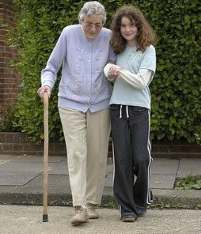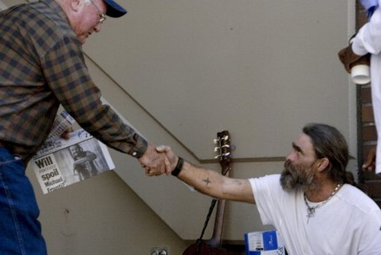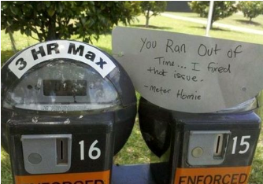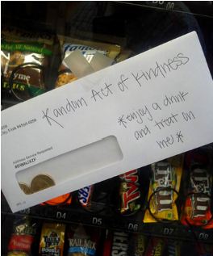
¡
Work together to come up with five
(5)
random acts of kindness that
you could do this week.
¡
Go away and do them!!
Random acts of kindness

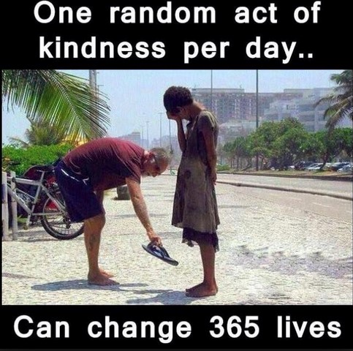
- http://www.worldtrans.org/pos/ran dkind.html
- https://rak.co.nz/
- https://www.stuff.co.nz/lifestyle/106651591/10-acts-ofkindness-to-do-this-random-acts-ofkindness-day
- https://www.randomacts.org/event /new-zealands-random-actskindness-day-3/
- https://www.kindspring.org/
Be a RAKtivist! ¡ https://www.kindnessinc.org/

