

6th annual Hoop School

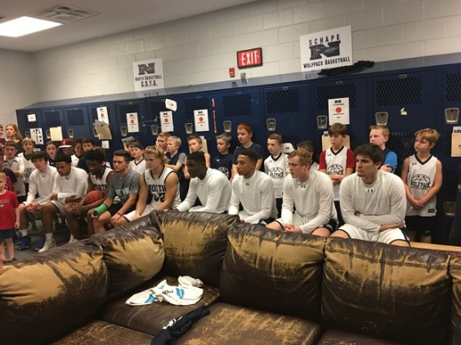
June 26th – June 28th
From 9 am – 1 pm
June 29th
From 9am- 12 pm

Your child will be coached by NPHS Coaches and the Varsity Team


Early registration: $105 by June 21st
Walk-Up registration$125 by June 26th @ 8:30 am

To make checks payable write them to npbpgc
You can mail them to 300 N Paulding drive Dallas, GA 30132



----------------------------------------------------------------------------------------------------------------------------------------------------------------
Name:__________________ Age:__________ DOB:___________ Grade(2017-2018 school year):___________
Parent name(s):_________________________ Address:__________________________________________________
Home/cell phone:_______________ Email:______________________________ Work phone:____________________
Insurance information*
Name of Policy:_______________ Company:________________ Policy number:_____________________
Waver: the above participant is in good health and has my permission to participate in this camp. In case of emergency I hereby give permission for my child to be given emergency medical treatment by on-site medical professionals, a local doctor, hospital, or dentist and hereby waive and release said camp from any and all liability from injuries incurred while attending camp and payment of said services are the total responsibility of the parent.
Parent Signature:______________________________________

