Task 1: Creating the XML File
XML Tree View
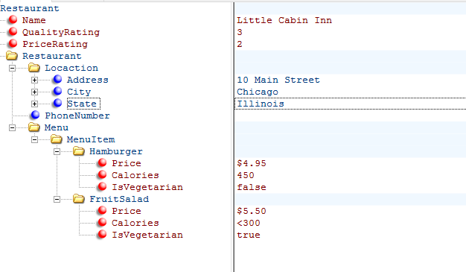
XML Output
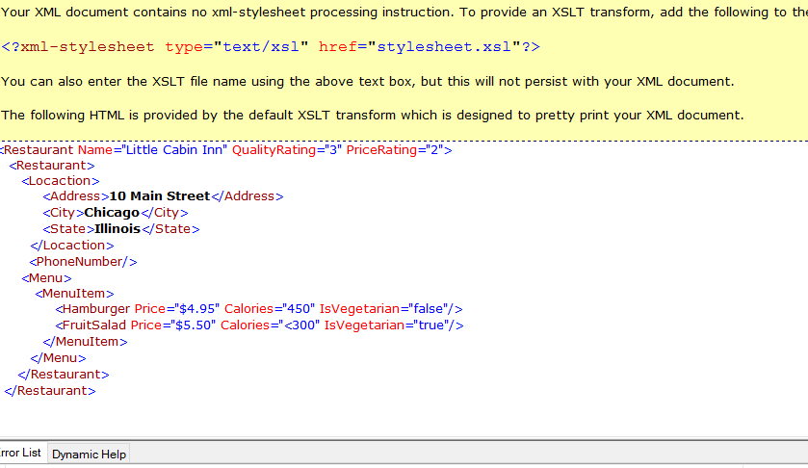

Task 2: Verifying Results on Google Chrome
Question 1 - 3
After opening the XMLFile1 on a browser the results looked just the same as the one expected for this task. Please see the screenshot below.
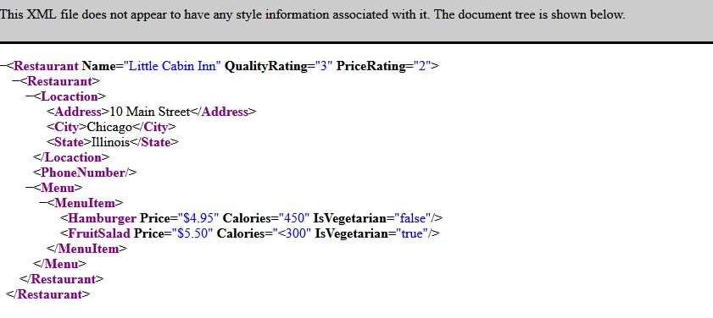

Question 4 - 8: Additional Restaurants
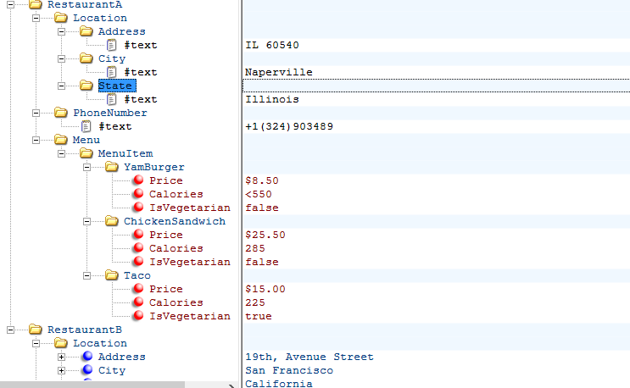

Task 3: Transforming with XSLT
After transforming the XML file into XSLT, the IDE I’m using could not trace the stylesheet. Please look at the screenshots below.
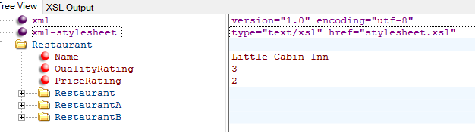

Screenshot: XSLT Transform Results
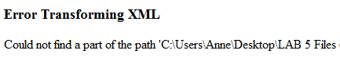
Question 1: Is the name of the restaurant displayed? Why or why not?
No, by looking at the results provided, the name “Restaurant” was marked as the Title. The title of a webpage is not displayed as content, but rather is displayed on the title bar of the browser to identify the page visited.

