CIT270 Integrative Programming (Lab Assignment 5) (100 Points)

Exercise 1: XML, XSLT

Task 1: Creating an XMLXML
Tree View
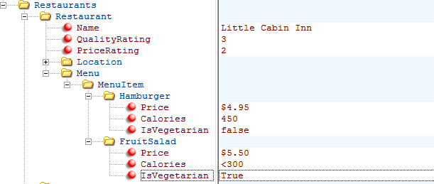
XML Output
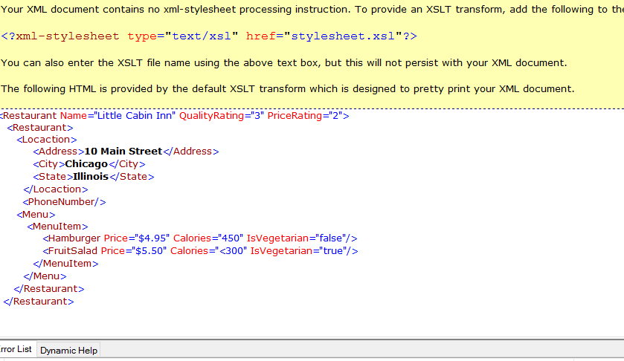

Task 2: Verifying Results on Google Chrome
Question 1 - 3
After opening the XMLFile1 on a browser the results looked just the same as the one expected for this task. Please see the screenshot below.
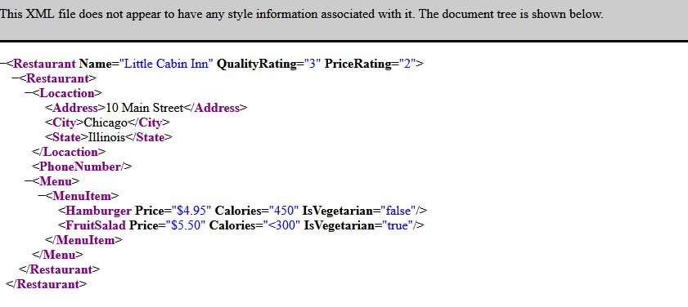

Question 4 - 8: Additional Restaurants
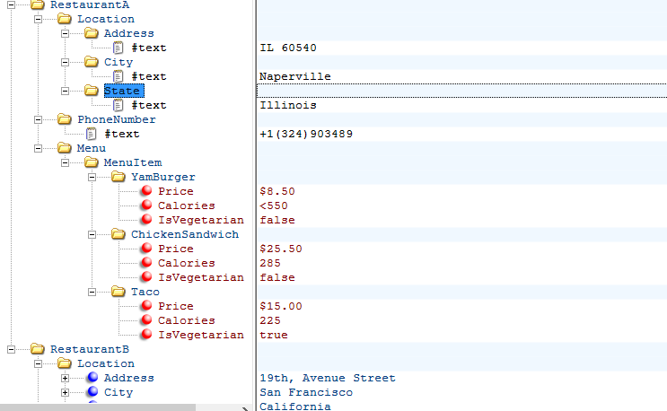

Task 3: Transforming with XSLT
After transforming the XML file into XSLT, the IDE I’m using could not trace the stylesheet. Please look at the screenshots below.
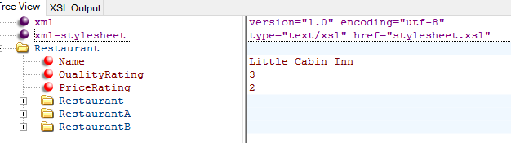

Screenshot: XSLT Results

Question 1: Is the name of the restaurant displayed? Why or why not?
No. This is because the select attribute in the xls should contain a valid path. The RestaurantPath Expression I used is this <p>In Chicago, I recommend <xsl:value-of select="Restaurant/Restaurant/RestaurantA"/>
While the above Xpath Expression is collect, the results were disappointing.

Screenshot: Results after modifying the Xpath Expression


Screenshot: Sorting
After adding the following element (<xsl:sort select="Location/State"/>) directly beneath the xsl:for-each statement the Restaurants were sorted by State as shown on the screenshot provided below.
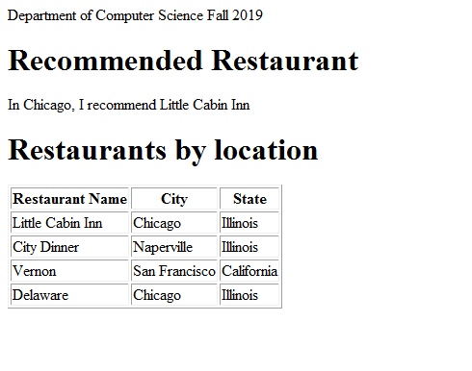

Screenshot: Results of Restaurants with Vegetarian Choices

