  - Student Name
Course
Date
  - Microsoft access assignment and Microsoft Visio Homework
B. Lab 1 Part
C Questions:
- Entities in the conceptual model eventually are converted to tables in the database, and the attributes convert to the fields within the tables. Given this information, list the attributes (fields) found in the supplier table.
The supplier table has ID as the primary key. Other keys include company, last name, email address, job title, business phone, home phone, Fax number and address. All entities of supplier must have ID, first name, last name and the job title.
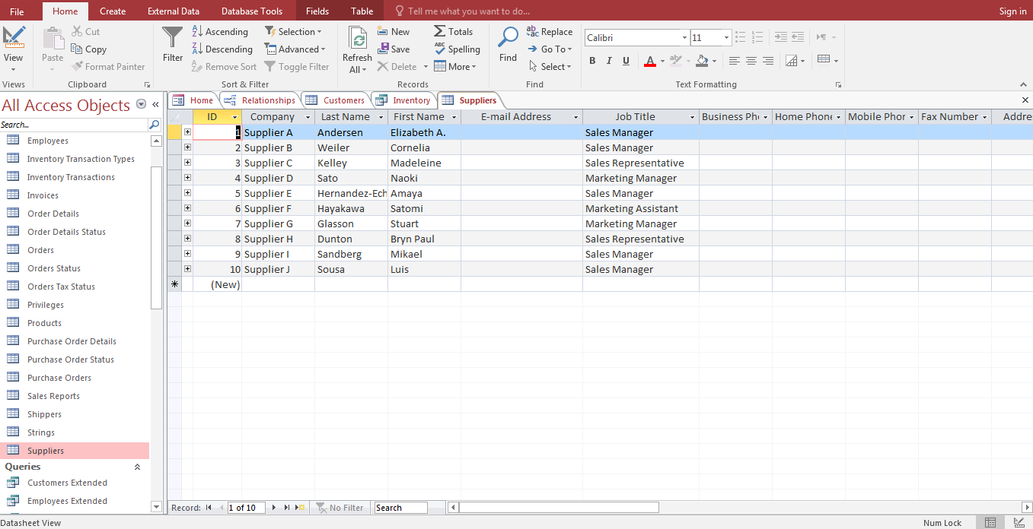

2. With the Customers table sorted in alphabetical order by city, what is the name of the first customer to appear in the table?
Xie
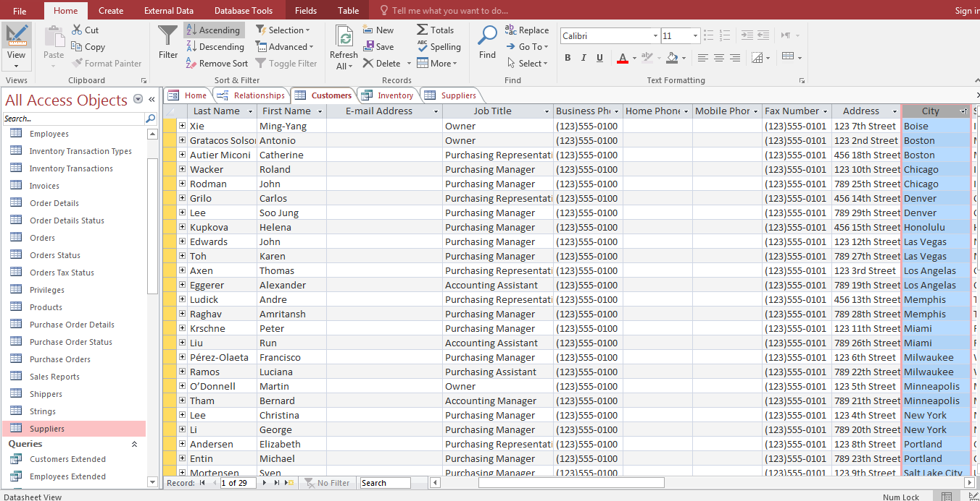
3. Who are the customers located in the Tennessee?
Raghav Amritansh and
Ludick Andre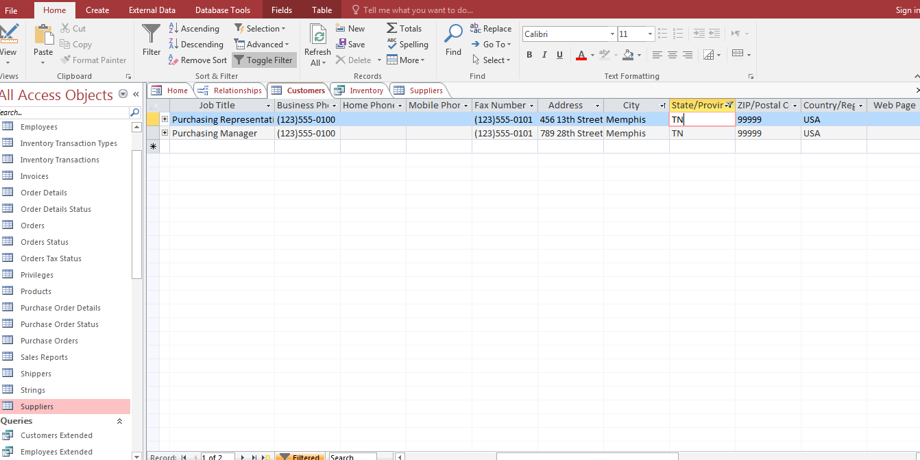

4. List the tables along with the primary key for each.
Customers –ID
Orders – Order ID
Shippers –Shipper ID
Order Details – Order ID
Suppliers - ID
Order Details Status -ID
Purchase Order – purchase Order ID
Invoice – Invoice ID
Inventory Transactions – Transaction ID.
Inventory Transaction Type – Transition ID
Order Tax Status –order Tax ID
Employee Privilege _ employee ID
Privilege – employee ID
Product Purchases – product purchase ID
Purchase order status –Status ID
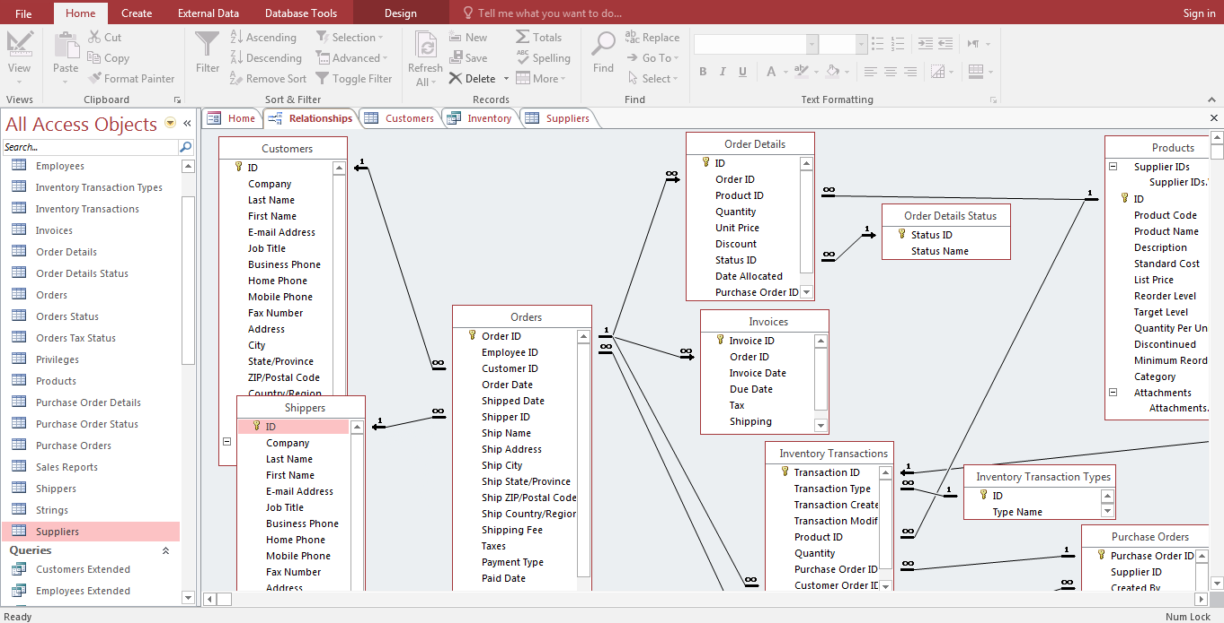

5. List the tables related to the Orders table.
Orders – Orders details
Orders – Invoice
Orders - Inventory transaction
Customers - Orders
Shippers _orders
Orders – orders Tax Status
Orders – employees
Inventory Transaction – Products
Inventory Transaction - Inventory Transaction Types
Inventory Transaction –Purchase Order Details
Product- Product Order Details
Purchase Orders –Purchase Order details
Purchase Orders – Suppliers

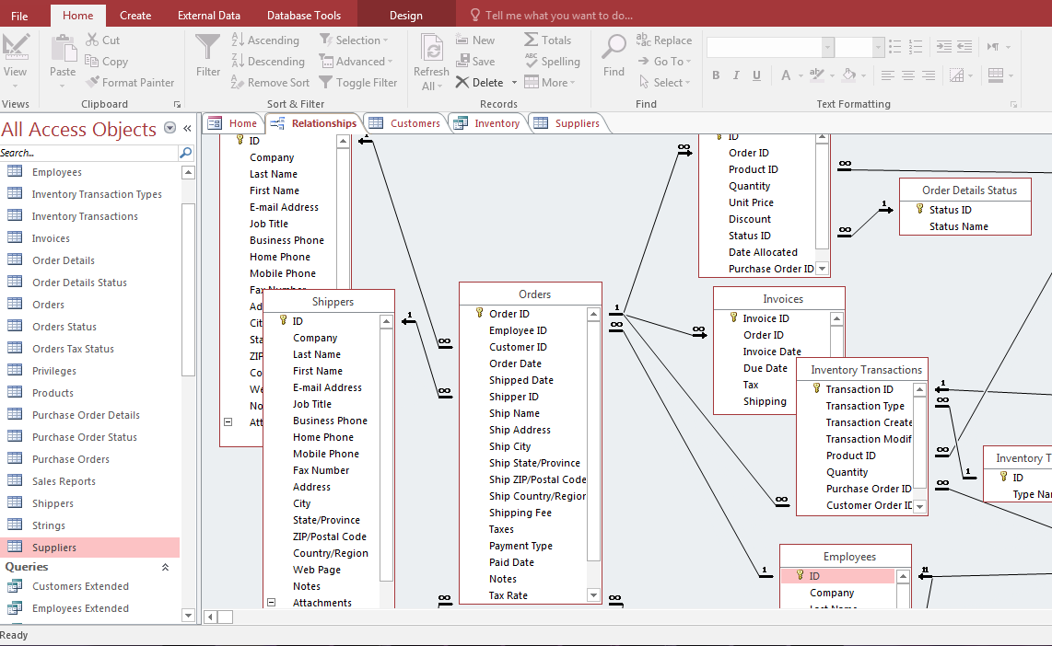

6. Open query Inventory on Hold by double clicking that query. What data is in this query (give the column names)? What is the Quantity on Hold for Northwind Dried Plums?
Quantity =20
