Amazon’s Data Needs
Name:
Institution:
Date:

Amazon’s Data Needs
Introduction
Amazon is an international company based in America in the online retail industry, digital streaming, AI, and cloud computing. It is among the largest technology companies in the world and the biggest online retailer in the world. Amazon has been expanding to various business portfolios. Amazon began as an online bookstore and has now extended into one of the largest companies in the world. Its diversification to technology and into various industries in the market has made it a big data analytics company (Cook, B., 2018). It among the top earners in terms of revenues in the world has the most sales in the e-commerce industry and is classified as a big four technology company together with Google, Apple and Facebook. This report discusses Amazon company in terms of its business operations, data requirements and data needs.
The Business
Amazon as said above has diversified into different business in the market. It offers a wide range of goods and services to its clients. It is a large company that has ventured into the technology sector heavily and therefore produces huge volumes of data. Amazon is a customer-focused company and all its business strategies are aimed at improving the relationship between clients and the company.
Business mission: The mission of the company is based on three main points. Low prices, best selection and the best convenience to its customers. The company strives to provide its customers with the best products, a wide range of goods and in the most convenient way (Cloud, A. E. C., 2011). In the e-commerce industry, the company focuses on satisfying the needs of their clients in the most convenient way.
Information systems: Amazon is one of the biggest companies in technology. They boast of Amazon web services, a cloud service that operates from global data centers. Amazon is a highly advanced company in the technology sector and has one of the best technology systems in the world. Amazon produces high volumes of data due to the high number of clients. They possess the ability to handle that huge amounts of data using their own information systems.
Organizational structure: Due to its large nature, Amazon operates in departments. The company has more than 600,000 employees whose management is decentralized. Its main structure is function-based. Each function consists of a group of employees and a manager in charge of the department and the function (Chen, H. M., Schütz, R., Kazman, R., & Matthes, F. , 2016).
Culture: The corporate culture of Amazon is based on pushing employees to come up with new and fresh ideas that aid the company to grow its creativity and innovation in the market. Through culture, Amazon has become one of the most innovative companies in the world and prides itself as a leading company in the technology sector. Amazon’s culture aligns with its mission, a company that is customer-centric.
Infrastructure: Amazon’s products are sold online. They, however, own multiple warehouses where they store their inventory. Aside from the warehouses, Amazon also has cloud computing infrastructure and mega distribution centers.
Purpose of the data: In the e-commerce industry, data analysis is key. They collect huge amounts of data including customers, merchants, and all the traffic in their systems. Amazon has various data analytics systems that make it easy to handle huge volumes of data they collect each and every day (Cook, B., 2018). The company has to collect real-time data on their customers purchasing behaviors for the e-commerce industry, for the digital streaming site, Amazon has to collect data on watch history, watching analytics of all their content, and for cloud computing, real-time data analysis, and storage for all their clients. Amazon is a company that depends on data for predictive analysis to its clients, exploring consumer wants and preferences and also acts as data analytic for other firms and consumers.
Data Requirements
Business and organizational policies: Amazon’s policy is to be a customer-centric company that prides itself as meeting all the demands and preferences of its customers. With such a policy, they need data on the customers' preferences so as to act on it for better services. Customer preferences include customers purchase behaviors, frequencies, likes, and tendencies.
Security: In the e-commerce industry, the most common means of payment is online payments such as credit cards, PayPal, debit cards, etc. (Cloud, A. E. C., 2011). For any payment, Amazon must be willing to provide a secure platform for payments. As part of US laws, all companies are provided to secure their client's data. The security of their data is a data need for Amazon for both compliance and cybersecurity.
Functional features: Amazon has invested in four major industries, e-commerce, digital streaming, AI, and cloud computing. All the technological platforms require complex data management and analysis for proper functioning (Chen, H. M., Schütz, R., Kazman, R., & Matthes, F. , 2016). For example, for a customer using their online retail platforms, Amazon uses the data on the customer's products visits and historical purchase to suggest to them similar products they might need. All of Amazon’s major departments depend on data for operation.
Currency: Amazon is a worldwide organization. It accepts more than 10 different currencies of the world. The company needs data on payment systems and the location of the customers to determine the currencies acceptable for payments. It, therefore, needs data on location for determination on what is the best currency their clients can pay using.
Consistency: Refers to how consistently does the company require the data for its day to day operations. First, Amazon, as stated above, relies on the data it produces for marketing purposes, decision making and better customer services. Amazon being a big analytics company and a big data hub, it consistently requires data for day to day operations (Cook, B., 2018). It needs to advise its clients on what goods are related to the ones they are buying; Amazons needs to store securely and analyze multiple gigabytes of data produced by their clients that use their AWS.
Adaptability. Due to the ever-changing customer needs, Amazon needs data to keep up to date with the current trends and procedures. The current trends on customer purchase behavior can only be provided by the data o their purchase history and trend. It is this data that helps Amazon determine the trends for better decision making.
Performance – The performance of a business is tied on the business strategy. Before making any strategies, a company will be interested in its current state and what levels and how to achieve the levels the company needs. To know the state of the company, it needs data on its sales statistics, clients, revenues, costs, etc. for proper analysis and decision making on the strategy to be applied (Cloud, A. E. C., 2011). Amazon uses a similar strategy. Analyzing its current position and using the available data to estimate its performance and potentials.
DATA MODEL
With the different levels of data, Amazon has a complex data model due to its high number of partners that are involved in their business model. Amazon has customers information, their payment information, merchant’s information, delivery and supply data. The company also has third parties such as media owners streamed via its digital streams and cloud computers using their AWS services. Amazons complexity of data involves the interactions between the buyers and the sellers.
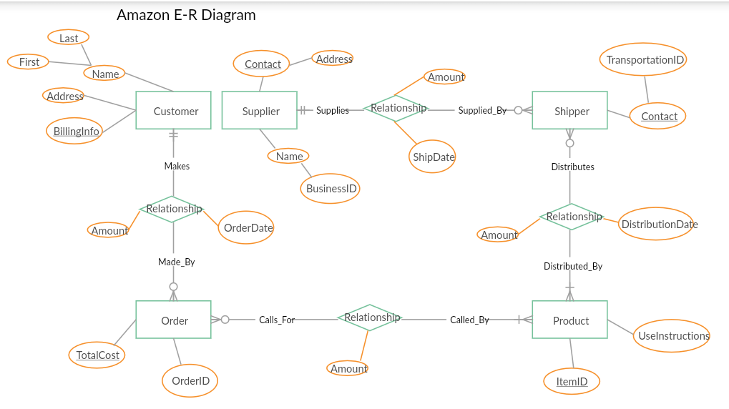
Chart 1: Amazon E-R diagram
From the above diagram, we note that the primary keys involved in Amazon data are the customers, suppliers, shippers, products and the order. The foreign keys of the data models are details about the customer, payments, and relationships between each of the primary keys in the model. There are so many factors that are considered in the order of a customer. Considering that Amazon has many clients, it had huge data needs that are solved using big data analytics.
Conclusion
Amazon is a company that depends on data for decision making, strategy planning and other forms of planning. The data available is produced by its own customers through the various customer orders placed, purchase history and website visits. With such data, they are able to analyze customer dynamics and trends in the market.

References
Chen, H. M., Schütz, R., Kazman, R., & Matthes, F.. (2016). Amazon in the air: Innovating with big data at Lufthansa. In 2016 49th Hawaii International Conference on System Sciences (HICSS), 5096 - 5105.
Cloud, A. E. C. (2011). Amazon web services. Retrieved November, 9(2011).
Cook, B. (2018). Formal reasoning about the security of amazon web services. International Conference on Computer-Aided Verification, 38 - 47.
Pipino, L.L., Lee Y.W., & Wang, R.Y. (2002). Data quality assessment. Communications of the ACM, 211 - 218.

