Instructions: Address each question below as it relates to the case study given.

A patient was brought to the Emergency Department by ambulance with two arrow wounds. One arrow is still in the patient on the left side; entering anteriorly between the 7th and 8th ribs in a 15 degree angle, the arrow head protruding posteriorly. The second wound is located in the posterior cervical triangle.
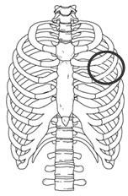
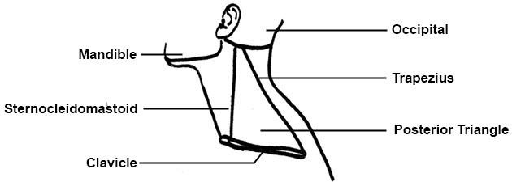

Answer the following questions using a minimum of five (5) academic references (you many not use Wikipedia, blogs, or other informal sources.) Use APA format in-text citations in your answers and include a reference page.

Question 1

- What serosal cavities have been penetrated by the first arrow?
- Explain the location, the microscopic cellular components of the serous membrane, and the purpose of the serous membrane.

Question 2

- Describe the Autonomic Nervous System and explain how the patient’s ANS reacts to the arrow attack and how it will affect the patient’s vital signs (P, BP, R, T).

Question 3

- Describe the trajectory of the first arrow using directional terms and anatomical planes.
- Identify and describe the organs and any other membranes that may have been affected by the first arrow.

Question 4

- Describe the cardiovascular system and explain how both the pulmonary and systemic circuits will be affected by both arrows.
- Include the effect on the Hematocrit and Hemoglobin values.

Question 5

- Identify the possible neuromuscular effects of the second arrow and explain your reasoning.
- Describe the components of a neuromuscular junction including key organelles.

Question 6

- Identify and describe the three labeled tissue types found in the tracheal slide (Slide 2) below. Include the subcategories and cellular components for each tissue type.
- How will the injuries affect this area?
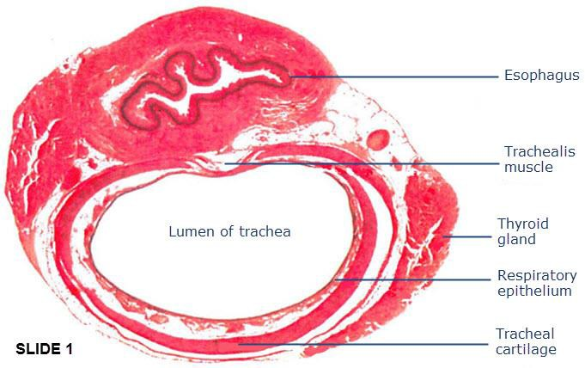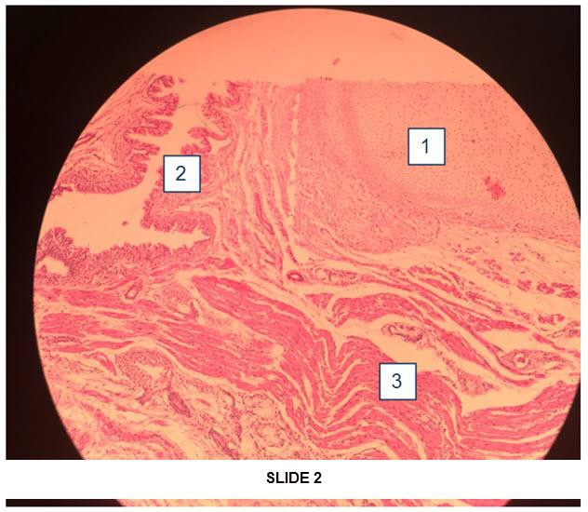
Types of Tissue Specify the subcategories of these tissues 1.
2.
3.

