Instructions: Address each question below as it relates to the case study given

A patient was brought to the Emergency Department by ambulance with two arrow wounds. One arrow is still in the patient on the left side; entering anteriorly between the 7th and 8th ribs in a 15-degree angle, the arrowhead protruding posteriorly. The second wound is located in the posterior cervical triangle.
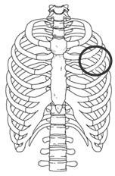
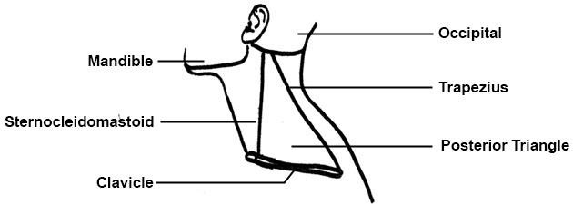

Answer the following questions using a minimum of five (5) academic references (you may not use Wikipedia, blogs, or other informal sources.) Use APA format in-text citations in your answers and include a reference page.

Question 1

What serosal cavities have been penetrated by the first arrow?

The serosal cavity that has been penetrated by the first arrow is the pleural cavity. The arrow is protruded in the intercostal space between rib 7, which is a true rib, and rib 8, which is a false rib (Clemens et al., 2016). The pleural cavity is located between the visceral and parietal pleura, surrounding each lung in which is also covered by a pleural membrane.

Explain the location, the microscopic cellular components of the serous membrane, and the purpose of the serous membrane.
The serous membrane, which is often called serosa, is modified by simple squamous epithelial cells, mesothelium, encircle around organs in the serous cavity, helping to lubricate organs from drying out and causing internal tears. Simple squamous epithelial cells are made up of one layer of flattened epithelial cells. There are two layers to the serous membrane: visceral and parietal. The parietal layer lines the wall of the serous cavity while the visceral layer lines enveloping organs, viscera (Nistor, Ciuche & Bontaș, 2020). There are serous membranes found in the peritoneal cavity, which is found within the abdominal and pelvic cavities; the pleural cavity which is separated by the mediastinum; the pericardial cavity, which is in the mediastinum of the thoracic cavity; lastly the vaginal tunics, which is the cavity of vaginal process.

Question 2

Describe the Autonomic Nervous System and explain how the patient's ANS reacts to the arrow attack and how it will affect the patient's vital signs (P, BP, R, T).
The Autonomic Nervous System (ANS) administer the involuntary operations and makes routine adjustments in our body. It conducts our body temperature, corresponds to our cardiovascular, respiratory, digestive, and excretory activities The ANS is always operative whether it be inhibiting organs, releasing neurotransmitters, or cause any short -term changes in the mentioned areas. There are four regions that mainly affect the activities of the ANS: thalamus, hypothalamus, which is the main center of the ANS, limbic system, and the cerebral cortex (Gilroy et al, 2018). Within these regions are controlled either by sympathetic division, affecting the Thora-columnar division, or parasympathetic division, affecting the craniosacral division. The patient with an arrow attack is mainly affected in the sympathetic division which is "fight or flight." The preganglionic fibers of the sympathetic and parasympathetic systems are myelinated while the postganglionic fibers aren't. The sympathetic and parasympathetic divisions of the ANS innervate most of the organs in the body, usually with opposing effects. During the attack, the ANS reacts by decreasing the blood pressure, this is due to the internal rupture by hitting a vein, causing a lot of external bleeding, since there is a detour of blood, the blood pressure decreases. The person's respiration also becomes hesitated, this is because of blood loss, if there is less blood, there is less gas exchange in the body, causing the body temperature to decrease because there will be less blood supply to organs especial vital organs like the heart, this will also make the pulse fast but weak at the same time.

Question 3

Describe the trajectory of the first arrow using directional terms and anatomical planes.

Identify and describe the organs and any other membranes that may have been affected by the first arrow.

The trajectory of the first arrow is located on the superior portion of the body when cut in a transverse plane, anteriorly and posteriorly when cut in a coronal plane, and on the lateral left side when cut in a sagittal plane. The trajectory is located on the left upper quadrant, specifically the left hypochondriac region. In this region, the arrow is protruding through all of the skin's layers. First the epidermis, including the stratum corneum, stratum granulosum, stratum spinosum, and stratum basale. Then the dermis, hitting sensory nerve fibers, tactile corpuscle, lamellar corpuscle, and hair follicle receptors, then the dermis. After going through the skin, it has also gone through the external oblique muscle, internal oblique muscle, intercostal muscles, then the serratus anterior muscle (Nistor, Ciuche & Bontaș, 2020). After going through the mentioned muscles, it will also injure the organs located in the left hypochondriac region through the intercostal space between rib 7, a true rib, and rib 8, a false rib because it does not have its attachment to the sternum. These organs are the stomach, diaphragm, and lungs. It will first pierce through the serous membrane of the stomach then its gastric mucosa then its posterior serous membrane, followed by the piercing of the parietal pleurae of the diaphragm, then the serous membrane of the lungs, into the lungs. When it pierces through the lungs, it affects the secondary (lobular) branch of the left inferior lobe of the lung, along with the tertiary branches, alveoli, and alveoli sacs (Khurana, Khurana & Kowlgi, 2019). This will drastically affect the gas exchange present in the alveoli sacs between the capillaries, causing the inability for blood to receive oxygen (O2.) After going through the lungs, it will go in between the intercostal space of the posterior rib 7 and rib 8 and it's intercostal muscles through the latissimus dorsi muscle, piercing through the skin once again.

Question 4

Describe the cardiovascular system and explain how both the pulmonary and systemic circuits will be affected by both arrows.
The cardiovascular system is the system that transports numerous substances, containing the heart, blood vessels, and the blood as its main constituents. The heart is a muscle located in the mediastinum, it contains a pericardium that circles the heart and a personal muscle, a cardiac muscle. The heart has and right and left atrium, and a right and left ventricle, these are called heart chambers. The atrium is superior to the ventricle and is divided by valves. The tricuspid is between the right atrium and right ventricle and a bicuspid is between the left atrium and the left valve. These valves prevent the backflow of the blood from the atrium to the ventricle. Arteries carry blood away from the heart, while veins carry blood towards the heart (Litviňuková et al., 2020). The flow of the heart from the right to left is as follows: the right atrium drains blood to the right ventricle by the tricuspid which is then transported to the pulmonary artery by the pulmonary valve which does a gas exchange with the capillaries in the lungs giving off carbon dioxide and receiving oxygen in the blood, then is transported by pulmonary veins to the left atrium, calling this a Pulmonary Circulation. Then the blood from the left atrium drains the blood to the left ventricle by the bicuspid, to the aorta, the largest artery, by the aortic valve, to the capillaries all over the body except the lungs, exchanging oxygen for carbon dioxide, then transported by the superior and inferior vena cava veins to the right atrium, calling this a Systemic Circulation. This whole process takes place within 24 minutes in our body. The arrow that is protruded in the serosal cavity affects the heart's Pulmonary Circulation Since it protruded through the inferior lobe of the lungs, it injured the secondary (lobular) branch and the tertiary branch that carries and holds the alveoli and alveoli sacs. The alveoli sacs are where oxygen is stored for gas exchange in the capillaries of the lung (Finley & Rusch, 2015). By damaging this area, it will be impossible for gas exchange to happen, causing insufficiently oxygenated blood to be delivered to the heart which slows down and breaks the pulmonary circulation and systemic circulation. The arrow penetrated in the posterior cervical triangle affects both circulations because if it is penetrated deep enough to reach the trachea, that will cause abnormal breathing which will affect the gas exchange in the circulations.

Include the effect on the Hematocrit and Hemoglobin values
The hemoglobin, which is red blood cells', value will decrease because of blood loss due to the injury in the intercostal ribs and especially in the posterior cervical triangle, where veins are located (Biga et al., 2020). The hematocrit, which is the total blood cell count, will increase because since there is a lot of blood loss, the blood production by osteoblasts in the bone marrow will increase.

Question 5

Identify the possible neuromuscular effects of the second arrow and explain your reasoning.
Since the second arrow was on the posterior cervical triangle, it affects the cervical nerves in that area. One of them is the Accessory Nerve (N XI) it is involved with the movement of the sternocleidomastoid muscle and the trapezius muscle (Lepore et al., 2019). With the arrow injuring this nerve, the patient will not be able to move their neck and shoulder. Another is the phrenic nerve which is located in the neck, if this is injured by the arrow, it will paralyze the diaphragm. Another is the cervical plexus, this will cause the neck and shoulders to become numb, this goes hand in hand with the accessory nerve.

Describe the components of a neuromuscular junction including key organelles
The neuromuscular junction is the location of communication between motor nerve axons and muscle fibers It is made up of four specialized cells. These are motor neurons, Schwann cells, and muscle fibers (Lepore et al., 2019). The function of the neuromuscular junction is to send signals from the motor neuron to the skeletal muscle fiber to provide good control of skeletal muscle contraction making it a voluntary movement. This process is guided by many active zones and junctional folds that promote high levels of transmitter release.

Question 6

Identify and describe the three labeled tissue types found in the tracheal slide (Slide 2) below. Include the subcategories and cellular components for each tissue type.
How will the injuries affect this area?
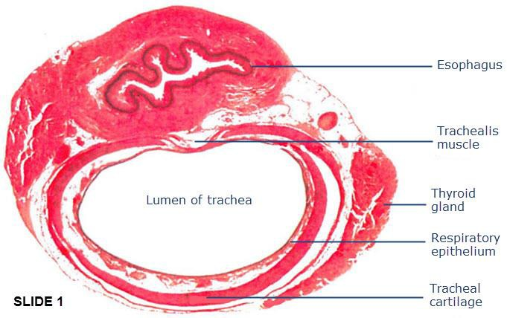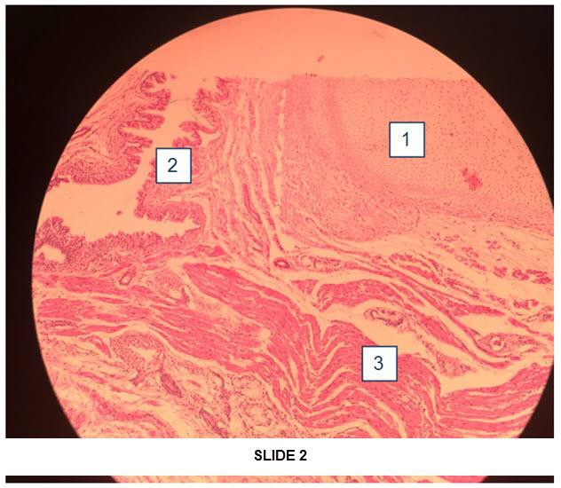
Types of Tissue Specify the subcategories of these tissues 1. Connective Tissue with the subcategory of Hyaline Cartilage. Hyaline cartilage is found in the nose trachea rings, and where ribs join the sternum
2. Muscular Tissue with the subcategory of Smooth Muscle. Smooth muscles are located in the hallow internal structures of the blood vessels, stomach, airway to the lungs, and the intestines.
3. Epithelial Tissue with the subcategory of Ciliated Pseudostratified Columnar Epithelium. The ciliated pseudostratified columnar epithelium is located along the respiratory tract.
How will the injuries affect this area?
The hyaline cartilage is affected by the first arrow, since it is in the intercostal space of rib 7, a true rib, which has hyaline cartilage attaching to the sternum, and rib 8, a false rib, which only has hyaline cartilage attached to the rib 7's hyaline cartilage. If the arrow affected it, it will break rib 7 attachment to the sternum and so will rib 8 (Finley & Rusch, 2015). The Ciliated pseudostratified columnar epithelium is affected by the second arrow since it is in the cervical region, if the patient has a hard time inspiring, it will dry these out causing dry throat which will then affect oxygen intake. Lastly, smooth muscle is affected by both arrows, because of gas exchange, the smooth muscles will eventually die due to blood loss.

References
Biga, L. M., Dawson, S., Harwell, A., Hopkins, R., Kaufmann, J., LeMaster, M., ... & Runyeon, J. (2020). Anatomy & physiology.
Clemens, M. W., Evans, K. K., Mardini, S., & Arnold, P. G. (2016). Introduction to chest wall reconstruction: anatomy and physiology of the chest and indications for chest wall reconstruction. Seminars in plastic surgery, 25(1), 5–15.
Finley, D. J., & Rusch, V. W. (2015). Anatomy of the pleura. Thoracic surgery clinics, 21(2), 157-163.
Gilroy, A. M., MacPherson, B. R., Ross, L. M., Broman, J., & Josephson, A. (Eds.). (2018). Atlas of anatomy (pp. 356-450). Stuttgart: Thieme.
Khurana, I., Khurana, A., & Kowlgi, N. G. (2019). Textbook of Medical Physiology_-Ebook. Elsevier Health Sciences.
Lepore, E., Casola, I., Dobrowolny, G., & Musarò, A. (2019). Neuromuscular junction as an entity of nerve-muscle communication. Cells, 8(8), 906.
Litviňuková, M., Talavera-López, C., Maatz, H., Reichart, D., Worth, C. L., Lindberg, E. L., ... & Nadelmann, E. R. (2020). Cells of the adult human heart. Nature, 1-10.
Nistor, C. E., Ciuche, A., & Bontaș, E. (2020). Embryology and Anatomy of the Pleura. In Thoracic Surgery (pp. 393-408). Springer, Cham.
Hello friend. Please remember to delete this part before submission
Thank you for working with me I must admit that I am really honored to do so. However, please take a look at the uploaded file and see if it meets your expectations. If so, kindly remember to release the funds on time and leave a 10-star rating. I will be very glad. Again, you can find me on this email (davykikuvi774@gmail.com) in case you have more work in the future. I will be at your service. Thank you in advance.

