8) 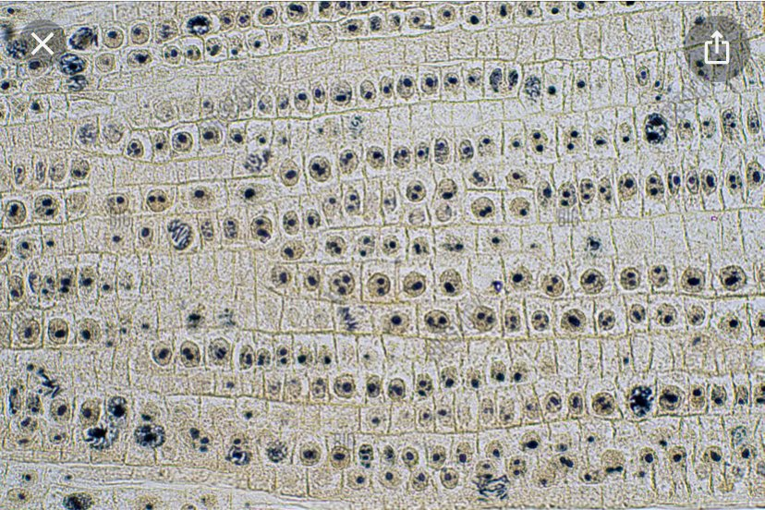
9) Interphase 18
Prophase 12
Metaphase 6
Telophase 2
Anaphase 2
10) Interphase 7.2 hours
Prophase 4.8 hours
Metaphase 2.4 hours
Telophase 0.8 hours
Anaphase 0.8 hours
11) Interphase with 7.2 hours

