Creating a unique 3D animated scene composed of Three.js graphic components:
To crete a scene first we need to setting up a scene and create a web page using html
We will start by setting up a scene, with a spinning cube.
Before you can use three.js, you need somewhere to display it. Save the following HTML to a file on your computer, along with a copy of three.js in the js/ directory, and open it in your browser.
Rendering the scene
function animate() { requestAnimationFrame( animate ); renderer.render( scene, camera ); } animate();
This will create a loop that causes the renderer to draw the scene 60 times per second.
Animating the cube
If you insert all the code above into the file you created before we began, you should see a green box. Let's make it all a little more interesting by rotating it.
Add the following right above the renderer.render call in your animate function:
cube.rotation.x += 0.1; cube.rotation.y += 0.1;
This will be run every frame (60 times per second), and give the cube a nice rotation animation.
CODE USED
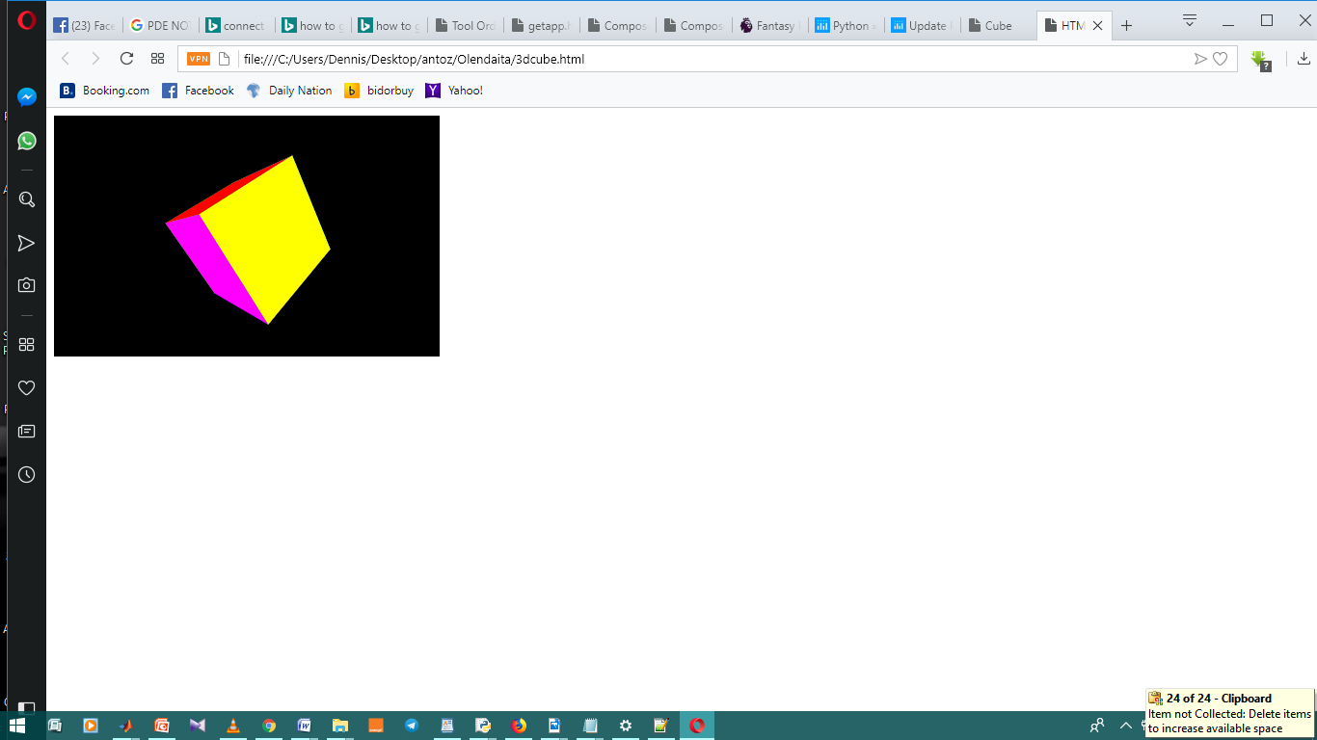

<!DOCTYPE html>
<html>
<head>
<title>HTML5 Experiment: A Rotating Solid Cube</title>
<script type="text/javascript">
window.onload = startDemo;

function Point3D(x,y,z) {
this.x = x;
this.y = y;
this.z = z;

this.rotateX = function(angle) {
var rad, cosa, sina, y, z
rad = angle * Math.PI / 180
cosa = Math.cos(rad)
sina = Math.sin(rad)
y = this.y * cosa - this.z * sina
z = this.y * sina + this.z * cosa
return new Point3D(this.x, y, z)
}

this.rotateY = function(angle) {
var rad, cosa, sina, x, z
rad = angle * Math.PI / 180
cosa = Math.cos(rad)
sina = Math.sin(rad)
z = this.z * cosa - this.x * sina
x = this.z * sina + this.x * cosa
return new Point3D(x,this.y, z)
}

this.rotateZ = function(angle) {
var rad, cosa, sina, x, y
rad = angle * Math.PI / 180
cosa = Math.cos(rad)
sina = Math.sin(rad)
x = this.x * cosa - this.y * sina
y = this.x * sina + this.y * cosa
return new Point3D(x, y, this.z)
}

this.project = function(viewWidth, viewHeight, fov, viewDistance) {
var factor, x, y
factor = fov / (viewDistance + this.z)
x = this.x * factor + viewWidth / 2
y = this.y * factor + viewHeight / 2
return new Point3D(x, y, this.z)
}
}

var vertices = [
new Point3D(-1,1,-1),
new Point3D(1,1,-1),
new Point3D(1,-1,-1),
new Point3D(-1,-1,-1),
new Point3D(-1,1,1),
new Point3D(1,1,1),
new Point3D(1,-1,1),
new Point3D(-1,-1,1)
];

// Define the vertices that compose each of the 6 faces. These numbers are
// indices to the vertex list defined above.
var faces = [[0,1,2,3],[1,5,6,2],[5,4,7,6],[4,0,3,7],[0,4,5,1],[3,2,6,7]];

// Define the colors for each face.
var colors = [[255,0,0],[0,255,0],[0,0,255],[255,255,0],[0,255,255],[255,0,255]];

var angle = 0;

/* Constructs a CSS RGB value from an array of 3 elements. */
function arrayToRGB(arr) {
if( arr.length == 3 ) {
return "rgb(" + arr[0] + "," + arr[1] + "," + arr[2] + ")";
}
return "rgb(0,0,0)";
}

function startDemo() {
canvas = document.getElementById("thecanvas");
if( canvas && canvas.getContext ) {
ctx = canvas.getContext("2d");
setInterval(loop,33);
}
}

function loop() {
var t = new Array();

ctx.fillStyle = "rgb(0,0,0)";
ctx.fillRect(0,0,400,250);

for( var i = 0; i < vertices.length; i++ ) {
var v = vertices[i];
var r = v.rotateX(angle).rotateY(angle);
var p = r.project(400,250,200,4);
t.push(p)
}

var avg_z = new Array();

for( var i = 0; i < faces.length; i++ ) {
var f = faces[i];
avg_z[i] = {"index":i, "z":(t[f[0]].z + t[f[1]].z + t[f[2]].z + t[f[3]].z) / 4.0};
}

avg_z.sort(function(a,b) {
return b.z - a.z;
});

for( var i = 0; i < faces.length; i++ ) {
var f = faces[avg_z[i].index]

ctx.fillStyle = arrayToRGB(colors[avg_z[i].index]);
ctx.beginPath()
ctx.moveTo(t[f[0]].x,t[f[0]].y)
ctx.lineTo(t[f[1]].x,t[f[1]].y)
ctx.lineTo(t[f[2]].x,t[f[2]].y)
ctx.lineTo(t[f[3]].x,t[f[3]].y)
ctx.closePath()
ctx.fill()
}
angle += 2
}
</script>
</head>
<body>
<canvas id="thecanvas" width="400" height="250">
Your browser does not support the HTML5 canvas element. <a href=#>Click here</a> to watch the video.
</canvas>

</body>
</html>
