Lab 4: Light & Kirchhoff’s Laws

Astronomy 141
Name(s): ___________________________
___________________________
___________________________

The only way we learn anything about astronomical objects is by studying the light they emit, absorb, or reflect. One of our most powerful tools is spectroscopy, the study of an object’s spectrum. With just its radiation we can infer an object’s temperature, composition, motion, and often more. Understanding how and why things emit as they do is critical.
In this exercise you will work in small groups to answer the following:
      - What can we learn about an object just by looking at the light it emits?
      - How do we distinguish between light emitted by a solid object or a gas?
      - How do we recognize different gases using their spectra?

Resources:
- Science With A Lightbulb: This video uses a simple lightbulb to demonstrate Stefan’s Law visually and discuss the consequences of Wien’s Law. Watch this video to complete the section on Kirchhoff’s First law.
- Spectrum Demo: Continuous and Emission: This video demonstrates the continuous spectrum of white light and the emission spectra of mercury, nitrogen, neon, and hydrogen, imaged through a diffraction grating. Watch this video to complete the section on Kirchhoff’s Second Law.
- Sodium Absorption Lines: This video reveals how burning sodium bicarbonate produces sodium absorption lines in a continuous spectrum. Watch this video to complete the section on Kirchhoff’s Third law.

Kirchhoff’s First Law:
A hot, opaque object emits at all frequencies – a continuous spectrum.
The continuous spectrum has a characteristic shape with a peak, and Wien’s Law says that the frequency of the peak (f_{peak}) is related to the object’s temperature (T):

f_{peak ∝ T} 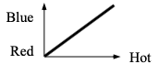
As T ↓ then λ_{peak} ↑ and vice versa. A hot object’s spectrum peaks at a lower, bluer wavelength while a cooler object looks redder.
A hotter object will be brighter following Stefan’s Law, which says that the energy emitted every second from every square centimeter of an object’s surface (called the flux) rises quickly with temperature:

flux _{∝ T}⁴ 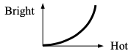
So a hotter object is much brighter than a cooler one. For example, if you double the temperature of something, it emits 2^4 = 16 times more energy every second from every part of its surface!
Watch this video and answer:
1. (5 points) How does the lightbulb’s brightness change as the voltage (temperature) increases? Is this expected?
As the voltage across filament increases the more current flows through it and the brightness of the bulb increases with increasing voltage. Yes, it is expected since as temperature increases more flux increases along with it.
2. (2 points) When the voltage (temperature) is very low, what color is the bulb? What is the bulb’s color when the voltage is very high?
When the voltage (temperature) is very low, the color is red-orange. When the voltage (temperature) is very high, the color is blue.
3. (10 points) Imagine you could see the spectrum of the lightbulb. How would the peak wavelength of the bulb change as you increase the voltage? Does this match what you would expect based on Wien’s Law?
On increasing voltage the color is shifting from red (higher wavelength) to blue (lower wavelength). The observations are in agreement to wien's law as the frequency increases with temperature. It is hard to comment whether the changes are linear or not.
Kirchhoff’s Second Law:
A hot gas emits only at specific frequencies – an emission line spectrum.
The spectrum emitted by an atom depends on its internal structure, so every atom has its own characteristic “fingerprint” of light.
Watch this video and answer:
4. (15 points) Draw the spectra of the emission tubes below in color. Record the spacing of the lines as carefully as possible. Label the element and the overall color of the tube.
Element: __Example_______ Overall color of tube: ___Green_____
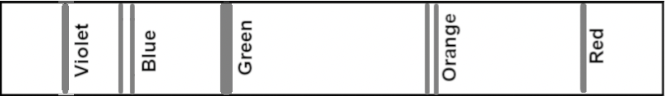

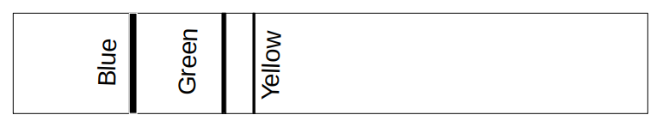
Element: Mercury Overall color of tube: Blue
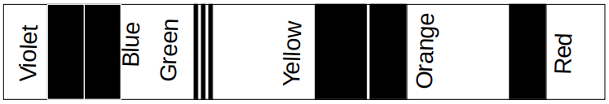
Element: Nitrogen Overall color of tube: Yellow-red
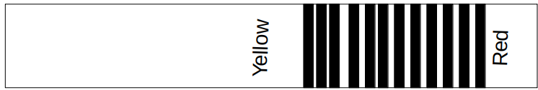
Element: Neon Overall color of tube: Yellow
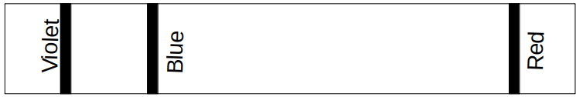
Element: Hydrogen Overall color of tube: White-Red

  - (5 points) Is a gas’s spectrum related to the overall color of its tube (without the diffraction grating)?
Yes the overall spectrum is the sum of all the colors(wavelength) we see with grating.
  - (10 points) If you looked at the spectrum of a gas cloud in space and saw a bright yellow-orange emission line with a few other fainter lines, what element would you think that cloud was made of?
Neon
Kirchhoff’s Third Law:
A cooler gas in front of a hotter opaque object absorbs light at specific frequencies – an absorption spectrum.
An atom absorbs light at the same frequencies that it emits, so its spectral fingerprint is the same in absorption as in emission. In this case the spectrum is now the rainbow with dark lines.
Watch this video and answer:
  - (3 points) Which color is missing from the rainbow?
Blue, violet
  - (10 points) If you looked at a star’s spectrum and saw a dark line in the red, blue/green and violet, which element would you conclude was in that star’s atmosphere? Explain.
Hydrogen, because hydrogen spectrum has these characteristic color (red, blue and violet)
Element: Hydrogen Overall color of tube: White-Red

