Titration Tutorial

Access the Lab Simulations from the content section on D2L under Laboratory. Find the lab that has the same title as shown above and click on it. Read the background information before starting the simulation.

Type your answers directly onto this document. Anywhere you see ###, you need to type something. Please type your answers in red. When finished, save the file as a Word document (.doc or .docx) or a PDF. Other file formats cannot be opened by your instructor and will not be graded. Submit your file on D2L by going to Assignments > Assessment and then clicking on the appropriate assignment folder.

You will be graded on the accuracy of your measurements and calculations, recording your measurements with the appropriate number of significant figures and units, and correctly answering any questions.

Experiment 1: Perform a Coarse Titration
NOTE: The volume from the buret should be recorded to two decimal places. Make sure to count down as you read the buret. For example, the reading in the buret below about 30.25 mL, as opposed to 31.75 mL.
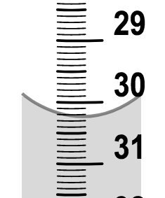

- Take a burette and a 50 mL beaker from the Containers shelf and place them on the workbench.
- Place the beaker underneath the burette as a waste container. Obtain 0.100 M sodium hydroxide from the Materials shelf and add 52 mL to the burette. In order to flush the air out of the buret tip, click and hold the stopcock of the buret for about 4 seconds to drain liquid from the buret into the waste container until the titrant level is at or below the 0 mL mark. Double-click the buret to read and record the liquid volume at the meniscus. Take a screenshot of this buret reading and insert it below. This is the initial titrant volume reading. This volume does not need to be exactly 0.00.
Initial titrant volume: 47.90 mL
Screenshot:
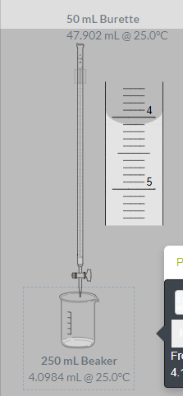
- Take a clean 10 mL graduated cylinder and a 150 mL Erlenmeyer flask from the Containers shelf and place them on the workbench.
- Take hydrochloric acid unknown solution #1 from the Materials shelf and add 5 mL to the graduated cylinder. Double-click to read and record the volume of HCl to two decimal places.
Volume of HCl: 5.00 mL
- Pour the hydrochloric acid from the graduated cylinder into the flask. Take phenolphthalein from the Materials shelf and add two drops to the flask.
- Take water from the Materials shelf and add 45 mL to the flask. This increases the total volume of the analyte solution, making it easier to see the color change. Please note that the value to use for the volume of hydrochloric acid when calculating its concentration is still 5 mL.
- Remove the 50 mL beaker and then move the Erlenmeyer flask onto the base of the burette. The Erlenmeyer flask is connected to the burette so that liquid will drip from the burette into the Erlenmeyer flask.
- Click on the stopcock. You should observe a drop dispensing from the burette. The volume dispensed should be about 0.05 mL. Double-click on the buret to observe the new volume remaining.
- Click and hold the stopcock for about 4 seconds. You should observe a stream of liquid dispensing from the burette. The volume dispensed should be about 2.00 mL. If the volume dispensed is above 2.50 mL, try holding the stopcock for a shorter period of time. Find the length of time you should click and hold the stopcock to deliver approximately 2.00 mL of titrant.
- Continue to add titrant in 2.00 mL increments. Pause after each dispensation. Record the buret reading after each dispensation. When the reaction reaches the end point, the solution changes color. Stop adding titrant when the end point is reached.
Note: In a classroom laboratory, you might position the flask and burette apparatus over a stir plate or swirl the solution after each dispensation. Stirring or swirling ensures the titrant is thoroughly mixed with the analyte. The titrant is automatically stirred with the analyte in this simulation.
- Record the buret reading before the end point as the final volume. You now know between which two volumes the end point occurred. For example, if you recorded 32.00 mL before the end point, but 34.00 mL was past the end point, record the 32.00 mL as your final volume.
Final titrant volume: 45.171 mL
- Keep the burette and waste beaker for use in the next experiment. Clear your station of all other containers by emptying the solutions into the waste and placing the containers in the sink.

Experiment 2: Perform a Fine Titration
- Prepare a burette and Erlenmeyer flask as described in steps 1–7 in Experiment 1. You can refill the buret with the same titrant by adding about 3 mL less than the maximum volume allowed. Double-click the buret to read and record the initial liquid volume at the meniscus. Take a screenshot of the buret reading and insert it below.
Initial titrant volume: 46.90
Screenshot:
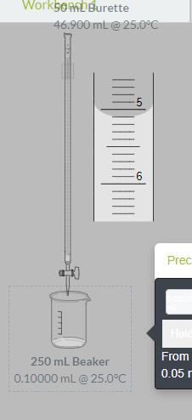

Volume of HCl: 5.00 mL

- Add the final volume (before the end point) determined in the coarse titration. To do this, click and hold the stopcock for longer periods of time. The solution in the Erlenmeyer flask should still be colorless.
- Add titrant one drop at a time and pause after each drop. This can be tedious, but if you click and hold you might miss the exact end point of the titration.
- When the solution in the Erlenmeyer flask changes color, stop adding titrant. Record the final volume of titrant dispensed. Take a screenshot of the buret reading and insert it below.
Initial titrant volume: 46.90 mL
Screenshot:
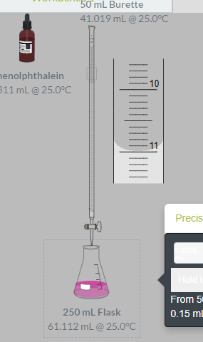
Calculate volume of 0.100 M NaOH delivered
(final titrant volume – initial titrant volume): 5.88
- In a classroom laboratory, you may perform the fine titration several times. Because this is just a tutorial, clear the bench of all materials, containers, and instruments, then return to your course page to complete any assignments for this lab.

Calculations and Questions
- From the volume of 0.100 M NaOH delivered in Experiment 2, Step 4, find the moles of NaOH used in the titration.

0.00469 mol NaOH
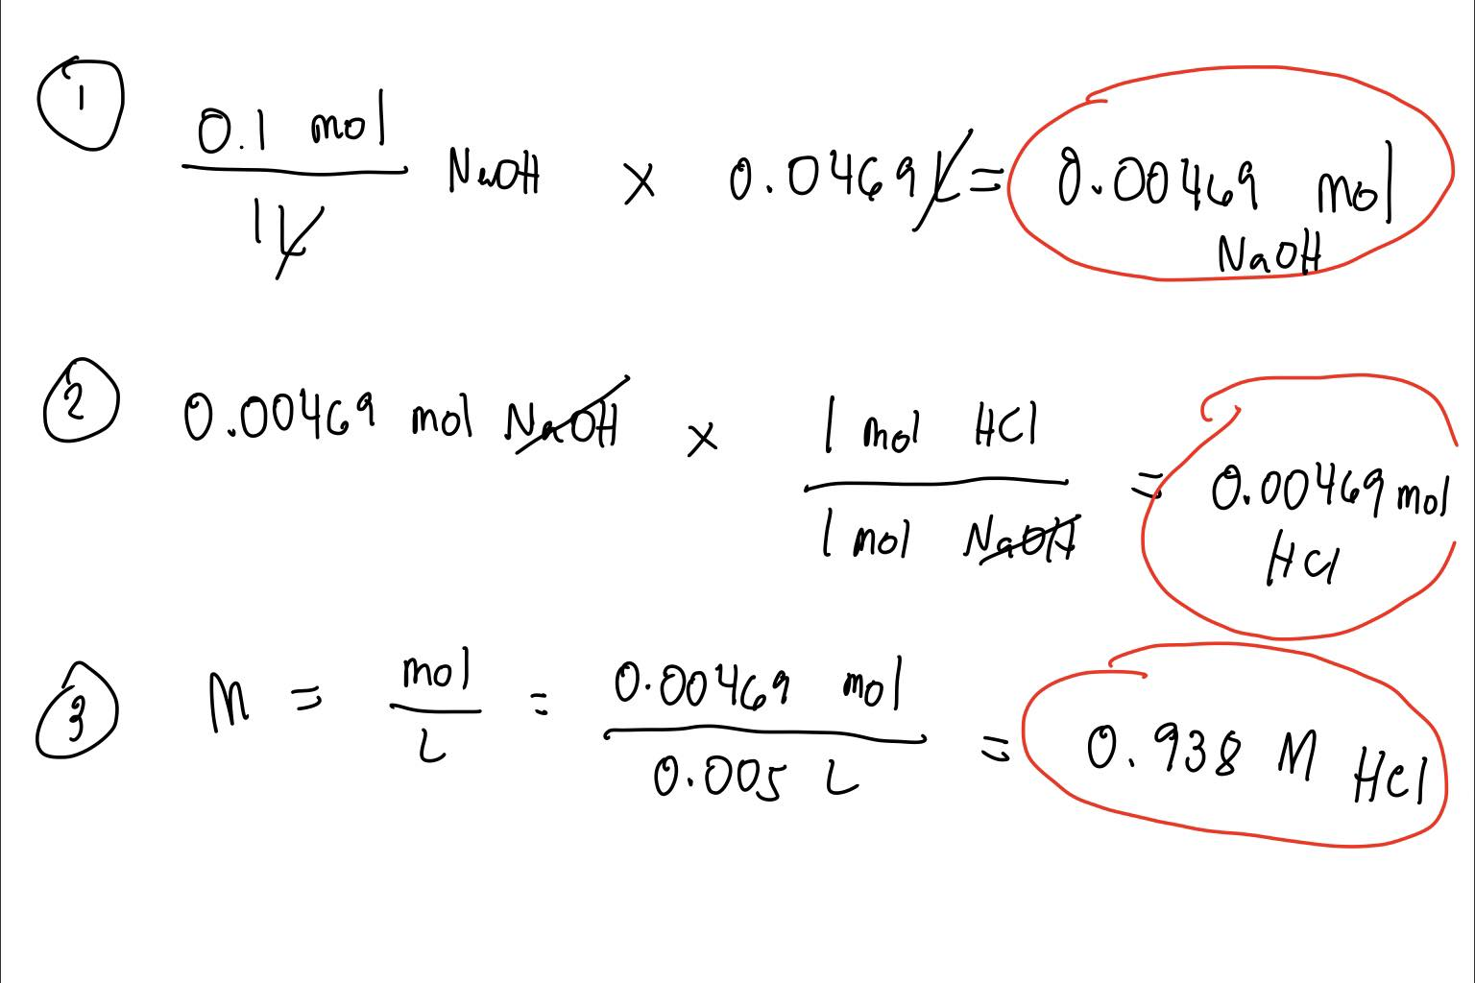

- Given the there is a 1:1 ration between the moles of NaOH and the moles of HCl, how many moles of HCl where present?

0.00469 mol HCl

- From the moles of HCl and the volume of HCl used in the titration, calculate the molarity of the unknown HCl solution.

0.938 M HCl

- Suppose that a student was not paying close attention during this experiment and added a few extra drops of the NaOH after the solution had already turned pink. How would this effect the calculated concentration of the HCl solution?

This further decreases the lone concentration of HCl since more salt is being formed from its reaction with NaOH.

NaOH + HCl NaCl + H₂O

If HCl will be added with more NaOH, these will produce more NaCl as the reaction progress thus reducing HCl molecules and subsequently reducing its concentration. Here, H+ shall decrease because of the neutralization process thus the pH of the solution will now increase.

- What would happen in this experiment if a student forgot to add the phenolphthalein?

The solution will not turn pink because Phenolphthalein functions as an indicator in the experiment – an indicator where it turns pink at acidic solutions. In cases when a student forgot to add phenolphthalein, this process should restart from titration.

