Requirement 1:
The existing functionality is shown as follow:
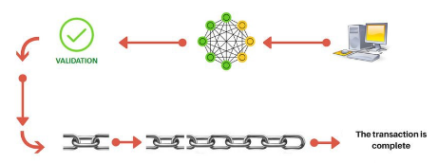
Requirement 2:
The external account of Ethereum can be provided as the account that represents the number of exchanges sent from the record's location. The external account can be shown below:
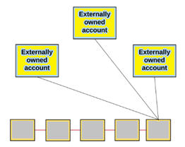
Similarly, the contract account of Ethereum can be provided as the account where the nonce is the number of agreements made by the record. The contract account can be shown below:
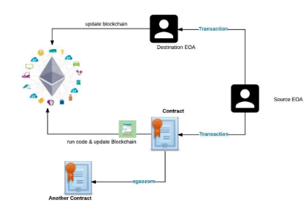
Requirement 3:
The ability for accounts to send coins to each other using transactions that include standard fields can be explained as every exchange in the blockchain is marked by the legitimate proprietor of the asset being exchanged the exchange. At the point when new coins are made they are relegated to a proprietor. This proprietor, thusly, can plan new exchanges that send those coins to others by basically installing the new proprietor's open key in the exchange and afterwards marking the exchange with his or her private key. Thusly, an evident connection of exchanges is made; each new exchange, with another proprietor, indicating the past exchange, with the past proprietor.
The diagram for that ability of Ethereum can be shown as follow:
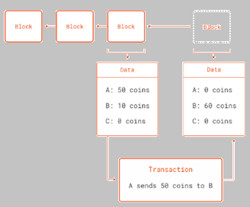
Requirement 4:
The ability for accounts to send data to each other using messages that include standard fields can be explained as when they get an approaching message, they play out some signature and nonce checks, and after that forward the message along to the proposed beneficiary with the expected information, and if the mark and nonce checks pass, they run the gave code in the record's specific situation.
The code for that ability of Ethereum can be shown as follow:
const Utils = require('web3-utils');
let txTr = {};
txTr.from = from.address;
txTr.to = to.address;
txTr.gas = GasLimit;
txTr.value = amount;
txTr.data = Utils.toHex('free');
web3.eth.sendTransaction(txTr);
const tx = new ethereumTx(txParams);
tx.sign(privateKey);
const serial_Tx = '0x'+tx.serialize().toString('hex')
console.log("serializedTx" , serial_Tx );
web3.eth.sendSignedTransaction(serial_Tx);
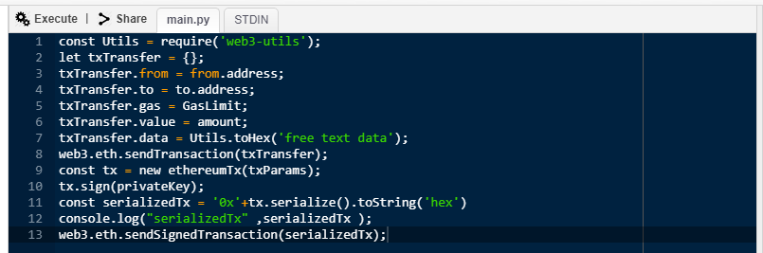
Requirement 5:
The code to implement a gas system similarly to the Ethereum protocol is given below:
pragma solidity ^0.4.19;
contract A {
(bytes32) {
address a = who;
uint l = m.length;
uint v = msg.value;
assembly {
if iszero(call(gas, a, v, add(m, 0x20), l, 0, 0)) {
revert(0, 0)
}
}
return 0;
}
}
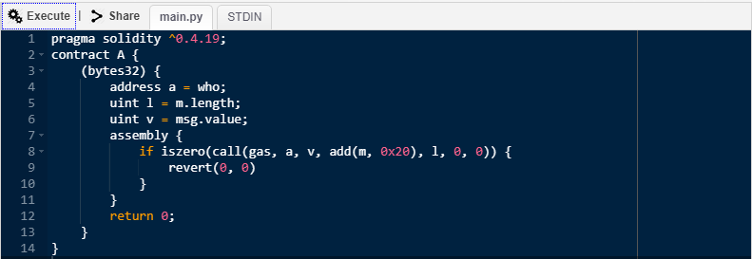
Requirement 6:
a) The executed code should securely execute real Python code included in the contract as follow:
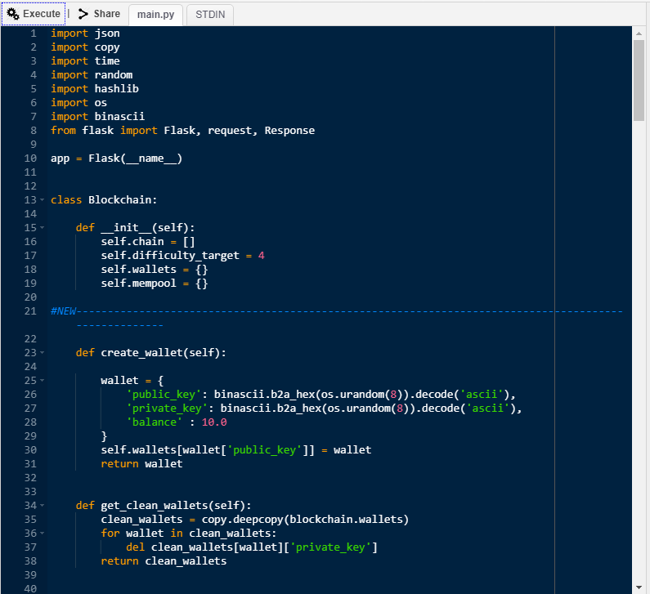
b) Contracts should only receive data, run their code, and return a response to the user as shown below:
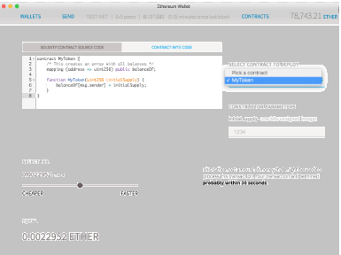
c) Contracts should push the updated state into the new block as shown below:
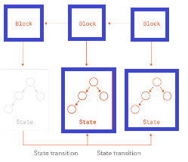
d) We can showcase one useful contract as follow:
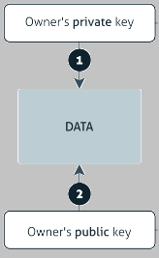
Requirement 7:
Blocks should include a separate data field to hold contract states as follow:
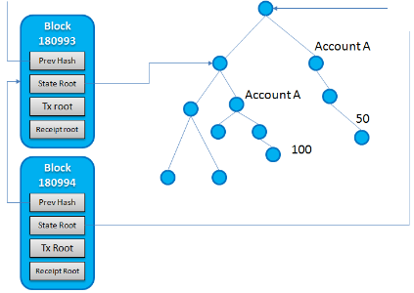
A second Merkle root field should be added to the block header as follow:
