- No.
- Yes.
- ….
  - 113.1429
  - 14.1429
  - $\frac{32}{3}*π*r^{3}$
- ….
  - -1
  - -1
  - $-x^{2}-x+1$
- …
  - -0.1111
  - Undefined
  - $\frac{1}{y^{2}+6y }$
- …
  - 6
  - 2
  - $\left|x^{2}\right|+4$
- Domain $(-2,2]$
Range $[-4,5]$
  - -4
  - -3
  - -4
  - 5
- Domain $\left(∞,∞\right)$
Range (-3,Ꝏ)
  - 0
  - -3
  - 3
  - 5
- No, y is not a function of x
- {-4.5, 6}
- {-1}
- {-3.87, 0, 3.87}
- ….
  - A vertical shift of f, c units up
  - A vertical shift of f, c units down
  - A horizontal shift of f, c units to the left
  - A horizontal shift of f, c units to the right
- ….
  - 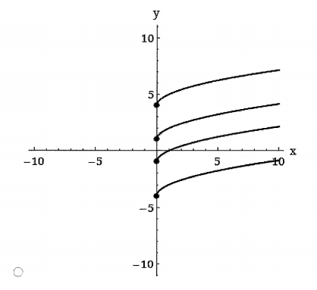
  - 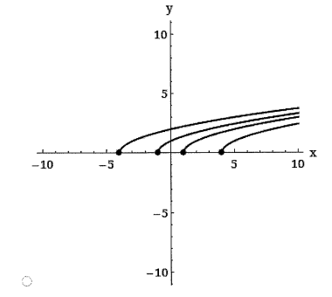
- ….
  - 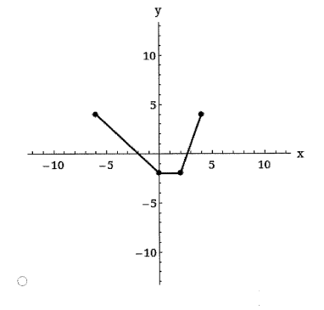
  - 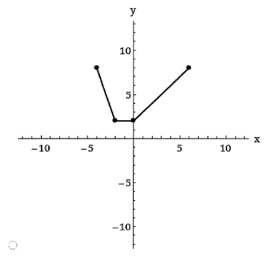
  - 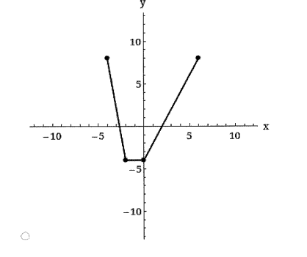
  - 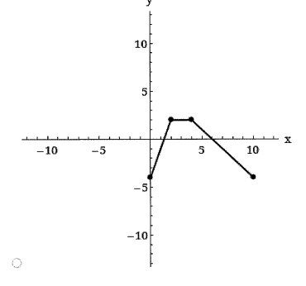
  - 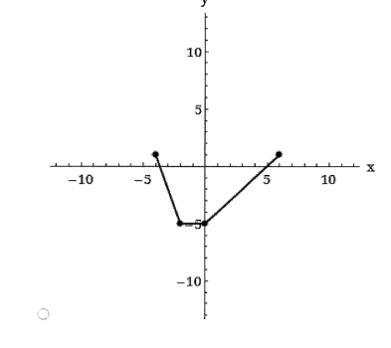
  - 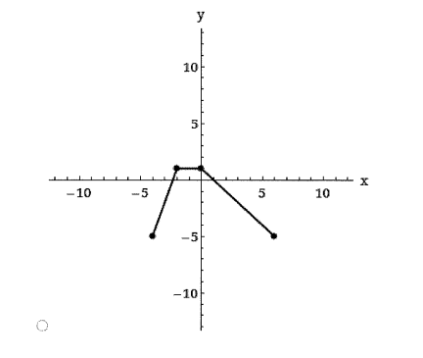
  - 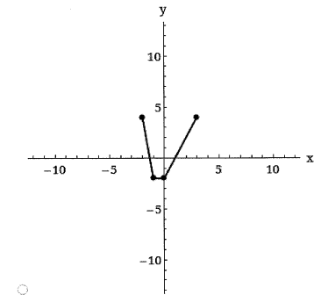
- ….
  - $y=x^{2}-1$
  - $y=-{\left(x+1\right)}^{2}+1$
- Parent function $y=x^{3}$
Transformation represented
- Horizontal shift of 2 units to the right
An equation for the function $y=({x-2)}^{3}$
- …
  - $f\left(x\right)=x^{3}$
  - $…$
  - Reflection in x axis
  - Horizontal shift of 4 units right
  - 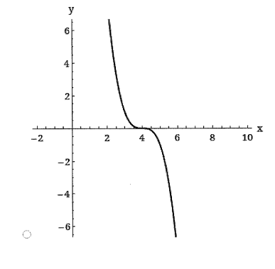
  - $g\left(x\right)=-f\left(x-4\right)$
- 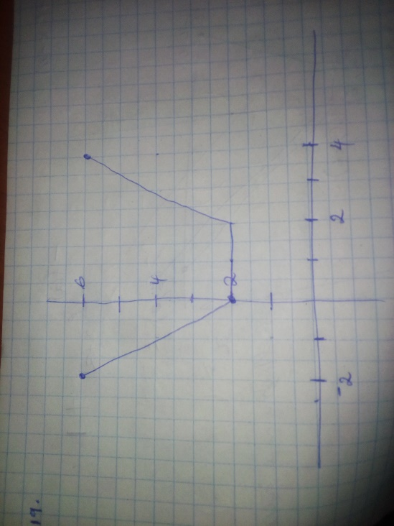
- …
  - $2x-7$
  - $4x-11$
  - $-3x^{2}+15x-18$
  - $-\frac{3\left(x-3\right)}{x-2}$
Domain of f/g $\left(-∞,2\right) and \left(2,∞\right)$
- …
  - $x^{2}+5+{\left(4-x\right)}^{0.5}$
  - $x^{2}+5-{\left(4-x\right)}^{0.5}$
  - ${(x}^{2}+5){\left(4-x\right)}^{0.5}$
  - $\frac{{(x}^{2}+5)}{{\left(4-x\right)}^{0.5}}$
$domain of\frac{f}{g}is (-∞,4)$
- $t^{2}-7t+13$
- -1.5
- …
  - $x^{2}-8x+16$
  - $x^{2}-4$
  - $x-8$
- ….
  - $\frac{8}{x^{2}+2x}$
  - $\frac{x^{2}+7}{x^{2}-1}$
Domain of f $\left(-∞,-1\right)and\left(-1,1\right)and\left(1,∞\right)$
Domain of g $(-∞,∞)$
Domain of f o g $\left(-∞,-2\right)and\left(-2,0\right)and\left(0,∞\right)$
Domain of g o f $\left(-∞,-1\right)and\left(-1,1\right)and\left(1,∞\right)$
- $f^{-1}\left(x\right)=\frac{x-7}{2}$
- $\frac{x-7}{2}$
- $\frac{x-7}{2}$
- $2x+7$
- $2x+7$
- $f^{-1}\left(x\right)=\sqrt{x-4}$
- $\sqrt{x-4}$
- $\sqrt{x-4}$
- $x^{2}+4$
- $x^{2}+4$
- 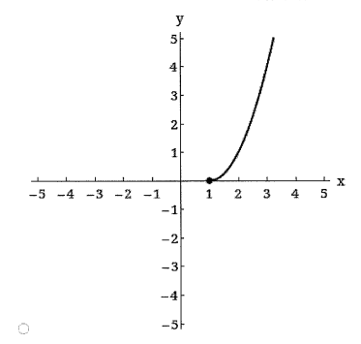
- …
  - $-\frac{5x+1}{x-1}$
  - $-\frac{5x+1}{x-1}$
  - $-\frac{5x+1}{x-1}$
  - $\frac{x-1}{x+5}$
  - $\frac{x-1}{x+5}$
  - $\frac{x-1}{x+5}$
Graphically
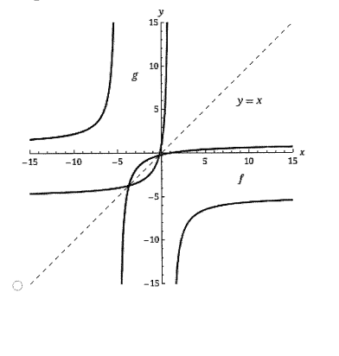
- …
  - $\sqrt[3]{x-3}$
  - 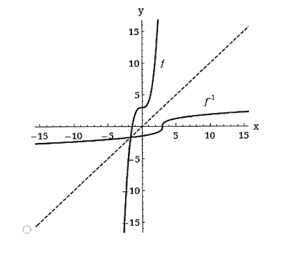
  - The graph of f^-1 is the reflection of f in the line y=x
  - Domain $\left(-∞,∞\right)$
Range $\left(-∞,∞\right)$

Domain $\left(-∞,∞\right)$
Range $\left(-∞,∞\right)$

