Project: (40 pts)
Mid-term Paper & Project ART100
Forged Art
Choose a favorite work of art from our textbook and recreate it. You can use any type media or process that you like. ​The​ one exception is​ you can’t photograph a picture of the work that you choose.
Critique Sheet based on your project (20 pts)
Mid-term Paper: (40 pts)
5 page, double-spaced paper, 12 pt, Times New Roman * 4 pages for the body of the paper
* 1 page for the bibliography/reference page
Resources
* minimum of three sources must be used and all sources must be cited * only used reputable sources (can’t use Wikipedia entries)
* use APA format.
1. Research and discuss the artist giving some insight into the artist background.
2. Discuss the work of art that you choose for the Forged Art Project and why you chose this work. 3. Discuss the style and/or movement of art that the artist worked in primarily.
4. Analyze your work of art that you created including the following: subject, style, process, media, discussing in detail a minimum of 3 elements & 2 principles. Make sure you discuss your project in detail.
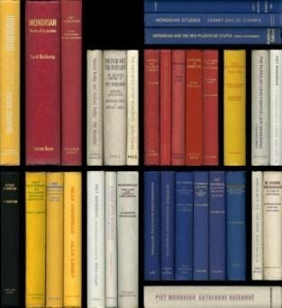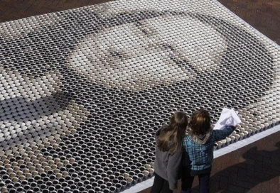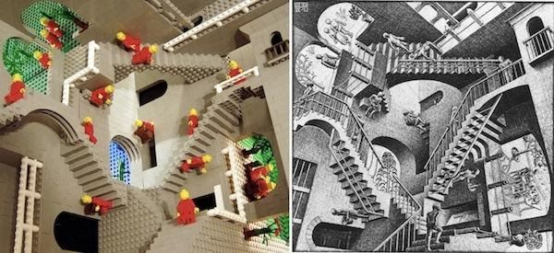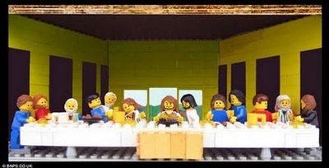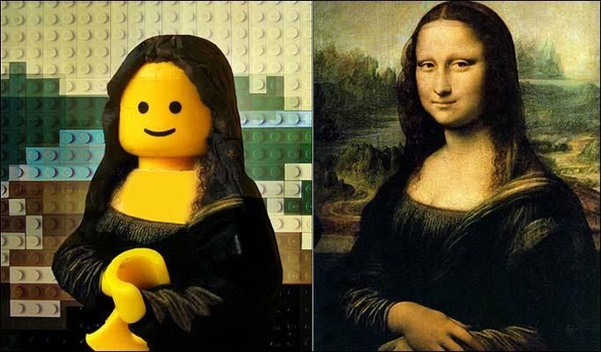
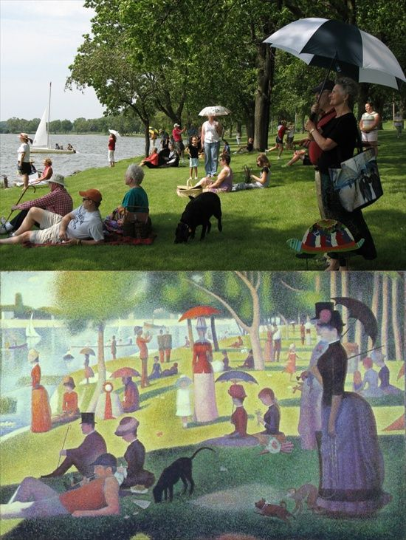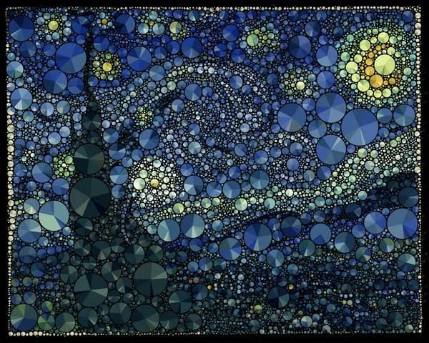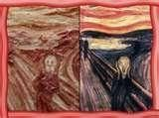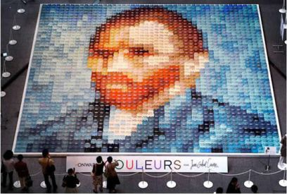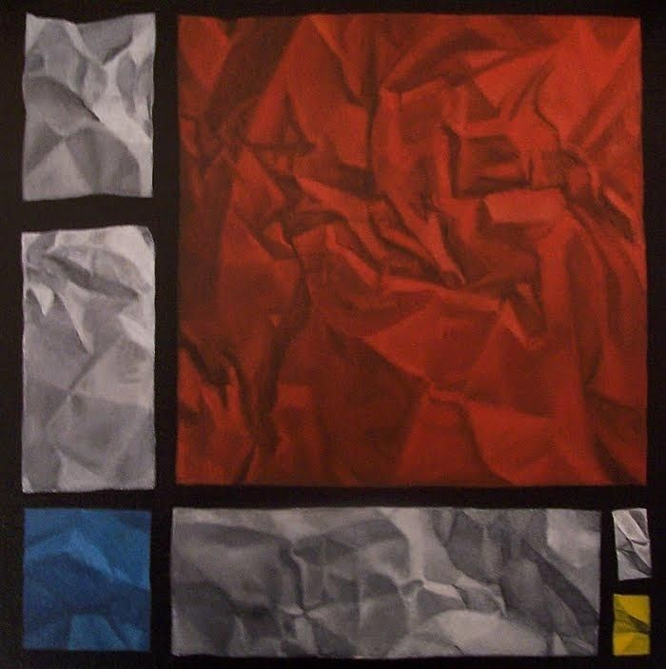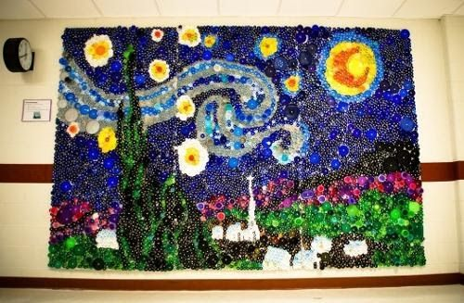

For
Critique Sheet based on your project (20 pts)
Art Criticism Worksheet
Principles:
What is the focal point of the artwork?
The first thing you see is
What kind of balance is used?
__Symmetrical-same on both sides
__Asymmetrical-different on each side
__Radial-central point and moves out
Are there any patterns in the artwork?
Which element/s is/are repeated?
Does the artwork look proportional correct?
Yes____ No ____
Is there a variety of elements? Yes____ No ____
Does the artwork look unified/complete? Yes__No __

interpretation - What is the purpose or meaning of the artwork?
What is happening in the artwork?

What is the artist trying to stay?

Does the title of the artwork tell you about the meaning or purpose of the artwork? Y N

What words describe the meaning of this artwork? (beauty, excitement, strength, love, mystery, enjoyment of work, happiness, fun, hope, adventure, loneliness, sadness, anger, exhaustion, war, peace, fear, courage)

What art style is the artwork?
____Representational/Realism
____Abstraction distortion of image via element/principle
____Nonobjective/Formalism/Non-
representational

judgement – This is your opinion
Do you like the artwork? Y N

Would you put this work in your home? Y N

What do you like about the artwork?

DESCRIPTION
Describe exactly what you see in the artwork

Title of artwork
Artist’s name
Date of artwork Size
Medium
(oil, acrylic, watercolor, metal, pencil, etc.)
Objects in the artwork

(people, animals, building, trees, sky, rocks
water, vehicles, food, clothes)

Analysis
The design- How is the artwork organized
Elements:
What kind of lines do you see?

(thick, thin, curved, straight, horizontal, vertical
jagged, diagonal, fuzzy spiral, dotted)
What kind of shapes do you see?

(geometric-circles, rectangles, squares, triangles
organic/ form shapes, hard edged, soft edged)
What kind of textures do you see?

(rough, smooth, soft, hard, dull, shiny)
What kind of colors do you see?

Primary,(R,Y,B) Secondary (O,G,V),
Complementary are opposite
colors (R/G, B/O, Y/V)
Warm (R,O,Y) Cool (B,V, G),
Neutral (brown, grey black, white)
Intense, Dull, Strong, Soft

Does the artwork show an illusion of space?
(deep space-see for miles)
(shallow space-cannot see very far)
(flat space-no space)
Where is the light coming from?
Do shapes/images have a range of value?
(do you see light, medium and dark colors)

