Visit the exhibition Too Much! in the Visual Arts Gallery and spend time with the projects and project descriptions. Take photographs. Review the curator's statement below from the exhibition. Think about the theme of consumerism and identity. Find connections from the works in the gallery to our discussions and readings thus far. During your visit to the gallery exhibition choose one or more of the projects in the gallery that stand out to you. Write a brief description of the project (and the artist) based on brief research. Choose 3 quotes from the readings and connect these to the artwork in the gallery that you chose. How can the projects help illustrate some of the points we have been discussing about media images, identity, consumerism, society and value? Do the messages presented by the artists connect with the messages we have been discussing? How does this exhibition draw attention to the argument around consumption? What are the social and environmental impacts of overconsumption and our individual role in this?
after reading the instructions for the essay
you can pick up to 3 of the pictures below to write about and below each picture I put the name of the person who did the piece and the name of it as well as what is It made of
I will attach the reading in another file where you can pick any 3 quotes and just try to make it relate to the art work and the essay

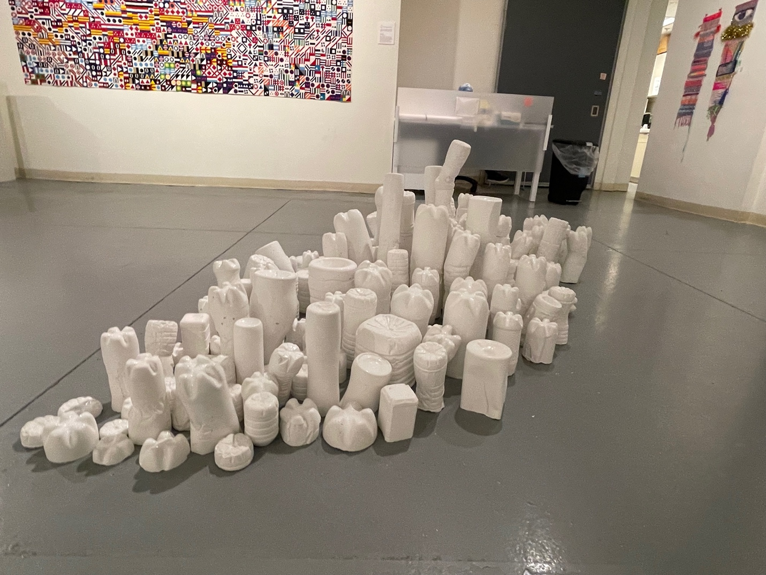

Made by Donna Conklin King the art is called Anenemy made of concrete
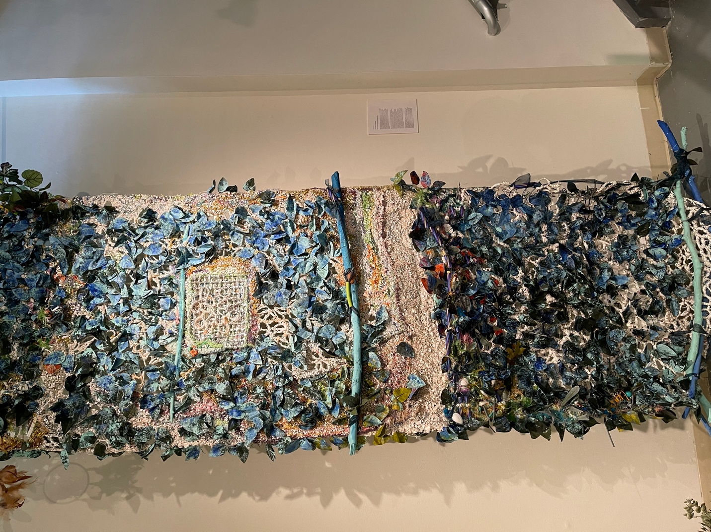
Made by Maggie Ens
GAUA calls us to healing
mixed media (branches,paint,toys,paper,various fibers, fauc plants, cut and interwoven milk cartons and a dream catcher)

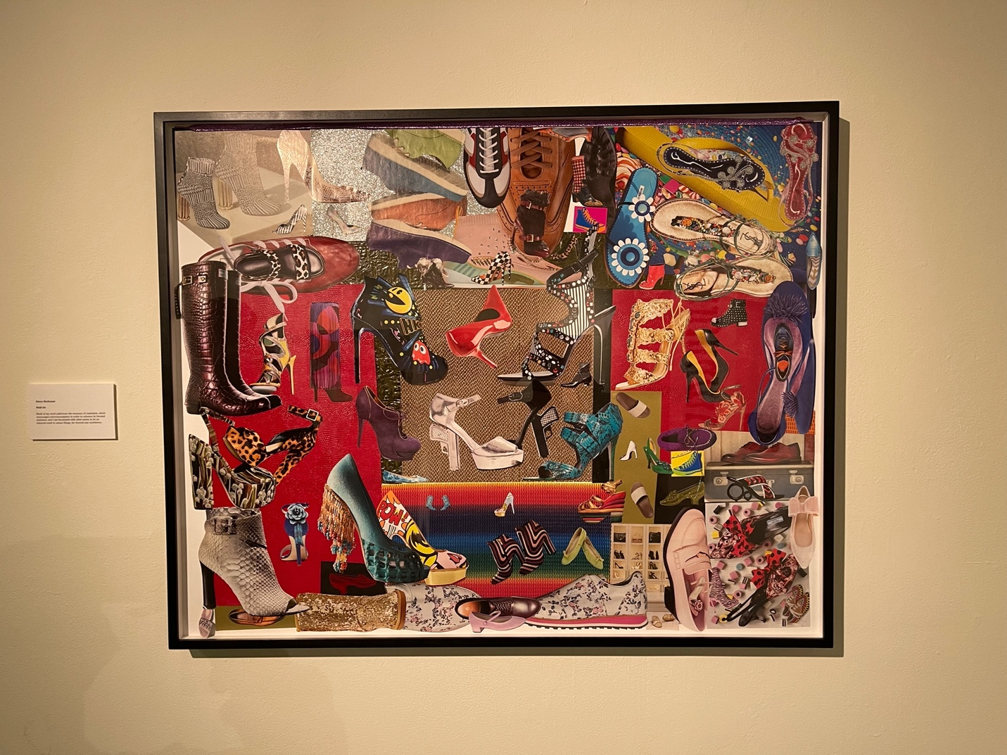
Made by Nancy Buchanan
walk on

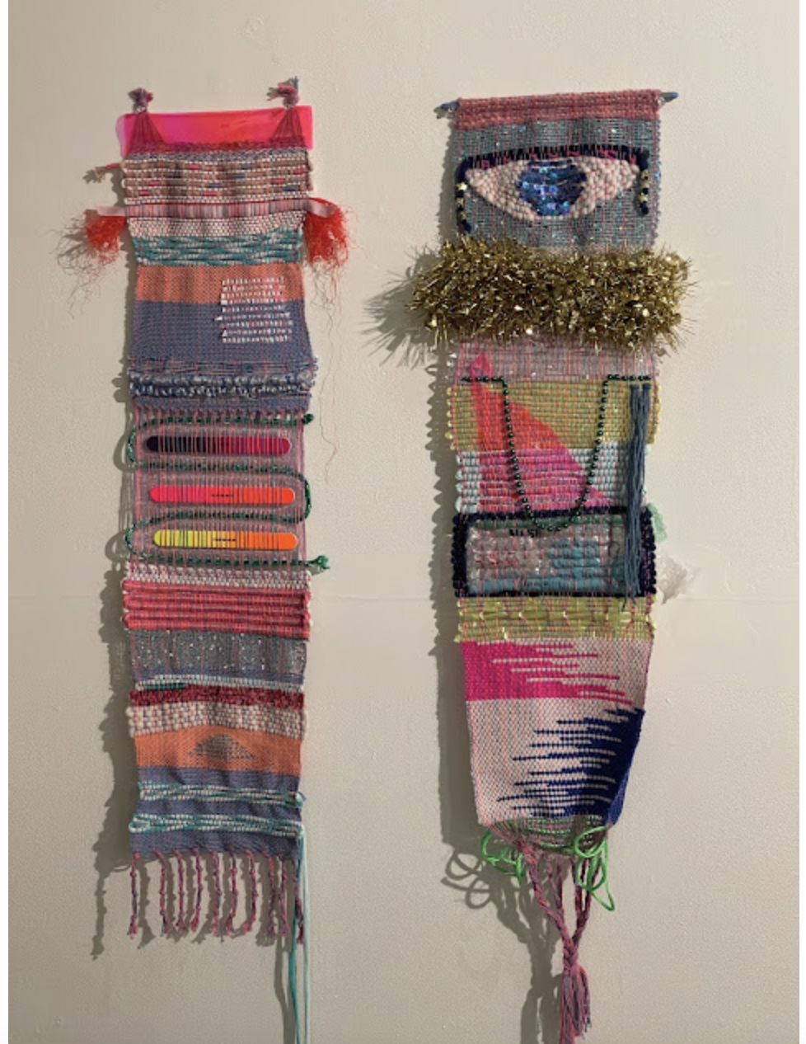
made by Vandana jain
nails/eyes
made cotton rug warp, sequins, colored jute, fluorescent na
files, paracord, plastic bags, mesh bag, transparent
pink vinyl, mask packaging, plastic twine, mardi gras
beads, tinsel garland, star pony beads, sequins, dowel

