Extinction Rebellion isn’t about the Climate

Yes, yes, I know. The climate is breaking down. It’s urgent. An emergency. We’ve only got a few years left to ‘fix’ it.

Indeed, we won’t fix it. Weather patterns will become increasingly unstable and unpredictable, and the effects it will soon have on how humans around the world grow food will be devastating, likely causing harvests to fail across entire continents and food prices to sky-rocket. Millions have already suffered due to the amplified instability. We’re facing imminent societal collapse (whatever that means), both around the world and in the UK. All of our lives are soon going to radically change.

None of this is particularly controversial. When a bus is driving with a certain momentum towards a person, it gets clearer and clearer that it will hit the person. After a certain point, it’s inevitable. And that’s where we stand now, with regards to the momentum of climatic change. The bus is about to hit us. Our lives are about to change. It’s not clear whether or not we’ll survive (as a species). Many species have already been run over. Two hundred species each and every day go extinct.

I’ve been with Extinction Rebellion (XR) from the start. I was one of the
15 people in April 2018 who came together and made the collective
decision to try to create the conditions that would initiate a rebellion. I
was a coordinator of one of the original five working groups, and I’ve
been organising with XR day-and-night since then (frugally living off
my savings so I don’t have to work, having quit an industry that paid me
£1000/week). And I’ve been in RisingUp (the organisation from which
XR has emerged) since the first RisingUp action in November 2016. I’m
a RisingUp Holding Group member, and a member of the XR
Guardianship Team.

And for the sake of transparency: that previous paragraph is all about me ‘pulling rank’—I’m trying to convince you to listen to what I have to say…

And I’m here to say that XR isn’t about the climate. You see, the climate’s breakdown is a symptom of a toxic system of that has infected the ways we relate to each other as humans and to all life. This was exacerbated when European ‘civilisation’ was spread around the globe through cruelty and violence (especially) over the last 600 years of colonialism, although the roots of the infections go much further back.

As Europeans spread their toxicity around the world, they brought torture, genocide, carnage and suffering to the ends of the earth. Their cultural myths justified the horrors, such as the idea that indigenous people were animals (not humans), and therefore God had given us dominion over them. This was used to justify a multi-continent-wide genocide of tens of millions of people. The coming of the scientific era saw this intensify, as the world around us was increasingly seen as ‘dead’ matter—just sitting there waiting for us to exploit it and use it up. We’re now using it up faster than ever.

Euro-Americans violently imposed and taught dangerous delusions that they used to justify the exploitation and reinforced our dominance, while silencing worldviews that differed or challenged them. The UK’s hand in this was enormous, as can be seen by the size of the former British empire, and the dominance of the English language around the world. There is stark evidence that everyday racial bias continues in Britain, now, today. It’s worth naming some of these constructed delusions that have been coded into societies and institutions around the world:

- The delusion of white-supremacy centres whiteness and the experience of white people, constructing and perpetuating the myth that white people and their lives are somehow inherently better and more valuable than people of colour.
- The delusion of patriarchy centres the male experience, and excludes/hinders female assigned people from public life (reducing them to a possession or object for ownership or consumption). Patriarchy teaches dominating and competitive behaviours, and emphasises the idea that the world is a place of scarcity, separation and powerlessness.

- The delusions of Eurocentrism include the notion that Europeans know what is best for the world.
- The delusions of hetero-sexism/heteronormativity propagate the idea that heterosexuality is ‘normal’ and that other expressions of sexuality are deviant.
- The delusions of class hierarchy uphold the theory that the rich elite are better/smarter/nobler than the rest of us, and make therefore better decisions.

There are other delusions. These delusions have become ingrained in all of us, taught to us from a very young age.
None of these delusions have ended, although some of the arguments

that supported them (e.g. phrenology) have been dispelled. They

continue to play out through each of us, in our ways of relating,

regardless of our identity. The current pride in the history of the British

empire, or the idea that the USA is on the side of ‘good’, continues to

enable neo-colonialism in 2019, taking the form of palm-oil

plantations, resources wars, and the parasitical financial sector, to

name but a few. The task of Extinction Rebellion is to dispel these

delusions. We need to cure the causes of the infection, not just alleviate

the symptoms. To focus on the climate’s breakdown (the symptom)

without focusing attention on these toxic delusions (the causes) is a

form a denialism. Worse, it’s a racist and sexist form of denialism, that

takes away from the necessary focus of the need for all of us to de-

colonise our selves.

My ancestors are European, some of whom claimed to ‘own’ people as
slaves. There are black people with the name Basden in the Americas,
and I have begun to mobilise my (white) family to make contact in
order to seek to pay reparations.

However, my own accountability cannot be fully paid through this. The insanity* of the mind of the coloniser continues today. It continues in the extraction of fossil fuels, minerals and water from the earth. It continues in deforestation and industrial agriculture. It continues in a callous culture of consumption, which intensifies each Christmas. It continues in evictions and deportations. It continues in the ways of relating to those around us that perpetuate separation and division.

The result is isolation, pain and suffering. The result can be felt at the
individual level—in the endemic levels of loneliness and mental-health
illness. It can be felt at the community level—in the theft of land for
plunder and profit by largely-European-and-US-based banks and
corporations. And it can be felt at the global level—in the polluting of
our air and oceans.

So Extinction Rebellion isn’t about the climate. It’s not even about
‘climate justice’**, although that is also important. If we only talk about
the climate, we’re missing the deeper problems plaguing our culture.
And if we don’t excise the cause of the infection, we can never hope to
heal from it.
This article is calling to all of those who are involved in XR who

sometimes slip into saying it’s a climate movement. It’s a call to the

American rebels who made a banner saying “CLIMATE extinction
rebellion”. It’s a call to the XR Media & Messaging teams to never get

sloppy with the messaging and ‘reduce’ it to climate issues. It’s a call to
the XR community to never say we’re a climate movement. Because
we’re not. We’re a Rebellion. And we’re rebelling to highlight and heal
from the insanity that is leading to our extinction. Now tell the truth
and act like it.

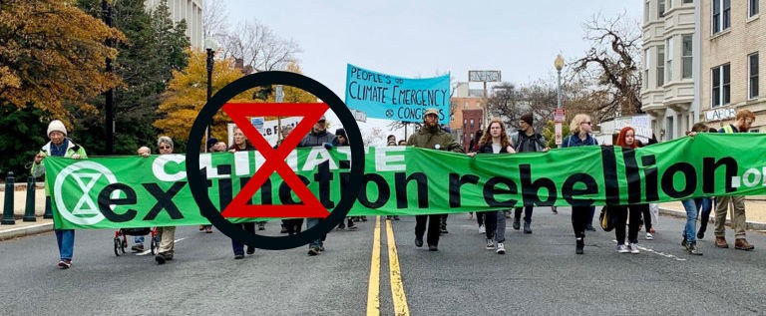

* I use the term ‘insanity’ carefully, with the intention of highlighting

the need for healing. Indigenous First Nation people helpfully taught

me to see the mindset of the coloniser as a sickness. In no way do I

intend to marginalise or discredit the experience of people who have

been labelled ‘insane’ by a normative system, nor who identify as being

‘insane’.

3/24/2019
Extinction Rebellion isn’t about the Climate – Stuart Basden – Medium

** Climate Justice refers to the injustice that those who are affected
first and worst by extreme weather events (the people in the poorer
countries, the majority of whom live in the Global South) are not likely
to be the ones who caused the climate emissions (the people who
consume the most, including the pathologically wasteful cultures of
Europe and Turtle Island (aka North America), and the rich who
live/travel around the world).

