### Answer short questions (2 marks, 0.5 each)
* What are the major Python versions? Are they inter-compatible?
* What are the advantages and disadvantages of a scripting language like Python?
* Name one Python package each for
* numeric calculation,
* image processing,
* data visualisation,
* machine learning.
* Explain the difference between mutable and immutable objects. Give an example for each.

## Functions (2 marks, 0.5 each)

* How to indicate a code block in Python?
* Explain the difference between local scopes and global scopes;
* Refer to Code 1 - 3 below and infer the difference between keywords `global` and `nonlocal`;
* Compare Code 4 and Code 5, explain why Code 5 is able to change the value of `x`. Hint: is it a new assignment or an in-place change?

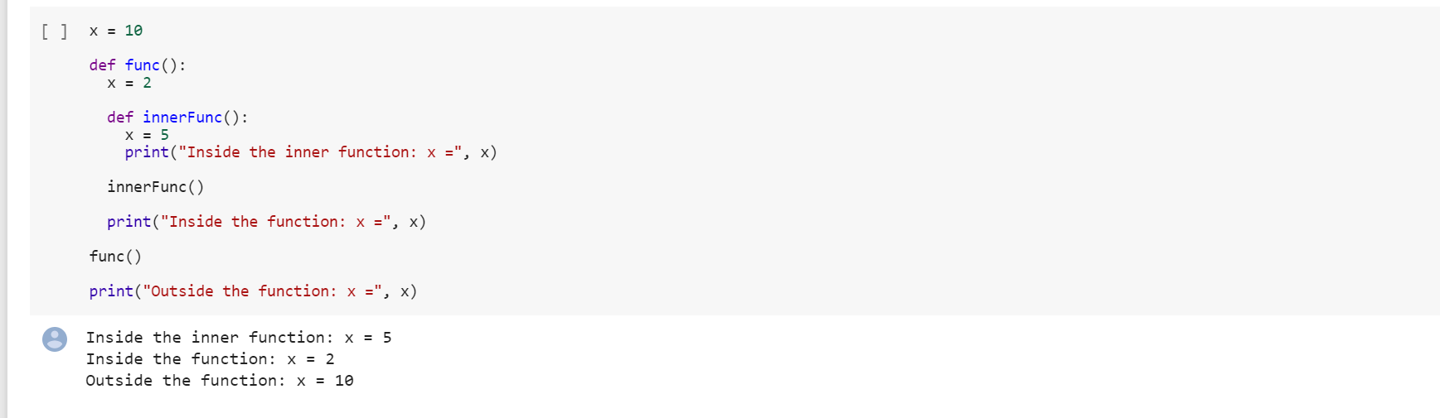

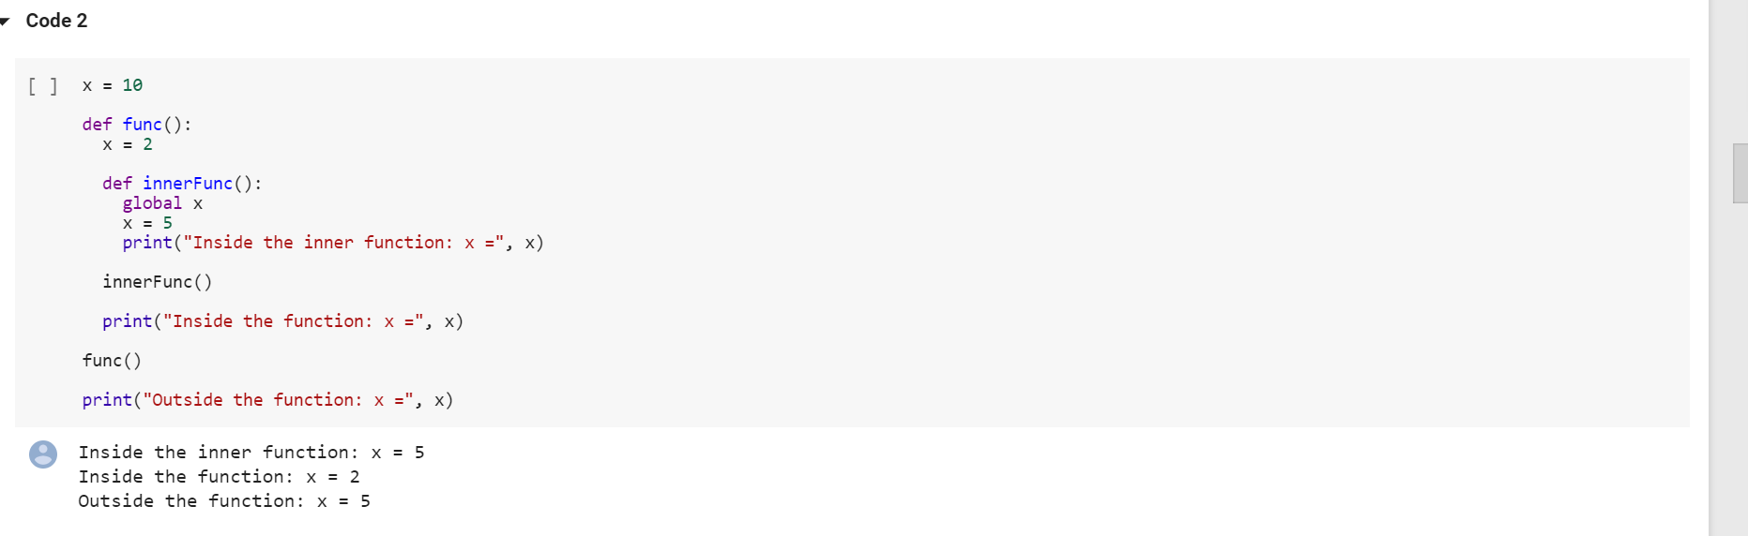

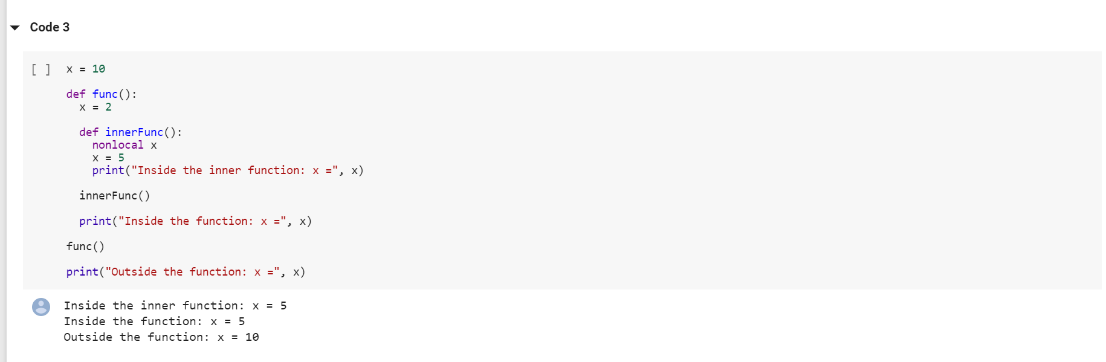

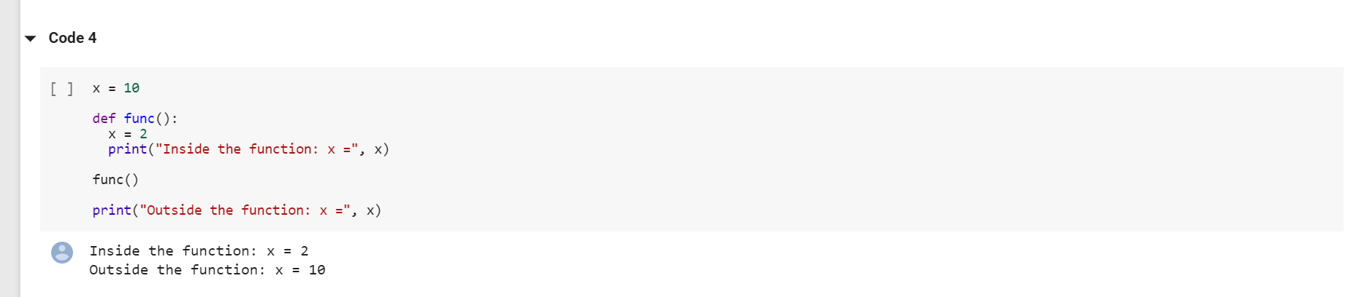

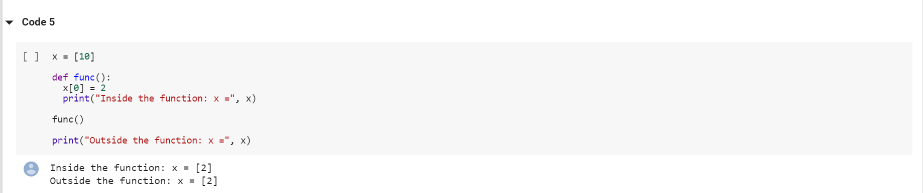

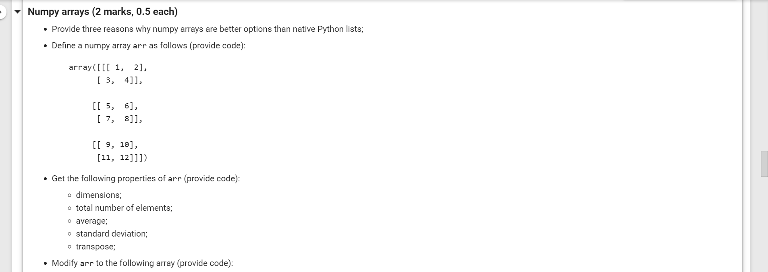

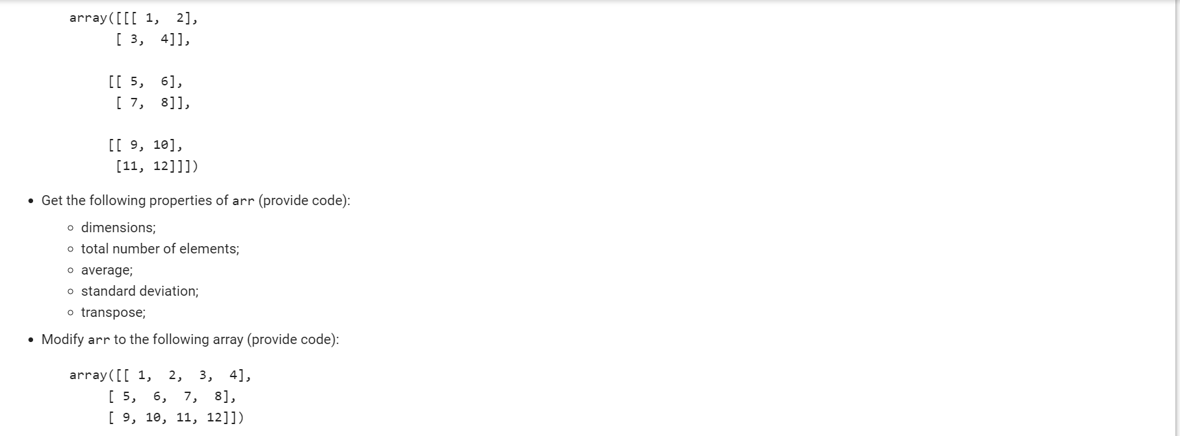
### Explain terminologies (1 mark)
* Supervised vs unsupervised learning
* Training vs testing
* Overfitting
* Gradient descent

### Data partitioning (1 mark)
Propose a data partitioning plan if the model has severl hyper-parameter to be determined.
### Explain terminologies (1 mark)
* Neural networks
* Weights and biases
* Backpropagation
* Activation functions
### Convolutional neural networks (1 mark)
* What are the major components of a convolutional neural network?
* What does each of these components do?
* When should you use a softmax activation function?
* What loss can you use for a multi-class classification task?

