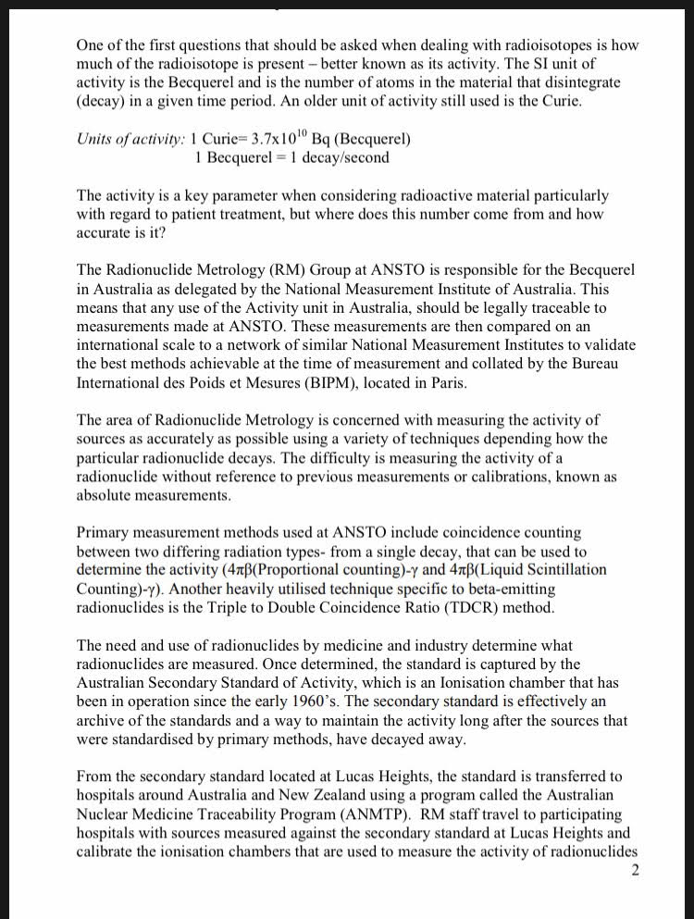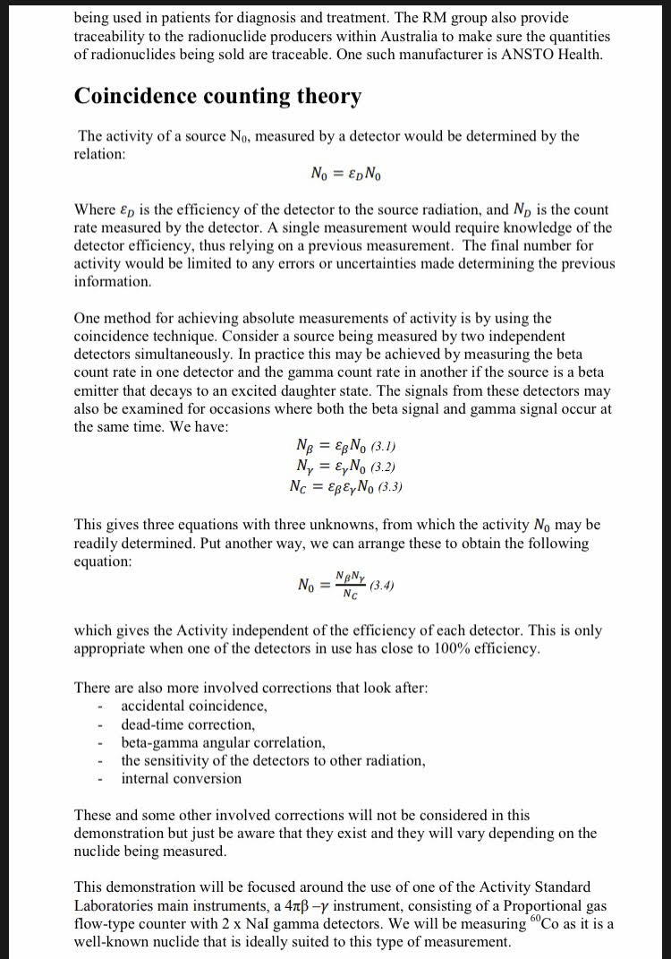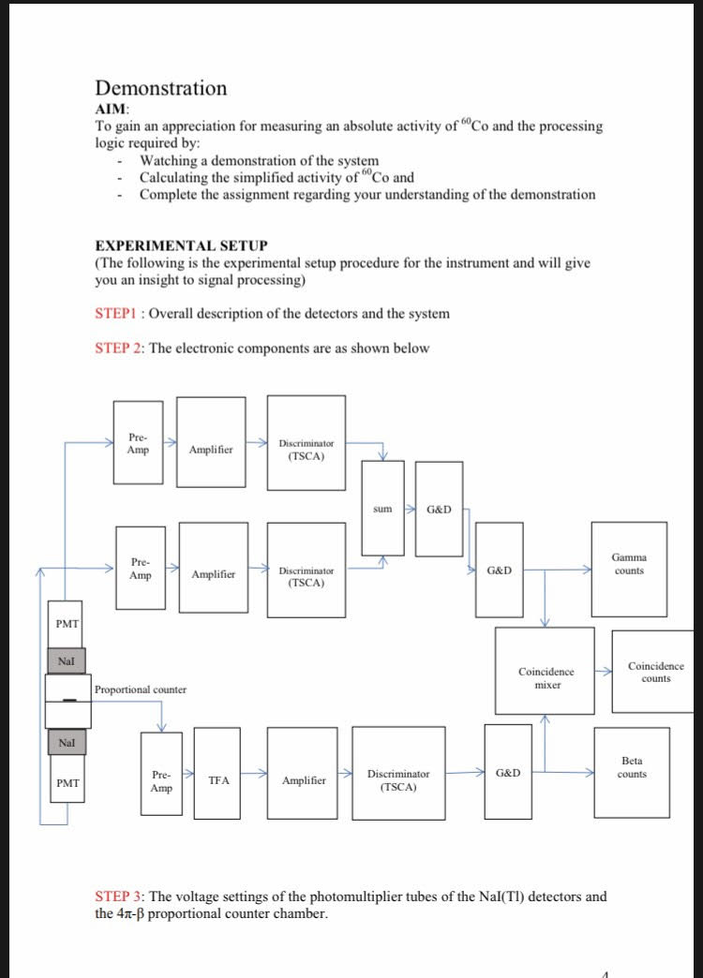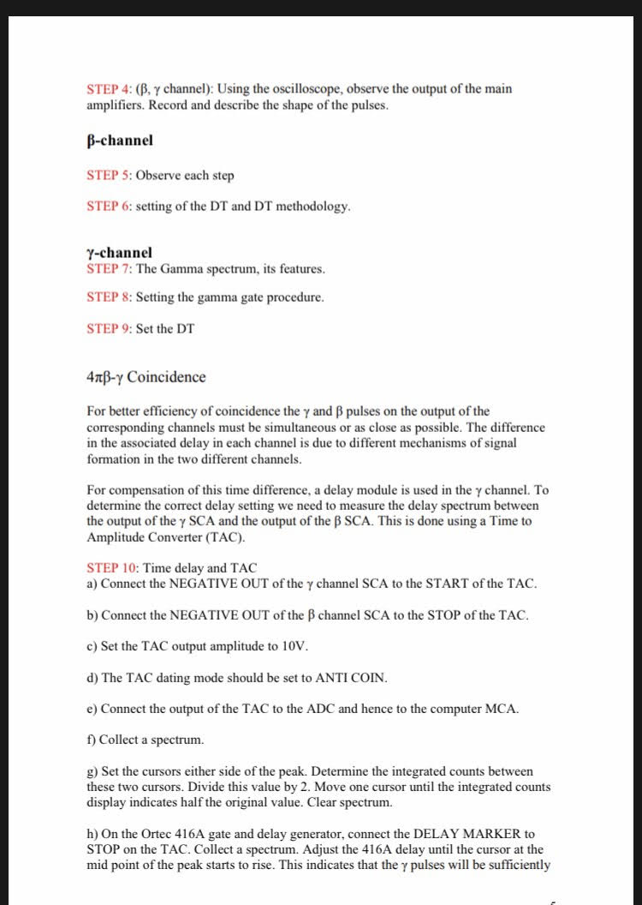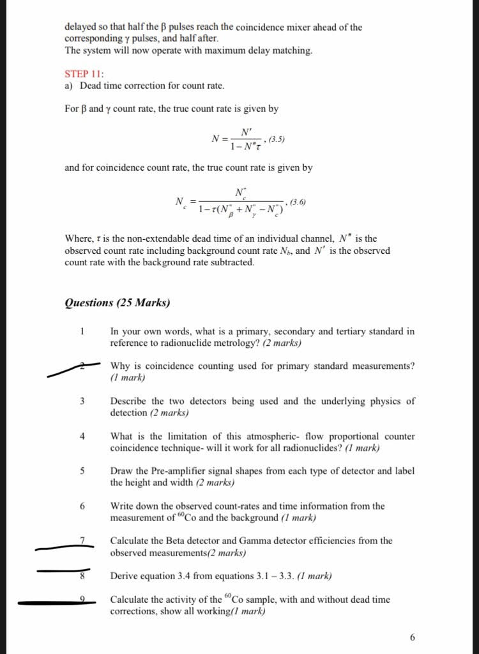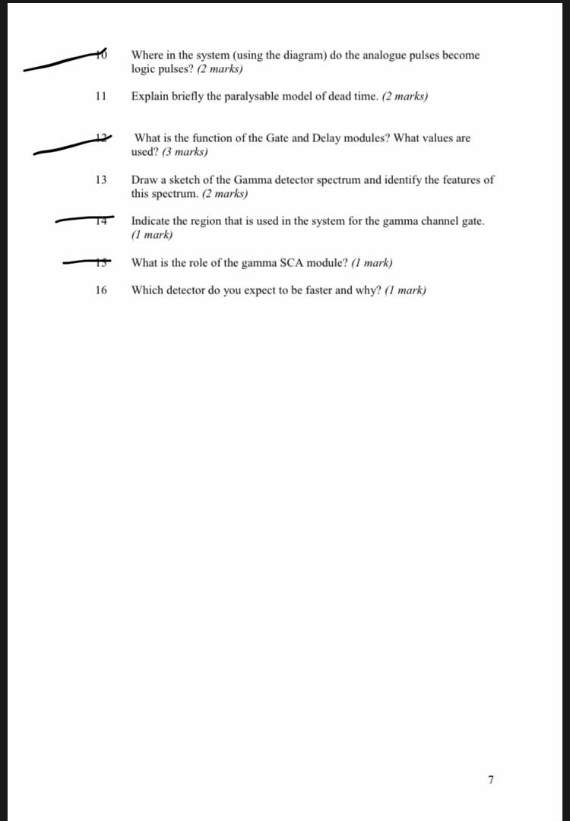
Dead time 10 micro seconds
With source measurements
Beta 2807916
Gamma 203191
Coincident count 167891
External timer 6000089
Internal timer 600 s
Background measurements
Beta 2204
Gamma 3256
Coincident count 32
External timer 6000089
Internal timer 600 s.
BETA signal.
High= 2500 mV. Width= 17.5 micro seconds.
Gamma signal
High= 200 mV. Width= 75 micro seconds.

