Assignment 4.1
Step One
Example of a technical document that is easy to use: Instructions for handling first aid for burns.
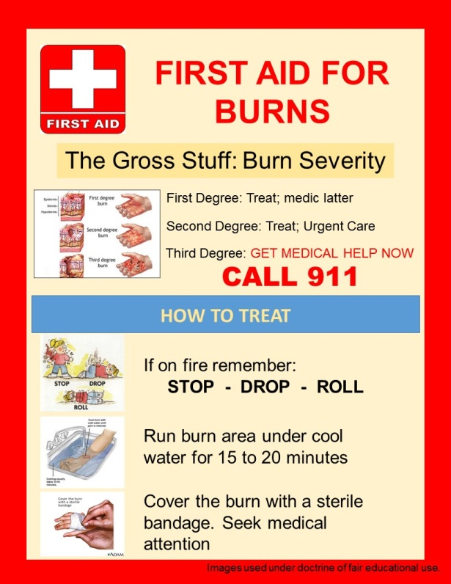
Characteristics of the document that makes it usable:
One of the characteristics of this document is that it has accurate content. This document's content has no errors that might interrupt the entire process of treating various degrees of burns. Another characteristic of this document is that it is satisfying. The user of these instructions is able to find it enjoyable to use this design because the information has a good flow. This means that the document is organized in an orderly manner, thus making it visible at a glance. For instance, the user can simply note that he or she should call 911 when the situation is worse.
Step Two
Example of a technical document that is hard to use: Instructions on how to change engine oil.
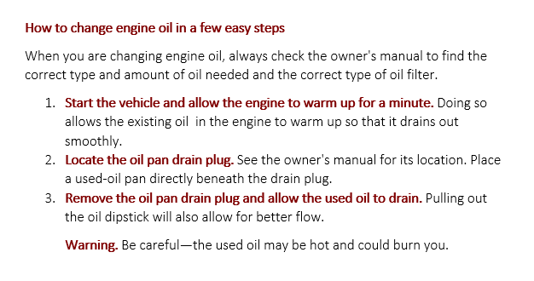
Characteristics that make the document hard to use:
One of the characteristics is that the author failed to give the timeframe for activities like warming the engine. In this case, an individual might overheat the car.

Step Three: Memo
Memo
Date: February 28, 2021.
To: Instructor
From: Melarqem
Subject: Revising the unusable document
After going through the instructions on how to change the engine oil, I realized that this document is unusable due to its inherent technicalities. I believe that there are some variables that should be improved to promote its usability. One of the changes that I would make to revise the document is incorporating the timeline. I will indicate the exact time that is required to warm up the engine because too much heat might compromise the entire process. I will also include certain images that demonstrate respective parts of the vehicle that a person might understand when changing the engine oil. All these imply that a picture is more than a thousand words.

