1) Draw Lewis structures for each of the following molecular compounds. Be sure to include any lone-pair electrons. (2 marks per structure)

H₂S
PH₃
HCN
Criteria:

Draw the Lewis structures for each molecular compound with accuracy
2) Draw a Lewis Structure (2 marks per molecule) and a Condensed Structural Formula (1 mark per molecule) for each of the following organic molecules.

Organic Molecule Lewis Structure Condensed Structural Formula
C₄H₁₀
C₄H₈
C₄H₆
Criteria:

Draw the Lewis structure for each organic compound with clarity
Draw the condensed structural formula for each organic compound with clarity

3) Name the following organic compounds. (2 marks per compound)
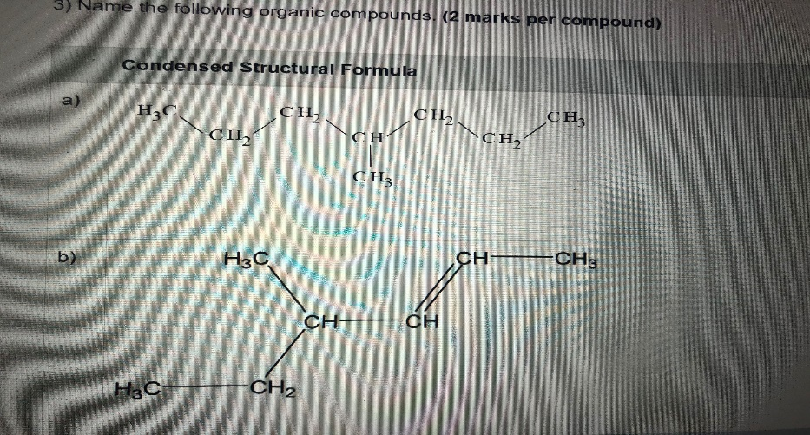
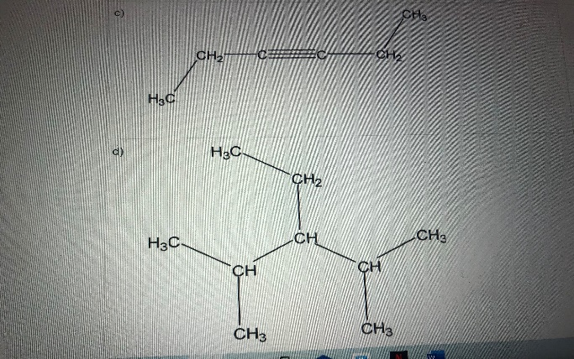

4) Draw condensed structural formulas for the following organic structures. (2 marks per structure)

a) 2-hexene

b) 3-ethyl-3-methylheptane

c) 1-butyne

d) 2, 5, 6-trimethyloctane
Criteria:

• Draw structural formulas of organic compounds with clarity

5) Identify the functional group present in each organic compound. (1 mark per compound)

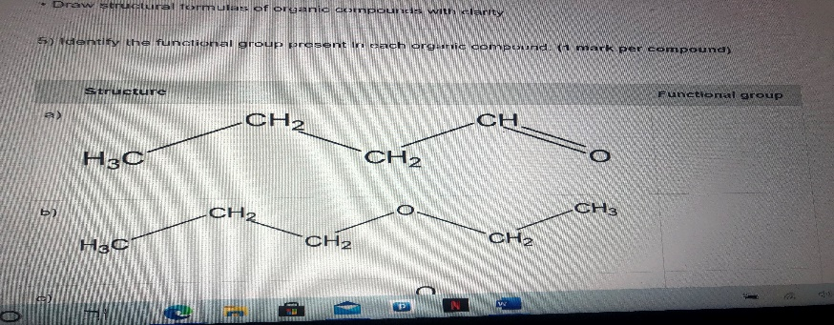
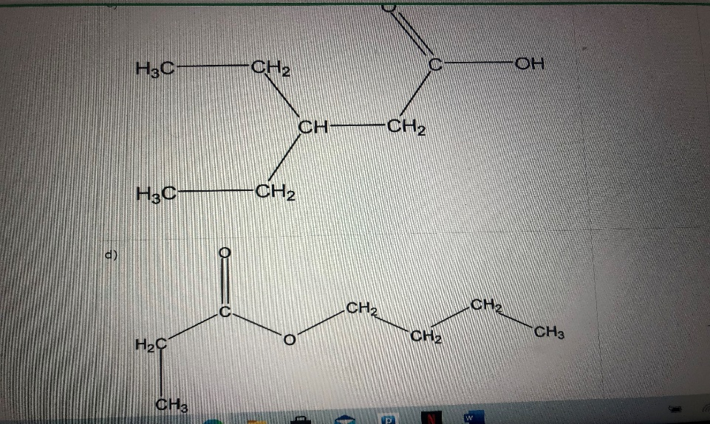

6) Classify the following reactions. (1 mark per reaction)
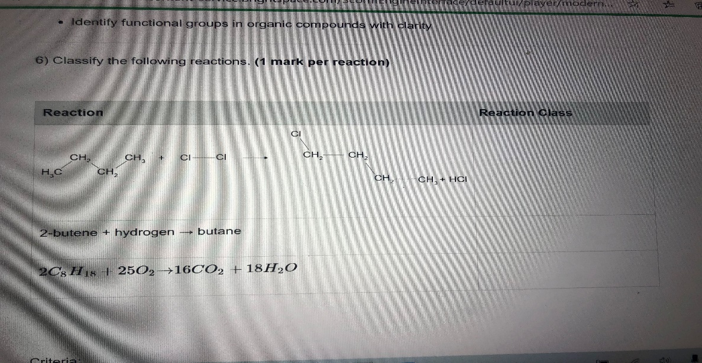
7) For each of the following compounds,

Draw the Lewis structure of a compound with clarity and accuracy (2 marks per chemical)

Determine if a chemical bond is either non-polar, polar, or ionic with clarity and accuracy (1 mark per chemical)

Determine if a compound is either non-polar, polar, or ionic with clarity and accuracy (1 mark per chemical)

Chemical Formula Lewis Structure Classify each bond non-polar, polar, or ionic. Show any calculations used to determine your answer. Classify the compound as non-polar covalent, polar covalent, or ionic. Explain your answer.
CF₄
HBr
N₂
Criteria:

Draw the Lewis structure of a compound with clarity and accuracy
Determine if a chemical bond is either non-polar, polar, or ionic with clarity and accuracy
Determine if a compound is either non-polar, polar, or ionic with clarity and accuracy
When you are ready, submit your assessment for feedback and a grade, by selecting the “Assignment” link and follow the submission directions.

