Lab Report Requirements
a)Describe the general features of the Milky Way
The Milky Way Galaxy’s structure is fairly typical of a large spiral system. Spiral galaxies and other types of galaxies are described in the article galaxy. This structure can be viewed as consisting of six separate parts:

1. The nucleus

At the very center of the Galaxy lies a remarkable object—a massive black hole surrounded by an accretion disk of high-temperature gas. Neither the central object nor any of the material immediately around it can be observed at optical wavelengths because of the thick screen of intervening dust in the Milky Way. Somewhat similar to the centers of active galaxies , though on a lesser scale, the galactic nucleus is the site of a wide range of activity apparently powered by the black hole.

2. The central bulge

Surrounding the nucleus is an extended bulge of stars that is nearly spherical in shape and that consists primarily of Population II stars, though they are comparatively rich in heavy elements. (For an explanation of Population II stars, see Stars and stellar populations.) Mixed with the stars are several globular clusters of similar stars, and both the stars and the clusters have nearly radial orbits around the nucleus. The bulge stars can be seen optically where they stick up above the obscuring dust of the galactic plane.

3. The disk

From a distance the most conspicuous part of the Galaxy would be the disk, which extends from the nucleus out to approximately 75,000 light-years. The Galaxy resembles other spiral systems, featuring as it does a bright, flat arrangement of stars and gas clouds that is spread out over its entirety and marked by a spiral structure. The disk can be thought of as being the underlying body of stars upon which the arms are superimposed. This body has a thickness that is roughly one-fifth its diameter, but different components have different characteristic thicknesses. The thinnest component, often called the "thin disk," includes the dust and gas and the youngest stars, while a thicker component, the "thick disk,” includes somewhat older stars.

4. The disk
From a distance the most conspicuous part of the Galaxy would be the disk, which extends from the nucleus out to approximately 75,000 light-years. The Galaxy resembles other spiral systems, featuring as it does a bright, flat arrangement of stars and gas clouds that is spread out over its entirety and marked by a spiral structure. The disk can be thought of as being the underlying body of stars upon which the arms are superimposed. This body has a thickness that is roughly one-fifth its diameter, but different components have different characteristic thicknesses. The thinnest component, often called the "thin disk," includes the dust and gas and the youngest stars, while a thicker component, the "thick disk,” includes somewhat older stars.
b)The idea of finding our location in the Milk way.
The position of the sun in the Milky Way can be further pinned down by measuring the distance to all the stars we can see. In the late 18th century, astronomer William Herschel tried to do this, concluding that the earth was in the center of a 'grindstone'-shaped cloud of stars. But Herschel was not aware of the presence of small particles of interstellar dust, which obscure the light from the most distant stars in the Milky Way. We appeared to be in the center of the cloud because we could see no further in all directions. To a person tied to a tree in a foggy forest, it looks like the forest stretches equally away in all directions, wherever one is.

Describe what data you will use,
More specifically, the researchers wanted data regarding Cepheid’s, which are a unique type of pulsating star. They were useful to the researchers because they pulse with regularity and brightness. This means that their true brightness can be calculated and compared to the brightness of them as seen here from Earth—doing so allows for very accurately measuring how far away from us they are. By amassing data from 2,431 Cepheid’s and putting them all on a map together, the researchers were able to produce a 3-D representation of the Milky Way, at least from the perspective of Cepheid’s. The model they created is the first to be built using direct measurements of star distances, thus it is the most accurate to date.

How you will use it to make a simple model of the Milky Way.
The important feature of a Cepheid Variable that allows it to be used for distance measurements is that its period is related directly to its luminosity. This relation allows us to work out how much brighter than the Sun the star is. From there we can calculate how much further away the star must be than the Sun to make it the brightness we see from Earth.
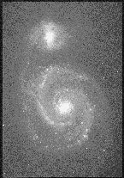
M51 - A close by galaxy whose distance could be found using Cepheid’s
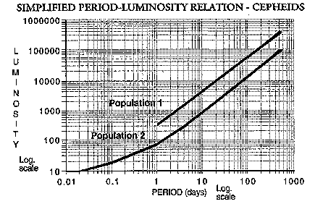
The only complication is that there are two types of Cepheid’s (Population 1 and Population 2). These have different relationships between their luminosity and period. Before the 1950s the measurements gave results for distances that we now know to be wrong. Therefore it is necessary to find out which type of star is being observed before this method can be used.

Show your data on the globular clusters and your graph of the results

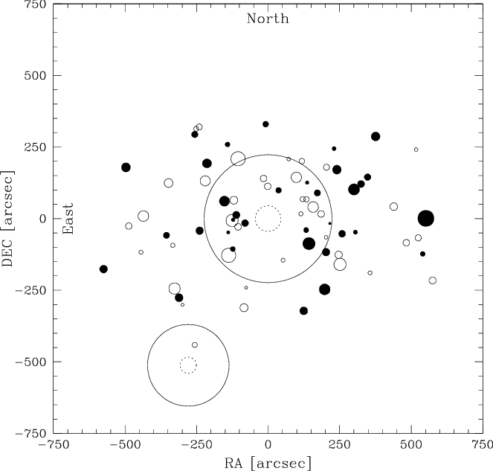

Globular Cluster Name | Direction (constellation) | Distance (Kly)
Pyxis | south | 4
Gemini | north | 3
Sagittarius | unknown | 5.2
Virgo | south | 7
Scorpus | unknown | 4.5
Scutum | unknown | 9.8
Corona Autralis | south | 15
Serpens | South east | 31
Ara | north | 11
Ophiuchus | south | 11
Lupus | South west | 10
Norma | east | 3
Bootes | south | 9
Apus | north | 5
libra | south | 6

