GEOS322 Homework 2: Visualizing the Large-Scale Earth
Name:
Due: Feb. 8 at 10 am

The ability to develop, analyze, and interpret large-scale diagrams and maps is a key skill for geoscientists. Figures, including some in your textbook, often sacrifice a physically accurate 1:1 scale in order to fit onto an 8.5 x 11 inch page. In the first half of this lab you will draw a detailed figure to scale and develop an interpretation. In the second half you will analyze and interpret the large-scale tectonic features from a topographic map of the western North America. Combine the requested figures, answers to questions, and codes into a single document and upload to D2L. Please include all your work!

1. Pie Diagram and the PREM model
The crust, lithosphere, and asthenosphere are thin in comparison to deeper zones of the Earth (lower mantle, outer core, and inner core). To investigate the true relative thickness and volumetric importance of these various layers, you will develop a cross-sectional diagram with no vertical exaggeration and compare this diagram with a 1D model of the Earth’s interior.
On the provided pie wedge, and using a millimeter-scale ruler and compass with a fine-tipped pencil, fill in a detailed structure of the earth (similar to Lillie Fig. 2.5, only as a wedge) at a scale of the radius of the Earth (6371 km) to the radius of the pie wedge (this needs to be measured). Illustrate the boundaries described below exactly to scale, at the depths or radii indicated. Carefully name and label depths to all boundaries and zones on the diagram. It may be difficult to accurately draw some of the thinnest layers, so do your best! Key layer radii:
Radius of Earth: 6371 km
Radius of Inner Core: 1221 km
Radius of Outer Core: 3480 km
a. Draw the arc representing the boundary between the inner core and the outer core using the inner core radius.

b. Draw the arc representing the boundary between the outer core and the lower mantle using the outer core radius.

c. Draw the arc representing the boundary between lithosphere and asthenosphere at 150 km depth below the Earth’s surface.

d. At 410 km depth, draw the arc representing the top of the transition zone.

e. At 660 km depth, draw the arc representing the boundary between the upper and lower mantle.

f. On the left half of the wedge, draw an arc representing the boundary between the oceanic crust and the mantle portion of the oceanic lithosphere. This boundary is called the Mohorovičić discontinuity (Moho for short) and is within the oceanic lithosphere; it separates the mafic oceanic crust of the lithosphere from the deeper mantle portion of the lithosphere called "lithospheric mantle". The average thickness of oceanic crust (excluding oceanic sediments deposited atop igneous basement) is 6 km.

g. On the right half of the wedge, draw an arc representing the boundary between the continental crust and the mantle portion of the continental lithosphere. This boundary is also called the Moho, but in this case it separates the felsic continental crust of the lithosphere from the deeper lithospheric mantle. The average thickness of continental crust (excluding sediments above the basement) is 35 km.

Problem 1 Cross-Section Wedge

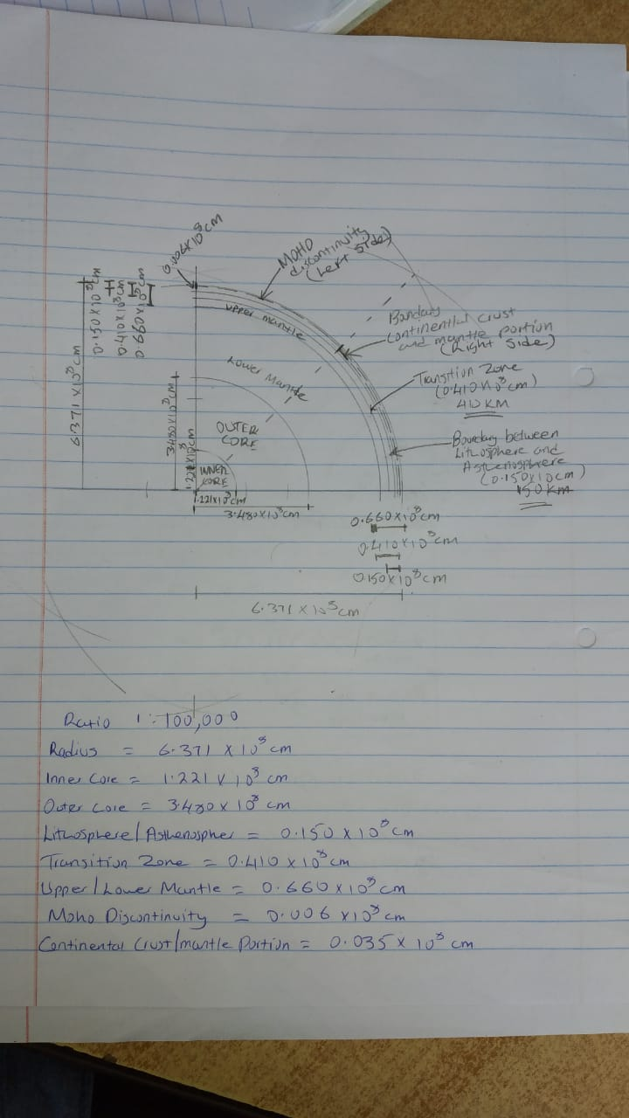

h. Calculate the following quantities:

-% of Earth's volume (km³) and mass (kg) made of continental crust (40% of all crust).

-% of Earth's volume and mass made of lithosphere.

-% of Earth's volume and mass in the core (inner core and outer core combined).

-% of Earth's volume and mass in the lower mantle.

Note: the formula for volume of a sphere is 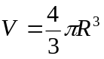, be mindful of unit conversions.
In your calculations, use the densities of 5.5 g/cm³, 2.67 g/cm³, 3.3 g/cm³, 4.5 g/cm³, 10.8 g/cm³ respectively for the whole earth, crust, lithosphere, lower mantle, and core.

Make sure to include your reasoning if you make any assumptions in the above calculations or estimations! Show your work!

i. Use the MATLAB code provided (plotprem.m) to plot the properties of the Earth with respect to depth. This code uses the Preliminary Reference Earth Model (PREM; Dziewonski and Anderson, 1981). The 4 columns of the model file are ordered as depth (km), P wavespeed (km/s), S wavespeed (km/s), and density (g/cm³). Open plotprem.m in MATLAB and study each line of the code. Run the code by typing “plotprem” in the MATLAB Command Window and press return. You should see a plot of Vp (P wavespeed) with respect to depth. Modify the code to plot Vp, Vs, and density on the same plot. Modify the legend of the plot to include Vp, Vs, and density. Turn in both the modified code and plot with the homework.

j. Use the models of density and seismic wavespeed variations with depth found on your plot to determine values expected for the density, P wavespeed, and S wavespeed above and below each major earth division that you have drawn in a-e.

Boundary | P-wavespeed  above | P-wavespeed  below | S-wavespeed  above | S-wavespeed  below | Density  above | Density  below
Inner/outer core

Outer core/lower mantle

Lithosphere/asthenosphere

410 km discontinuity

660 km discontinuity

k. Where does the largest change in these three quantities occur? How do they change at this location and why?

l. Modify the MATLAB code provided to calculate pressure inside the Earth. Before starting, create a new MATLAB file by typing “cp plotprem.m pressure.m” in the Terminal window and press return. Open the new file by typing “open pressure.m” in the MATLAB Command window and press return. The equation for calculating pressure is very simple: Pressure (Pa) = density (kg/m³) x gravitational acceleration (m/s²) x thickness (m). Note that the unit for pressure is a pascal (Pa), which is equal to 1 kg/ms². Gravitational acceleration can be approximated as 9.81 m/s². If the Earth had constant density at all depths, pressure could be calculated by multiplying density, gravitational acceleration, and the depth of interest. The fact that density changes with depth complicates this calculation. The Earth must be divided into thin layers of constant density. The pressure at any given depth is the sum of pressures from each layer above this depth. Use the density model in PREM to calculate pressure inside the Earth. At what pressure does the 660 km discontinuity occur? Note that depth in the PREM model is given in kilometers and needs to be converted to meters for this calculation. Note that density in the PREM model is given in g/cm³ and needs to be converted to kg/m³ for this calculation. Hint: Use 1000 m as the thickness of each layer. Turn in the modified code with your homework.

2. Regional Tectonic Interpretation
Below are two maps of the western United States. The first is a blank map of the western United States showing only coastlines and political boundaries. The second map adds shaded topography to this region. You will use this map to identify and comment on the major tectonic features of the western United States and the adjacent Pacific Ocean basin, which has been reworked significantly during the Mesozoic and Cenozoic eras.
Blank map of the western United States

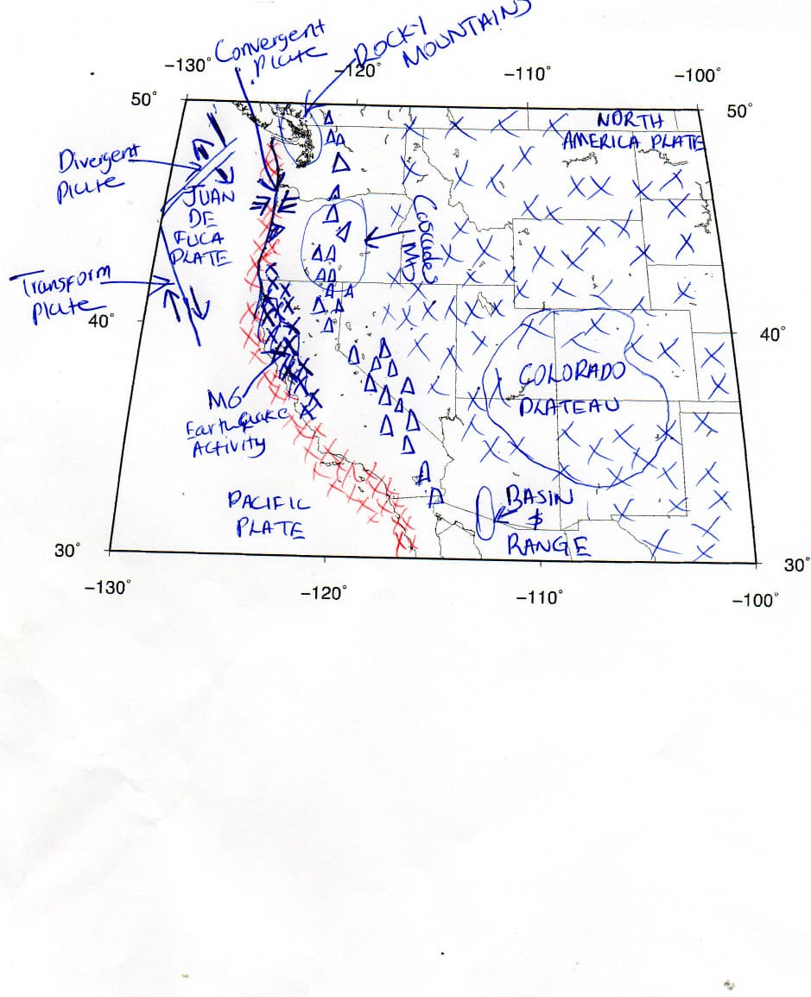
Shaded topography of the western United States

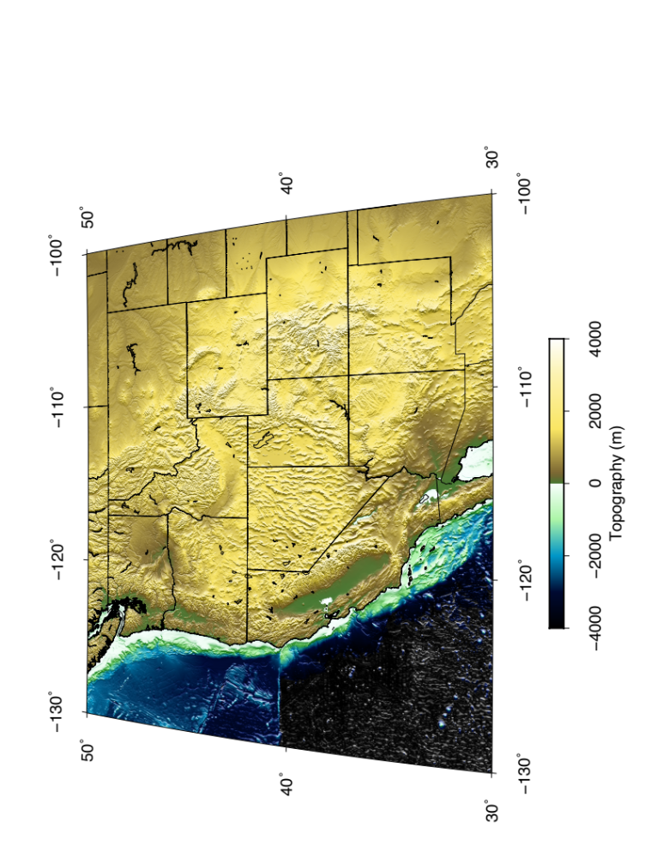

Labeling and Questions

On the blank map:

a. Identify and label the positions of the following features on the map:
(1) Lithospheric plates: North America, Pacific, Juan de Fuca
(2) Plate boundaries types: Convergent, Divergent, or Transform
a. Include direction of relative motion across each boundary
(3) Tectonic features: Cascade Mtns, Basin & Range, Rocky Mtns, Colorado Plateau

b. Draw X’s to represent the area of significant (>M6) earthquake activity (i.e. active plate margins).

c. Draw Δ’s on current zones of volcanic activity.

d. Numerous geophysical experiments have studied western North America over the past several decades, providing observations of changes in the thickness of the crust and lithosphere, and constraining how the mantle deforms beneath the continent. Using the following conventions, on the blank map, add red shaded regions where you would expect thinner than average crust and lithosphere, and blue shaded regions where you would expect thicker than average crust and lithosphere.

General rules: (High elevation > 1000m, Low elevation < 1000m)
-High elevation, extended thin
-High elevation, compressed thick
-Low elevation, continental margin thin

(1) What processes helped to form the properties of the average crust beneath the Basin and Range?

The processes that helped form the properties of the average crust beneath the basin and range are the tectonic stretching of the lithosphere after hot magma moved beneath the region causing the surface to swell and collapse due to its weight and gravity.

(2) What processes helped to form the properties of the average crust beneath the Cascade Mountains?

The Cascade Mountains were formed as a result of volcanic activity.

