COVID-19 Impact on Global Supply Chain

Student’s Name
Institutional Affiliation
Course Number and Name
Instructor Name
Due Date

COVID-19 Impact on Global Supply Chain
The novel COVID-19 pandemic has had immense negative impact on many industries worldwide. Not only is the availability of a variety of raw materials, intermediate products and finished products been disrupted but their supply has also been impacted very negatively as goods and services are not able to move. The impact on the availability and supply of these products have in return affected the Global supply chains(GSCs) which were showing rapid growth over the past few decades. Some economists have even predicted that the global trade economy volumes would decline from 13% to 32% (Jackson et al, 2020)
The pandemic has resulted in unprecedented shuttering in some mechanism of GSCs. For instance the movement of automobiles, food, pharmaceuticals and electronics have greatly been disrupted to a large extend. Unlike other pandemics, covid-19 has affected the GSCs throughout all its stages as it has caused a major turbulence acquiring of raw materials, manufacturing and processing, transportation and logistics of these products and services and even the demand for these products have rapidly reduced as there is reduced cash flow in people’s pockets as many were laid off from their income opportunities.
Ever since the pandemic was first announced, over 210 countries had reported a number of cases. For instance, after the end of August 2020, there had been already more than 20 million confirmed cases and above 700 thousand deaths that were reported to the World Health Organization (WHO) (WHO, 2020). If unmitigated, the pandemic would have become even more severe and situation even becoming worse (Ali &Alharbi, 2020). This is the most devastating event the world is experiencing after the Second World War and they has been predicted to have reduced by 3% in 2020(IMF, 2020).
To ensure no rapid spread of the virus governments came with certain precautionary methods so as to curb the spread. For example, travel restrictions, partial or total lockdown which have in turn aided in the robust hurting of the economy as mechanics of GSCs. These restrictions altered the presence of active labor, logistics of raw materials and active ingredients. The situation is even becoming worse due to the tightening of these restriction as many predict that the pandemic is going to be long-term.
How the GSCs is Impacted
Covid-19 is the first pandemic the world is experiencing as there were some few pandemics that have passed the only difference is that economic recovery after those pandemics were fast but for this pandemic the recovery plan is even not completed. The magnitude of this pandemic can be shown in the figure below;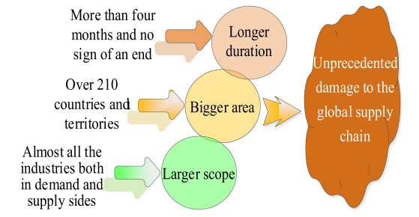
Figure 1: effects of covid-19 on GSCs (Ali &Alharbi, 2020).
Some pandemics are only limited to a number of geographic locations for example wars, tsunamis, earthquakes and nuclear reactions, however that is not the case with covid-19 as within its first 5 months it had already spread across the universe. The most disturbing being that it is unpredictable on when the pandemic will end thus these restrictions will keep on harming the global economy as it has halted all the stages of GSCs from production to consumer level.
Main GSCs Disruptions
The logistics of GSCs has been halted starting from supply of raw materials to the delivery of consumer goods. The figure below show the disruptions that are experience by now; 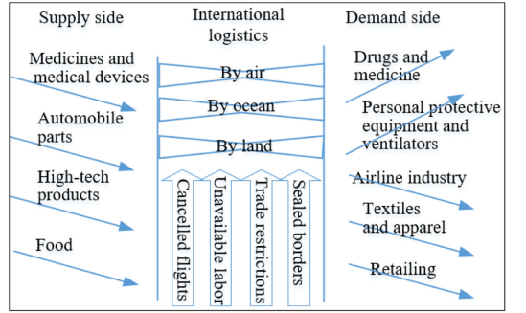
Figure 2: GSCs disruption by covid-19 pandemic.
There are generally two types of products namely innovative products and functional products. In normal times, functional product do have a stable supply. For instance, face masks in normal times fall under functional products but during covid-19 period masks have turned to be innovative products as their demands have sky rocketed immensely.
As many cities turned to lockdown as one of their ways of curbing the spread of covid-19, the supply and demand for other consumables went down immensely whereas the supply and demand for the products that aid in curbing the virus went up. For example the demand for electronics went down whereas demand for masks went up. Closing of borders made the logistics by road, water and air to delayed or even cancelled making the other sectors of the GSCs to be suspended or even experience total shutdown.
Visible Immense Effects
- This interruption of global logistics. Due to restrictions in countries borders there has been negative immense impacts on GSCs. For example, drastic fall in labor force caused by quarantine restrictions. This caused some of the plants to shut down their operations as logistics for their supply chain was completely shattered. In addition, there was an effect of shattering of the international aviation which in return caused limited air cargo movement and capacities as borders were closed. This has caused reduction in the GSCs in return as rate of exports and imports reduced. According to Dowsett and Lee (2020), more than 6.2 trillion dollars of goods are transported by air each year and that that 35% of world trade is contributed by air cargo.
- Demand distortion. The demand for products such drugs and other pharmaceuticals went up as there was panic buy for this items causing there unavailability in the market for example hydroxychloroquine and chloroquine (Costenbader, 2020). Ventilators and PPEs demand went up as compared to other years (WHO, 2020). According to ICAO (2020), Demand for airline services also declined and is projected to reduce even further from 57% to 64% by 2021. The demand for goods from textiles and apparels has greatly reduced too, example in Europe it had reduced by 50% by 2020 (ILO, 2020). Lastly, retail services were affected as some goods were out of market and others were completely not moving from the store (Petulla, 2020).

Conclusion
In conclusion, the covid-19 pandemic has greatly impacted the GSCs by a large extend as many countries depend on the international trades and relations. For these case there is need for firms and plants to create mitigation protocols for the potential ongoing impacts by developing resilient plans on the supply chains. The level of preparedness if these firm depend on the understanding of the impact of covid-19 on GSCs. It is clear that when supply chain is halted at one stage the final consumer is also affected which creates negative impacts on GSCs. In case of disruptions, the capability to response is vital in ensuring plants take cost effective contingency plans so that their GSCs may not be adversely affected for a longer period of time.
Delayed responsive measures to ensure that there is no immense effects on GSCs solely depended on the governments measures on how to aid the supply chain of their countries so as to avoid massive losses. When there is a late response to the aid of GSCs leads to adverse impacts on it and making the sectors to shutter its operations. The pandemic has made plants and firms to re-establish and reevaluate their GSCs and start the process of achieving agility and efficiency in case of a massive disruption. Some countries have provided their firms with contingency plans and aids that ensures they are well equipped to deal with the impacts and risks to their GSCs.

References
Ali and Alharbi. O.H. (2020). “COVID-19: Disease, management, treatment, and social impact,” Science of the Total Environment, vol. 728, 2020, Art. No. 138861.
Costenbader. K. (2020). “Groups urge Pence to address hydroxychloroquine shortages
After demand spikes for COVID-19,” March 24, 2020. [Online]. Available:
https://www.healio.com/news/rheumatology/20200324/groups-urge-pence-to
Address-hydroxychloroquine-shortages-after-demand-spikes-for-covid19
Dowsett. S., and Lee. J. (2020) “Coronavirus turmoil spreads to airline cargo operations,”
Reuters, London, U.K., February 5, 2020. [Online]. Available: https://www.reuters.
com/article/us-china-health-airlines-freight/coronavirus-turmoil-spreads-to
airline-cargo-operations-idUSKBN1ZZ09S
International Civil Aviation Organization. (2020)."Effects of Novel Coronavirus (COVID-
19) on civil aviation: Economic impact analysis,” August 12, 2020. [Online].
Available: https://www.icao.int/sustainability/Documents/COVID-19/
ICAO_Coronavirus_Econ_Impact.pdf
International Labour Organization. (2020). “COVID-19 and the textiles, clothing, leather
and footwear industries,” International Labour Organization, Geneva,
Switzerland, April 8, 2020. [Online]. Available: https://www.ilo.org/wcmsp5/
groups/public/—ed_dialogue/—sector/documents/briefifingnote/wcms_741344.
Pdf
International Monetary Fund. (2020). “IMF executive board concludes 2020 article IV
consultation with the United States,” August 2020. [Online]. Available: https://
www.imf.org/en/News/Articles/2020/08/10/pr20279-united-states-imf
Executive-board-concludes-2020-article-iv-consultation
Jackson .J. K., Weiss .M.A., Schwarzenberg .A. B., and Nelson .R.M. (2020). “Global
Economic effects of COVID-19,” Congressional Research Service,
Washington, DC, USA, April 10, 2020. [Online]. Available: https://fas.org/sgp/
crs/row/R46270.pdf
Petulla. A. (2020). “SEO in the age of COVID-19: Organic impacts on the retail
Industry,” Search Engine Journal, April 10, 2020. [Online]. Available: https://
www.searchenginejournal.com/seo-covid-19-retail-industry-impact/359168/ #close
World Health Organization.(2020). “Shortage of personal protective equipment
Endangering health workers worldwide,” March 2020. [Online]. Available:
https://www.who.int/news-room/detail/03-03-2020-shortage-of-personal
Protective-equipment-endangering-health-workers-worldwide
World Health Organization. (2020). “WHO Coronavirus Disease (COVID-19) Dashboard,”
August 17, 2020. [Online]. Available: https://covid19.who.int/?gclid ¼
CjwKCAjw1ej5BRBhEiwAfHyh1PboTaikmKqxtHBloCQ
lC1bm7UM2kW0MvRKsvy4N79wIksWjzFSJhoCNFoQAvD_BwE

