- +A delivery person has two different delivery routes that he follows. The first route is 24.75 miles long and the second is 34.75 miles long. He travels each route 5 times a week. After 7 weeks, how many total miles has he traveled?
=24.75*5*7=866.25
=34.75*5*7=1216.25

=866.25+1216.25=2082.50 miles

- Sets A, B, and C are subsets of the universal set U.
These sets are defined as follows.
U | ={ f, g, h, p, q, r, x, y, z}
A | = {f, g, q, r}
B | = {g, h, p, r, x}
C | = {q, r, x, y}
Find
𝐴′∪ (𝐶∩𝐵) _C n B={r, x}
A U (C n B) = {f, g, q, r} u {r, x}
= {f, g, q, r, x}
3.Raina paid $19.99 for a 7.98-kg bag of dog food. A few weeks later, she paid
$20.38 for an 8.39-kg bag at a different store.
Find the unit price for each bag. Then state which bag is the better buy based on the unit price.
Round your answers to the nearest cent.
Unit Price for the 7.98-kg bag:
$19.99/7.98
= $2.51
Unit Price for the 8.39-kg bag:
$20.38/8.39= $2.43
Which is the better buy? $2.43 is better because its price is cheaper

- Suppose that 18 inches of wire cost 72 cents.
At the same rate, how much (in cents) will 14 inches of wire cost?
=14*72/18
=4*14
=56 cents

- Jane purchased a prepaid phone card for $25. Long distance calls cost 13 cents a minute using this card. Jane used her card only once to make a long distance call. If the remaining credit on her card is $23.18, how many minutes did her call last?
$25-$23.18=$1.82
$1.82*13=14 minutes
- Two trains leave stations 240 miles apart at the same time and travel toward each other. One train travels at 80 miles per hour while the other travels at 70 miles per hour. How long will it take for the two trains to meet?
Do not do any rounding.
240/70=3.428575
240/80=3
3+3.42857=6.428575

- Amanda split 5/8 pounds of candy among 4 people.
What is the unit rate in pounds per person?
Write your answer in simplest form.
(5/8)/4
=5/32 pounds per person

- The ratio of men to women working for a company is 4 to 3. If there are 64 men working for the company, what is the total number of employees?
1/3*64*7/4=48 women

- Suppose that the distance a car travels varies directly with the amount of gasoline it uses. A certain car uses 19 gallons of gasoline to travel 475 miles. If the car travels 700 miles, how much gasoline does it need?

d=Kg
475=k*19
K=19
700=19*g
=36.84gallons

- When a constant force acts upon an object, the acceleration of the object varies inversely with its mass. When a certain constant force acts upon an object with mass 9 kg, the acceleration of the object is 7 m/s^2 If the same force acts upon another object whose mass is 21 kg, what is this object's acceleration?
A=k/m
7=k/9
k=63
a=63/21
a=3m/s^2

- Find the slope of the line passing through the points (−7, 5) and (−8, 2).

2-5/-8+7
=1/5

- Write an equation in slope-intercept form for the line with y-intercept
−1 and slope −3.
-3=y+1/x
-3x=y+1
y=-3x-1

- Ivanna is a software saleswoman. Her base salary is $2300, and she makes an additional $80 for every copy of English is Fun she sells.
Let P represent her total pay (in dollars), and let N represent the number of copies of English is Fun she sells.
- Write an equation relating P to N
2300+80N where Nis the cost of a book
- Then use this equation to find her total pay if she sells 28 copies of English is Fun.
=2300+(28*80)
=2300+2240
=$4540

- Customers of a phone company can choose between two service plans for long distance calls. The first plan has a $19 monthly fee and charges an additional $0.10 for each minute of calls. The second plan has a $15 monthly fee and charges an additional $0.14 for each minute of calls. For how many minutes of calls will the costs of the two plans be equal?
Let the minutes be x ,then
19+0.1x=15+0.14x
19-15=(0.14-0.1)x
4=0.04x
X=4/0.04=100minutes

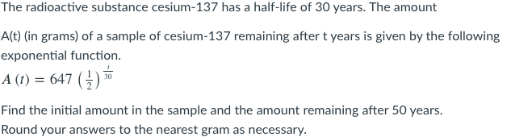
Initial Amount
= 647(1/2)^0/30
=647*1
=647grams
Amount after 50 years
=647(1/2)^50/30
=647*(1/2)^5/3
=203.79grams

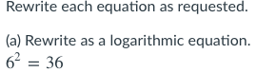
16log 6^2=log 36
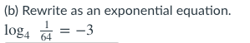
4^-3=1/64

- A book sold 33,400 copies in its first month of release. Suppose this represents 7.9% of the number of copies sold to date. How many copies have been sold to date? Round your answer to the nearest whole number.
100%/7.9%*33400=422785
18.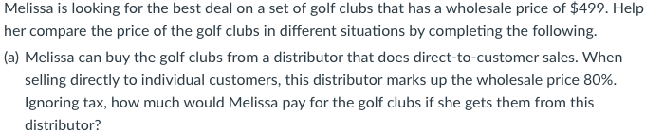
180%/100%*499=$898.2

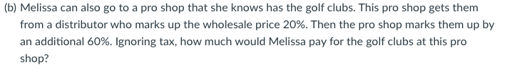
120%/100%*499=$598.8
160%/100%*598.8=$958.08
(c) Which is the better deal?
Deal (a) is cheaper

19. The price of a technology stock has dropped to $9.73 today. Yesterday's price was $9.84. Find the percentage decrease. Round your answer to the nearest tenth of a percent.
$9.84-$9.73=$0.11
% decrease=0.11/9.84*100%=1.118%
1.1%

20. The half-life of a radioactive isotope is the time it takes for a quantity of the isotope to be reduced to half its initial mass. Starting with 145 grams of a radioactive isotope, how much will be left after 4 half-lives?
Use the calculator provided and round your answer to the nearest gram.
145*(1/2)^4=145*1/16
=9.0625 = 9 grams

21. How long will it take for a $2000 investment to grow to $2500 at an annual rate of 7%, compounded semiannually? Assume that no withdrawals are made. Do not round any intermediate computations, and round your answer to the nearest hundredth.4 years

22. 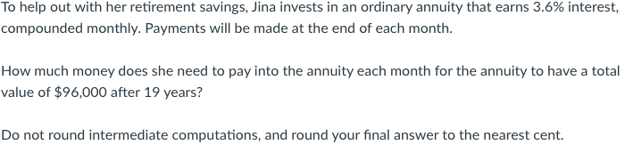

$1515.79
23.
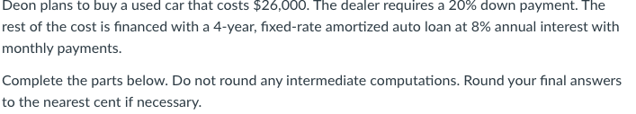
- Find the required down payment.$5200
- Find the amount of the auto loan.$20800
- Find the monthly payment.$433.33

24. Trey's garden is in the shape of a rectangle. It measures 8yd long and 6yd wide. He wants to cover the garden with mulch for the winter. The coverage of each bag of mulch is measured in square feet.

- Find the area of the garden in square feet?.8yd*6yd=48yd
=48*9
=432 square feet
- Trey wants to cover his garden in mulch. He doesn't have any to begin with and he can't buy partial bags of mulch. Each bag of mulch covers 95 square feet. How many whole bags of mulch will he need in order to completely cover his garden?
432/95=4 whole bags
- If each bag of mulch costs $14.50, how much will Trey need to spend on mulch?
432/95*$14.50=$65.93

25. A container holds 24 pints of lemonade. How much is this in gallons?
24*1/8=3 gallons

26. A rectangular board is 1.2 meters long and 0.8 meters wide. What is the area of the board in square millimeters? Do not round your answer
.(1.2*0.8)=9.6m^2=9600000 square millimeter

27. A boy weighs 66 pounds. How much does he weigh in kilograms? Use the following conversion: 1 kilogram is 2.2 pounds.
=66pounds*1kg/2.2 pounds=30kg

28. A cyclist rides her bike at a rate of 9 kilometers per hour.
- What is this rate in meters per second?
9*5/18=2.5 meters per second
- How many meters will the cyclist travel in 5 second?
5*9000/3600=12.5 meters

29. 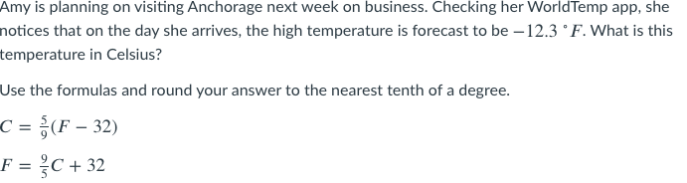
=5/9(-12.3-32)
=-24.6
F=9/5(-24.6)+32
=-12.28
30. 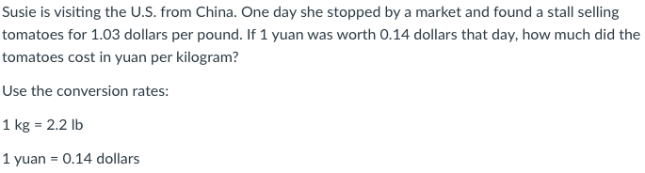
=1.03/0.14
=7.357
31. A catering service offers 4 appetizers, 7 main courses, and 8 desserts. A customer is to select 2 appetizers, 6 main courses, and 6 desserts for a banquet. In how many ways can this be done?
4!/2!2!*7!/6!1!*8!/6!2!
=1176

32. At a deli counter, there are 8 sandwiches with meat and 5 vegetarian sandwiches. Trey is at the counter buying sandwiches for a picnic. In how many ways can he choose 6 sandwiches if fewer than 3 must be vegetarian sandwiches?
8!/6!*5!/3!=1120p

33. An organization will give a prize to a local artist. The artist will be randomly chosen from among 6 painters, 2 sculptors, and 9 photographers. What is the probability that the artist chosen will be a painter or a sculptor?
Write your answer as a fraction.
(6/17)=(2/17)=8/17

34. Suppose one card is drawn at random from a standard deck. Write all of your answers as fractions.
- What is the probability that the card drawn is a face card?
p(face)=6/52=3/26
- What is the probability that the card drawn is a club?
p(club)=10/52=5/26
- What is the probability that the card drawn is a face card and a club?
P(face and club)=p(face)*p(club)
=3/36*5/26
=15/26
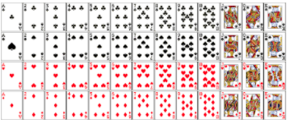

35. 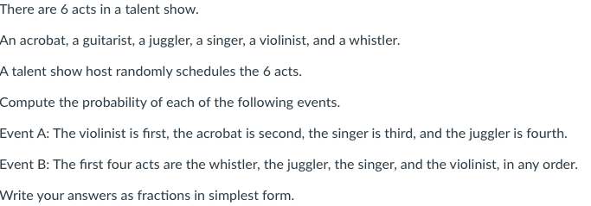

P(A) =(1/6*1/3*1/2*2/3)=1/54
P(B) =(1/4*1/4*1/4*1/4)=1/256

36. 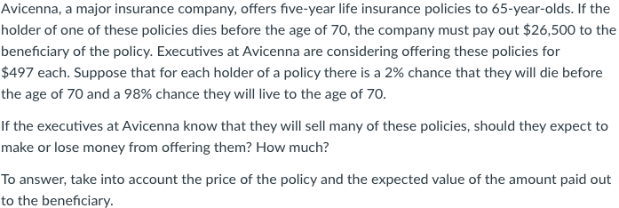

- Avicenna can expect to _gain_____ money on offering these policies.
- How much money should they expect to gain/lose on the policies sold?

37. At a factory that produces pistons for cars, Machine 1 produced 486 satisfactory pistons and 324 unsatisfactory pistons today. Machine 2 produced 648 satisfactory pistons and 152 unsatisfactory pistons today. Suppose that one piston from Machine 1 and one piston from Machine 2 are chosen at random from today's batch. What is the probability that the piston chosen from Machine 1 is unsatisfactory and the piston chosen from Machine 2 is satisfactory?
P(machine 1 unsatisfactory ) and p(machine 2 unsatisfactory)
324/810*152/800
=0.075062

38. 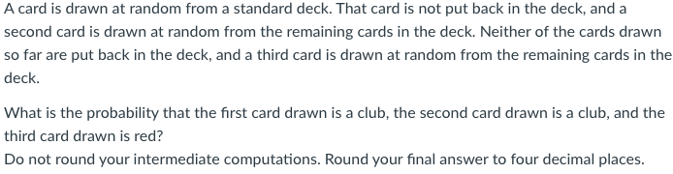
P(first club)=10/52=5/26
P(second club)=9/51=3/17
P(third club)=26/50=13/25

(P1)*(P2)*(P3)
=5/26*3/17*13/25
=0.01765

39. A fair die is rolled 6 times. What is the probability of having no 2 and no 6 among the rolls? Round your answer to three decimal places.(2/3)^8=0.039

40. There are 10 women and 8 men with a chance to be on a game show. The producer of the show is going to choose 12 of these people at random to be contestants.
What is the probability that the producer chooses 7 women and 5 men? Round your answer to three decimal places.
7/10*5/8=7/16=0.438

41. A survey showed that 24% of college students read internet news on a regular basis and that 83% of college students regularly watch the news on TV. The survey also showed that 20% of college students both follow TV news regularly and read internet news regularly.
- What is the probability that a randomly selected college student reads internet news regularly, given that he or she watches TV news regularly? Round your answer to the nearest hundredth.
P(internet news/watches TV)
0.24/0.83=0.29
- What is the probability that a student watches TV news regularly, given that he or she regularly reads internet news? Round your answer to the nearest hundredth.
P(watches TV / internet news)
0.83/0.24=3.46

42. 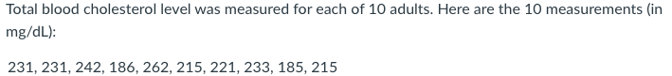

- What is the median of this data set? If your answer is not an integer, round your answer to the one decimal place.
185,186,215,215,221,231,231,233,242,262
221+231=452/2=226
- What is the mean of this data set? If your answer is not an integer, round your answer to one decimal place.
185+186+215+215+221+231+231+233+242+262/10
=222.1

43.
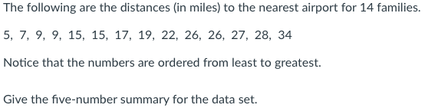
Minimum: 5
Lower quartile: 9+9/2=9
Median: 17+19/2=18
Upper quartile: 26+27/2=26.5
Maximum: 34

44. On a nationwide test taken by high school students, the mean score was 49 and the standard deviation was 13. The scores were normally distributed. Complete the following statements.
- Approximately 99.7% of the students scored between __23____ and _75______
- Approximately ____68____% of the students scored between 36 and 62.

45. The scatter plot shows the number of years of experience, x, and the hourly pay rate, y, for each of 24 cashiers in Arizona.
- Write an approximate equation of the line of best fit for the data. It doesn't have to be the exact line of best fit.
y=x+2
- Using your equation from part (a), predict the hourly pay rate for a cashier with 14 years of experience.
y=14+2
=16

