Economics 201(L02) Instructor: Atsuko Tanaka
Assignment #1 (Total: 10 marks)
Fall 2021
Last revised on Sep 14 (minor revision in Question 2 j.)

Due October 15, 2021 23:59 (Submit your assignment to the D2L Dropbox)

Directions: Your assignment file should be named “LASTNAME_HW1” where you will substitute your last name for LASTNAME in the filename. Please write down how you arrived to your conclusions. If reasoning is rigorous and correct, you will get partial credits even if the answer is not.
Submit your assignment to D2L Dropbox (Folder “Assignment 1”). No late assignment will be accepted. If you want to make a change, you can upload the whole file as a new submission in the same folder---your grade will be based on the most recent submission.

Question 1. [Textbook Ch.1] (1 mark)
a. Read Modules 1-5 “Economics of Everyday Life” by Dr. Chris Bruce (can be found on D2L, ).
Using your own word, explain in 2-3 lines what incremental benefit is.

The marginal expenses incurred in the generation of new good or service units is its incremental benefit. By spending extra energy, time and resources in producing a good or service, additional benefit may be derived. However, this extra energy, time and resources is a cost expenditure made to gain the extra benefit.

b. According to Dr. Bruce, how can we explain that a house in the suburbs is less expensive than a comparable house in the areas near the center of the cities?

The actual cost of any property must include the expense of travelling to and from work. However, at the same time, there is a larger demand for houses near the center of cities where majority of people work. Therefore, as per the argument in module 20, increased demand causes an increase in price.

c. “The optimal (best) levels of pollution, crime, and safety are greater than zero.” Use the concept of the marginal thinking to evaluate the statement. Answers should be limited to one third of a page.

Decision-makers must use marginal thinking to determine if the advantage of purchasing one additional unit of something outweighs the expense. From this perspective, the cost incurred to achieve zero level of pollution and crime needs to be weighed and considered. More would be spent to reduce and eliminate pollution and crime. More will be spent to increase safety levels to 100%. This is the cost of achieving this. But since human satisfaction is also limited. As individuals consume more and more of any one good, the less is the pleasure they will get from “one more,” incremental unit of that good. Hence, zero levels of pollution and crime might not result in the pleasure that might be derived from above zero levels.

Question 2. [Textbook Chapter 2, 3] (0.5 mark)
Gregg and Mia both make meatloaf and bake bread. It takes Gregg three hours to bake six loaves of bread and two hours to make three meatloaves. It takes Mia three hours to bake eight loaves of bread and two hours to make three meatloaves. Currently Gregg and Mia do not trade with one another. For this problem assume that Gregg and Mia have linear production possibility frontiers and that they do not trade with anyone else.
a. Suppose Gregg and Mia each have 60 hours this week that they can devote to bread baking and meatloaf cooking. Construct graphs depicting the production possibility frontiers for Gregg and Mia. In your graphs make sure you label the x-axis and y-axis clearly. In your graphs, measure bread on the vertical axis and meatloaf on the horizontal axis.

b. What is Gregg’s opportunity cost of producing one loaf of bread?
70 Meat loaves
c. What is Gregg’s opportunity cost of producing one meatloaf?
359 loaves of bread
d. What is Mia’s opportunity cost of producing one loaf of bread?
175 Meat loaves
e. What is Mia’s opportunity cost of producing one meatloaf?
480 loaves of bread
f. Given the above information, who should produce meatloaf? Explain your answer.
Greg should produce meat loafs. Producing one meatloaf results in less bread being made compared to that made by Mia.
g. Given the above information, who should produce bread? Explain your answer.
Mia should produce bread. Producing one meat loaf results in more bread production for Mia compared to Gregg.
h. Provide the range of acceptable prices in terms of meatloaf that twenty loaves of bread will trade for given the above information.
Twenty Loaves of bread should trade for 13-15 Meat loaves
i. Provide the range of acceptable prices in terms of bread that thirty meatloaves will trade for given the above information.
Thirty Meat loaves should trade for 45 Loaves of bread

j. Construct the joint PPF for Gregg and Mia measuring bread on the vertical axis and meatloaves on the horizontal axis.

Question 3. [Textbook Ch.2, 3] (0.5 mark)
Use the information in the table below to answer this set of questions. Suppose that each of the following points in the table is a point on the production possibility frontier for Lalaland. Furthermore, suppose that the PPF for Lalaland is linear between each of these combinations-for example, the PPF is linear between points A and B, between points B and C, etc.
Combination | Pounds of Butter | Number of Guns
A | 1000 | 0
B | 800 | 110
C | 600 | 150
D | 400 | 175
E | 0 | 200
- Draw a graph of Lalaland’s PPF measuring guns on the vertical axis and butter on the horizontal axis. Label both axes as well as combinations A, B, C, D, and E.

- Given the above information, what is the opportunity cost of producing 200 more pounds of butter if Lalaland is currently producing at point C?
150 Guns

- Given the above information, what is the opportunity cost of producing 200 more pounds of butter if Lalaland is currently producing at point B?
110 Guns

- Given the above information, what is the opportunity cost of producing 100 more pounds of butter if Lalaland is currently producing at point D?
175 Guns

- Given the above information, what is the opportunity cost of producing one additional gun if Lalaland is currently producing at point B?
800 Pounds of butter

- Given the above information, what is the opportunity cost of producing one additional gun if Lalaland is currently producing at point D?
400 Pounds of butter

Question 4. [Textbook Chapter 4] (1 mark)
For each of the following scenarios sketch a diagram representing the scenario and then answer the given questions.
- The market for cell phones is initially in equilibrium. Smart Phone introduces a new phone that provides radically improved services for consumers at the same time that the Federal government decides to implement an excise tax on cell phone producers. Describe the effect of these changes on the equilibrium price and quantity in this market. Assume that this new phone only affects consumers’ tastes and preferences.
Effect of the tax on the supply-demand equilibrium is to shift the quantity toward a point where the before-tax demand minus the before-tax supply is the amount of the tax. A positive change in tastes or preferences increases demand (shifts it right/up).
D1
D0
price
Quantity
S0

With a positive change in taste and preferences, the demand of the phone is likely to improve. This would lead to an increased price. The excise duty would also increase the price of the phones. This increased price would likely put off some people hence the equilibrium price would increase but with a small amount to D1.

- The market for bicycles is initially in equilibrium. The Surgeon General announces that a study has been done that indicates bicycling is a major contributor to good health for those who bicycle regularly. At the same time the price of gasoline increases due to political unrest in the major oil producing regions of the world. Describe the effect of these changes on the equilibrium price and quantity in this market.

D1
D0
price
Quantity
S1
S0
EP

The positive review on bicycles leading to good health would increase the taste and preference for bicycles. On the other hand, increased oil prices leading to increased fuel prices would result in increased transportation costs if the bicycles are not produced locally. Hence, the demand would increase while supply remains the same or even reduces. This results in a higher equilibrium price EP.

- The market for soft drinks is initially in equilibrium. The price of sugar, a major ingredient in soft drinks, increases while at the same time, the number of producers in the industry doubles. Describe the effect of these changes on the equilibrium price and quantity in this market.

D0
price
Quantity
S1
S0
EP1
S2

EP2

EP0

Increased prices in production would increase the price of the commodity to EP1 from EP0. When the producers double, the price would drop to EP2. However increased producer levels would result in higher demand for raw materials like sugar. This would increase the price of production leading to the equilibrium price increasing to EP1 again.

- The market for leather jackets is initially in equilibrium. Then, the price of labor used to manufacture the jackets increases. Describe the effect of this change on the equilibrium price and quantity in this market.

D0
price
Quantity
S0
EP0
P0

The price would increase due to increased labor costs.
Question 5. [Textbook Chapter 4] (1 mark)

Suppose that there are only two consumers, Jennifer and David, in the market for widgets. Jennifer’s demand curve for widgets is given by the equation P = 100 – (1/2)Q while David’s demand curve for widgets is given by the equation P = 50 – (1/2)Q. The market supply curve in the market for widgets is given by the equation P = 10 + Q.
- Draw a series of side by side graphs: in the first graph, depict Jennifer’s demand curve for widgets; in the second graph, depict David’s demand curve for widgets; and in the third graph, depict the market demand curve for widgets. Make sure you label all three graphs completely and carefully; make sure you label any “kink” points with their coordinates as well as labeling any axis intercepts.

Jennifer’s demand curve for widgets is given by the equation P = 100 – (1/2)Q

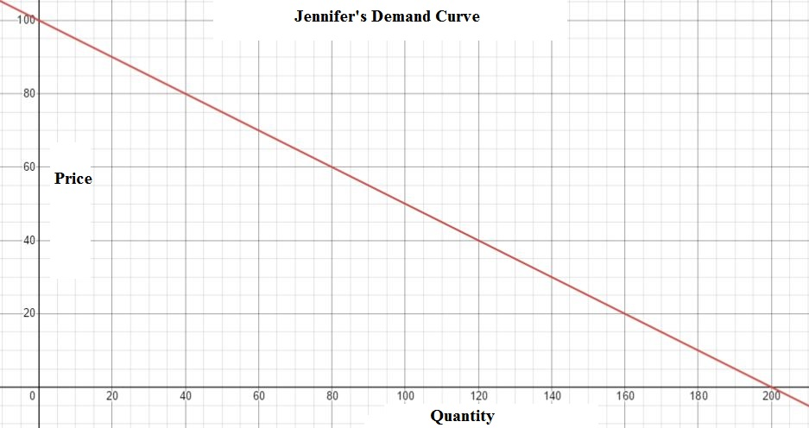

David’s demand curve for widgets is given by the equation P = 50 – (1/2)Q

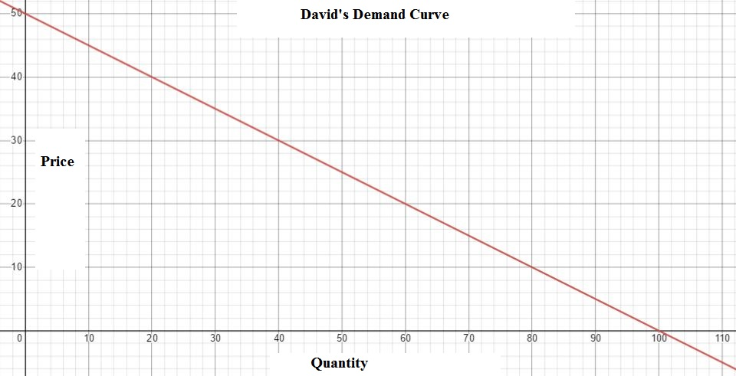

Market supply curve in the market for widgets is given by the equation P = 10 + Q.

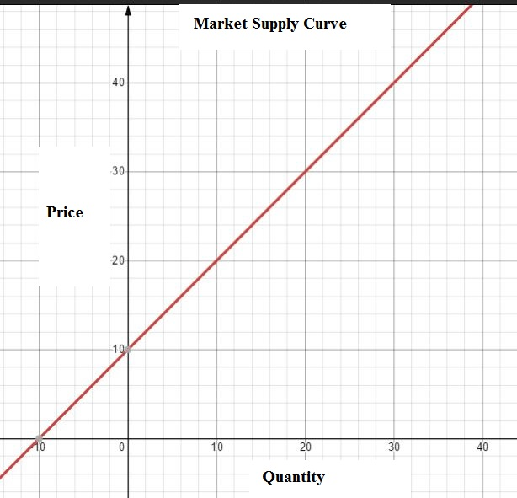

- Write a set of equations and their relevant ranges for the market demand curve.
$$P = 100 – (1/2) Q$$
$$P = 50 – (1/2) Q$$
$$P = 10 + Q$$

- Explain how you will determine which demand curve equation you will need to use in order to find the equilibrium price and quantity in this market.
Since the supply curve remains the same, we can use the supply curve equation to compute a common quantity, apply the common quantity to the two demand curves to obtain the equilibrium price for each demand curve.

- Find the equilibrium price and quantity in this market given the above information.
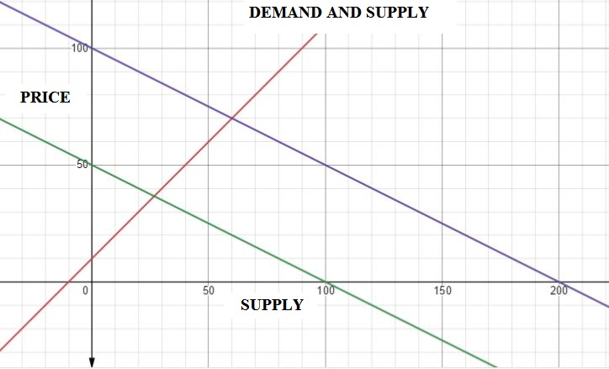

Question 6. [Textbook Chapter 5] (0.5 mark)

For each of the following pairs of goods, identify which good in the pair has the higher price elasticity of demand. Explain your answers.

A good's price elasticity of demand is a measure of how sensitive the quantity demanded is to its price. When the price rises, quantity demanded falls for almost any good, but it falls more for some than for others.

  - Coke; entire soft drink industry
Entire soft drink industry.
Increased prices of soft drinks in general would lead to a greater drop in demand of soft drinks compared to that of coke since coke is established in the industry.

  - Visits to the doctor; visits to the baseball stadium

Visit to the baseball stadium.
A visit to the doctor is in most cases a necessity that cannot be avoided. While a visit to the baseball stadium is a luxury. Hence, visit to the baseball stadium has the higher price elasticity of demand.

  - Gasoline consumed each year; gasoline consumed each week

Gasoline consumed each week
Gasoline consumed each week is influenced by prices to a higher level than that consumed each year. The factors affecting the demand for gasoline in a year are more than during a week. Throughout a year, factors might come in play that would mitigate the demand such as increased supply.

  - Insulin for a diabetic; dialysis treatment for someone with kidney disease

None. Both would require equal quantities overtime despite changes in prices given the critical nature of the products being offered.

  - Water; diamonds
Diamonds.
The price of water will not change the demand for water given the critical nature of water , drinking, cleaning, construction etc. However, diamond, especially decorative diamonds, are luxury products.

Question 7. [Textbook Ch.7] (0.5 mark)
Suppose that there are three identical firms in an industry and that each firm’s supply curve is given by the equation P = 10 + Q. Furthermore, suppose that the market demand curve is given by P = 100 – Q.
- What is the market supply curve given the above information? (Hint: you might find it helpful to draw a sketch to guide your work here.)

firm’s supply curve is given by the equation P = 10 + Q
market demand curve is given by P = 100 – Q

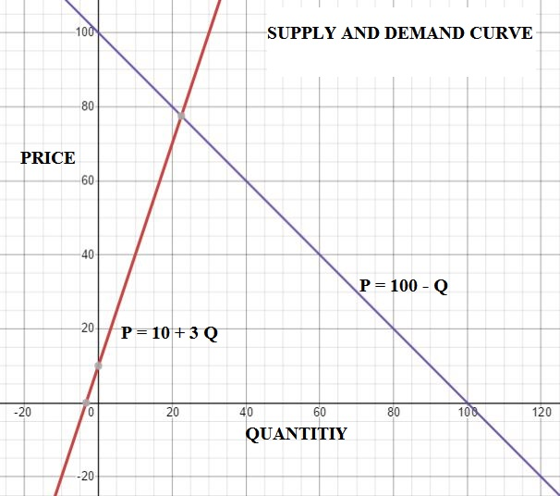

- What is the equilibrium price and quantity in this market?

$$Price= 77.5$$
$$Quantity = 22.5$$

- Calculate the value of total revenue in this market.

$$77.5 ×3= 232.5$$

Question 8. [Textbook Chapter 6,7] (1 mark)

Suppose the market for corn in a country is described by the following demand and supply equations:
Demand: P = 100 – (1/2)Q
Supply: P = 10 + (13/10)Q
Use this information to answer the following set of questions.
- What is the equilibrium price and quantity in this market? For your answers you may round to the nearest whole number.

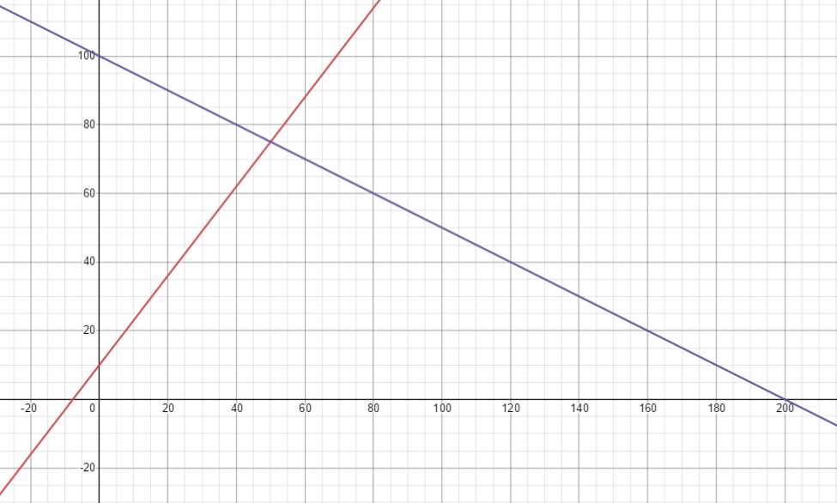

- What is the value of total revenue for farmers in this market?
$75

Suppose the government institutes a price support in this market of $80 per unit of corn.
- Given the price support, how many units of corn will consumers buy?
40Units

- Given the price support, how many units of corn will the government buy?
50 Units

- Given the price support, what is the cost to the government of this program if storage costs are $10 per unit of corn stored?
20 units

Question 9. [Textbook Chapter 8] (1 mark)

Consider the market for soft drinks. You know that the demand curve in this market contains the points (Q, P) = (100,000, $1.00) and (50,000, $2.00). You also know that the demand curve is linear. The linear supply curve contains the points (Q, P) = (0, $0) and (50,000, $1). The government decides they want to decrease consumption of soft drinks from its current equilibrium level to 50,000 drinks. You are asked to analyze this situation and provide answers to the following questions.

(Q, P) = (100,000, $1.00) and (50,000, $2.00).
(Q, P) = (0, $0) and (50,000, $1)
50,000

- How big an excise tax will the government need to implement in order to reduce consumption to 50,000drinks?
$0.5

- Given the above scenario, calculate the tax revenue the government will collect when they implement an excise tax that reduces consumption to 50,000 drinks.
$$\$0.5 ×50,000=\$25000$$

- What is the deadweight loss associated with this excise tax?
$$80,000-50,000=30,000$$

Question 10. [Textbook Chapter 9] (1 mark)
Consider the small closed economy of Isoland and its market for bananas. Currently, the domestic demand and supply curves for bananas are given by the following equations:
Domestic Demand: P = 1000 – (1/5)Q
Domestic Supply: P = 200 + (1/15)Q
Furthermore, you know that the world price of bananas is equal to $300 per unit of bananas. Hint: you will likely find it helpful to draw a sketch or several sketches as you proceed with this problem.

- If Isoland remains a closed economy, what will be the equilibrium price and quantity in the market for bananas in this economy?
$$Equilibrium price =\$250$$
$$Equilibrium quantity =750$$
- Suppose Isoland opens the banana market to trade. Will Isoland import or export bananas when it changes its status from a closed economy to an open economy? Explain your answer.
Export
The price at which each banana is sold within the island is 250. This is $50 lowere than the global price of $300.

- Calculate the value of consumer surplus in the banana market when Isoland is a closed economy and the value of consumer surplus in the banana market when Isoland is an open economy. Will domestic consumers be in favor of opening the market to trade? Explain your answer.

Surplus before = 0
Surplus After = - 750

The consumers will not be in favour of opening the market since there would be shortage in the quantity of supplied banana.

- Calculate the value of producer surplus in the banana market when Isoland is a closed economy and the value of producer surplus in the banana market when Isoland is an open economy. Will domestic producers be in favor of opening the market to trade? Explain your answer.

Surplus before = 0
Surplus After = +750

Domestic producers will be in favour of producing more

Question 11. [Textbook Chapter 10] (1 mark)

Consider the market for gasoline in the country of Good Will. The market for gasoline in this country is currently described by the following demand and supply equations:
Demand: Q = 50,000 – 5000P
Supply: Q = 20,000P
where P is the price per gallon of gasoline and Q is gallons of gasoline. Although the good citizens of Good Will are aware that consuming gasoline creates externality costs on their society the current gasoline market does not incorporate any of these externalities.

- Describe at least four possible externality costs associated with the consumption of gasoline.
An externality is a cost or benefit caused by a producer that is not financially incurred or received by that produce. Four possible externality costs associated with the consumption of gasoline include
Air pollution
Water pollution at extraction point
Earning foreign exchange for the country involved
Taxes
- Given the externality costs you delineated in (a), where do you think the marginal social cost of gasoline curve is relative to the given supply curve? That is, are the two curves the same, is the marginal social cost of gasoline curve to the right of the market supply curve, or is the marginal social cost of gasoline curve to the left of the market supply curve?
$50,000

- Given the above information, what is the current market equilibrium quantity and price?
Equilibrium Price = $2
Equilibrium Quantity = 40,000

- Suppose that the government analyzes the externality costs in this market and concludes that the market should ideally result in 20,000 gallons of gasoline being consumed if all the externalities associated with gasoline consumption were internalized in the market. Assuming the externality costs are per unit of usage of gasoline and are constant, what is the externality cost per gallon of gasoline consumed?
Externality cost =$1

Question 12. [Textbook Chapter 11] (1 mark)

Consider a community that has two residents, Bob and Mandy. Bob and Mandy would both like to see streetlights installed in their community and they are busy trying to decide what the optimal amount of streetlights for their community is and what price they should each contribute for each streetlight installed. Luckily they are both willing to reveal their preferences and so we do not have to worry about the free rider problem. Bob’s demand for streetlights is given by the equation Q = 10 – P and Mandy’s demand for streetlights is given by the equation P = 5 – (1/2)Q. The marginal cost of providing a streetlight is $3.

- On your homework paper draw three graphs vertically one above the other. The first graph should be labeled “Bob’s demand”; the second graph should be labeled “Mandy’s demand”; and the third graph should be labeled “market demand”. On each graph the horizontal axis should be labeled “Quantity of Streetlights” while the vertical axis should be labeled “Price of Streetlights”. Now in each graph draw in the demand curve corresponding to your label. Remember that the market demand curve will be a vertical summation of the individual demand curves since a public good is non-rival.

- Write an equation for the market demand curve for the public good.

Bob’s demand equation Q = 10 – P
Mandy’s demand equation P = 5 – (1/2)Q.
- What is the optimal number of streetlights for this community? Show how you found this number.
5

- What price per streetlight will Bob pay? What price per streetlight will Mandy pay? Why do Bob and Mandy pay different amounts for each streetlight that is produced?

