DNA & Gel Electrophoresis.
INTRODUCTION
Gel electrophoresis involves analyzing and separating DNA fragments according to their sizes and charges. DNA fragments are negatively charged; hence, DNA fragments are attracted towards the positive nodes when an electric current is applied. (Purdue University 2012) The rate at which attraction takes place varies due to the sizes, and the current applied. (Brooker 2012) Thus, fragments concentrate according to their sizes and charges on the cathodes. Gel electrophoresis takes place in a gel-like medium. The Gel is extracted from seaweed, and it is preferred since it has pores at the end.
The process of electrophoresis is significant since it is widely applied forensically or when testing a child's paternity. Scientists have also embraced the electrophoresis process in identifying the causes of various diseases. It is also use to analyze the outcomes of polymerase reaction chain and to distinguish different species.
DNA is an acronym for Deoxyribonucleic Acid and has double-stranded molecules which are helical in shape, forming a ladder-like structure. DNA components include four nucleotides: Adenine, Guanine, Thymine, and Cytosine. The DNA molecule of an individual contains two genomes, one gotten from the female and the other from the male. DNA is present in almost all parts of the human body: in saliva, fingerprints, blood, hair, fingernails, and sperm.
DNA fingerprinting, or what is known in other terms as genetic forensic, is a technique used to identify individuals by analyzing their DNA characteristics. Fingerprinting has become significant in the crime-solving system since its introduction in 1984 by Alec Jeffery of the University of Leicester. It provides vivid evidence that somebody committed a crime. Every human has unique DNA; therefore, two people can have identical DNA except twins (Varsha 2006). This technique is widely applied to curb crimes and ensuring villains do not go unpunished. The techniques locate minisatellites' genome patterns which are unique to everyone.
In case of murder or rape case, police try their best to uncover the evidence. The only thing that helps trace the villain is a sample of DNA on the victim's body. The forensic team must prove the DNA sample belongs to the suspect. It can also be used in paternity determination. In 1994, a child won a case against his birth father, who inherited an estate from his dad. The child is said to have been conceived in 1943 after her employer raped her mother. The man denied his actions, but DNA testing proved he was the birth father (New York 1994).
This techniques has helped reduce the issues associated with the identification since no two individuals with same DNA. You also don’t require specific sample size to get the needed information. Small samples provides similar identification results as large specimen.
MATERIALS AND METHODOLOGIES.
The fundamental idea behind Gel electrophoresis and DNA fingerprinting is forcing out the DNA through the porous gel. The DNA molecules move when a current is introduced on the Gel. The molecules which are negatively charged moved toward the positive pole.
- There are several fundamental steps of carrying out gel electrophoresis. According to the Bio-Rad Forensic DNA fingering kit, the following methods are applied:
- Restriction of DNA samples
- Agrogose gel electrophoresis of DNA samples
- Analysis and interpretation of Results.
- Materials required:
- Adjustable pipette
- Gel box
- Pre-made Agrogose Gel
- DNA samples from the crime scene
- Carbon electrodes, and power supply.
Step 1: restriction digestion of DNA samples
This step involves rehydration of the DNA samples, buffer the samples, and restriction of enzymes aliquot restriction enzymes. The process takes 30-60 min to prepare. This enzyme divides the DNA into specific base patterns.
Step 2: Gel electrophoresis and visualizations of DNA fragments.
This process involves separating the DNA fragments according to their sizes in order to get the pattern.
The Gel is poured in the electrophoresis apparatus and ensures the Gel's pores are close to the black electrode, and at the bottom of the Gel apparatus is close to the red electrode. The chamber is then covered with a lid.
The apparatus is then plugged in the power supply, and a current of 100v is passed through it for thirty minutes.
After the electrophoresis is over, the power is unplugged, and the lid of the chamber removed, the Gel is carefully pulled out to avoid slipping off. Place the Gel on the staining tray to identify it.
There are two methods of staining: Quick staining, which requires twelve to fifteen minutes. In this method, add 120ml of 100x Fast Blast stain for two minutes. Rinse with preheated water (40-45 degrees Celcius) for ten seconds.
Continue distaining the Gel while shaking for five minutes to get the best result. Pour the remaining in the waste beaker and record the results.
Method two is known as overnight staining. Unlike in quick staining, here, we use 120ml 1x DNA stain instead. The concoction is let to stain overnight—no distaining in this method.

RESULTS
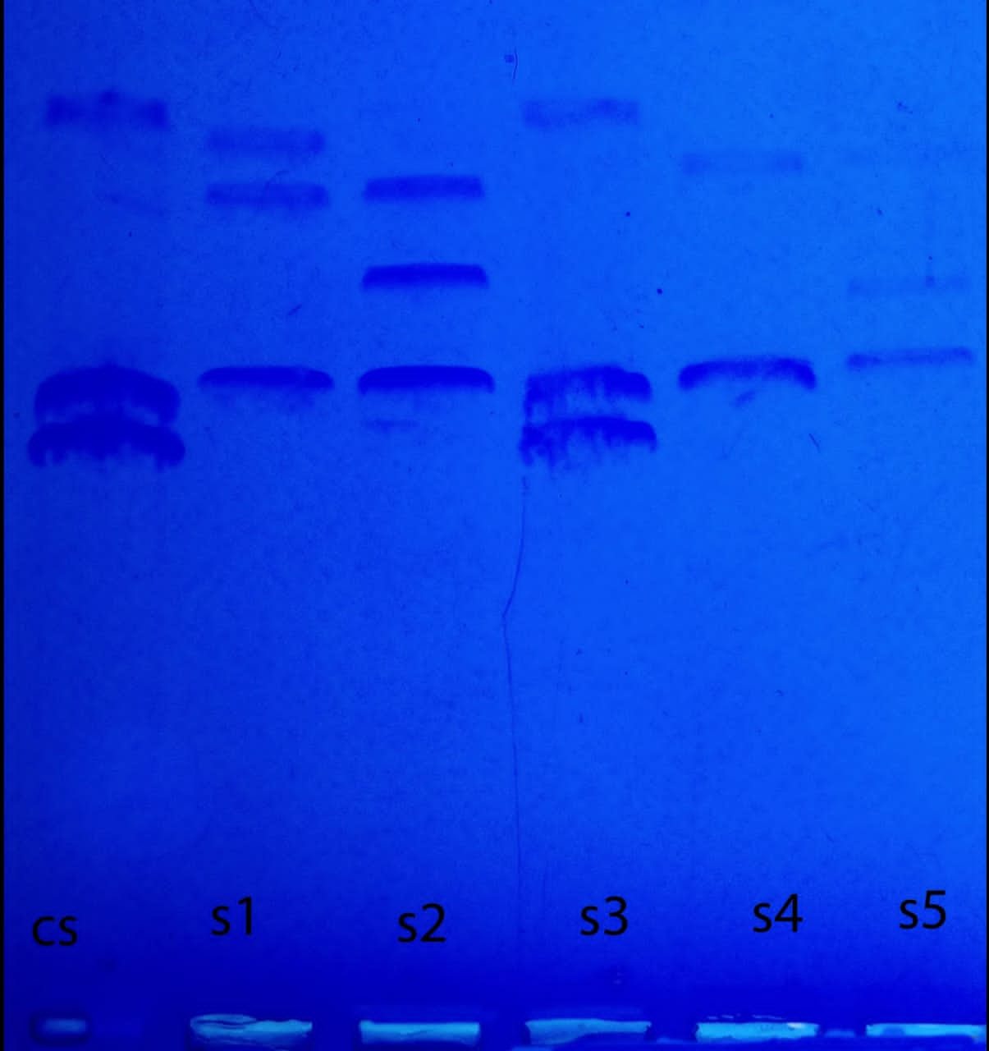Image of the Stained Gel.
The DNA sample on scene S1 and S2 belongs to the same individuals since they have the same fragments. The CS and S3 matches meaning s3 are sample DNA of the suspect.
DISCUSSION
DNA Fingerprinting Data

 | Crime Scene | S1 | S2 | S3 | S4 | S5
Band 1 | 22 mm | 25 mm | 25 mm | 22 mm | 25 mm | 25 mm
Band 2 | 25 mm | 36 mm | 31 mm | 26 mm | 33 mm | 29 mm
Band 3 | 40 mm | 38 mm | 36 mm | 39 mm |  | 34 mm
This experiment demonstrated agarose gel electrophoresis's ability to separate the fragments of the DNA from the crime scene into their sizes by applying a mixture of stains to the Crime scene samples. The experiment effectively exhibited that the DNA molecules were varying in size, charge, and in components. Most of the molecules were charged negatively at neutral pHs and only one was positively charged. The positive charged travelled to the black anode while the negative charged moved to the red cathode. The smaller molecules moved fast compared to larger molecules that dragged along the Gel.
To identify the suspect DNA, first, determine the distance traveled by a specific fragment.
The crime scene and S3 samples seem to be identical. Both produce a closer banding sequence on the Gel. S3 sample fragments traveled and distance 22mm, 26mm(+/-1), and 39mm, respectively. This evidence can be used against a suspect in the court of law to prove:
Paternity of a child.
In a scenario where a child's paternity is in doubt, DNA fingerprinting can be useful (Rafael 2009). If a man is accused of denying his child, saying it is not his, DNA testing is undertaken, and the evidence is presented in court. (New York Times 1994).
In case of rape, murder, and theft
A suspect is accused of rape, and a DNA test may be taken from the samples collected from the victim's body. These samples include fingerprints, sperms, and saliva. The results can be provided on the court to prove him guilty or not. In 2018, a man named Roy Charles was arrested after DNA tests from 1991-2006 crime scenes matched with his. He was convicted for 40 rape cases.
When one is a suspect of murder, or the police are trying to unveil the cause of murder, the police may collect fingerprints, hair strands which they can use to convict the suspect.
LIMITATIONS
The primary limitation of Genetic forensic is that it is 100% accurate. It rely on imperfect human being to process and provide the information.

REFERENCES
Http://www.wikipedia.com
http://www.google.com
Varsha. “DNA Fingerprinting In The Criminal Justice System: An Overview. “DNA & Cell Biology 25.3(2006): 181-188. Academic Search Premier. Web. Nov. 2013.
Purdue University Van Project. (1996). Retrieve April 4, 2021, from http://www.chem.purdue.edu/te Rafael. The benefits of DNA fingerprinting retrieved on March 4, 2021.
Krawczark, Micheal, and J. Shmidtke. DNA fingerprinting. 2nd ed. Oxford, UK: Bios Scientific, 1998. Brooker, Robert J., Eric Widmaier, Linda Graham, and Peter Stiling. (2011). Genetic Technology. Biology, 415.nt.

