Numeracy Unit
(Level IV Graduate Math)
Draft
(NSSAL)
©2014
(Last Update: April 2015)
This resource is the intellectual property of the Adult Education Division of the Nova Scotia Department of Labour and Advanced Education.
The following are permitted to use and reproduce this resource for classroom purposes. The following are permitted to use and reproduce this resource for classroom purposes. • Nova Scotia instructors delivering the Nova Scotia Adult Learning Program
- Canadian public school teachers delivering public school curriculum
- Canadian non-profit tuition-free adult basic education programs
- Nova Scotia Community College instructors
The following are not permitted to use or reproduce this resource without the written authorization of the Adult Education Division of the Nova Scotia Department of Labour and Advanced Education.
- Upgrading programs at post-secondary institutions (exception: NSCC)
- Core programs at post-secondary institutions (exception: NSCC)
- Public or private schools outside of Canada
- Basic adult education programs outside of Canada
Individuals, not including teachers or instructors, are permitted to use this resource for their own learning. They are not permitted to make multiple copies of the resource for distribution. Nor are they permitted to use this resource under the direction of a teacher or instructor at an unauthorized learning institution.

Acknowledgments
The Adult Education Division would also like to thank the following NSCC instructors for piloting this resource and offering suggestions during its development.
Eileen Burchill (IT Campus)
Krys Galvin (Truro Campus)
Barbara Leck (Pictou Campus)
Suzette Lowe (Lunenburg Campus)
Alice Veenema (Kingstec Campus)

What is Numeracy?
Numeracy is not the same thing as mathematics. Numeracy refers to an individual’s ability to understand and use mathematical information at school, at work, and in everyday life.” (Human
Resources and Skills Development Canada). Numeracy activities ask you to solve a variety of real world applications using very basic mathematical concepts (e.g. operations with whole numbers, simple fractions, decimals, percentages, and signed numbers, interpreting graphs, etc.). For example, when a person completes an expense claim at work where they have to summarize and total all of their expenses for a business trip on an expense claim form; this is considered a numeracy activity. There is obviously mathematics associated with this task (e.g. adding decimal numbers), but the ability to apply these basic mathematical concepts to this real world context is what makes it a numeracy activity.
Mathematics includes numeracy but is much broader than numeracy. Mathematics also requires people to think and work
Mathematics
Numeracy
in greater levels of abstraction. For example, solving linear equations like 3 14 6 2x   x using algebra would be considered a mathematics activity, but would not be considered a numeracy activity. The question is not supplied in a real world context, and even if it was, it is unlikely going to be a context that many people are going to experience in their daily lives.
Numeracy Activities | Mathematical Activities Beyond Numeracy Activities
- Estimating your grocery bill.  - Mentally calculating a 15% tip for a waiter/waitress.  - Completing an expense claim form.  - Examining the departure and arrival times on an airlines website and choosing the best option for you.  - Calculating the total cost of a car rental.  - Using the scale provided on a map to determine the actual distance between two locations.  - Adjusting a recipe to prepare a greater number of food items. | - Solving a linear equation. • Calculating the missing side of a triangle using the Law of Cosines.  - Solving a 2 by 2 system of equations using elimination.  - Determining the equation of a linear function.  - Calculating the standard deviation for a set of data.  - Use the regression analysis features on a graphing calculator to determine the line of best fit.
The challenging thing about true numeracy activities is that the contexts are so varied that it takes some time to figure out which mathematical concept or concepts apply. You cannot simply memorize a procedure; you have to think. Even when the mathematical concepts are obvious and fairly simple, there can be other challenges. For example, expense claims are largely the same in that you list your expenses (accommodations, meals, and mileage) and then total them. However, expense claims come in many different forms and you have to be able to figure out which columns and rows need to be filled with the appropriate information. The form itself is
NSSAL
often more challenging than the mathematics embedded within this form. Again, you have to think your way through each of these unique situations. This can made numeracy activities a little more frustrating. However, as you near the end the end of Graduate Math, you need to realize that you have all the necessary knowledge and skills to handle these types of questions. Believe in yourself and realize that the course of action for many of these questions will take a little time to figure out. Be patient.

About this Unit
There are two fundamental differences between this unit and the other Graduate Math units you have used in this course.
- There are no worked examples in this unit. The reason stems from fact that true numeracy questions are so varied that they cannot be condensed into a handful of categories, each with set procedures for solving them. With all the varying contexts, you have to figure out which mathematical concepts apply. This cannot be taught by supplying a multitude of worked examples.
- There is no answer key for this unit. Sometimes learners will use the strategy of "working backwards from the answer," to figure out how to complete question. We did not want this to occur. In other cases, the mathematics behind the question is not that difficult but the challenge is interpreting the information supplied in a table and/or in a written description. Supplying a final answer sometimes discourages learners from thinking deeply about the information supplied. For these two reasons, the author of this resource chose not to include an answer key with the student resource.

Recommended Assessment Practice for the Numeracy Unit
The ALP curriculum consultant recommends that assessment for this unit is divided into two components. Fifty percent of the unit mark could be based on the completion of the unit where the instructor checks the final answer to each of the numeracy questions in this resource and assigns a mark based on the percentage that are correct. If the learner has fared poorly on the submitted work, instructors can allow learners to correct their mistakes and resubmit the material.
The remaining fifty percent of the unit mark could be based on an open-book test created by the LAE and available to instructors on the NSCC SharePoint site. Normally open book tests are not recommended in Level IV Math courses, but with the high variability of numeracy questions, coupled with the lack of worked examples in this resource, this makes this assessment practice perfectly acceptable for this unit.

The Big Picture
The following flow chart shows the six required units and the four optional units (choose two of the four) in Level IV Graduate Math. These have been presented in a suggested order. Instructors and students may choose to alter this order to best serve the needs of the learner. Not all of the units take the same amount of time to complete. For example, the Consumer Finance Unit is quite short. By contrast, the
Graphs and Function Unit and the Measurement Unit (A and B) tend to take the greatest amount of time.
Math in the Real World Unit (Required)
•
Fractions, decimals, percentages, ratios, proportions, and signed
numbers in real world applications
•
Math Games and Puzzles
Solving Equations Unit (Required)
•
Solve and check equations of the form
D
Cx
B
Ax



,
C
Bx
A


2
, and
C
Bx
A


3
.
Consumer Finance Unit (Required)
•
Simple Interest and Compound Interest
•
TVM Solver (Loans and Investments)
Graphs and Functions Unit (Required)
•
Understanding Graphs
•
Linear Functions and Line of Best Fit
Measurement Unit (Required)
•
Part A: Imperial and Metric Measures
•
Part B: Perimeter, Area and Volume
Choose two of the four.
Linear
Functions and
Systems of
Equations Unit
Trigonometry
Unit
Descriptive
Statistics Unit
Numeracy Unit

Angles and Triangles Unit (Required)

•
Angle and Line Relationships
•
Similar Triangles
•
Pythagorean Theorem

Course Timelines
Graduate Level IV Math is a two credit course within the Adult Learning Program. As a two credit course, learners are expected to complete 200 hours of course material. Since most ALP math classes meet for 6 hours each week, the course should be completed within 35 weeks. The curriculum developers have worked diligently to ensure that the course can be completed within this time span. Below you will find a chart containing the unit names and suggested completion times. The hours listed are classroom hours.
Unit Name | Minimum  Completion  Time in Hours | Maximum  Completion  Time in Hours
Math in the Real World Unit | 24 | 34
Solving Equations Unit | 20 | 28
Consumer Finance Unit | 15 | 18
Graphs and Functions Unit | 25 | 30
Measurement Unit (A & B) | 22 | 30
Angles and Triangles Unit | 14 | 16
Selected Unit #1 | 18 | 22
Selected Unit #2 | 18 | 22
 | Total: 156 hours | Total: 200 hours
As one can see, this course covers numerous topics and for this reason may seem daunting. You can complete this course in a timely manner if you manage your time wisely, remain focused, and seek assistance from your instructor when needed.

Numeracy Questions (Calculators are permitted.)
Your instructor will only be looking at your final answer for each of these questions and be assigning a mark accordingly. He/she will not be examining of your pencil-and-paper work. So should you show all your work? Our recommendation is that you do because, following the completion of this unit, you will be writing an open-book test where you are able to use your completed unit as a resource. Also feel free to jot down any notes that may help refresh your memory as how you completed each of the questions.
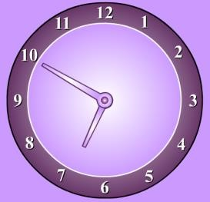
- Based on the clock shown on the right, what time will it be in a half hour?
____8:20_______
- You purchase an item for $13.65 (after taxes) and pay with a $20 bill. How much change should you get?
$6.35__________
- Below you have been provided with a written statement and three numbers. Fill the numbers such that the statement makes sense.
2 | 16 | 18
Normally _18____ people attend the neighborhood watch meeting. That number decreased slightly by __2___ such that __16___ people attended.
- Match with the most suitable unit of measure.
(a) | the length of an automobile |  | c | kilograms (kg)
(b) | amount of fat in a serving of french fries |  | d | metres (m)
(c) | weight of large bag of potatoes |  | b | litres (L)
(d) | width of a computer screen |  | f | kilometres (km)
(e) | amount of gasoline in a vehicle's gas tank |  | e | grams (g)
(f) | distance covered in a one hour car ride |  | g | millilitres (mL)
(g) | amount of medicine in a medical syringe |  | a | centimetres (cm)
- If Nashi earns $12 an hour and works from 11:30 a.m. until 6:30 p.m. with paid breaks, how much does she earn before deductions?
$ _____84______
- What is the length of the line segment? Include the units of measure.
1 2 3 4 5 6 7
cm
________6.1cm__________
- The container on the right has some water in it. Approximately how full is the container? Answer as a percent.
___75________%
- A single chocolate bar is selling for $0.95. A four pack of the same chocolate bar is selling for $2.99. How much is saved by buying the four pack, as opposed to buying four individual bars?
$____1.01______
- The graph on the right shows the age distribution of registered nurses (RNs) in Canada for the year 2009.
0
5000
10000
15000
20000
25000
30000
35000
40000
<24
25-2930-3435-3940-4445-4950-5455-5960-64
65+
Age
Number of RNs
Approximately how many registered nurses in 2009 were between the ages 25 and 34?
__54900_________ nurses
- Out of 400 randomly selected adults, 124 said that they go out to dinner 4 or more times in amonth. Based on these results, out of a population of 18 000 adults, how many would one predict dine out less than 4 times a month?
______12520____ adults
- An item normally costing $16.95 (before tax) is discounted by 20%. If tax is 15%, what thetotal price of the discounted item?
$___19.49_______
- The following sketch shows the height of one tree compared to the height of another tree. Ifthe trees are side by side and the larger tree is 40 feet high, estimate the height of the smaller tree.

_____15_____ feet
- Three numbers and a written statement have been supplied below. Fill the numbers such thatthe statement makes sense.
150 | 70 | 10
Kadeer likes to use __10____ grams of ground coffee to make __150____ millilitres of coffee. He also likes the coffee to be served at __70____ ºC.
- Roof pitch is a way to describe the steepness of a roof. If aroof has an 8:12 pitch, it means that the roof rises 8 feet over a horizontal run of 12 feet. If a roof had an 8:12 pitch, what would be the height for a horizontal run of 21 feet?
8
feet
_14.42________ feet 12 feet
- Which one of these four measures is the largest? Circle the correct answer.
(a) 3000 metres (b) 40 millimetres (c) 9000 centimetres (d) 2 kilometres
- A car rental agency charges a flat rate of $55 per day plus $0.10 per kilometre. If Mary rentsa car for 3 days and drives 400 kilometres, how much money will he owe for the rental?
$_______205___
- Using the chart below, determine how many calories the average 140 pound person woulduse when he/she plays hockey for one hour?
Average Calories Used in 30 minutes
Activity | Calories Burned by 140 pound Individual | Calories Burned by 180 pound Individual
Walking | 139 | 178
Swimming | 192 | 248
Aerobics | 223 | 286
Hockey | 256 | 329
Bicycling | 277 | 356
___512______ calories
- Rana is travelling in her car for 8 hours.The graph shows the distance she travelled during that trip.
0
50
100
150
200
250
300
350
400
450
0
1
2
3
4
5
6
7
8
time (hours)
distance (km)
What was Rana's average speed over the first 5 hours trip of the trip?
_______60___ km/h
- Below you have been provided with a written statement and four numbers. Fill three of thefour numbers such that the statement makes sense. One of the numbers does not belong.
126 | 37 | 2.8 | 45
Margaret is ___2.8___ times heavier than her young daughter Angela. If Angela weighs __45____ pounds, then Margaret weighs __126____ pounds.
- A fence needs to be built around the following property. How much fencing is needed?
2.8 m
_________24.2___ metres
4.9 m
3.4 m
7.2 m
- A family needs to catch their 8:45 a.m. flight to Florida. They must arrive at the airport 2 hours before departure in order to clear security. If the car trip from home to the airport takes 35 minutes, what is the latest time they can leave home?
____6:10_______ a.m.
- 2.05 kilograms is the same as:
    - 2 kilograms 50 grams
    - 2 kilograms 5 grams
    - 2 kilograms 5000 grams
    - 2 kilograms 500 grams
- A particular swimming pool is the shape of a rectangular solid. Its length is 10 metres, itswidth is 8 metres, and its depth is 2 metres. If the pool is  full with water, how many cubic metres of water are in the pool? Include the units of measure.
______120000m^3________
- A gift shop had the following hours of operation posted.
Store Hours:  Nov-Apr | Mon-Fri | 10 a.m. to 6 p.m.
 | Sat-Sun | 11 a.m. to 5 p.m.
May-Oct | Mon-Fri | 10 a.m. to 8 p.m.
 | Sat-Sun | 10 a.m. to 6 p.m.
How many hours per week is the store open in July?
____588_______ hours
- Using the ruler drawn on the page, determine the length of the line segment in inches.
 | 1 | 2 | 3
____25________inches
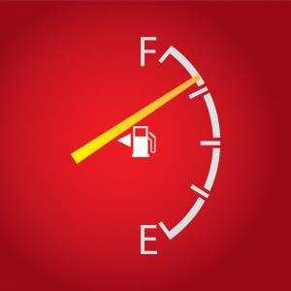
- A fuel gauge is shown on the right. When full, the gas tank forthis particular car can hold 65 litres of fuel. Based on the fuel gauge reading shown, about how much fuel is in the tank?
___60________ litres
- The total bill for your dinner at a restaurant is $38.69 (after taxes). If you wish to leave a15% tip for great service, about how much money should you leave for the tip?
$____44.49_____
- When the store opens, there was $200 in the cash register. At the end of the day, theemployee records the following money in the cash register.
 | Number
$50 Bills | 4
$20 Bills | 15
$10 Bills | 7
$5 Bills | 4
$2 Coins | 10
$1 Coins | 8
25¢ coins | 14
10¢ coins | 12
5¢ coins | 18
How much more money is there in the cash register at the end of the day than when the store opened?
$_888________
- There are 100 centimetres in a metre. What fraction of a metre is 40 centimetres?
(a)  (b)  (c) (d) 
- The membership at the ski club went from 2345 members to 2531 between December 2012 and December 2013. What was the percentage increase in ski members during that period of time?
__7.93________%
- Below you will find the rainfall data for a particular community forfive years.
 | Total Rainfall for the Month (mm)
 | May | September
2008 | 42 | 34
2009 | 65 | 70
2010 | 71 | 128
2011 | 102 | 30
2012 | 30 | 38
What is the difference in mean rainfall in May and mean rainfall in September?
______2____ mm;
- Below you have been provided with a written statement and four numbers. Fill three of thefour numbers such that the statement makes sense. One of the numbers does not belong. You are also supplied with a diagram showing the cross-section of the countertop that is talked about in the statement.
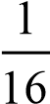 |  | 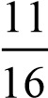 | 
A particular __3/4____ inch counter top is comprised of a__3/8vinch particle board core with thin layer of laminate measuring ___1/16___ of an inch thick glued on top.
core
- The outdoor temperature reading at 5:00 a.m. is shown on thethermometer on the right. If the temperature rises at a rate of 2ºC per 10º hour, what will be the temperature at 10:00 a.m.?
____20___ ºC 5º
0º
-5º
- One litre of cleaner is mixed in a ratio of 1 part cleaner to 8 parts water (i.e. 1:8). How muchcleaning solution does this make altogether? Include the units of measure
_________9________
- The following chart looks at times taken by runners to complete last month's road race.
Time taken in hours:minutes:seconds | Number of Runners
Under 2:30:00 | 12
Between 2:30:00 and 2:59:59 | 45
Between 3:00:00 and 3:29:59 | 78
Between 3:30:00 and 3:59:59 | 63
Between 4:00:00 and 4:29:59 | 42
4:30:00 and over | 32
How many runners completed the race in less than 3 hours and 30 minutes?
_____135_______ runners
- The mid-day temperatures of five Canadian cities on a particular day in January are listedbelow.
City | Mid-day Temperature
Halifax | -6ºC
Montreal | -9ºC
Toronto | -3ºC
Winnipeg | -14ºC
Victoria | 6ºC
The following day, the mid-day temperature in Halifax increased by 3ºC, and the mid-day temperature in Winnipeg decreased by 2ºC. How many degrees warmer at mid-day is Halifax than Winnipeg on this day?
_13______ºC
- The scale on the map is 1 : 20 000 (i.e. 1 unit of length on the map is equal to 20 000 units oflength in the real world). On the map, the distance between two towns is 14.2 cm. What is the actual distance between these two towns in kilometres?
____71_______ kilometres
- A typist takes 4 minutes to type 120 words. How long (in minutes) will it take the typist totype 2520 words?
___84________ minutes
- The instructions for an orange drink state that you must mix one part orange concentrate tothree parts water. If so, how many millilitres of orange concentrate are needed to make 3 litres of orange drink?
_____1000______ millitres
- A bundle of roof shingles covers 33 square feet of roof. How many bundles are needed tocover a rectangular roof measuring 20 feet by 8 feet?
_____5______ bundles
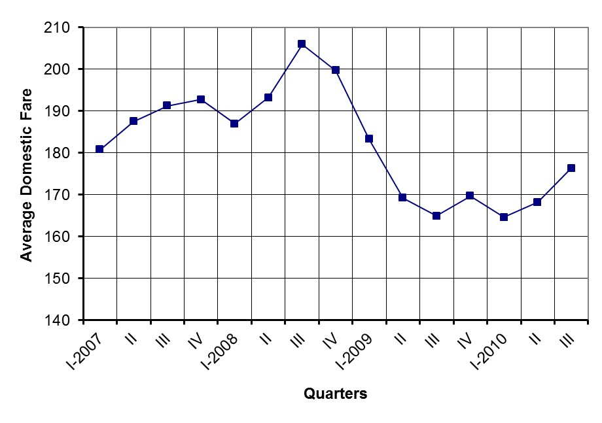
- The following bar graph shows the populations of five Canadian communities. Marcus looksat the graph and states that the population Sarnia, Ontario is less than half of the population of Trois-Riveres, Quebec. Marcus is wrong.
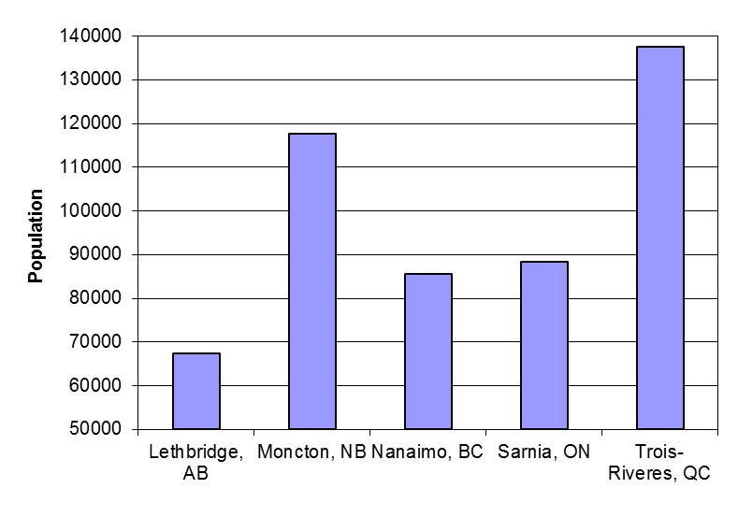
Why can this bar graph be misleading?
    - The numbers on the vertical axis do not increase evenly.
    - The communities should be listed based on there geographic position, specifically from west to east.
    - The bars are the wrong width.
    - The vertical axis does not start at 0
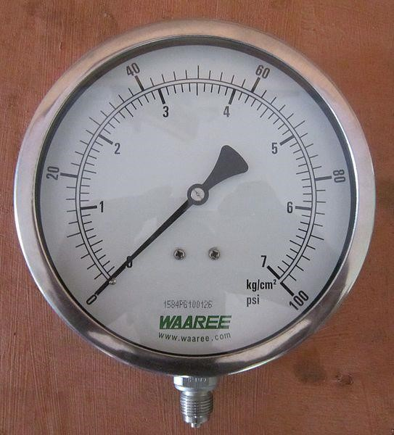
- The pressure gauge on the right measures airpressure. The outer scale measures pressure in pounds per square inch (psi). The inner scale measures pressure in kilograms per square centimetre (kg/cm²).
How many kilograms per square centimetres are equal to 44 pounds per square inch?
____0.44______ kilograms per square centimetres
Coverage:
Up to 1 L /110 ft² (10.5 m²)
- Charu has to paint the ceilings in her house. The ceilings total 3500 square feet (325 squaremetres). The label on the paint container supplies the following information regarding coverage. How many cans of ceiling paint should she purchase to complete the ceilings knowing that a can holds 3.78 litres of paint?
__1________ cans of ceiling paint
- The following line graph shows how theaverage price of a domestic flight from Halifax changed between the first quarter of 2007 until the third quarter of 2010.
Between what two quarters was the greatest increase in the average price of a domestic flight from Halifax?
________________ and _______________
- The following chart shows the different temperature ranges for different grades of motor oils.
Grade | Temperature Range
SAE 5W-30 | -25ºC to 20ºC
SAE 5W-40 | -25ºC to 35ºC
SAE 10W-30 | -20ºC to 30ºC
SAE 10W-40 | -20ºC to 35ºC
SAE 15W-40 | -15ºC to 45ºC
SAE 20W-40 | -10ºC to 45ºC
Which grade of motor oil has the smallest temperature range?
_____SAE 5W-30________
- The table below shows the pay rates of three employees. The employees get paid overtimefor the number of hours over the regular 40 hour work week. There is also a bar graph showing the number of hours worked by each employee on a specific week.
 | 38  39  40  41  42  43  44  45  46  47  48  49  50  51  Theriault  Chopra  Kennedy  hours worked
  Employee | regular | overtime
  Kennedy | $16/hour | $24/hour
  Chopra | $18/hour | $27/hour
  Theriault | $14/hour | $21/hour
How much less did Theriault earn than Kennedy earn on this specific week?
$___47________
- You are returning to Canada and have to exchange your US dollars to Canadian dollars. Onthat day, the conversion rate is one Canadian dollar is worth $0.92 US dollars. If you have $640 US to exchange, you much will you receive in Canadian currency?
$_6.96__________
- The sales of personal computersfrom three stores over four weeks are shown in the graph.
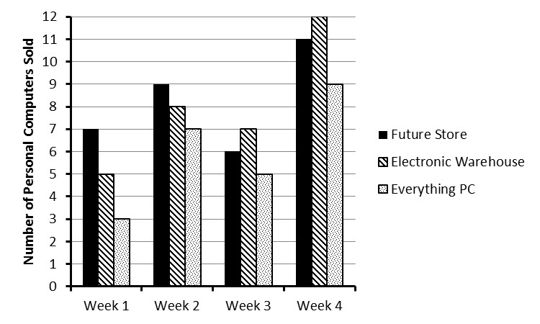
For each personal computer sold, Everything PC makes $85 profit. How much profit does Everything PC made on the sales of personal computers over this four week period?
$___2040________
- There are 30.48 centimetres in 1 foot. There are 5280 feet in 1 mile. How many centimetresare in 0.5 miles?
___80467.2________ centimetres
- The following recipe makes one loaf of banana bread.
      - 250 grams of all-purpose flour
      - 5 grams of baking soda
      - 110 grams of brown sugar
      - 2 grams of salt
      - 115 grams of butter
      - 2 eggs (beaten)
      - 525 grams of mashed overripe bananas
    - If you have to make 4 loaves of banana bread for your community center's fund raiser, how many grams of butter would you need?
__460________ grams
    - If you only have 1.3 kilograms of all purpose flour, what is the maximum number of loaves of banana bread you can make?
__6________ loaves?
    - What is the ratio of baking soda to salt in this recipe?
____5:2__________
- The following chart shows the Canadian population based on age at three different periods oftime (1991, 2001, 2011). Please note that all population numbers are supplied in millions.
 | 1991 | 2001 | 2011
0-4 |  | (million)
0-4 | 1.91 | 1.70 | 1.64
5-12 | 3.04 | 3.23 | 2.77
13-24 | 4.57 | 4.81 | 4.98
25-34 | 4.87 | 3.99 | 4.17
35-44 | 4.37 | 5.10 | 4.51
45-64 | 5.37 | 7.29 | 9.47
65-69 | 1.07 | 1.13 | 1.49
70-79 | 1.44 | 1.82 | 1.99
80+ | 0.66 | 0.93 | 1.33
Total | 27.30 | 30.01 | 32.36
    - By how much did the population of 35 to 44 years olds change between 1991 and 2011?
__133000_______________ people
    - What percentage of the population was between 45 and 64 years old in 2001? Round your answer to the nearest whole number.
______1____%
    - Which one of these statements is false regarding people 80 years of age or older in 1991 and 2011?
      - The population of 80+ year olds approximately doubled between 1991 and 2011.
      - The proportion of 80+ year olds in 1991 to 80+ year olds in 2011 is approximately two to one.
      - The population of 80+ year olds increased by 0.67 million between 1991 and 2011.
      - The population of 80+ year olds in 1991 is approximately one half that of the same age group in the year 2011.
- Below is a portion of a furniture store inventory table. Use this table to answer the questionsbelow.
Product ID | Description | Department | Price | Retail Cost | Count
639382000393 | Leather Armchair (brown) | Family | $575.00 | $385.00 | 6
397336007325 | Wingback Chair | Family | $420.00 | $280.00 | 8
639382001472 | Leather Love Seat (brown) | Family | $800.00 | $615.00 | 5
397336000678 | Sectional Sofa (microfiber) | Family | $1450.00 | $925.00 | 3
639382002595 | Leather Sofa (brown) | Family | $1050.00 | $760.00 | 6
639382001671 | Leather Sofa (beige) | Family | $1100.00 | $875.00 | 2
745364000541 | 6pc. Dining (oak) | Dining | $780.00 | $490.00 | 3
745364000462 | 6pc. Dining (maple) | Dining | $680.00 | $415.00 | 2
745364000479 | 8pc. Dining (maple) | Dining | $790.00 | $540.00 | 2
532891003492 | Childs Bedroom Set (maple) | Bedroom | $725.00 | $475.00 | 3
479102001896 | Twin Mattress | Bedroom | $230.00 | $120.00 | 5
    - What is the retail cost of an oak six piece dining set?
$_____490_____
    - What is the price of a brown leather loveseat?
$_____1050_____
    - How much profit is made on the sales of a maple eight piece dining set?
$____250____
    - How much profit in total is made if they sell every brown leather armchair they have in stock?
$_____1740_____
- Refer to the map below. Notice that it includes the compass bearings, identifies thedirections one can travel down a street (i.e. one-way vs. two-way), and identifies the entry points of the building using a thick line along the edge of the building.
Bank of Truro
Toy
Store
Town
Hall
Will's
Furniture
Joel's
Deli
Shin
St.
Aim
Department
Store
Johnson Rd.
Qazi Lane
Jacob St.
Agate Ave.
Ryan Rd.
Matthew St.
Carter Cres.
A-1
Photo
Beckford Ave.
Shoes R Us
Pet
Store
Kate's
Boutique
Duke
Tower
N
S
E
W
Theriault Dr.
With each of these questions assume that you are driving from the entrance of one building to the entrance of another building along the most direct route.
    - You start out on Ryan Rod. You turn right onto Qazi Lane, then right onto Matthew Street, then left onto Jacob Street, and then left onto Theriault Drive. What direction (north, south, east or west) are you now facing?
_north____________
    - Which of the following is the most direct driving route from Shoes R Us to the Town Hall?
      - East on Beckford, then north on Johnson, then east on Jacob, and then south on Matthew
      - West on Beckford. then north on Theriault, then east on Jacob, and then so south on Matthew
      - West on Beckford, then south on Theriault, then east on Agate, and then north on Matthew
      - East on Beckford, then south on Johnson, then east on Agate, and then north on Matthew
- Candice needs to purchase season passes to the local ski hill for her and her small family.Her family is made up of herself (age ), her partner (age 39), her son (age 11), and her daughter (age 4). The ski hill's website provides the following table listing the various season pass options.
Category | Rate | Total
Senior (age 60+) | $219 + tax | $251.85
Adult (ages 18 to 59) | $279 + tax | $320.85
Student (ages 12 to 17) | $249 + tax | $286.35
Child (ages 6 to 11) | $199 + tax | $228.85
Infant (ages 5 and under) | $49 + tax | $56.35
Family * | $899 + tax | $1033.85
* - Family is defined as parents and their children (under the age of 18 years) within the same household
    - How much should she be spending in total (after taxes) to purchase season passes for all family members?
$870.55__________
    - Two years later, the season pass rates remain the same. What is the cheapest price (after taxes) for Candice's family?
$__928.05________
Nutrition Facts
Serving Size 70 g
Amount Per Serving % Daily Value*
Calories 259
Total Fat 3 g 4%
Saturated Fat 1 g 6%
Trans Fat
Cholesterol 10 g 3%
Sodium 561 g 23%
Carbohydrates 48 g 16%
Fibre 1 g 6%
Sugars 7 g
Protein 11 g
Vitamin A 1% Vitamin C 1% Calcium 9% Iron 14%
* Percent Daily Values are based on a 2000 calorie diet. Your daily values may be higher or lower depending on your calorie needs.
- The nutrition facts for an instant macaroni and cheesedinner are supplied on the right.
    - How many grams of cholesterol are in a 70 gramserving of this macaroni and cheese dinner?
__10______ grams
    - What percentage of the daily amount of carbohydrates would be found in a 210 gram serving of this meal?
___70_____%
    - How many calories would be in a 180 gram serving of this meal?
_____25___ grams
- The following map shows the position of a hiker (dot in upper right-hand corner) in relationto his cottage (dot near the lake's edge). A scale is provided on the map.
Cottage
Hiker
Cottage
Hiker

Scale 1 centimetre equals 350 metres
- How far is the hiker from his cottage in kilometres?
___1.4_______ kilometres
- Assuming that he walks at a rate of 3 kilometres per hour and travels in a straight line towards his cottage, how long will it take him to reach the cottage?
__28________ minutes
- A local sports team needs to buy promotional T-shirts. The company that can make thesepromotional T-shirts gives the following costs.
 | Cost (before tax)
Basic set-up charge | $50
First 40 T-shirts | $12 per shirt
Extra T-shirts above the 40 | $9 per shirt
    - If the team needs 200 T-shirts, what is the cost?
$__1920________
    - If the team only wants to spend $1500 on T-shirts, how many T-shirts can the team buy?
31__________ T-shirts
- The following chart shows the driving distances between different communities in NovaScotia.
 | Halifax | Truro | Digby | Amherst | Yarmouth | Sydney
Halifax | 0 | 94 | 228 | 196 | 304 | 399
Truro | 94 | 0 | 296 | 108 | 379 | 301
Digby | 228 | 296 | 0 | 398 | 104 | 600
Amherst | 196 | 108 | 398 | 0 | 479 | 402
Yarmouth | 304 | 379 | 104 | 479 | 0 | 683
Sydney | 399 | 301 | 600 | 402 | 683 | 0
    - How many kilometres would you cover driving from Sydney to Digby and back?
___1200_______ kilometres
    - You travel from Halifax to Sydney at a speed of 85 kilometres per hour (km/h). Which one of the following is the best estimate of the time it will take?
(i) 4 hours (ii) 4 hours 20 minutes
(iii) 4 hours 40 minutes (iv) 5 hours
(c) It takes you 5 hours to travel from Amherst to Yarmouth. On average, how fast are you going?
__95.8_________ kilometres per hour
- A science teacher needs 95 millilitres (mL) of vinegar for each of her students. There are 25 students in her science class. Vinegar comes in 1 litre (L) bottles. How many bottles of vinegar does the teacher need for her class?
1__________ bottles
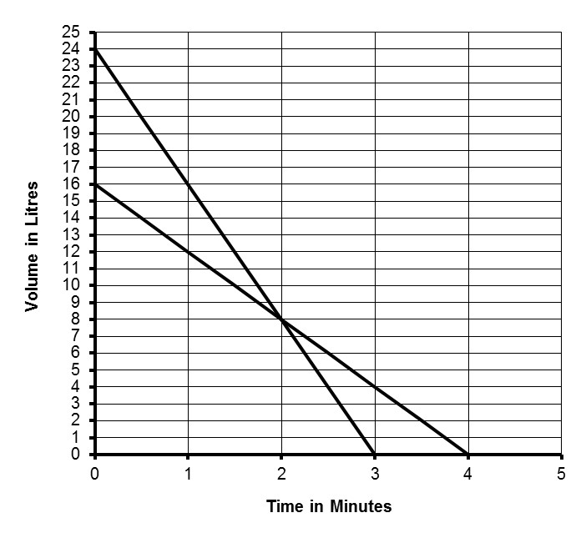
- Two different pumps are used to emptytwo different storage tanks. They are switched on at the same time. he graph shows how much fluid remains in each tank over time.
Tank B
Tank A
    - How fast, in litres per minute, is fluidbeing drained from Tank B?
__8_________ litres per minute
    - How much longer did it take to drain Tank A than Tank B?
_1_________ minute(s)
    - Between what times does Tank B have more fluid than Tank A?
Between _____0_ minutes and ____2
__ minutes
    - How much more fluid is in Tank A compared to Tank B at 2.5 minutes? Include the units of measure.
_____one litre____
    - The situation is changed slightly such that Tank B initially contains 20 litres of fluid. When will be the first time that the two tanks have the same amount of fluid?
____2______ minute(s)
- The following diagrams show the start time and finish time for an employee on a particularday.
Start Time in the Morning Finish Time in the Evening
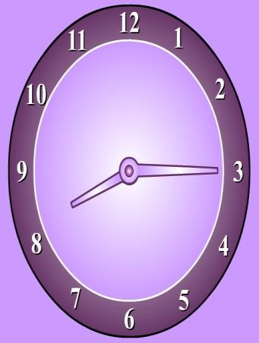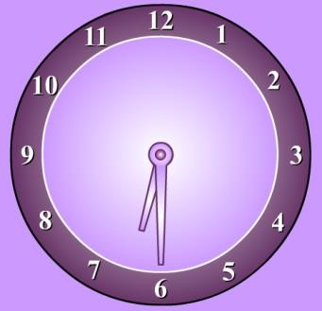
    - At what time did the employee start work?
____8:15______
    - If this employee is given a 45 minute unpaid lunch break, how long is his/her paid work day? Include the appropriate units of measure.
______8hrs 32 minutes_______________
    - The employee earns $16 per hour for the first eight hours and $24 per hour for every hour after the eight hours. How much will he/she make this day before deductions (e.g. taxes, employment insurance, etc.)?
_______140.80____
    - If the employee only wished to earn $120 (before deductions) that day, at what time would the work day have ended? Do not forget to factor in the 45 minute unpaid lunch break.
____4:32_______
- A large container, which can hold 20 litres of water, is being filled at a constant rate. Thefollowing series of diagrams show the water levels at different times.
time = 0 minutes | time = 1 minute | time = 2 minutes | time = 3 minutes
  10 L
  10 L
  10 L
  10 L
    - How much water is in the container at two minutes? Include the appropriate units of measure.
____10 litres_________________
    - Which one of the following represents the ratio of the litres of water in the container at 1 minutes to the litres of water in the container at 3 minute in simplest terms?
(i) 2:3 (ii) 3:2
(iii) 1:3 (iv) 3:1
    - Assuming that the container continues to fill at a constant rate, when will it be full? Include the appropriate units of measure.
_____after 5 minutes________________
    - How fast is the water being added to the container?
_____5____ litres per minute
    - Which one of these four equations describes the amount, A, of water in the container
(measured in litres) in terms of the time, t (measured in minutes).
(i) A 2 6t (ii) A 2 6t
(iii) A 2 6t (iv) A 2 6t
 | Char. | Toronto | Calgary
Jan | 111 | 63 | 17
Feb | 95 | 57 | 20
Mar | 85 | 66 | 20
April | 82 | 67 | 30
May | 82 | 73 | 50
June | 83 | 63 | 92
July | 73 | 81 | 68
Aug | 93 | 67 | 56
Sept | 86 | 61 | 35
Oct | 97 | 62 | 19
Nov | 126 | 67 | 16
Dec | 116 | 64 | 15
- The precipitation over a one year period for three
Canadian cities (Charlottetown, Toronto, and Calgary) has been supplied in the table and graph below. All measurements provided are in millimetres (mm). Use this information to answer the questions below.
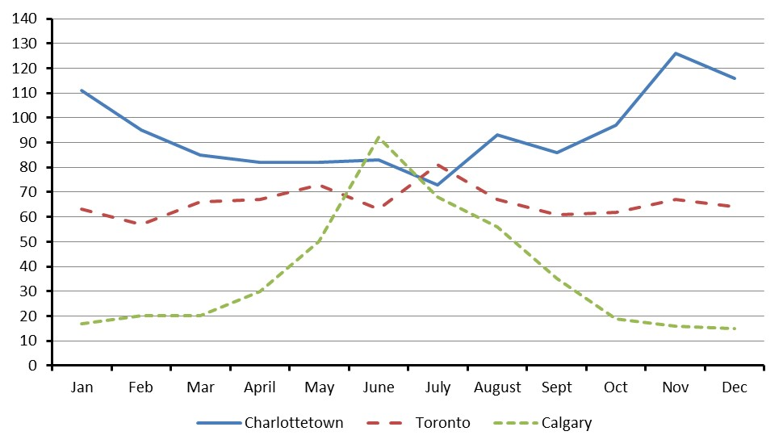
    - By how much did the highest monthly amount of precipitation for Charlottetown differ by the highest monthly amount of precipitation for Calgary?
____125_____ millimetres
    - In Calgary, there was a large increase in the amount of precipitation from one month to another. How large was the increase?
_____20______ millimetres
    - What was the average monthly amount of precipitation for Toronto in this particular year?
_______65____ millimetres
    - What was the average daily amount of precipitation for Charlottetown in September? There are 30 days in September.
______85_____ millimetres
    - There are 10 millimetres in one centimeter. There are 2.54 centimetres in one inch. How many inches of precipitation fell in July in Toronto?
____275.6_______ inches
    - In what month were the amounts of precipitation in these three cities the closest to each other?
_____June____________
- A company has four different offices in four different communities. The company offersoptional life insurance to each of its employees. Not all of the employees chose to take this insurance even though it is at a discounted rate.
Office | Number of Employees | Number of Employees Taking the Optional Life Insurance
Truro Office | 10 | 4
Halifax Office | 28 | 9
Amherst Office | 8 | 3
Sydney Office | 16 | 7
What percentage of employees chose to take the optional life insurance?
______37.10__%
- NS Electrical Controls sells electrical equipment to other businesses. The following sales order is from NS Controls to one of its customers, Hammond Controls Company. The sales order is incomplete.
NS Electrical Controls Sales Order
163 Harbourview Road
Halifax, NS Date: Sept 23, 2014
B2H 1P7 Invoice Number: 5649

Sold To: Hammond Controls Company Shipped To: (same)
528 Water Street
Antigonish, NS
B2G 1R2
Item # | Description | Quantity | Unit Price | Amount
31132 | Switch, DPDT 240v 100a | ???? | $17.26 | $690.40
31068 | Switch, DPDT 240v 50a | 30 | $11.54 | $346.20
34345 | Circuit Breaker, SP 120v 30a | 60 | $18.91 | $1134.60
31283 | Switch, SPDT 240v 100a | 50 | $12.66 | $633.00
34361 | Circuit Breaker, DP 120v, 15a | 25 | ???? | $548.00
 |  |  | Subtotal | ????
 |  |  | Tax (15%) | ????
 |  |  | Total | ????

    - The items on the sale order were not listed in any specific order. Some businesses prefer that the items be listed in order, based to their item number. Order the five item numbers from smallest to largest.
__31068__________, _____31283_______, ____31132________, ____34345________, ___34361_________
    - Determine the quantity of DPDT 240v 100a switches that were sold to Hammond Controls Company.
_______40_____
    - What was the unit price of a DP 120v 15a circuit breaker?
$ ___21.92________
    - What should be the total at the end of the sales order?
$_______3352.2____
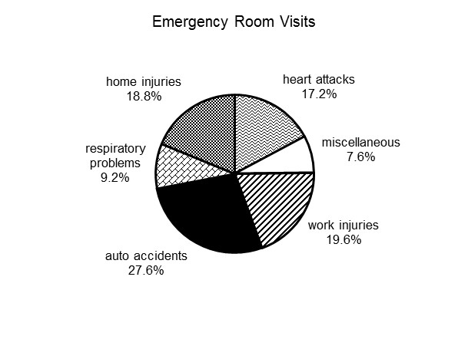
- There were 1250 emergency roomvisits last month at a particular hospital. From those visits a circle graph describing the different types of visits was created.
    - What percentage of the visits were for work related injuries?
____19.6______%
    - How many visits were for respiratory problems?
___115_______ visits
    - Which type of injury or medical condition was responsible for 345 visits?
___________auto accidents_________________
    - How many more visits were home injuries compared to heart attacks?
___20_______ visits
    - What is the ratio of visits for respiratory problems to visits for automobile injuries?
____23:69______
- In a large retail store employing 276 people, approximately 58% of them are female. Of thefemale employees, 35% are 45 years of age or older? How many employees are female and less than 45 years of age?
___104______ employees
- Which one of these four options is likely the next figure for the sequence shown on the left?Circle your selection.
 | (a) | (b) | (c) | (d)
☹, , , , ☹, , , , ☹,… |  |  | ☹ | 
- Anne Theriault spent two days inspecting a project site. Below you will find Anne's partially completed expense claim form. Anne claims a flat rate for meals ($7.83 for breakfast, $10.43 for lunch, and $17.39 for supper).
Statement of Expenses
Name: Anne Theriault | SIN: 987 654 321
Address: 37 Forrest Ave | Position: Senior Project Manager
City: Dartmouth | Office Phone #: 902-555-4981
Purpose of Trip: Inspection of Amherst Site
Expenses
Date: | Details of Expense  Meals: (no receipts required): Breakfast - $7.83, Lunch - $10.43, Supper - $17.39 | Total
Feb 24 | Meals: Lunch and Supper | ????
Feb 24 | Accommodations (Amherst Gamma Hotel) | $139.00
Feb 25 | Meals: Breakfast and Lunch | $18.26
 | Tax (15%) | ????
 | Subtotal Expenses | ????
Travel Information
Date: | Travel Details | From: | To: | Total km | Travel Rate | Total
Feb 24 | Toll Highway |  |  |  |  0.43 | $4.00
Feb 24 | Own Vehicle | Dartmouth | Amherst | ???? |  0.43 | $82.99
Feb 25 | Toll Highway |  |  |  |  0.43 | $4.00
Feb 25 | Own Vehicle | Amherst | Elmsdale | 154 |  0.43 | ????
 |  |  |  |  |  0.43
 |  |  |  | Subtotal Travel |  | ????
 | Total Claim |  |  |  |  | ????
Claimant's Signature: Anne Theriault |  |  |  | Date: Feb 27, 2014
Approval Signature: |  |  |  | Date:

    - How many kilometres did Anne claim for travel for February 25?
_____154______ km
    - How much, before taxes, should Anne claim for meals on February 24?
$_____139______
    - Tax must be paid on all expenses. How much tax will she pay in total?
$___28.94________
    - How much should Anne be reimbursed for travelling from Amherst to Elmsdale in her own vehicle?
$_____66.22______
    - How far did Anne travel in her own vehicle on February 24?
_1.72__________ km
    - How much should Anne claim in total for her two day site inspection?
$_____157.21______
- A parallelogram (i.e. a special type of four-sided figure) is reflected in a mirror. Which oneof the following would represent the resulting image in relation to the original figure? The original parallelogram is on the left and the dotted line represents the mirror plane. Circle your selection. b
(
a
)
(
b)
(
c)
(
d)
- Candice is traveling from Halifax to Regina on Wednesday, October 22, and returning onWednesday, October 29. She went to a national airline’s website and entered her departure and return dates, and the website generated the following possible flights and prices. The prices do not include fees and taxes.
Selecting Departing Flight
Halifax (YHZ) – Regina (YQR) – Wednesday Oct 22, 2014
Flight | Departs | Arrives | Duration | Econo | Flex | Plus
WS 175  WS 603 | 6:40 AM  Halifax (YHZ)  10:15 AM  Toronto (YYZ) | 8:00 AM  Toronto (YYZ)  11:30 PM  Regina (YQR) | 2h 20m  3h 15m | $514.11 | $547.46 | $622.21
WS 229  WS 314 | 7:25 AM  Halifax (YHZ)  12:00 PM  Calgary (YYC) | 9:52 AM  Calgary (YYC)  1:14 PM  Regina (YQR) | 5h 27 m  1h 14m | $509.59 | $542.94 | $617.69
WS 257  WS 369 | 12:40 PM  Halifax (YHZ)  7:20 PM  Toronto (YYZ) | 1:59 PM  Toronto (YYZ)  8:35 PM  Regina (YQR) | 2h 19m  3h 15m | $710.49 | $759.94 | $899.09
Selecting Return Flight
Regina (YQR) – Halifax (YHZ) - Wednesday Oct 29, 2014
Flight | Departs | Arrives | Duration | Econo | Flex | Plus
WS 156  WS 700 | 6:15 AM  Regina (YQR)  3:15 PM  Toronto (YYZ) | 10.18 AM  Toronto (YYZ)  6:16 PM  Halifax (YHZ) | 3h 3m  2h 1m | $404.89 | $702.74 | $891.34
WS 3273  WS 228 | 7:00 PM  Regina (YQR)  10:35 PM  Calgary (YYC) | 7:49 PM  Calgary (YYC)  6:23 AM+1  Halifax (YHZ) | 1h 49m  4h 48m | $348.89 | $501.84 | $609.94
WS 3273  WS 648  WS 246 | 7:00 PM  Regina (YQR)  1:00 AM+1  Calgary (YYC)  7:20 AM+1  Toronto (YYZ) | 7:49 PM  Calgary (YYC)  6:43 AM  Toronto (YYZ)  10:21 AM  Halifax (YHZ) | 1h 49m  3h 43m  2h 1m | $686.36 | $901.41 | $1047.46
  - There is one option for flying from Regina to Halifax with one stopover, specifically in Calgary. What are the flight numbers associated with this option?
__________WS 3273_____________________
  - If Candice leaves Halifax at 7:25 a.m. and arrives in Regina at 1:14 p.m. flying “Flex” class, how much will she pay before taxes and fees?
$_____542.94________
  - What is the total time in the air travelling from Regina to Halifax using flights WS 3273, WS 648, and WS 246? Include the appropriate units of measure.
___________2 hours 1 minute________________________
  - How much, before fees and taxes, is the most economical trip from Halifax to Regina and return?
$____348.89__________
  - How much does Candice save, before fees and taxes, using “Econo” class as compared to “Plus” class when traveling from Halifax to Regina using flights WS 257 and WS 369?
_______188.6_______
  - There is only one option that allows Candice to land in Halifax on Wednesday, Oct 29. What are the flight numbers associated with this option?
____________WS__156, WS __7___________________
- A hotel and convention center has three rooms that they rent out for major events. Tablesand chairs can be placed in five different arrangements. The following table provides the dimensions of rectangular rooms in feet and the number of tables and chairs based on each of the arrangements for each of the rooms. The diagrams below the table illustrate the different arrangements.
 | Dimen.  in feet | U-Shaped |  | Hollow Rectangle |  | Boardroom |  | Classroom |  | Brainstorm
 | Dimen.  in feet | tables | chairs | tables | chairs | tables | chairs | tables | chairs | tables | chairs
Forrester  Room | 46 by 40 | 10 | 32 | 12 | 40 | 8 | 28 | 8 | 24 | 10 | 40
Garnett  Room | 40 by 36 | 9 | 29 | 10 | 34 | 6 | 22 | 6 | 18 | 8 | 32
Thompson Room | 28 by 24 | 5 | 17 | 6 | 22 | 4 | 16 | 4 | 12 | 4 | 16
Diagrams:
U-Shaped Hollow Rectangle Boardroom

Classroom Brainstorm

    - How many more tables can you use in the Forrester Room in the hollow rectangle arrangement as compared to the boardroom arrangement?
___12______ tables
    - Which arrangement minimizes the seating in the Garnett Room?
_______classroom_________________
    - What is the area of the smallest room? Include the appropriate units of measure.
___________672_____________
    - How many 8 foot long tables can be placed end-to-end along the longest wall of the Thompson Room?
____11_____ tables
    - Knowing that room rental is more for larger rooms, which room and which arrangement would be most economical for a client who wishes to have 33 people attend his/her meeting?
Room: _________forrester room______________ Arrangement: _____Hollow Rectangle__________________
    - How many chairs are there for each table when the tables are placed in the brainstorm arrangement?
______2_____
- The six different views of an object constructed using interlocking cubes is shown below.
Front View | Back View | Right View
Left View | Top View | Bottom View
Which one of the objects below would have produced the six views above? Circle your selection.
(a) | (b) | (c) | (d)
- A phone survey asked 90 households to report the number of electronic devices thatconnected to the internet (e.g. smartphones, tablets, game consoles, computers, etc.). They were also asked to sate how many people lived in the household.
 |  | Number of People in the Household
 |  | 1 | 2 | 3 | 4 | 5 | 6 or  more
Number of Electronic Devices that Connect to the Internet in the  Household | 1 | 1 | 2 | 3 | 1 | 0 | 0
 | 2 | 1 | 1 | 3 | 2 | 0 | 0
 | 3 | 0 | 2 | 5 | 8 | 3 | 1
 | 4 | 1 | 3 | 7 | 7 | 6 | 2
 | 5 | 0 | 1 | 3 | 5 | 6 | 4
 | 6 or more | 0 | 0 | 2 | 4 | 3 | 2
    - How many households that were surveyed have four electronic devices connected to the internet and have five people in the household?
_____5___ households
    - How many households that were surveyed have three electronic devices connected to the internet?
________6_ households
    - What percentage of the households surveyed have 6 or more electronic devices that connect to the internet?
_____0.53___%
    - The results from this survey are used to predict the number of electronic devices connected to the internet in a community made up of 3600 households. How many household would one expect to have 2 or fewer electronic devices connected to the internet?
___approximately 20______ households
- A house is being built. Part of the project schedule is shown below.
Activity | June |  |  |  |  |  |  |  |  | July
Activity | 22 | 23 | 24 | 25 | 26 | 27 | 28 | 29 | 30 | 1 | 2 | 3 | 4 | 5 | 6 | 7 | 8 | 9 | 10
Excavation
Foundation
Framing
Septic Field
Well Drilling
Siding
Rough-In Electrical
    - Over what dates is the sliding of the house scheduled to occur?
Between ________June 25_____________ to ___July 9____________________
    - The framing of the house was delayed because the roof trusses arrived late. How many days was the framing stopped until the roof trusses arrived?
______1____ day(s)
    - On what date(s) are the framing crew and septic field crew going to be on the project site together?
____July 6___________________
    - How many days are scheduled from the point they start the excavation to the point where they complete the well drilling?
____10_____ days
- Below is an incomplete monthly bank statement for Jane Doe. Use this statement to answerthe questions below.
FIRST BANK OF CANADA  1472 Martin ST, PO BOX 2358  HALIFAX NS B2T 4M8  JANE DOE  1459 PARKHURST DR  DARTMOUTH NS B2T 1A6 |  |  | CHEQUING ACCOUNT STATEMENT  Page: 1 of 1
 |  |  | Statement Period |  | Account No.
 |  |  | 2014-10-09 to 2014-11-08 |  | 00008-123-  456-7
Date | Description | Ref. | Withdrawals | Deposits | Balance
2014-10-04 | Previous Balance |  |  |  | 869.52
2014-10-06 | Interac Purchase – Petro Canada | 2365 | 54.60 |  | 814.92
2014-10-09 | Payroll Deposit - IWK |  |  | 985.64 | 1800.56
2014-10-10 | Interac Purchase – Tim Hortons | 1584 | 7.85 |  | 1792.71
2014-10-11 | Bill Payment - VISA | 9672 | 140.00 |  | 1652.71
2014-10-15 | ATM Withdrawal - INTERAC | 3990 | 81.25 |  | 1571.46
2014-10-15 | Fees - Interac |  | 1.50 |  | 1569.96
2014-10-20 | Interac Purchase - Superstore | 1325 | 168.45 |  | 1401.51
2014-10-20 | Cheque | 154 | 67.40 |  | 1334.11
2014-10-21 | Cash Deposit |  |  | 260.00 | 1594.11
2014-10-22 | Interac Purchase - Winners | 2374 | 87.40 |  | 1506.71
2014-10-23 | Payroll Deposit - IWK |  |  | 985.64 | ????
2014-10-27 | Interac Purchase – Canadian Tire | 1748 | 34.85 |  | 2457.50
2014-10-31 | Loan Payment | 1348 | ???? |  | 2027.50
2014-10-31 | Cheque | 155 | 230.00 |  | 1797.50
2014-10-31 | Cheque | 156 | 835.00 |  | 962.50
2014-10-31 | Cheque | 157 | 115.40 |  | 847.10
2014-10-31 | Fees - Monthly |  | 5.00 |  | 842.10
*** Totals*** |  |  | 2258.70 2231.28
    - How much money did Jane spend at Superstore on October 20 using her INTERAC card?
$____1334.1________
    - How much money was withdrawn from the account over this one month period?
$_____2258.70_______
    - What should be the balance on the account on October 23?
$_____2492.35_______
    - How much was Jane’s loan payment on October 31?
$____________
- The following inventory list is used by a grocery store.
Homestead Grocery Inventory List Date: Tuesday, January 13, 2015
Product Name | Row  Position  Identifier | Product  Category | Present Quantity | Maximum  Quantity | Reorder Quantity | Reorder  Time in  Days
Koca-Kola (2 L) | A1 | Beverage | 27 | 50 | 20 | 2
Diet Koke (2 L) | A1 | Beverage | 21 | 40 | 15 | 2
Betsie Kola (2L) | A1 | Beverage | 16 | 50 | 20 | 2
A&M Root Beer (2 L) | A2 | Beverage | 14 | 25 | 10 | 3
NS Dry Ginger Ale (2L) | A3 | Beverage | 16 | 20 | 10 | 4
Bay's Potato Chips (255 g) | B1 | Snack | 15 | 35 | 20 | 2
Morito's Taco Chips (220 g) | B2 | Snack | 24 | 35 | 15 | 3
Willie's Carmel Corn (220 g) | B2 | Snack | 7 | 15 | 10 | 6
Triple Mint Gum | C1 | Chewing Gum | 13 | 30 | 15 | 1
Moosey Fruit Gum | C1 | Chewing Gum | 8 | 25 | 10 | 2
Excite Gum | C1 | Chewing Gum | 18 | 20 | 10 | 3
    - What is the maximum number of Excite Gums the store wishes to have in stock?
___20______ Exite Gums
    - How many more Diet Kokes does the store need to sell before it has to reorder this item?
______6___ Diet Kokes
    - When the clerk receives the inventory list, he notices that one of the beverages needs to be reordered. If he reorders it immediately, on what date should it arrive?
______________1st May_____________
    - If the store has to reorder Bay’s Potato Chips every three days, how many bags of this product are they selling each day?
_____15_____ bags of Bay’s Potato Chips per day
- The men’s clothing store had a sale on dress pants. They advertised the following.
Men’s Dress Pant Sale!
Buy one pair – get the second (of equal or lesser value) for half price.
If you wish to buy two pairs of pants regularly priced at $54.95 and $69.95, how much in total will you pay during the sale (before taxes)?
249.8
- The local home décor store can make customized window blinds. The following chart showsthe different options and prices.
Width of Blinds | Type | Price per Item | Price per Item when 2 or more of the same item are purchased
24 inches to 35 inches | Vinyl Blinds | $49.95 | $39.95
24 inches to 35 inches | Aluminum Blinds | $54.95 | $44.95
24 inches to 35 inches | Wood Blinds | $59.95 | $49.95
36 inches to 47 inches | Vinyl Blinds | $69.95 | $59.95
36 inches to 47 inches | Aluminum Blinds | $74.95 | $64.95
36 inches to 47 inches | Wood Blinds | $79.95 | $69.95
48 inches to 59 inches | Vinyl Blinds | $89.95 | $79.95
48 inches to 59 inches | Aluminum Blinds | $94.95 | $84.95
48 inches to 59 inches | Wood Blinds | $99.95 | $89.95
How much would you pay (before taxes) for five 30 inch wood blinds and one 46 inch aluminum blind? 324.7
- Find or create a unique multi-step multi-concept numeracy question. Write out the question nand solve it. Show all your work. question 79
(5*49.95)+ 74.95 =324.7

