Exercise 1:
Complete the phylogenetic tree below using the provided pictures. Then, list 3 potential synapomorphies that differentiate the organisms. (1 pt)
The presence or absence of legs
The number of limbs present in the species
Presence of wings in some species which are missing in others
Birds and the common ancestors of dinosaurs and birds

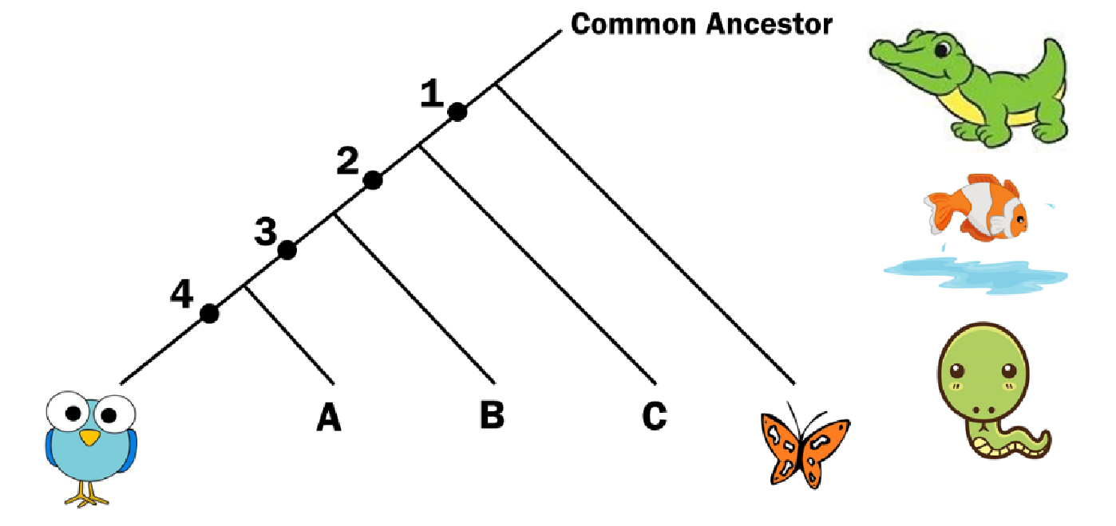

- What organism matches the letters in the phylogenetic tree above?
  - Birds
  - butterfly.
  - fish

- What are the 4 synapomorphies listed above?
  - Birds and dinosaurs and their common ancestors
- Birds and crocodiles and their common ancestors
- Birds and the common ancestors of dinosaurs and birds

Exercise 2:
While exploring a planet in another solar system we discovered the following 4 interesting alien species. After being told that species "A" is very primitive, we decided to use it as the outgroup. To understand the evolution of this species we bring YOU on to the project to build a phylogenetic tree.
Build a phylogenetic tree and include synapomorphies based on the images of the aliens below. There is also a character matrix, which just shows the presence (1) or absence (0) of a characteristic in an alien species. (2 pts)

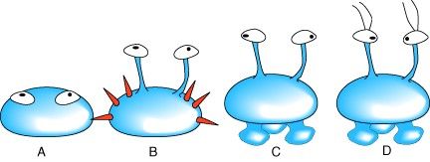

The following character matrix is scored:
Character A B C D
- Eyes present 1 1 1 1
- Spine present 0 1 0 0
- Eyes on stalks 0 1 1 1
- "Feet" present 0 0 1 1
- Antennae present 0 0 0 1
Shape/ Synapomorphy | Character/Trait
Club (Outgroup) | Presence of spines
Heart
Diamond
Spade
Synapomorphy 1
Synapomorphy 2
Synapomorphy 3
Synapomorphy 4

Exercise 3:
Simulate evolution starting with a 10 base ancestral DNA sequence. Roll the dice to determine which base will mutate and what type of mutation will occur. Fill in the DNA sequences for all the internal nodes and tips shown in this worksheet. PRINT AND
TURN IN SCAN OF EXERCISE 3(2 pts)
  - Each group will begin with the same 10-nucleotide ancestral sequence.
  - For every million years of time that passes, you will introduce 1 mutation.
  - The 10-sided dice will determine which nucleotide gets the mutation.
  - The 4-sided dice will determine what type of mutation occurs.
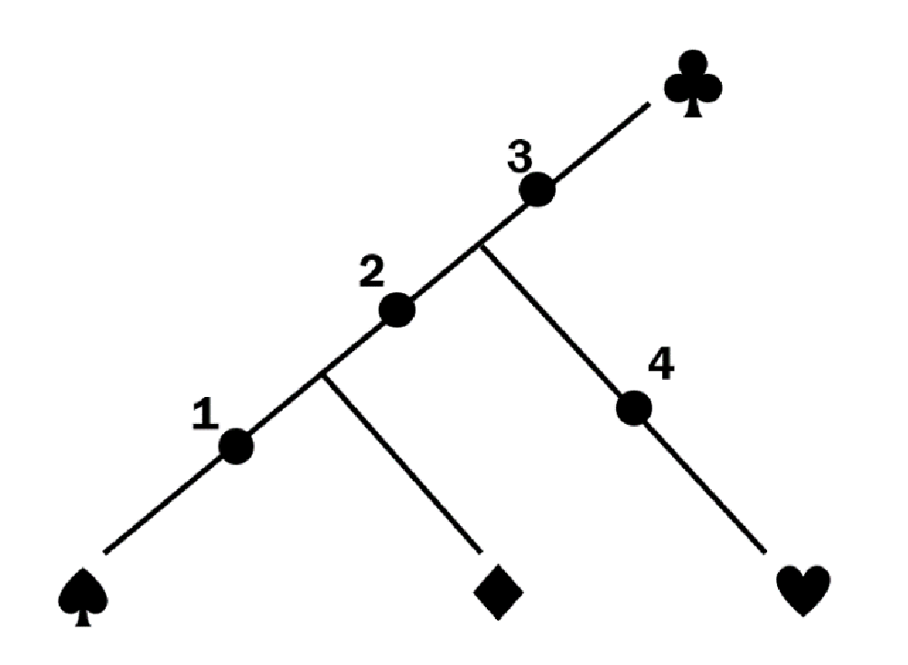
The ancestral DNA sequence will be:

1 | 2 | 3 | 4 | 5 | 6 | 7 | 8 | 9 | 10
A | T | C | T | G | C | G | G | A | T
From there, you will begin to simulation the process of evolution by rolling dice. You can find dice to roll by googling “roll dice.”
To begin, for ancestral node 1, you will “mutate” one of the nucleotide base pairs according to the numbers rolled. The 10-sided dice will tell you what base to change and the 4-sided dice will tell you what the new base will be. You will use the table below to determine the new base.
Dice | New Base
1 | A
2 | C
3 | G
4 | T
Let’s say you roll the roll below:
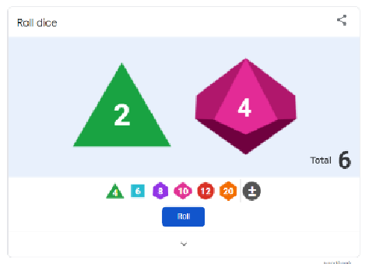
The 4 means the 4th base will change and the 2 means that the new base will be “C”.
The Ancestral Node 1 will then be:

1 | 2 | 3 | 4 | 5 | 6 | 7 | 8 | 9 | 10

A | T | C | C | G | C | G | G | A | T
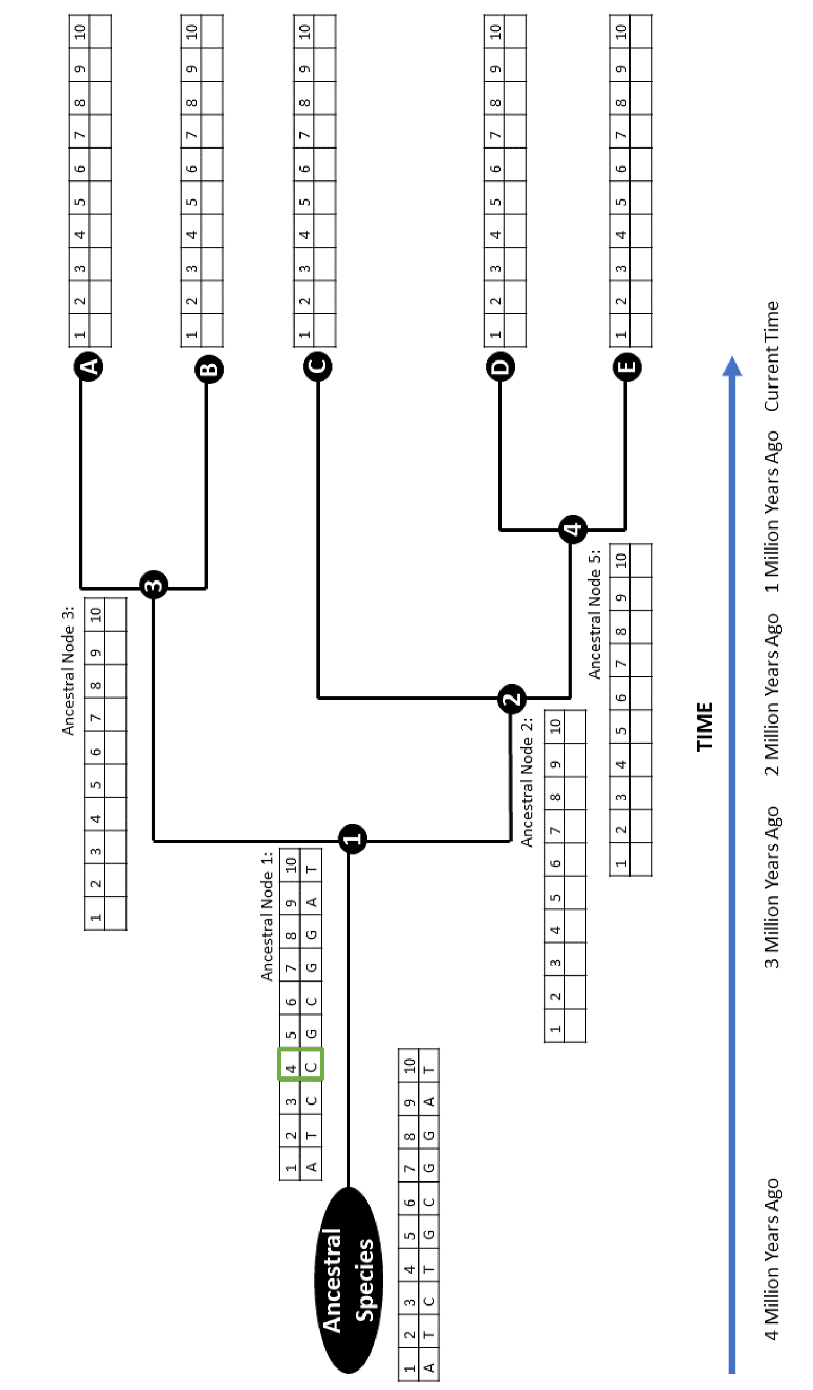



1 | 2 | 3 | 4 | 5 | 6 | 7 | 8 | 9 | 10
A | T | C | T | G | C | G | G | A | T

There will be a genetic change in the 10th base
A | T | C | T | G | C | G | G | A | A

