Pre-Lab Questions
- What are chromosomes made of? The chromosomes are made up of chromatids which comprise DNA molecules.
- Research the differences between mitosis and binary fission. Identify at least one difference, and explain why it is significant. Mitosis takes place in Eukaryotic cells while binary fission takes place in Prokaryotic cells and some in unicellular eukaryotic cells. In eukaryotes, DNA is present than prokaryotes, which requires more regulation. DNA replication and its segregation cannot occur simultaneously in eukaryotes whereas in Prokaryotes it occurs simultaneously during the binary fission. Hence prokaryotes take lesser time for cell division than eukaryotes.

- Cancer is a disease related to uncontrolled cell division. Investigate two known causes for these rapidly dividing cells and use this knowledge to invent a drug that would inhibit the growth of cancer cells.
A: gain of function in proto-oncogene: these are genes involved in regulating proliferation cell growth due to a mutation in DNA.P roto-oncogenes gets converted into cellular oncogenes, this occurs when genes duplication and translocation of proto-oncogene are active. By this, when the involved cells have a gain of function mutation, they initiate a phase of external growth factor signal, and cells will undergo cell division, which leads to cancer.
B: loss of function in the tumor suppressor gene, which suppresses tumor formation, when they lose function on both alleles, they stop suppressing tumor, hence resulting in uncontrolled cell division.

Experiment 1: Observation of Mitosis in a Plant Cell

Result Tables
Table 1: Mitosis Predictions
Predictions | OOOMMMM
Supporting Evidence

Table 2: Mitosis Data
Stage | Number of Cells in Stage | Total Number of Cells | Calculated % of Time Spent in Each Stage
Interphase | 26 | 65 | 40
Prophase | 11 | 65 | 17
Metaphase | 5 | 65 | 17
Anaphase | 6 | 65 | 9
Telophase | 17 | 65 | 26
Cytokinesis |  |  | N|A

Table 3: Stage Drawings
Cell Stage | Drawing
Interphase
Prophase
Metaphase
Anaphase
Telophase
Cytokinesis

Post-Lab Questions
- Label the arrows in the slide image below with the appropriate stage of the cell cycle.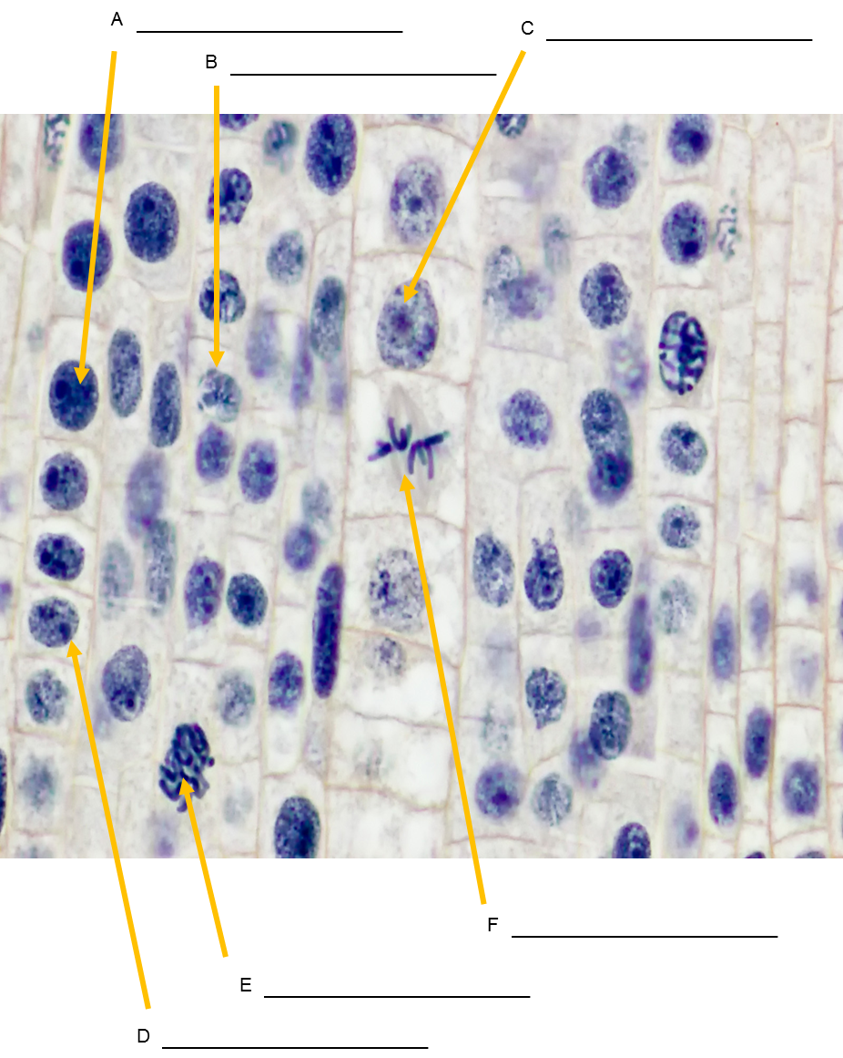
A:Anaphase
B: Prophase
C: Cytokinesis
D:Interphase
E: metaphase
F: telophase
- In what stage were most of the onion root tip cells in? Based on what you know about cell cycle division, what does this imply about the life span of a cell? In the interphase stage, some cells may take longer to grow while others take a shorter period due to availability of nutrients, e.g., nitrogen which speeds up its evolution.
- Were there any stages of the cell cycle that you did not observe? How can you explain this using evidence from the cell cycle? Cytokinesis
- As a cell grows, what happens to its surface area to volume ratio? (Hint: Think of a balloon being blown up). How does this ratio change concerning cell division? The surface area to its volume ratio decrease. This is because the volume of the cell increases at a greater rate than the surface that surrounds the cell.
- What is the function of mitosis in a cell that is about to divide? The function of mitosis if for growth and replacement of worn-out cells.
- What would happen if mitosis were uncontrolled? It can become harmful by causing the growth of multiplied cells hence interfering with the normal functions.
- How accurate were your time predictions for each stage of the cell cycle? Most of my predictions were based on my data for each cell stage; Telophase was close to accurate while interphase was exactly the correct predicted; my prediction for prophase was the most inaccurate.
- Discuss one observation that you found interesting while looking at the onion root tip cells. The cells being enlarged in prophase stage, the nucleolus is no longer visible, the chromosomes appear shortened within the nucleus.

Experiment 2: Tracking Chromosomal DNA Movement Through Mitosis

Cell Cycle Division: Mitosis Beads Diagrams
Prophase: In this stage, cells start to break down structures and building others; the chromosomes start to condense.
Metaphase: Chromosomes align at the metaphase plate.
Anaphase: The sister chromatids separate from each other pulling on the opposite end of the cell.
Telophase: The chromosomes start to decondense and return to their normal form.
Cytokinesis: The division of the cytoplasm to form two new cell overlap within the final stage of mitosis.

Post-Lab Questions
- How many chromosomes did each of your daughter cells contain? Each daughter cell contains 46 chromosomes.
- Why is it important for each daughter cell to contain information identical to the parent cell? Because in mitosis, a cell divides to form two identical daughter cells which are important for the daughters to have a copy of every chromosome.
- How often do human skin cells divide? Why might that be? Compare this rate to how frequently human neurons divide. What do you notice? Skin cells go through division phase once a day, which means they undergo mitosis more frequently. The process is repeated to make the cycle complete. The neurons don't undergo division.
- Hypothesize what would happen if the sister chromatids did not split equally during anaphase of mitosis is that the daughter cell will not be identical hence causing mutation.

Experiment 3: The Importance of Cell Cycle Control

Data
1.Cell cycle can arrest and delay functions.
2.It repairs the damaged DNA .
3.it senses defects that occur during the process of DNA replication.
4.it controls the cycling of the cycle ensuring the cells enter the next phase when the previous one is complete.
5.To initiate and terminate chemical reactions in the cell cycle.

Post-Lab Questions
- Record your hypothesis from Step 1 in the Procedure section here. This aimed at helping to count the number of chromosomes, their pairs, their sizes, and the homologous chromosomes.
- What do your results indicate about cell cycle control? The cell cycle controls some protein processes, which triggers the advancement through the cell cycle.
- Suppose a person developed a mutation in a somatic cell that diminishes the performance of the body's natural cell cycle control proteins. This mutation resulted in cancer but was effectively treated with a cocktail of cancer-fighting techniques. Is it possible for this person's future children to inherit this cancer-causing mutation? Be specific when you explain why or why not. Yes, it is possible for that person's future children to inherit the mutation since cells that are already destroyed by cancer divides further even when there is a cocktail induced.

