Lab 11: Deuterostomes

In this lab, we will be using pictures included at the end of this week’s PowerPoint as well as some videos. Please complete this worksheet and turn in via Blackboard. Make sure to read Chapter 14: Deuterostomes in the lab manual (pgs. 99-107).
- There will be several drawings/sketches required in this lab. Please make sure to preview your document before submitting on Blackboard to ensure it is still legible. (Hint: You can export your Microsoft Word file as a PDF or save your completed document as a PDF and submit the assignment as a PDF and this should eliminate any overlapping of pictures.)

Investigation 1: Echinoderm Embryology and Diversity
- Examine these pictures of sea star development. Circle the blastula stage and the middle gastrula stage. What is the difference between the two?

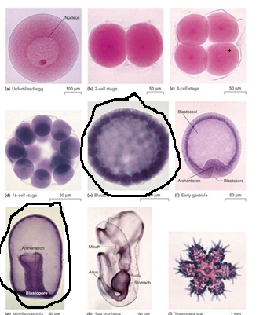

blastula forms immediately after fertilization while the middle gastrula stage forms after blastula.
- Examine the pictures of different echinoderms below. What kind of symmetry do they have? Draw the axes of symmetry on one of the pictures to help you answer this question.

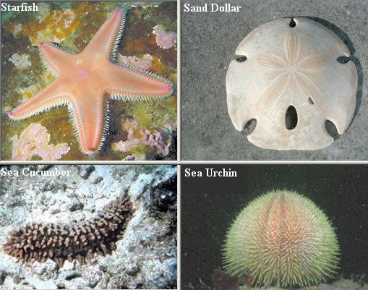
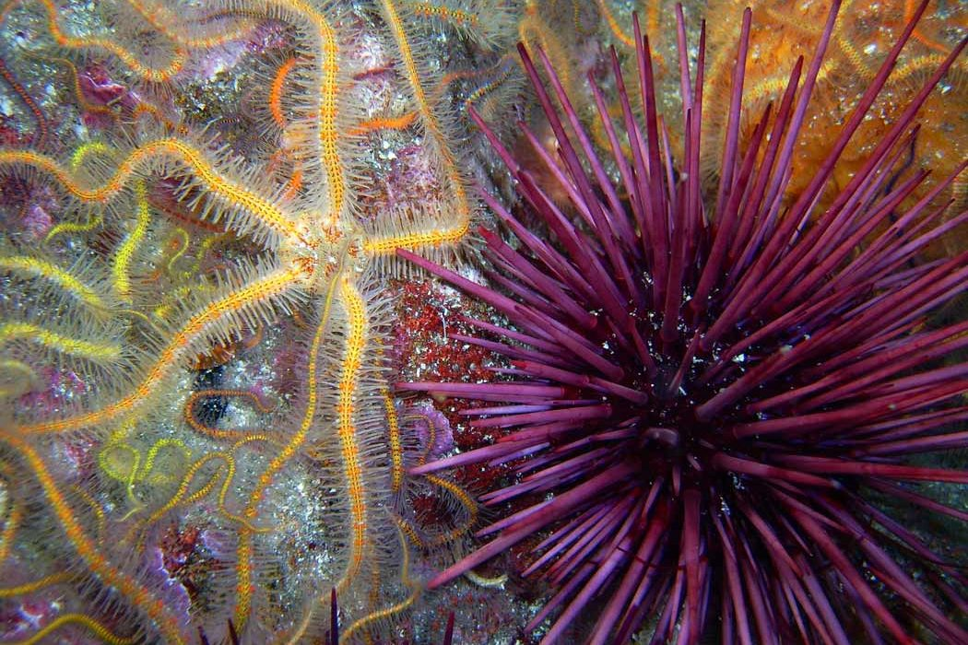
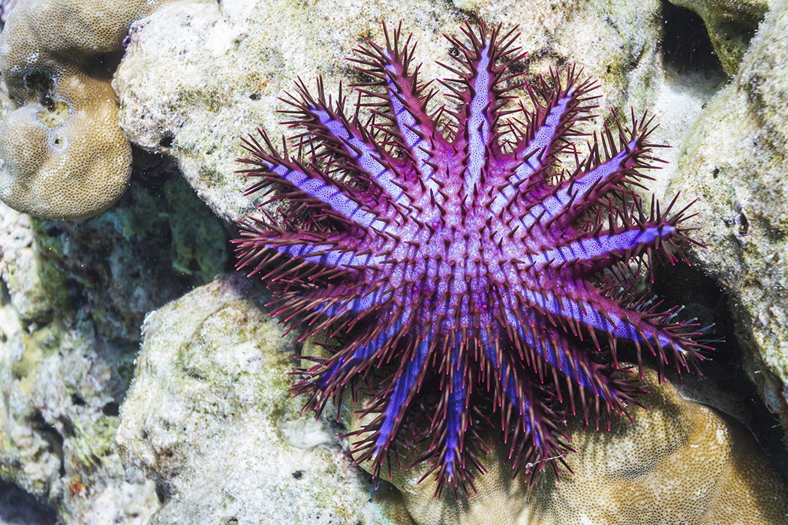

1. Types of symmetry: They have a bilateral symmetry
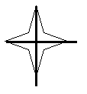

Investigation 2: Invertebrate Chordates
- Examine these images of Amphioxus and compare them to Figure 14.2 in your lab manuals. Do you see segmentation? Where? What are the four chordate characteristics present in Amphioxus?

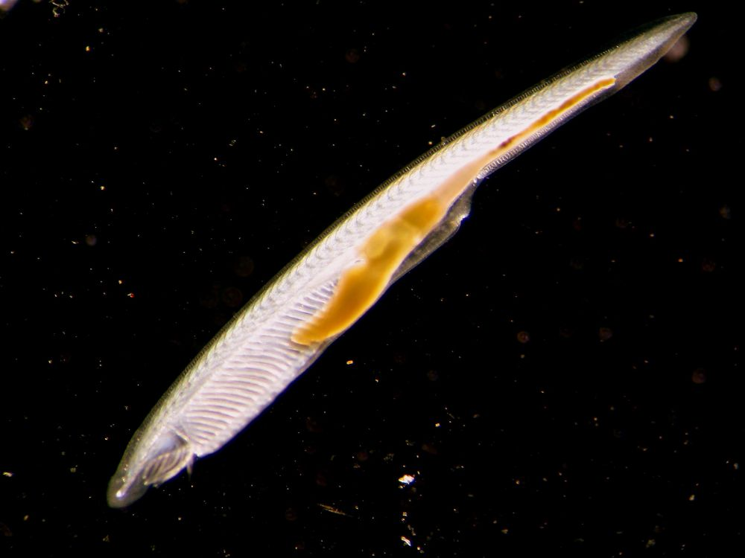
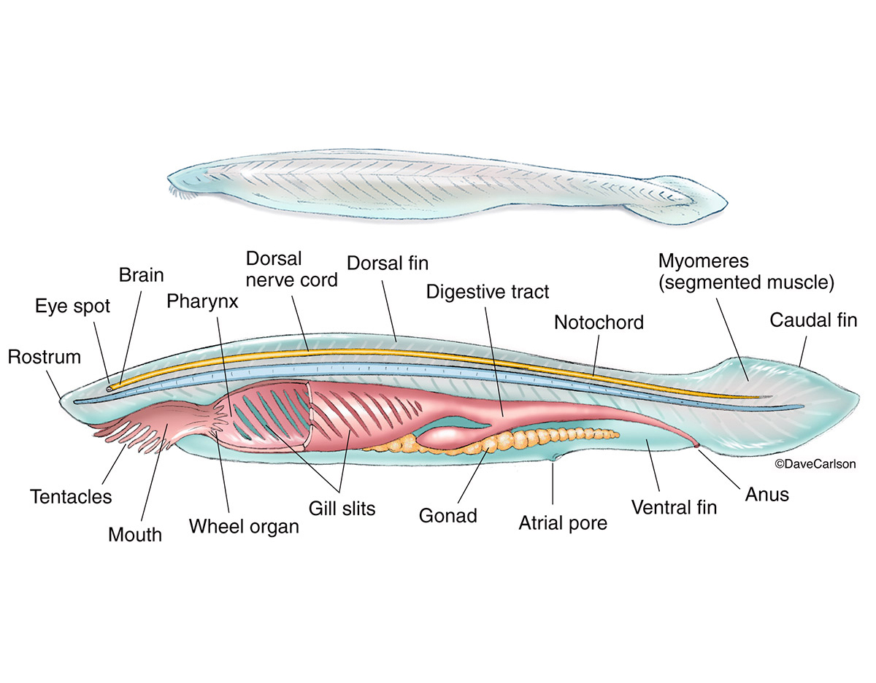
Yes there is segmentation in the hind brain which generates rhombomeres.

Presence of the post anal tail
The presence of the dorsal hollow nerve cord
Presence of the pharyngeal slits
Notochord seen

- Observe this image of a lancelet cross-section. Locate and label the nerve cord and notochord. You can use Figure 14.2 for help.

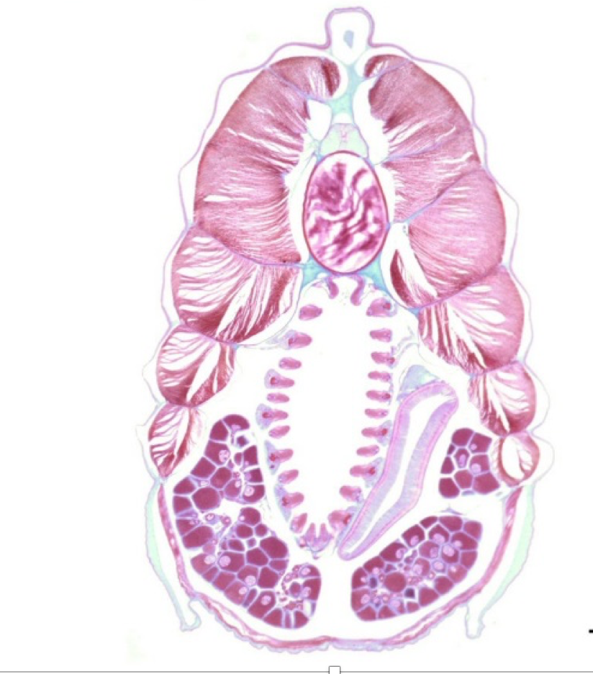
notochord
Nerve chord

Investigation 3: Perch Dissection
- a. Use the following links to study Perch anatomy and Perch dissection.
https://www.youtube.com/watch?v=yCfsrs6Y8M4
https://www.youtube.com/watch?v=r2u5roIr6x0
Draw a diagram of the exterior of the fish, labeling the fins, operculum, and lateral line.

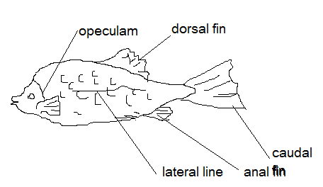

b. Next, draw the interior of the fish, including the gills and digestive system. Use Figure 14.3 to help you with this.
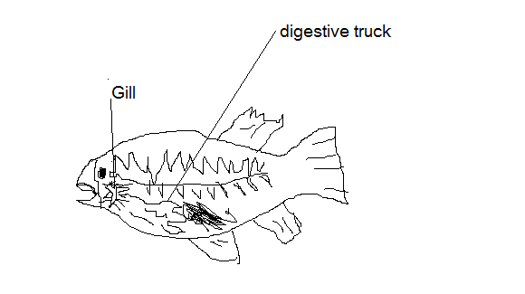

Investigation 4: Survey of Terrestrial Vertebrates
- Examine these vertebrate forelimbs. Count the number of bones in each segment. Do they all follow the same pattern? Do some of the bones look fused in any of the limbs? Explain which ones in which animals?

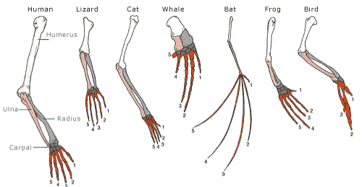

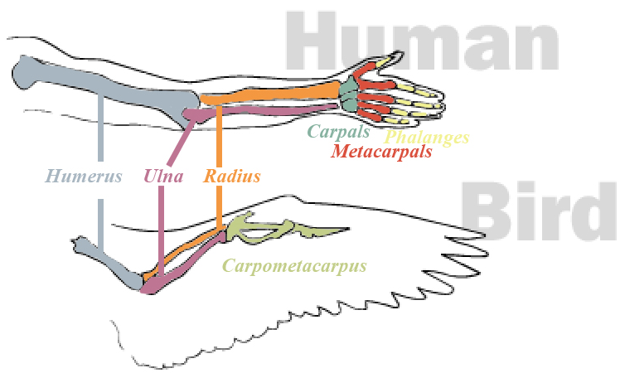

They have have 1 long borne, then 2 that extend to the next joint, then the enf of the limb have 5 sets of born.
All of the above follow the same pattern of 1-2-5
The bird has group of fused bones

- Observe these images of skins from different vertebrates. Are there any similarities between the avian feathers and reptile scales? Explain. Observe the feathers, scales, and fur. How does the structure relate to the function?

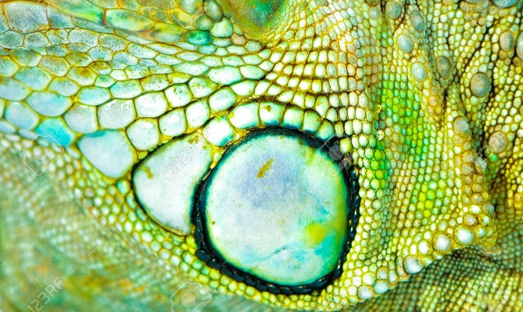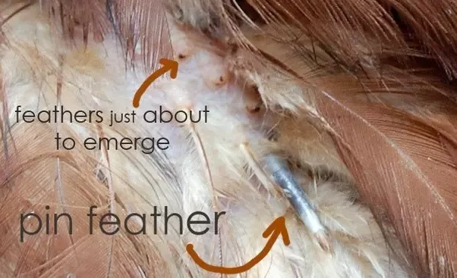
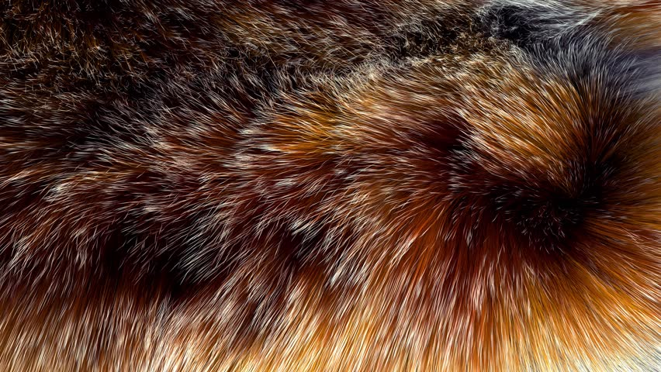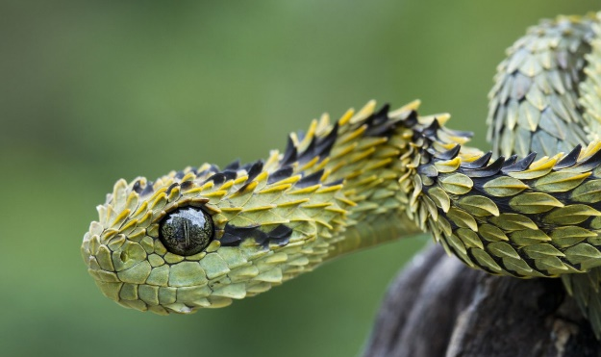
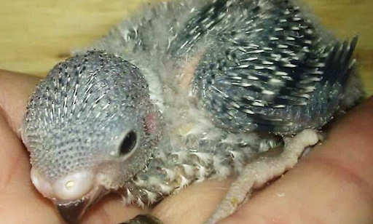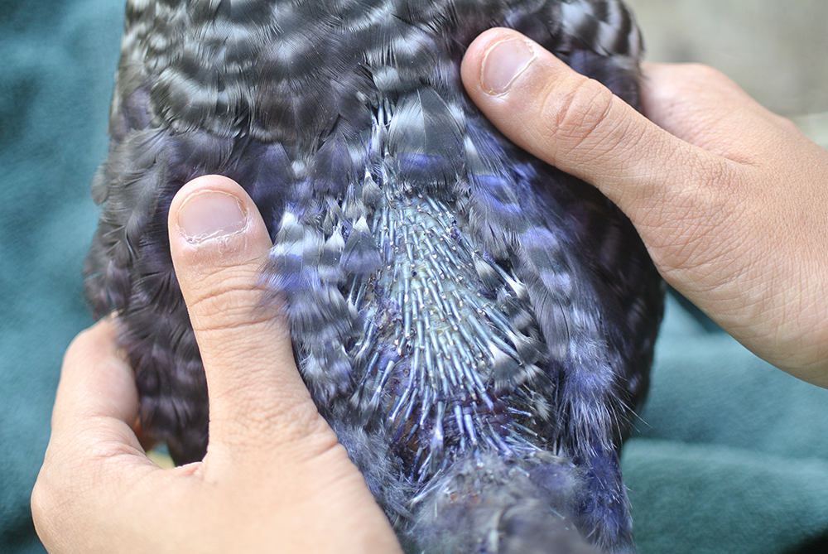
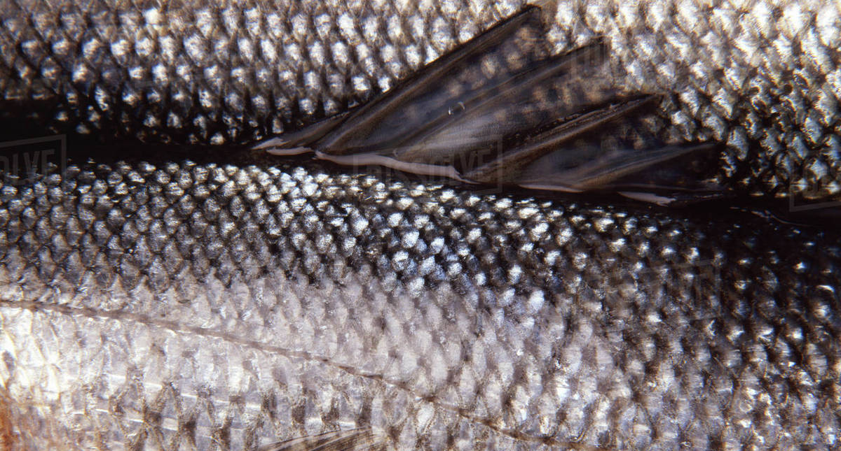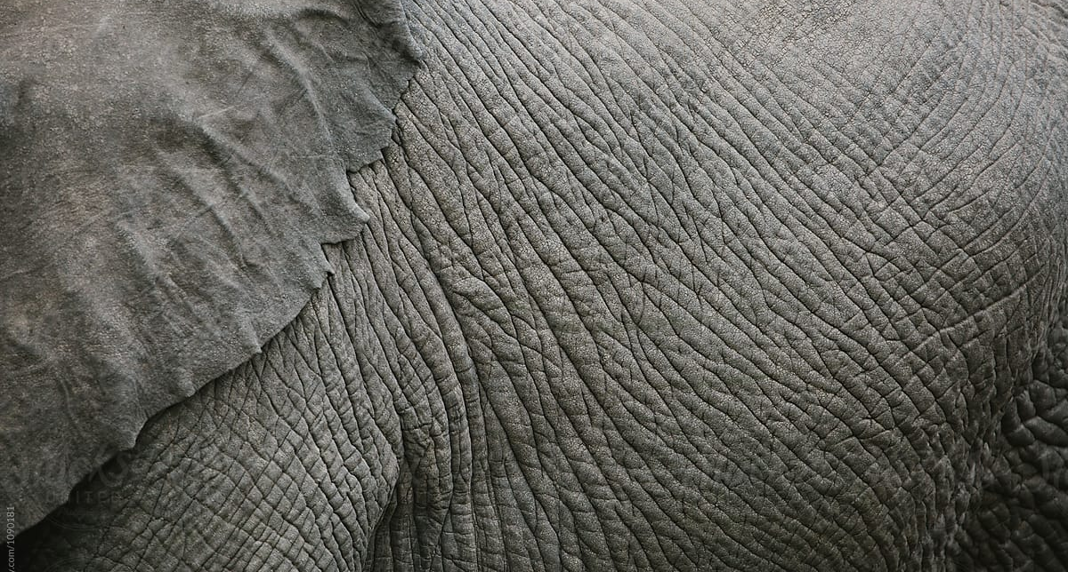
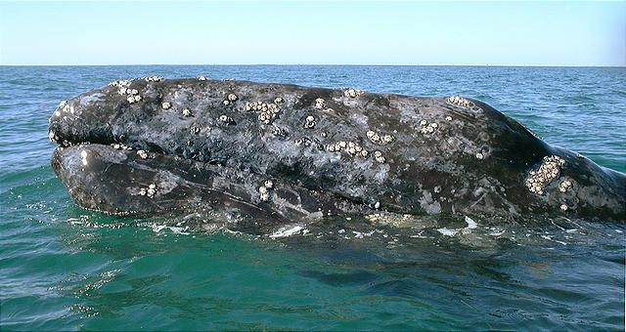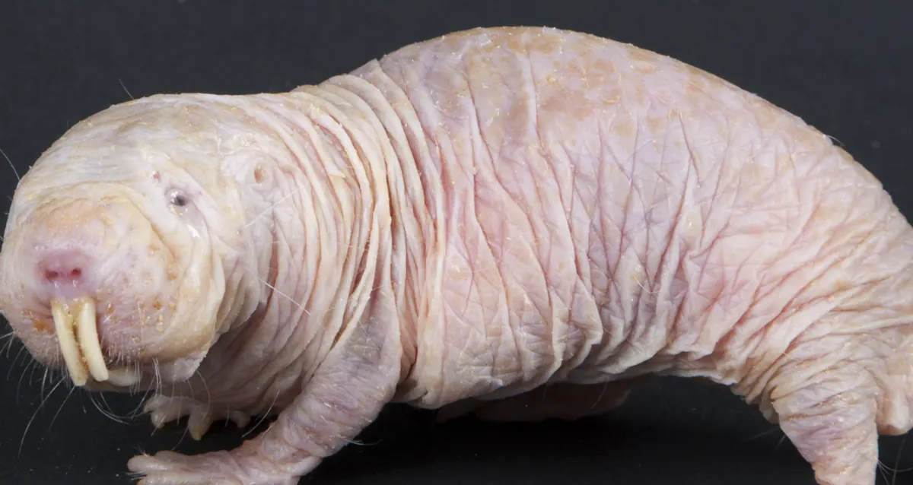
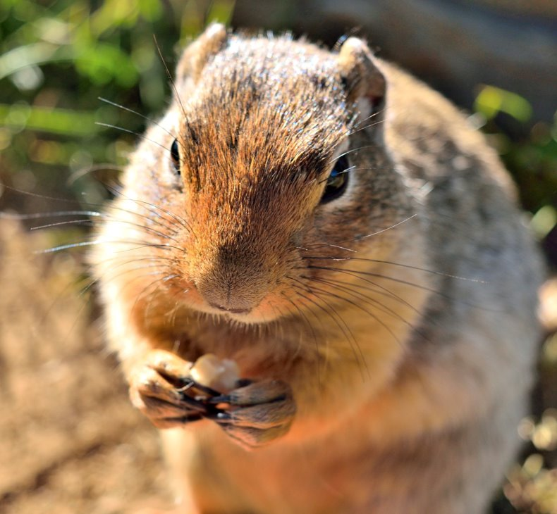

The skin surface is curved with hair which forms a thick layer called fur.
The fur on the body surface is for waterproofing ,protection the undercoat and skin from external factors.
Presence of mucus on the scales for easy movement of the fish in water
And also protects against predators.
The scales are overlapping.
A thin and moist skin for gaseous exchange
Presence of tough and leathery skin in elephant.
Similarities between scales and feathers: They are both overlapping over each other.
They both play a protective role to internal parts of the body

