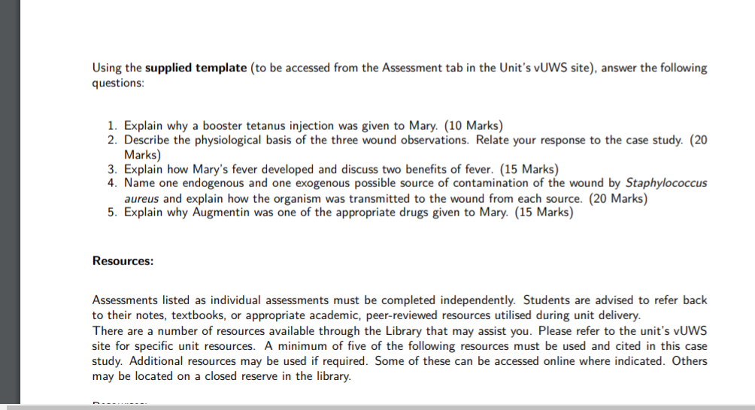
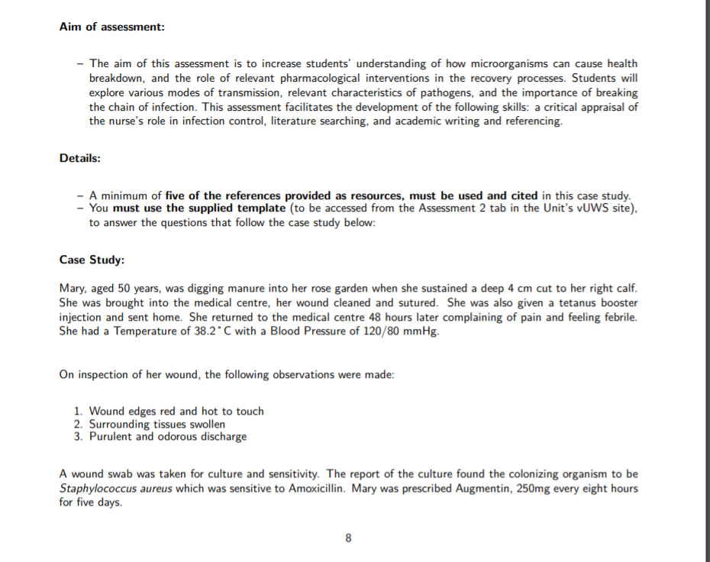

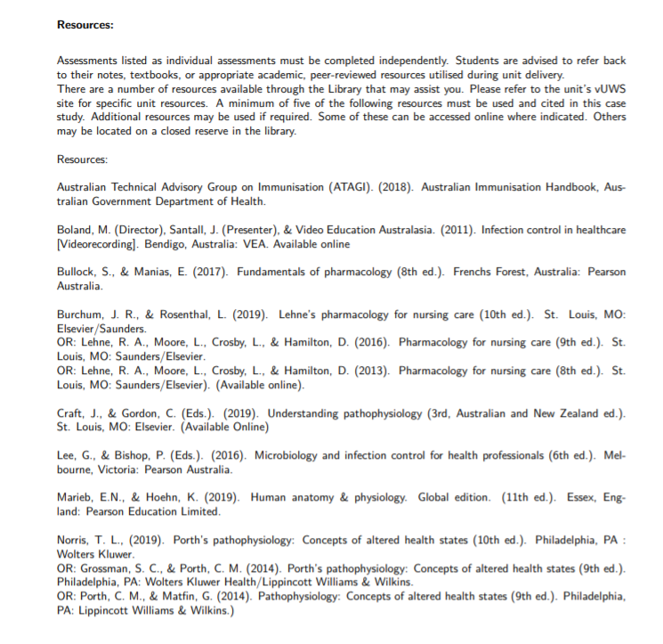

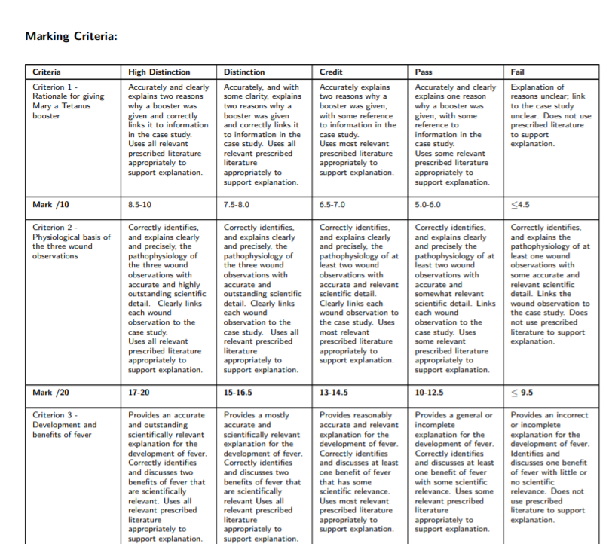

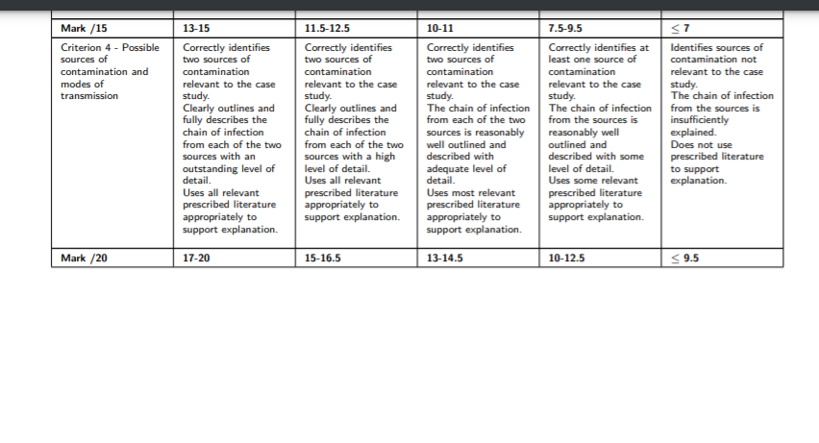

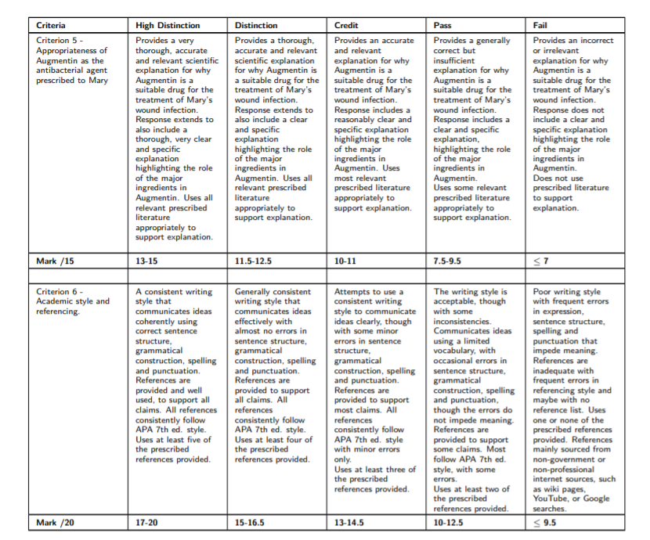

This template must be used to answer the case study. (Please type your answers within the box underneath each question)

Student name (LAST NAME first name):
Student number:
Campus:
Tutorial session (time and room no.):
Tutor’s name:
- Rationale for giving Mary a tetanus booster (Total: 10 marks)
  - What is the organism that causes tetanus and why is it of concern in this situation?
(5 marks)
Tetanus fact sheet

  - Discuss the rationale for giving Mary the tetanus booster. (5 marks)
Australian immunisation handbook

- Physiological basis of the three wound observations (Total: 20 marks)
Marieb & Hoehn p. 816 – 819; Lee & Bishop p. 190 – 195; Craft, Gordon, Huether, McCance, Brashers & Rote Chapter 13
  - For each of the three wound observations indicate, and provide a rationale, as to whether it is a sign or a symptom. (2 marks)
  - Name and discuss the physiological basis of the first observation. (6 marks)
  - Name and discuss the physiological basis of the second observation. (6 marks)
  - Name and discuss the physiological basis of the third observation. (6 marks)

- Development and benefits of fever (Total:15 marks).

Lee & Bishop p. 196-197; Craft, Gordon, Huether, McCance, Brashers & Rote Chapter 13; Marieb & Hoehn, p. 821 - 822
  - How did Mary’s fever develop? (9 marks)
  - Discuss two ways in which fever is beneficial. (6 marks)
- Possible sources of contamination and modes of transmission (Total: 20 marks)
Lee & Bishop p. 140-144; Boland, M. (video)
  - Name one endogenous source of contamination and discuss the mode of transmission from the source to the new host. (10 marks)
  - Name one exogenous source of contamination and discuss the mode of transmission from the source to the new host. (10 marks)
- Appropriateness of Augmentin as the antibacterial agent prescribed to Mary (Total: 15 marks)

Lee & Bishop p.266-269, p.279-283; Lehne (8th edition) p.1059-60; p.1065-1067; Bullock & Manias 8th Edition p.4, p.847-848,
  - Given the colonizing organism was Staphylococcus aureus, discuss why Augmentin is an appropriate prescription? (6 marks)
  - Describe the added benefits that Augmentin provides, with reference to the role of the major ingredients in Augmentin. (9 marks)
- Presentation (Total: 20 marks)
  - Referencing in-text and in reference list conforms to APA 7th ed. referencing style.
  - Critique supported by relevant literature as prescribed.
  - Correct sentence structure, paragraph, grammatical construction, spelling, punctuation, and coherent presentation.

