Prediction and Occurrence of Blizzard
Student Name
Institution Name

Table of Contents
Abstract 2
Prediction and Occurrence of Blizzard 3
1.1 Introduction 3
2.0 Data Collection and Management 6
3.0 Blizzard Indicators 7
4.0 Methodology 8
5.0 Data Analyses 8
6.0 Discussion 9
7.0 Conclusion 10

Abstract
Natural disasters are among the great potential causes of total damage in many continents. As such, people have engaged in research science and technology that tries to predict occurrence of such disasters as well as understand measures that can be used to quantify them as well as reduce their damage. This research employs science and technology to reveal methods used to predict the occurrence of blizzard as well as analyze a case study where blizzard occurred and measures are taken to predict and quantify it. Meteorological methods such as climate measurement, use of balloon satellites and radars have been used to predict occurrence of blizzards. Analyses of the 2015 blizzard occurrence in the United States has also been used to engage other methods of predictions such as scaling, the area of displacement and real-time twitter information. In this case, the number of displaced regions has been represented by numbers and six units of measurement taken before storm, during the storm and after the storm.

Prediction and Occurrence of Blizzard

1.1 Introduction
In many continents, occurrence of natural disasters has been a common issue that occurs untimely leading to huge losses such as building damage, displacement of people, financial and environmental damage. As much as this disaster are untimely, their huge impact has developed concern and people has engaged science and technology that tries to predict their occurrence such that proper mitigation can be done in a timely manner (Akasah, 2015). Besides, research is also employed to have more understanding of the natural disaster phenomena. For example, there is an undergoing research that seeks to explore on causes of such disasters both naturally and through human physical activities. For instance, research indicates that natural happenstances, such as volcanic eruptions, landslides, Tsunamis, liquefactions predispose such phenomena apparently human activities such as mining, ocean explosive and expansion of cities is also a potential cause of such happenstances (Bromet, 2016).
Blizzard is among the natural disasters happening in many countries today. It is a severe snowstorm that is always accompanied by high winds. Since it is a disaster-prone to destruction, there are many technologies emerging for the prediction of such disasters. Studies reveal that prediction and forecast of the atmosphere is similar to human prognosis as such, it requires a preliminary diagnosis before the future can be predicted. There are many scientific methods and technology that can be used to forecasts storms. For example, Agencies such as storm prediction center deals with study of climatology to understand or to measure the current state of climate condition as well as predict happenstance of blizzards (Doruta, 2016). For example, studying thunderstorms hails and tornadoes entail study of how they change as well as referring from historical records of their occurrence. Carbin one of the SPC meteorological expert reveals that the pattern of summer and winter is one of the methods they use to predict occurrence of risks associated with blizzards. Studies indicate that in south and middle regions of United States great risks of blizzards occurs during spring and early times of the summer.
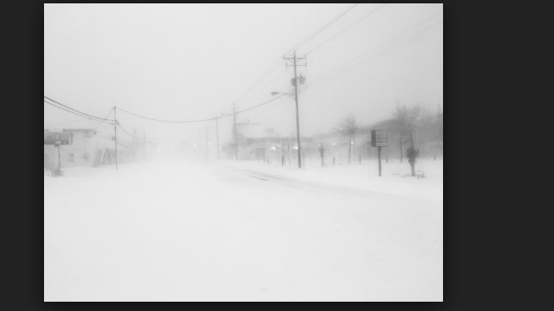
Figure 1: Blizzard occurrence
Meteorological research indicates that during this time, air that is moist and warm left after the winter cyclone meets with the wind from the jet stream and as a result, high winds tornadoes and dangerous hail are created. Having known this, forecasters can be Able to predict the storm system of the year. As such, predictions involve measurement of current weather conditions such as air pressure temperature and wind speed (Lunzeng, 2008). This information is combined with that of weather balloons that are positioned at various heights in the atmosphere to measure air conditions. Apparently, they also combine this information with that of satellites placed in the atmosphere to measure moisture and position of clouds. Such a combination enables the meteorologist to have an accurate data collection. Since this approach is linked to technology, the weather and satellite data collected is fed into a numerical simulation run by a supercomputer. These computers have abilities to crunch numbers and output a model that indicates the atmosphere behavior (Shannon, 2015). The output of the model is compared with manual weather observations and if it matches, it becomes a model for making blizzard predictions.
Besides balloons and simulators, there are other electronic gadgets that can be used to monitor the occurrence of the blizzards. One of this system is a radar. A radar is a system that detects the direction and presence of phenomena by sending signal waves that are reflected back for interpretation. It happens that when a storm is brewing, radar energy is beamed on the cloud’s precipitation. The nature of the reflected signal indicates the density of the snow, hail and moisture of the storm system (Dorruta, 2016). Apparently, the frequency of the signal reveals to the scientist the direction of the storm. That is whether the storm is moving towards the radar or away from the radar. It happens that if the storm is in a rotating mode, it could lead into a tornado, however, this kind of blizzard need to be forecasted early in advance. Geostationary operational environmental satellites are techniques used to measure the occurrence of hurricanes. In this case, hurricanes are type of blizzards that come as a result of violent winds (GOES) are used to monitor the eastern and western parts of United States regions (Shannon, 2015). Dvorak technique is another method used to measure the occurrence of blizzards. Hurricane hunters are also used to detect and measure the occurrence of hurricane storms like blizzards. Similar to the satellite balloons the ejected plane gathers information related to humidity, temperature and wind speed. To predict the damage, the forecasters, utilize the gathered data to categorize, blizzards in the scale of 1 to 5. This is a rating that quantifies the speed of the storm, its potential to cause damage, and creation of a storm surge. The scale of 1 to 5 informs reveals that scale one predicts occurrence of a dangerous wind that can cause damage. Scale five suggest that a catastrophic damage is likely to occur. Therefore, evacuation can be made in advance.

2.0 Data Collection and Management
To quantify the effects, predictions and occurrence of the blizzard storm, the statistics for 2015 winter storm were analyzed. It happened that in this year, a severe storm occurred during winter in the northeastern part of United States. The impact of this storm was large such that it was declared by the federal management of emergency cases. Six of the United States were affected by this disaster. That is Rhode Island, New Hampshire, Massachusetts, Connecticut, New Jersey and Maine among others (Bromet, 2016). The hazard brought about heavy snow in New England that had a blizzard condition in the parts of Massachusetts and Rhode Island. This blizzard began on 29th January and to the early morning of 27th. Spatial box coordinates were used to narrow the area to cater for statewide impact and population distribution. Longitude were read from -73.508 to 69.859) while Latitudes were read from 41.187 to 42.887. It was also realized that in this area storm duration occurred from 26th January to 28th January. The snow that fell on the affected area had a height of 2 to three feet of snow which was accompanied by severe winds that had a gust of over 70 mph. Regional snowfall index is used to estimate the impacts of blizzards occurring in a given region (Lunzeng, 2008). With respect to the blizzard that occurred in this region, the RSI index was 6.158. According to this value, this figure shows that the blizzard occurrence was a major storm. As a result, many activities such as driving, air crafts operations, schools and weather research were all banned for the two-day occurrence of the storm. Additional data was obtained from geotags that included twits obtained from API streaming. Real-time data tweet collection was most preferred in order to enhance efficiency as well as comply with Twitter's term of service. For every 1.24% of the API streaming, 1% of the tweets were collected. The collection database offers 95% accuracy that is represented by 7.8 meters (Akasah, 2015). The five per cent error is assumed to have been caused by devoice factors and fluctuation of the weather changes. To enhance more accuracy, the data were collected four days before the storm week, during the storm week and after the storm week. The total number of tweets made on this day were 2,691,346. For a duration of 42 days with a daily data volume of 64,080 tweets.

3.0 Blizzard Indicators
To quantify the presence of blizzards in the affected states, analyses of daily displacements was considered where the daily trajectory of every user was calculated and analyzed. For a person to be considered a victim of displacement, the distance between two consecutive geolocations was considered for a person displaced within a day. To enhance accuracy, displacement of at least 8 meters was considered. Six of the 8-meter parameters were taken as samples of population. As a result of this analyses, the quantified data varied between 12576 – 70,565. The percentage bearing the six sets of displacement. Sets taken during storm week and the pre-storm week was taken plotted and computed.
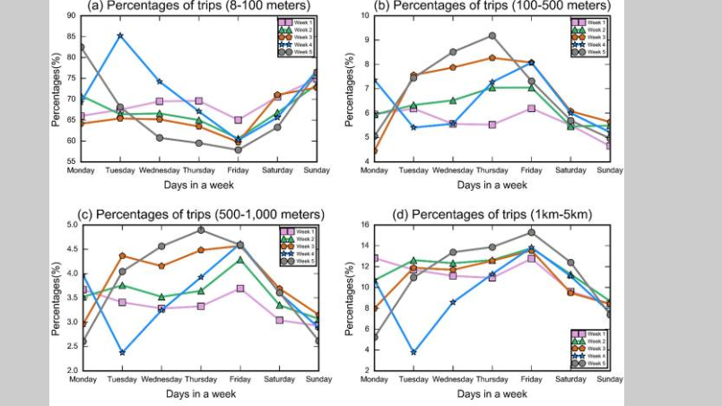
Figure 2: Weekly sets of 8-meter displacement

4.0 Methodology
This research used both quantitative methods to analyze data and simulation modelling. It had been found that scientist quantifies parameters like air pressure, air temperature and wind speed to measure the current condition of the weather as well as predict future occurrence of the blizzard. Apparently, the data obtained is then passed through a simulation process that outputs a model used to predict the occurrence of the blizzard disaster. Additionally, the research uses tabulation and graphic to reveal the trend of storm occurrence during prestorm storm week and end of storm session. This relationship involves the percentage of displacement in order to create the relationship between variables as indicated in the table below.
Table 1: Results
Condition before Pre-storm period | Condition during storm period | Condition after storm period | Tweets
Strength of radar signal s change | Over 1000,000 people displaced | Displacement continues at a slower rate | 1,500,000
8-meter displacement set | Six states displaced | 12576-70565 people displaced | 2000,000

5.0 Data Analyses
From the above data, it can be seen that before blizzard occurrence there was a weather forecast that predicted the occurrence of a storm. Change of strength of the radar signal transmitted in the atmosphere indicated a change of climate condition. This predicted the occurrence of a storm in the United States that would hit a number of states in the year 2015. Caution was given before the storm could happen. During the snowfall accompanied by a blizzard over one million people were displaced and the blizzard slowed the rate of displacement after the storm. At this time real twitter handle had 1000,000 tweets from weather experts that were giving data about the storm occurrence. Four weeks before displacement the 8-meter geolocation represented the six states displaced during the storm. After the storm, over 12576 people were displaced and the twitter hand had 2000,000 tweets revealing about the condition of the storm.

6.0 Discussion
From this research, it is evident that natural disasters such as hurricanes and blizzards are potential elements of massive destruction. As such, science and technology has engaged a number of methodologies to quantify and predict the occurrence of such disasters. This research has engaged a combination of predictions and analyses to analyze and predict the occurrence of blizzards. Following the winter storm that happened in the United States in the year 2015, the research has used empirical geo-temporal data to predict and analyze the occurrence of that storm before, during and after the storm. Apparently, the research has engaged the use of simulation models to quantify the condition of the atmosphere that can be used to predict the occurrence of a storm. Scaling theory of 1 to five has also been used to categorize the nature of the disaster likely to occur in a region. Regions under scale one has been categorized as areas of dangerous damage while regions of scale five have been categorized as catastrophic regions.
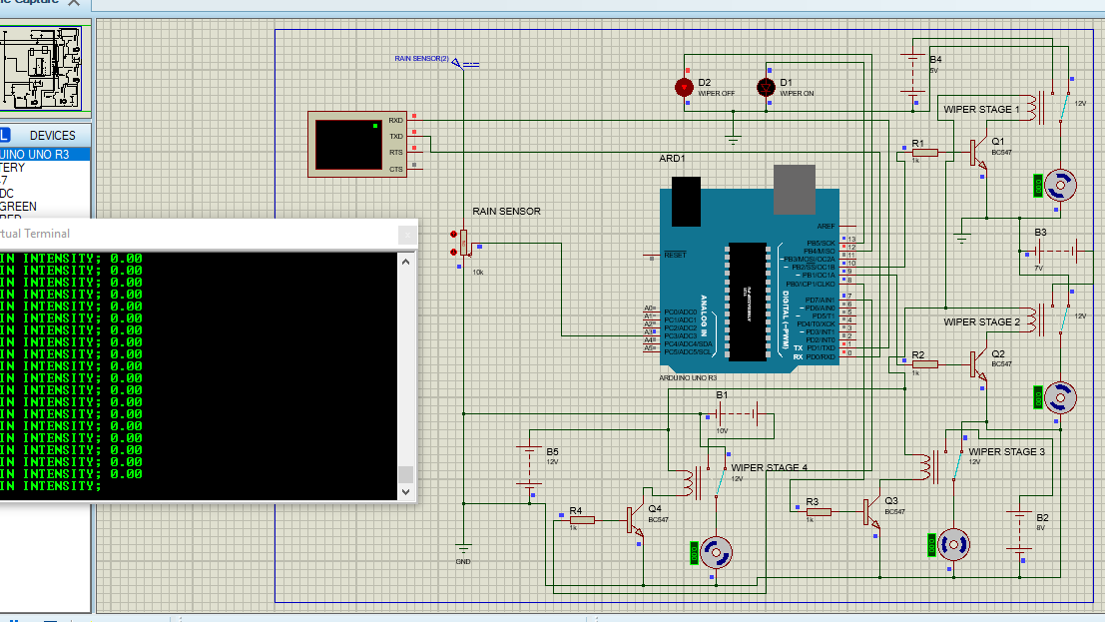
Figure 3:Simulation model for a radar predictor

7.0 Conclusion
To conclude, it has been found that there are different ways that natural disasters such as blizzards and hurricanes can be quantified. This research has utilized science and technology to quantify predictions of blizzard occurrence as well as analyzing the storm disaster that occurred in the United States of America in the year 2015. Theories and analyses applied in this research can be used to predict the future occurrence of blizzards and therefore induce necessary mitigations. Technology such as radar systems has been found to be very accurate in terms of predicting the occurrence of a blizzard. However, more information from satellite balloons and field studies has been incorporated to fully quantify occurrence and damage of blizzards.

Reference
Akasah, Z. A., & Doraisamy, S. V. (2015). Malaysia flood: impacts and factors contributing towards the restoration of damages. J. Sci. Res. Dev., 2(14), 53-59.
Bromet, E., & Dew, M. A. (2016. Review of psychiatric epidemiologic research on disasters. Epidemiologic Reviews, 17(1), 113-119.
Doruţa, C. (2016). Early Blizzard Phenomena in Southeastern Romania. Case Study: 2–3 November 1980. Present Environment and Sustainable Development, 10(1), 105-116.
Flora, S. D. (2015). tornadoes of the United States (Vol. 194). Norman: University of Oklahoma Press.
Lunzeng, X. F. Q. G. Y. (2008). Economical Assessment of the Lose's Value Brought by the Blizzard and Frozen Disasters to the Forest in the Ecosystem Services——Take the Disaster Forest of Fujian Province as the Example [J]. Scientia Silvae Sinicae, 11, 036.
Shannon, H. D., & Motha, R. P. (2015). Managing weather and climate risks to agriculture in North America, Central America and the Caribbean. Weather and Climate Extremes, 10, 50-56.

