Brain Activation during speech and non speech in preschoolers who stutter
Students Name
Institution Affiliation
Date of Submission

Abstract
We conducted a speech-related to the nervous system of arousal of preschool-age children, thus discovering that some stutter and others who do not stutter. The association of children's proclivity who end up experiencing negative emotions, thus leading to children's self-reported attitude to speaking. Electrodermal activity measures were collected from 20 preschool-age children, and they engaged in doing a nonword repetition task. Children's who had a proclivity to experience negative emotions during the practice were to be assessed keenly then a parent report was to be made. Children's communication attitude was also evaluated, and a self-report questionnaire was made regarding the same matter. We had to conduct this study to investigate what are the significant potential differences in levels of sympathetic arousal while in the performance of speech and non-speech tasks between the two kinds of children
While conducting it in a challenging nonword repetition task, the preschool-age CWS have a higher sympathetic arousal level compared to CWNS. Although CWS rating was done by their caregivers and proposed that they are more fearful and prone to sadness easily, this kind of children's have tendency to experience stronger and more frequent negative emotions which are not associated with their sympathetic arousal level during the speaking. Lastly, since CWS have a more negative attitude during communication than CWNS, this is not directly related to their level of sympathetic arousal during the speaking. Our research suggests to us that age-appropriate social communication tasks are not inherently more stressful than for preschool-age CWS and are therefore not associated with state-related stress or being anxious that is often reported for adults who stutter. Speaking tasks that place a higher demand level on children's cognitive-linguistic system can also be more taxing and challenging to preschool CWS than CWNS, after that leading to a higher level of arousal.
Introduction
Stuttering is a problem that arises, making it difficult for individuals when speaking. It mostly affects small children. When a study was conducted, it showed that stutter has increased in number in preschoolers mainly affecting the right and left auditory part of the brain of the affected children. To the affected individuals, this can be evidenced by the continuous repetition of words during speech delivery. Stutters are also aware of the terms or syllables which interrupts them during communication making them not to have a constant flow while speaking. Due to that, these individuals develop wired behaviour like trembling or blinking eyes while speaking.
Due to this continued abnormality, one may change the pattern of words speech because of the repeated pulses when speaking (Chang et al. 2009). While children are too young, they can start stuttering because they are training themselves on how to speak. This is majorly caused by the fact that it is excellent interaction between these small kinds of different stages of growth. Some may be trying to ape what others say, thus leading to stuttering at this stage. Research has also shown that boys are more prone to stutter than girls at a high rate (Garnett et al. 2019). When also people are not speaking fluently and are stammering while communicating can also be referred to as stuttering. There is also a tremendous structural brain difference between individuals who stutter, and those do not like the results are given out by researchers.
The term stuttering can also be as referred to as involuntary sound repetition of words. This is so because the stutters do not do it voluntarily, but because it is an abnormality a one can not run away from it. Currently, in the whole world, approximately four times as many men as women stutter, encompassing more than half of the world's population (Smith & Weber 2016). When we tried to carry out the differences between preschoolers who stutter and those who do not we vividly, found that mostly on stutters can communicate in a more faster way and they are also easily understood, this encourages them to be more sharp and courageous and express without fear.
Stuttering partispants also a great problem while trying to make precise movements since there motor for sensosory controls are affected by this disorder.Different authors concluded that there is a great difference for stutters and those who do not in brain functioning.This is mainly due to difference in celebral blood flow thus making stutters to convert message slowly compared to non stutters.
Brains function differently at this region during speech production and also in planning process for speech and non speech vocal tract gesture. A research has also found that there is increased motor activation and decreased auditory activation during speech production for stutters compared to non stutters.
An experiment contucted found that functional arbnomalities would be greatly present during vocal tract gesture which majorly do not elicit stuttering. This therefore indicated that any difference in brain activation could not be the only result of stuttering.
Symptoms of stuttering
According to Kleinow (2018), a person who stutters majorly is characterized by a prolonged pattern and trend of words that commonly repeat themselves as an individual speaks. This can also lead to a habit of a person speaking so slowly due to the fear of wrong pronunciation of words. Others may shake hands, and they're even lips to tremble as they communicate verbally. There is high complexity to stutters moreso to the preschoolers, and thus attention is mostly required while listening to them (Walsh et al. 2018). Brain activation to stutters is considerably low, and there is also an excellent probability for them to perceive and internalized information with competence. Stuttering is also evidenced by related psychological problems like inability to give feedback quickly. Preschoolers with this disorder are also unable to make speech movements quickly (Wieland et al. 2015).
Hypothesis.
Some preschoolers are predisposed to stutter by their genetic makeup.This makes them growing up with the same disorder-which is an inherited abnormality; thus losing they are courageous. Stuttering in preschoolers can be stopped or at least improved to the point that a child will not pay attention to any residual speech disfluency (Piispala et al. 2019).
Stuttering in preschoolers who have the speech disorder can lead to them having a stigmatized disability and this can result to anxiety and high allostatic stress load.Chronic nervoursness reduces the amount of acute stress which is necessary to trigger to stuttering. Many preschoolers who stutter report a high emotional cost and they can easily isolate themselves from other children due to fear. Stutters controlled language activated does not function properly thus displaying disfluent speech and abnormal circuitry.
Methodology.
Study Participants.
A total of 20 preschoolers (male 11 and female 9) will be involved in this study. They first had to visit a clinic for a thorough check-up before the beginning of this study. The assigned doctor had to make some diagnoses to these participants like testing there hearing ability and depression level. There results for each individual were gathered and recorded down on a piece of paper.The participants will also be passed through various specialist and consultants to obtain excellent final results for them.
Individual Assessment Session Methods
The participants were taken through a small practice of exam like where words were written on a whiteboard at different positions, and each participant was given a chance to read them at different positions. This experiment will be conducted repeatedly while results were still being recorded, and we were able to determine the speed and fluency of each individual. All the candidates who were involved in this experiment were to have a final copy of results showing how first can one read and speak too (Walsh et al. 2017).
The diagram below shows how individual assessment was done; experiment was set up during the acquisition of FMRI, speech, as well as signal corrected noise (SCN). The paremeters were used for auditory finding to make sure of their attentiveness in the course of the functional scanning moment. The auditory target (similar to the sound of a water drop) appeared randomly during each time.
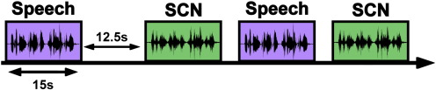
Participant Characteristics
We keenly checked on the participant's behaviour during reading. This would easily enable us to determine the tremendous underlying problem in every individual. The primary identities were the standing mode, reaction of lips during reading and the behaviour of hands.WE were also able to know the sight capability of them (Harrewijn et al. 2017).
We also found that during reading, gender majorly led to partispants speech language ,type and number of disfluencies one could produce. There was a great difference in number of stutters in male prescholers who had various disfluencies thus indicating that gender sensitivity is a issue when stuttering is concerned.Partispants were also categorized between parents and caregivers to determine how many are affected by this issue.
The diagram below indicates how brain activation from controls during speech and non speech tasks as observered in different partispants who stutter.
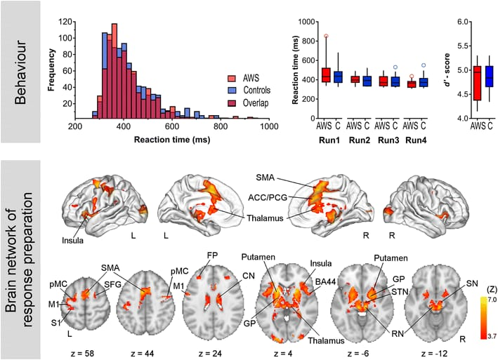
Results
We were able to discover that only those who had a great ability to read quickly at a different position were also the most effective ones when it came to speaking since they were more fluent. According to Dinoto et al. (2019), the age stages between the preschoolers also evidenced that speaking fluently was not easy, thus giving a clear result that age matters a lot in communication.
At first, we made a comparison on the response from repeat trials with the reverse, and there was no substantial difference. However, the answer noted from the two types of reaction were used for production analysis. During the production process after examination of the brain of a preschooler who stutter and those who don't, it showed that none stutters had a high level of brain activation. This was identified in the individuals' two side precentral gyri, parietal lobule as well as the right side cerebellum. On the other side stuttering, preschoolers had greater activation than the others in the bilateral transverse temporal gyri closed to Heschl’s gyrus, left cerebellar culmen, and bilateral putamen. These results were the same for the speech and non-speech preschoolers.
According to Piispala et al. (2018), raw motor evoked potentials (MEPs) from the abductor digiti minimi muscle contralateral to transcranial magnetic stimulation of the motor cortex in ten preschoolers who stutter and thirteen fluent speaking control participants; at baseline (pre), during (D), and after (post) performance of a speech task specified on the abscissa, that is rest speech task (RE), solo reading (SR), chorus reading (CR), spontaneous speech (SP), singing (SI), or non-verbal orofacial movements (NM). The left (LH) and the right (RH) hemisphere were stimulated in random order. Mean ± standard error.
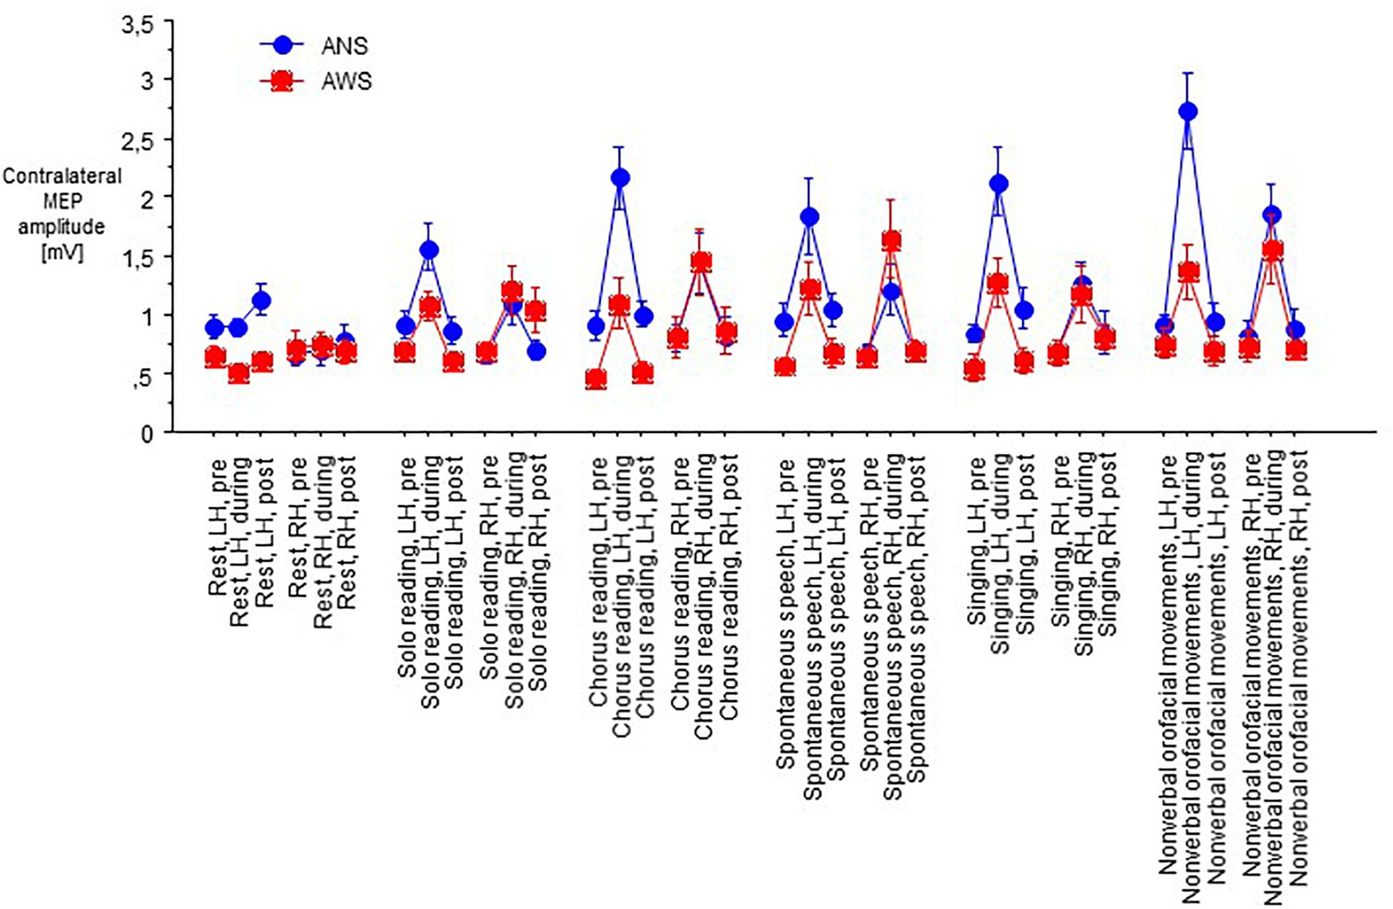
Discussion
The purpose of conducting this study using different specialist was to aid in determining the effects and results of stuttering during speech and in reading. Giving the participants repetitive chances to read words at different position enabled us to discover where their stuttering effect comes in. We, therefore, realized that only through mutual support and regular diagnosis can help us to reduce the rate of stuttering. Those with persistent stuttering should be often encouraged and be motivated but not being depicted by there colleagues (Piispala et al. 2017).
In the lab during experimentation, we found that the level of activation was increasing at the right STG and decreasing at the left side in the group of preschoolers who were selected. This was also closed to the control of both the speech and the non-speech individuals that were contrary to other studies where two-sided STG deactivation was shown in preschoolers who stutter during the speech, and those who don't stutter were fluent. Also, the study focused on brain activation, especially for speech pronunciation without stuttering by using the speech utterance of double syllables which was compared with the reading of sentences and conversations. Also, we rejected the few scans for stutter preschoolers' analysis. This was to account for the differences in the findings from the other research work on oral reading with stuttering and without stuttering.
Conclusions
Stuttering is a disorder, and it negatively affects peoples speech and capability to speak. It is also a source of discomfort to those who are most affected since they may not always be happy as they communicate since they are aware that they are going to make mistakes.
As I sum up, in this research paper, I have discussed stuttering where stuttering preschoolers have the same differences in brain activation. This is evident from the use of the controls, especially during speech and non-speech practice moments, therefore indicating that the problem is not specifically on speech. We also noted a consistency in functional activation abnormalities stimulation defects in parts that are important to the auditory-motor combination in stuttering preschoolers through perception and planning for speech and non-speech preschoolers. For preschoolers, when stuttering is noticed, the caregivers should always be in the frontline to support these young to grow to have a feeling of belonging and appreciating there lives.
References
Chang, S. E., Kenney, M. K., Loucks, T. M., & Ludlow, C. L. (2009). Brain activation abnormalities during speech and non-speech in stuttering speakers. NeuroImage, 46(1), 201-212.
Dinoto, A., Busan, P., Formaggio, E., Bertolotti, C., Menichelli, A., Stokelj, D., & Manganotti, P. (2018). Stuttering-like hesitation in a speech during the acute/post-acute phase of immune-mediated encephalitis. Journal of fluency disorders, 58, 70-76.
Garnett, E. O. D., Chow, H. M., Choo, A. L., & Chang, S. E. (2019). Stuttering severity modulates effects of non-invasive brain stimulation in adults who stutter — frontiers in Human Neuroscience, 13, 411.
Harrewijn, A., Schel, M. A., Boelens, H., Nater, C. M., Haggard, P., & Crone, E. A. (2017). Children who stutter show reduced action-related activity in the rostral cingulate zone. Neuropsychologia, 96, 213-221.
Kleinow, J. (2018). How the Brain Influences the Cognitive, Emotional, and Motor Aspects of stuttering. More Than Fluency: The Social, Emotional, and Cognitive Dimensions of Stuttering, 7.
Piispala, J., Määttä, S., Pääkkönen, A., Bloigu, R., Kallio, M., & Jansson-Verkasalo, E. (2017). Atypical brain activation in children who stutter in a visual go/nogo task: An ERP study. Clinical Neurophysiology, 128(1), 194-203.
Piispala, J., Starck, T., Jansson-Verkasalo, E., & Kallio, M. (2018). Decreased occipital alpha oscillation in children who stutter during a visual Go/Nogo task. Clinical Neurophysiology, 129(9), 1971-1980.
Smith, A., & Weber, C. (2016, November). Childhood stuttering: Where are we and where are we going?. In Seminars in Speech and Language (Vol. 37, No. 04, pp. 291-297). Thieme Medical Publishers.
Walsh, B., Tian, F., Tourville, J. A., Yücel, M. A., Kuczek, T., & Bostian, A. J. (2017). Hemodynamics of speech production: an fNIRS investigation of children who stutter. Scientific reports, 7(1), 4034.
Walsh, B., User, E., Bostian, A., Mohan, R., Gerwin, K. L., Brown, B., ... & Smith, A. (2018, September). What are predictors for persistence in childhood stuttering?. In Seminars in speech and language (Vol. 39, No. 04, pp. 299-312). Thieme Medical Publishers.
Wieland, E. A., McAuley, J. D., Dilley, L. C., & Chang, S. E. (2015). Evidence for a rhythm perception deficit in children who stutter. Brain and language, 144, 26-34.

APPENDIXES
CWNS-Children Who Do Not Stutter
CWS- Children Who Stutter
DTI- Diffusion Tensor Imaging
HG- Heschl’s Gyrus
PWS – People Who Stutter
STG – Superior Temporal Gyrus

